Centre Wellington Hydro Ltd.

OEB Staff Questions

EB-2019-0025

**Centre Wellington Hydro Ltd.**

**EB-2019-0025**

**Staff Question-1**

**Ref: IRM Model, Tab 3**

**Manager’s Summary, p. 12**

On page 12 of the Manager’s Summary, Centre Wellington Hydro identified the variance between the amount proposed for disposition and the amount reported in RRR for Account 1568 (LRAM) only. Tab 3 of the IRM Model shows a variance for Account 1580 (RSVA – Wholesale Market Service Charge) of a credit of $1,233. Please provide an explanation on this variance amount.

**Staff Question-2**

**Ref: IRM Model, Tab 3**

**Manager’s Summary, p. 13**

On page 13 of the Manager’s Summary, Centre Wellington Hydro stated that it filed a blank Account 1595 Workform given that it is not proposing to dispose of any of its 1595 balances as a full year has not passed since the sunset rate riders date expired.

1. Please confirm that the credit balance of $8,628 showing for 2017 would not be eligible for disposition.
2. All sub-accounts eligible for disposition are to have the 1595 Workform completed, regardless of whether the account is being requested for disposition. Please file a complete 1595 Workform for any eligible year(s) (e.g., 2017).

**Staff Question-3**

**Ref: IRM Model, Tab 3**

OEB staff identified an error in a formula in Tab 3 of the IRM Model. The formula for cell BM41 currently shows as follows: BM41 = SUM (BM39, BM40) - BM37.

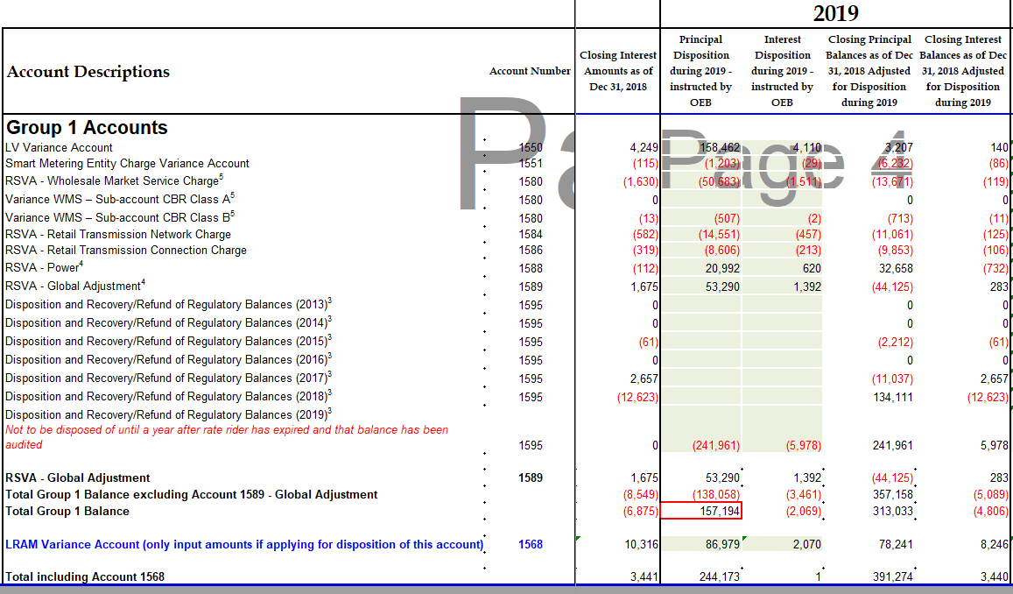

The correct formula should be: BM41 = SUM (BM39, BM40). OEB staff has corrected the formula in cell BM41 in Tab 3 of the IRM Model. Please confirm that the attached IRM model accurately reflects the correction.

**Staff Question-4**

**Ref: IRM Model, Tab 3**

In Tab 3 of the IRM Model, Centre Wellington Hydro selected “no” with respect to whether Accounts 1588 and 1589 are being requested for disposition. Please confirm whether “yes” should have been selected and update Tab 3 accordingly.

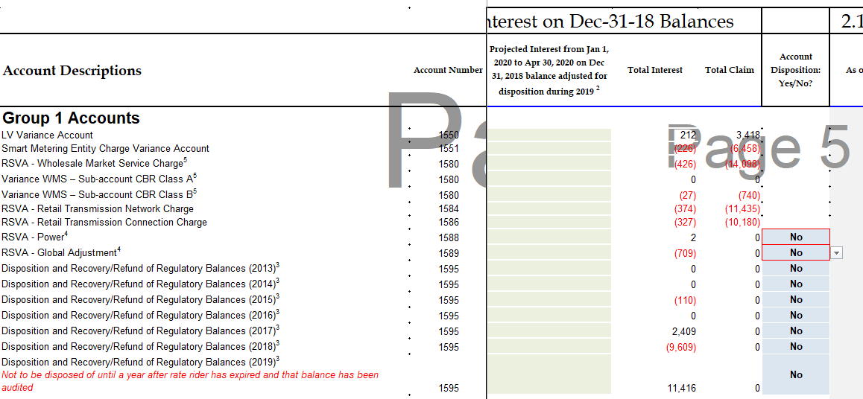

**Staff Question-5**

**Ref: Manager’s Summary, p. 18**

**CWH_Reply to OEB_Incomplete Letter_2020 IRM_20190823_20190827, p. 3**

On February 21, 2019, the OEB issued its letter entitled *Accounting Guidance related to Accounts 1588 Power, and 1589 RSVA Global Adjustment* (GA) as well as the related accounting guidance. In their 2020 applications, distributors are to provide a status update on the implementation of the new accounting guidance, a review of historical balances, results of the review, and any adjustments made to account balances.

The OEB set out its expectations for final disposition requests of commodity pass-through account balances as noted in the Addendum.[1]

At the above noted first reference Centre Wellington Hydro stated the following:

CWH is confident after studying the new accounting guidance published by the OEB and reviewing CWH’s DVA’s historical balances which were disposed of in CWH’s 2019 IRM, that those balances approved on an interim disposition are accurate and complete and should be deemed final disposition.

At the above noted second reference Centre Wellington Hydro stated the following:

CWH is currently in the process of updating CWH’s methodology in order to comply with the new accounting guidance effective January 1, 2019…

1. Please explain why Centre Wellington Hydro is seeking recovery of its deferral and variance account (DVA) balances approved on an interim disposition in its prior proceeding, on a final basis in this proceeding, when Centre Wellington is still in the process of updating its methodology to comply with the OEB’s new accounting guidance issued February 21, 2019.
2. Please provide further details on the review that was completed, and any summary reports available (e.g. how the review was done).
3. If adjustments to the DVAs have not been quantified, please provide a timeline as to when the applicant expects any discrepancies to be resolved.

**Staff Question-6**

**Ref: Manger’s Summary, p. 19**

At the above noted reference, the Account 1588 balance is described. Specifically, regarding the Global Adjustment (GA) file “GA-Analysis-Workform-Instructions-20190715.docx”, “Appendix A GA Methodology Description Questions on Accounts 1588 & 1589” (or page 15 of the document), the table in Question 1 for Account 1588 requests the “Balance December 31, 2018”.

1. Please confirm that the first line of this table represents the Account 1588 general ledger balance as at December 31, 2018.
2. Please confirm that last line of this table represents the closing principal Account 1588 balance as at December 31, 2018 in the DVA continuity schedule (cell BG28).
3. Please explain any differences between (i) and (ii), considering any OEB-approved dispositions that occurred in the year
4. Please also repeat steps (i), (ii), and (iii) for Account 1588 balances as at December 31, 2017.
5. If the revised table shows a material change in the assessment of the Account 1588 balance, please quantify and explain.
6. Please also file a similar table relating to 2017 balances for Account 1588.
7. Please quantify and explain any large amounts shown in these tables relating to 2017 and 2018 balances.

**Staff Question-7**

**Ref: Manager’s Summary, p. 14**

At the above noted reference Centre Wellington Hydro stated the following:

During 2017 CWH did not have any Class A customers. As of July 1, 2018, CWH had two customers become Class A. The same two customers effective July 1, 2019 have continued to be Class A customers.

Please complete the 2020 IRM generator model by populating the additional tabs applicable to customers that have transitioned to Class A, specifically the CBR additional tab and the GA additional tab.

**Staff Question-8**

**Ref: Manager’s Summary, p. 17**

At the above noted reference Centre Wellington Hydro stated the following:

The Global Adjustment revenue, which is billed directly to the non-RPP customers, is posted directly to account 4707 – Global Adjustment from our CIS system and accrued back to the appropriate month, via a monthly journal entry.

1. Please explain why GA revenue is posted directly to an expense account, Account 4707 Global Adjustment, instead of revenue accounts.
2. Please explain and quantify any impact on Account 1588 and Account 1589 from Centre Wellington Hydro posting GA revenue to an expense account, instead of revenue accounts.
3. Please explain Centre Wellington Hydro’s process in more detail to conform to the OEB’s February 21, 2019 Accounting Guidance, when it is evident that some deviations may remain.

**Staff Question-9**

**Ref: Manager’s Summary, p. 21**

At the above noted reference Centre Wellington Hydro stated the following:

CWH does the 1st true up by monthly true up of the GA rate to final rate, as described in Section 10 “Global Adjustment” in the Managers Summary of CWH’s 2020 IRM Application, and quarterly/annually 2nd true up of the estimated volume to actual volume. The actual volume is obtained from our billing system, which separates the volume of each TOU/Tier 1 & 2 and uses the particular prices for each TOU/Tier 1 & 2.

1. Please describe how Centre Wellington Hydro’s Account 1588 and Account 1589 balances are accurate, considering Centre Wellington Hydro is only performing certain true-ups on a quarterly/annual basis, instead of a monthly basis.
2. If there are impacts on Account 1588 and Account 1589 from only performing these true-ups on a quarterly/annual basis, instead of a monthly basis, please describe and quantify the impacts.

**Staff Question-10**

**Ref: Manager’s Summary, p. 21**

At the above noted reference Centre Wellington Hydro stated the following regarding whether CT 1142 has been trued up for with the IESO for all of 2018:

Yes, CWH has trued up CT1142 with the IESO for all of 2018 and booked it into 2018.

At the above noted reference Centre Wellington Hydro also stated the following regarding whether which months from 2018 were trued up in 2019:

The October to December 2018 actual volume true up was done in 2019 and booked into 2019.

At the above noted reference Centre Wellington Hydro also stated the following regarding whether these true ups were recorded in the 2018 or 2019 balance in the General Ledger:

CWH estimated the above true up at year end and accrued estimate in 2018.

1. Please explain Centre Wellington Hydro’s potentially contradictory statements that all true-ups for 2018 have been booked into the 2018 versus its comment that the October to December 2018 actual volume true up was booked into 2019.
2. Does Centre Wellington Hydro mean that an estimate was booked in the 2018 general ledger for the October to December 2018 actual volume true up, which was reversed in 2019, and the actual true up for this period was booked in 2019? Please explain.
3. If there are impacts on Account 1588 and Account 1589 from recorded an estimate of the October to December 2018 actual volume true up in 2018 versus the actual amount, please describe and quantify the impacts.

**Staff Question-11**

**Ref: Manager’s Summary, p. 21**

**Manager’s Summary, p. 15**

**Manager’s Summary, p. 22**

At the above noted first reference Centre Wellington Hydro stated the following regarding the process for the initial recording of CT 148 in the accounts (i.e. 1588 and 1589):

CT 148 from IESO invoice is pro-rated based on the actual percentage of RPP/non-RPP consumption for the actual month and then booked into Account 4705 Power Purchased and Account 4707 Charges – Global Adjustment. The variance of GA charges and GA revenue is transferred into Account 1589 RSVA GA, the variance of Power Purchased and Energy Sales is transferred into Account 1588 RSVA Power. No part of CT 148 is posted to 1588 or 1589 directly.

At the above noted second reference, Centre Wellington Hydro stated the following regarding the percentage of each TOU period or Tier block:

The percentage of each TOU period or Tier block is calculated by dividing the volume of each TOU period or Tier block by total kWh’s for all of the tiers or blocks respectively. CWH obtains the volume breakout between the RPP tier and TOU buckets, by pulling stats codes used from its CIS system. This breakout is based on the previous months actual consumption used within each TOU period/tier block. This percentage is calculated each month, although from month to month it is very consistent. For example, in the August 2018 IESO submission the volume breakout is based on the monthly volumes billed in July for June’s consumption. CWH bills its customer on the calendar month.

At the above noted third reference, Centre Wellington stated that no true-up is needed, as the “actual” percentage of RPP and non-RPP is used:

CWH used the actual percentage of RPP and non-RPP to split the amount on CT 148 in 2018. Therefore, there is no true-up needed in 2018.

1. Please explain why “the actual percentage of RPP/non-RPP consumption for the actual month” is used, when at the time of initial recording of CT 148 into the accounts, the actual percentages would not be known. Are the actual percentages known, for example, due to the use of smart meter data?
2. Please explain why the description of the “actual” percentage of RPP/non-RPP consumption is different between the above noted first reference and the above noted second reference.
3. Please confirm whether Centre Wellington Hydro uses the above noted first reference or the above noted second reference to determine the “actual” percentage of RPP/non-RPP consumption and describe how it is in conformity with the OEB’s new accounting guidance issued on February 21, 2019.
4. Please also describe Centre Wellington Hydro’s statement that no true-up is needed in 2018, as per the above noted third reference, and describe how it is in conformity with the OEB’s new accounting guidance issued on February 21, 2019.

**Staff Question-12**

**Ref: IRM Model, Tab 3, filed August 12, 2019**

**IRM Model, Tab 3, filed August 27, 2019**

At the first above noted reference, Centre Wellington Hydro filed its initial IRM Generator Model. At the second above noted reference, Centre Wellington Hydro filed a revised IRM Generator Model, particularly regarding Tab 3, the DVA Continuity Schedule.

OEB staff notes that Centre Wellington Hydro has provided the following Account 1588 and Account 1589 balances as at December 31, 2017:

**Table 1 – Different Account 1588 and Account 1589 Balances as at December 31, 2017**



**Table 2 – Similar Account 1588 and Account 1589 Balances as at December 31, 2018**



1. Please explain the differences shown in column E of the above noted Table 1, also discussing the reasons why there are no differences shown in column H of the above noted Table 2.
2. If there are impacts on Account 1588 and Account 1589 from the differences shown in column E of Table 1, please describe and quantify the impacts.

**Staff Question-13**

**Ref: LRAMVA workform, Tab 1**

The LRAMVA balance in Table 1-a inadvertently includes 2019 savings amounts that are automatically pulled from Table 1-b. As a result, the total LRAMVA balance in Table 1-a and Table 1-b do not match.

1. In Table 1-b, please unhide rows 78 and 79 and remove the 2019 amounts in these rows that are not part of the LRAMVA claim.
2. Please confirm that Table 1-a of the LRAMVA workform has been updated.

**Staff Question-14**

**Ref: LRAMVA workform, Tab 3**

Tab 3 provides a template for distributors to input distribution rates by customer class. Based on the effective implementation dates of Centre Wellington Hydro’s tariff of rates, please revise the number of months entered in row 16 of Tab 3 to “0” in order to reflect a January 1 implementation date.

**Staff Question-15**

**Ref: LRAMVA workform, Tabs 2 and 5**

There are various entries in Table 5-d that OEB staff seeks clarity on, as it relates to the calculation of 2018 lost revenues.

1. Please confirm that actual savings from 2011 to 2014 CDM programs were embedded in the 2018 base load forecast. If confirmed, please explain why the persistence of 2011 to 2014 savings in 2018 have been included in Table 5-d.
2. As the LRAMVA threshold (of 7,405,795 kWh) includes forecast savings from 2015 to 2018, please confirm that it is appropriate to exclude the lost revenues from 2011 to 2014 in 2018, and modify Table 5-d accordingly.
3. Please clarify whether any 2017 unverified savings adjustments have been included in Tab 5. If yes, please ensure that the 2017 savings adjustments are entered in Table 5-c (as they relate to 2017 programs).
4. Please explain why the 2018 unverified savings entered into Table 5-d in the LRAMVA workform do not match the 2018 savings included in the P&C report (dated December 31, 2018). Please revise the entries, in Table 5-d, using the latest P&C report to support the 2017 unverified savings adjustments and 2018 unverified savings included in Tab 5 of the LRAMVA workform.

**Staff Question-16**

**Ref: LRAMVA workform, Tab 6**

Table 6-a includes projected carrying charges that are calculated up to December 31, 2020. Please update Table 6-a of the LRAMVA workform to include projected carrying charges up to December 31, 2019 only.

**Staff Question-17**

**Ref: LRAMVA workform**

1. If Centre Wellington Hydro made any changes to the LRAMVA workform as a result of its responses to the above LRAMVA questions, please file an updated LRAMVA work form, the revised LRAMVA balance requested for disposition, and a table summarizing the revised rate riders.
2. Please confirm any changes to the LRAMVA workform in response to these LRAMVA questions in “Table A-2. Updates to LRAMVA Disposition (Tab 2)”.

1. Addendum to Filing Requirements For Electricity Distribution Rate Applications - 2020 Rate Applications, dated July 15, 2019