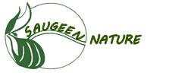
Saugeen Nature
c/o Nikki May
R.R. #2
Priceville, Ontario
N0C 1K0

Christine Cinnamon
Sr. Project Manager, Planning and Permitting
AECOM
Christine.cinnamon@aecom.com

RE: Owen Sound Phase 4 Reinforcement Project – Environmental Report
Saugeen Nature Comments

Dear Christine

We, the board members of Saugeen Nature, thank you for giving us the opportunity to comment on the Environmental Report. While we appreciate that Union Gas is taking many extraordinary precautions to do this project in an environmentally sensitive way, we still have several concerns based on our review of the ER.

Some of these comments are similar to those we have mentioned before. Where we bring them up again, it is because we feel that they are not adequately answered in the report.

Our concerns are outlined below.

Table 3-2: Comparative Route Analysis

The Table comparison clearly shows that impacted high quality natural environment features are far fewer for highway 6 than any of the others, even with requirement to stay well away from highway edge. But it is obvious that social and cultural factors have taken precedence in the decision to go with Concessions 2 and 4. It is unfortunate that Ontario society has still not become sufficiently aware of the value of our remaining natural features to the current and future health of the ecosystem and thus human communities.

Construction Activities Step 8, p. 88

Use of local water for pressure testing:
- Does this include taking water from sensitive natural areas such as Harrison Lake and Fen?
- And discharging it into these areas?
- Which surface water sources will be used?
- One of our members lives near a small wetland that he watched being drained dry by water takings for a construction project. We would like to hear your comments on this situation.
- Is water discharged back into the same water body from which it was taken to prevent transfer of invasives?
- What is done to ensure the safety of the water inhabitants during withdrawals and after discharges.
- Can you tell us which bodies of water will be used? We know of a local example where a wetland was pumped dry during road construction.
- Is the inside of the pipe cleaned of processing oils and solvents before being installed, so that these do not get into the local water during pressure testing?

Table 6-2, Effects on Soil Resources, page 92

What is list of species that are proposed for re-vegetation?

Ibid., Page 93

Description of soil contamination does not include seed transfer of invasive species, our especial concern is phragmites, but there are others. Washing anywhere along the route will move seed to that washing area.

Table 6-4: Effects on Surface Water

Under water quality issues: no mention of contamination with invasive species seed – potentially a greater hazard to surface waters than chemicals

See also questions and comments above under Step 8.

Section 6.2.1: Aquatic Resources

No mention of potential hazards to fish habitat as a result of local water takings for pressure testing of pipe. Same in Table 6-6.

We have concerns about frogs and salamanders and their eggs as well as fish species.

Section 6.2.2: Terrestrial Resources

Finally mentioned: Damage to vegetation and degradation of ecological communities may also occur due to contamination by non-native and invasive species brought in or carried along the route on construction equipment and/or personnel clothing.

It is important to mention requirement to rigourously clean equipment before bringing onsite and after contact with species like phragmites. Carrying out cleaning operations 30 m from wetlands will not prevent spread because seed can be washed over the ground into wetlands, and phragmites can take hold in drier ground.

Better to work early in the season, before phragmites comes into seed and to keep away from phragmites infested areas once the reed has gone to seed. We note that three patches of phragmites were found along the route.

Several of us have been working hard to dig up the patch of phragmites adjacent to Kinghurst at the roadside. This patch threatens a good quality wetland that is just behind the berm put up when the road was built. It would be very discouraging for us to find that further patches get started along this area, or any other that threatens high quality habitat in the ANSIs and wetlands along the route. Because Round Up usage is strongly discouraged in wet areas, hand digging or expensive mechanical equipment are the only options for removal. And multiple years of work are required to eradicate a patch, as work at other sensitive areas in Ontario has shown.

Table 6.7: Effects on Vegetation and Ecological Communities

For re-vegetation it would be preferable to use native seed from local, or at least Ontario sources.

Would prefer to see more references to use of control materials that will block the transfer of invasive seed along the route, especially in sensitive areas. This includes methods not only for installation but also careful removal so that seed-contaminated soil on the work-area side of the material is buried or removed entirely from the area.

Section 6.2.2.2 Wildlife

We have concerns, especially around Kinghurst and Harrison Lake and Fen

- Where the road divides wetlands and/or woodlands, turtle nests and basking amphibians can be found on the roads and roadsides in the appropriate seasons. These may be affected even if the work is confined to the gravelled part of the road. Snapping turtles, as one example are often seen laying their eggs at the edges of the gravel roads in this area. The nests are there until the following spring.
- About young snakes basking on the road in September and October. In fall of 2018, there were record numbers of these seen; garters and red-bellied snakes being two species noted along gravelled roads and even paved roads in Grey County.

These concerns can be somewhat allayed if work is done in such a way to avoid these periods near wetlands and woodlands. For example, laying pipe in the road at a time when turtle hatching and laying are at their lowest frequency in areas that are near wetlands.

The Saugeen Nature board also asks that we be informed of the timing for the construction work in the Kinghurst Reserve and Harrison Lake and Fen. We would like to be able to observe the precautions that are taken to protect this high quality habitat.

Thank you for your consideration of these comments.

Regards
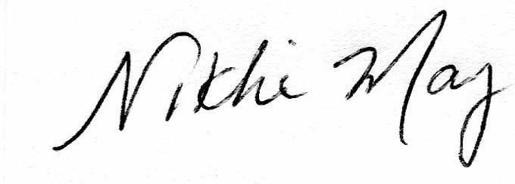

Nikki May
Past President, Saugeen Nature

