InnPower Corporation (InnPower)
2020 IRM Application
EB-2019-0047
Application Analysis
October 10, 2019

Staff Question #1
Ref: IRM Rate Generator, Tab 3. Continuity Schedule
In 2016, Account 1550, RSVA LV Variance Account captured transactions debit transactions of $583,100. In 2017, further debit transactions amounted to $445,237. In 2018, debit transactions were $265,570. These transactions account for the total 2018 closing balance of $1,293,907.
- Please provide a table for the years 2016, 2017, and 2018 which outlines, by rate class, all Revenues and Expenses related to LV charges.
Answer:
See file IRR staff question 1_2_3_EB-2019-0045_November 5_2019.xlsx
Question 1, 2, 3 – Adjustments to Rate Generator Model
- Adjustment to 1580 CBR in 2016 principle column (Cell AL23, AL25) for $10,131.12 – Calculated as difference of $103,370.01 revenue and $93,238.89 expense. Previously amounts for CBR were not separated out for 2016.
- Adjustment to 1580 CBR in 2016 interest column (Cell AQ23, AQ25) for $60.66 - Calculated as 10,131 prorated equally over 12 months x 1.10% (interest rate the same all year). Previously amounts for CBR were not separated out for 2016.
- Adjustment to 1580 CBR in 2017 principle column (Cell AV23, AV24 and AV25). CBR amounts were separated out mid 2017. There was an adjustment for YTD cost, with no adjustment for revenue. Revenue amount was included and variance was recalculated.
- Adjustment to 1580 CBR in 2017 interest column (Cell BA23, BA24 and BA25). Amount calculated as interest for new principle amount in 2016 and 2017.
- Adjustment to 1580 CBR in 2018 principle column (Cell BF23, BF24, BF25) – Amount adjusted to reflect correct principle amount.
- Adjustment to 1580 CBR in 2018 interest column (Cell BK25) – Amount calculated as interest for new principle amount in 2016 and 2017.

- Please provide an explanation for material differences between revenues and expenses
Answer:
There are no material variances

Staff Question #2
Ref: IRM Rate Generator, Tab 3. Continuity Schedule
In 2016, Account 1580, RSVA Wholesale Market Service Charge captured credit transactions of $317,938. In 2017, further credit transactions amounted to $275,006. In 2018, credit transactions were $35,850.
- Please provide a table for the years 2016, 2017, and 2018 which outlines, the retail volumes, rates and revenue by rate class, and the wholesale volumes, rates and expenses related to RSVA Wholesale Market Service Charge.
Answer
See file IRR staff question 1_2_3_EB-2019-0045_November 5_2019.xlsx
- Please provide an explanation for material differences between revenues and expenses
Answer:
There are no material variances

Staff Question #3
Ref: IRM Rate Generator, Tab 3. Continuity Schedule
IRM Rate Generator, Tab 12. Historic Wholesale
In 2016, Account 1584, RSVA Retail Transmission Network Charge captured debit transactions of $726,323. In 2017, further debit transactions amounted to $314,868. In 2018, debit transactions were $381,546.
In 2016, Account 1586, RSVA Retail Transmission Connection Charge captured debit transactions of $592,663. In 2017, further debit transactions amounted to $320,942. In 2018, debit transactions were $329,317.
- Please provide tables for the years 2016, 2017 and 2018, by rate class, including volumes and RTSR charges, for all Revenues, as well as the wholesale transmission/host distributor transmission volumes and rates for all expenses reconciling back to the annual RSVA variances. Please provide explanations for material differences between revenues and expenses by year, and between years.
Answer:
See file IRR staff question 1_2_3_EB-2019-0045_November 5_2019.xlsx
There are no material variances.

Staff Question #4
Ref: IRM Rate Generator, Tab 15. RTSR Rates to Forecast
InnPower is proposing increases to its RTSR rates from 7.7% to 17.5% in 2020.
- Please reconcile the components of the increase, i.e. price and volume contributors explaining causes for each of the reasons for the increase, provide a table by rate class outlining the drivers of the proposed increase to both the connection and network RTSRs.
Answer:
See file IRR staff question 4_EB-2019-0045_November 5_2019.xlsx
- To the extent that the increase is driven by changes in wholesale and retail billed volumes, please explain the underlying reasons for the change in wholesale volumes, and retail volumes billed quantities for 2017 and 2018.
Answer:
The above noted increases in RTSR’s are driven from the cost of power, i.e. charges from Hydro One. InnPower’s cost of power has been significantly increased due to a number of months where InnPower was the recipient of double peak billing from Hydro One. As you will see from the file IRR staff question 4_EB-2019-0045_November 5_2019.xlsx, on average InnPower’s billed MW from Hydro One invoices are normally less than or slightly above 50MW, as is denoted by the numbers in black in column J of the above noted file. However you will also see that there were 13 months over the past 3 years where InnPower’s Hydro One invoices were abnormally high due to Hydro One’s double peak billing. The values in red in column J of the above noted file show abnormal billings from Hydro One. As InnPower’s current RTSR’s were reflected to capture the “normal” Hydro One charges, this has lead to InnPower’s RTSR rates being insufficient to capture the true cost of power, which in turn has lead to the above noted increases.

Staff Question #5
Ref: Rate Generator Model, Tab 3 - DVA Continuity Schedule
- Please explain the “Interest Adjustment” for a debit of $958,573 in Account 1588 shown for year 2018 on the DVA Continuity Schedule.
Answer:
Amount was put in wrong column, should be in column BF under principle instead of interest. The amount is calculated based on the attached file above. The amount is made up of RPP 2nd True-up for the year and difference between unbilled and actuals.
Please see file IRR staff question 5_EB-2019-0045_Novmeber 5_2019.xlsx

Staff Question #6
Ref: IRM Rate Generator, Tab 4. Billing Det. For Def-Var
In cell J4, InnPower has not indicated that it confirms the accuracy of the information entered in this worksheet.
- Can InnPower can confirm the accuracy of the information in this worksheet?
Answer:
InnPower has confirmed the accuracy of the data in Tab 4 cell J4.
- If a) cannot be confirmed, please provide details on the information InnPower believes should be populated, and reconcile this to the information populated.

Staff Question #7
Ref: Manager’s Summary, Appendix B
IRM Rate Generator, Tab 4. Billing Det. For Def-Var
IRM Rate Generator, Tab 5. Allocating Def-Var Balances
InnPower explained that the 2016 Group 1 rate riders were calculated based on a 12 month disposition, but was collected for 24 months. It explained that this collection results in a credit owing to customers of $438,430. The factors for this include:
- An over collection of the GA Rate Rider for 2016
- An over collection of other rate variance accounts for 2016
- No collection of 1595 for the years 2009-2014, even though disposition was intended.
In column O of the second reference, InnPower has proposed recovery of 1595 to be allocated 61% to Residential, 14% to General Service less than 50 kW and 25% to General Service 50 kW to 4,999 kW. OEB staff notes that these are the same percentages located in column C of the third reference – reflecting the kWh proportions for allocation of 2020 rate riders.
OEB Staff notes that the rate riders contributing to the Account 1595 (2016) balance are varied, and may have different allocations. For instance, the GA rate rider was allocated to rate payers on the basis of non-RPP kWh:
- Please complete the attached worksheet itemizing the drivers of the Account 1595 (2016) balance. Add further columns, if necessary.
Answer:
Please see file IRR staff question 7a_EB-2019-0045_November 5_2019.xlsx
- Does InnPower consider it reasonable to allocate 1595 (2016) on the basis calculated in step a)?
Answer:
InnPower agrees that the above noted account should be disposed of based on the calculations provided in the file, IRR staff question 7a_EB-2019-0045_November 5_2019.xlsx
- If InnPower disagrees with b), Please confirm that InnPower is proposing to dispose of 1595 using the total kWh share in the current application, rather than proportionate share from the 2016 rate application.
- If InnPower disagrees with b) and c) cannot be confirmed, please explain the methodology used and provide a derivation of the allocation percentages in column O of the first reference.

Staff Question #8
Ref: Manager’s Summary, page 14.
IRM Rate Generator, Tab 6. Class A Consumption Data
InnPower states that it “has had two customers who have transitioned to Class A or the Industrial Conservation Initiative (“ICI”). The second reference indicates that Customer 1 transitioned in 2017, and spent the entire year of 2018 in Class A. Customer 2 does not have consumption data for 2017, implying a 2018 transition. However, Customer 2 has both the first and second half of 2018 recorded as being in Class A.
The total 2018 consumption for non-transitioning customers reconciles to that of Customer 1 alone.
- Please confirm that there are only two Class A customers, and no other customers have been Class A customers.

Answer:
Yes, there are only two customers.

- Please indicate when Customer 2 became a Class A customer.

Answer:
Customer 2 became a Class A customer July 1, 2018. The original submission should have indicated consumption January 2018 – June 2018 as Class B.

Staff Question #9
Ref: IRM Rate Generator, Tab 6.2a. CBR B_Allocation
The Total Consumption Less WMP Consumption has not been populated for 2017 and 2016.
- Please provide the total consumption less WMP consumption for 2017 and 2016.
Answer:
Please see updated Rate Generator model Tab 6.2a.

Staff Question #10
Ref: Completeness Item #2 filed Aug. 30, 2019, DVA Continuity Schedule
- InnPower has made material adjustments to its commodity accounts from 2015 to 2018 as indicated by the evidence (an excerpt reproduced below) as it was not performing proper true-ups in the past.
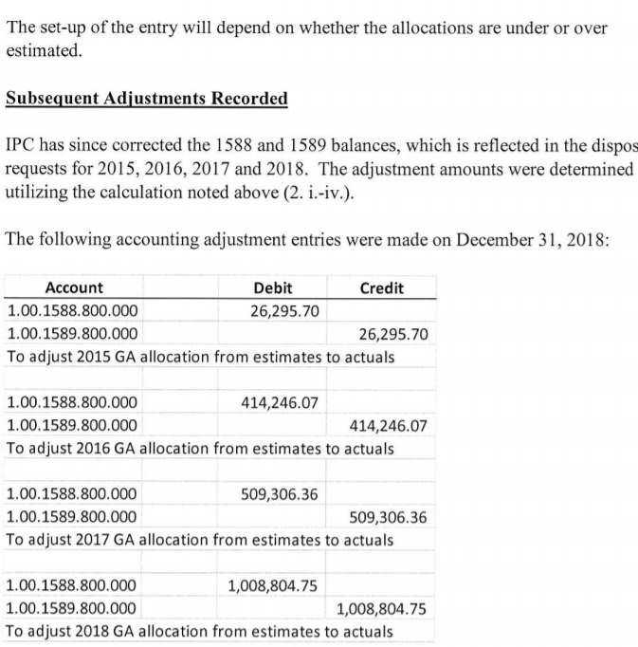
- In addition, the OEB expressed numerous concerns over InnPower’s settlement and accounting processes and its Group 1 account balances, and ordered an audit. It stated:

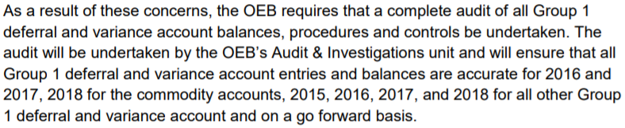

OEB staff notes that the audit has not yet been completed.
Given the magnitude of the adjustments made by InnPower to the commodity accounts (provided in part a) above), and the OEB’s concerns over the accuracy of InnPower’s commodity variance accounts, why does InnPower deem it appropriate to dispose of the commodity account balances before the completion of the audit?
Answer:
InnPower has requested in its application an interim rate order in the event that a full disposition was not ordered. The interim order is to alleviate the potential for increased rates as a result of disposing of 3 years, or more, of Group 1 accounts. InnPower agrees and confirms that the OEB has not started the audit on InnPower’s Group 1 accounts. To our knowledge the OEB has not been in contact with InnPower to setup or arrange the audit which, as noted above, was included in the Decision and Rate Order EB-2018-0045 issued December 13, 2018. InnPower is requesting that an interim rate order be issued for the disposition of the Group 1 accounts until such time as the OEB audit has been performed and completed.

Staff Question #11
Ref: GA Analysis Workform for years 2015, 2016, 2017 and 2018
The Table below provides the calculated loss factor in the evidence for each of the 4 years:
Year | Calculated Loss Factor
2015 | 1.0720
2016 | 1.0747
2017 | 1.0385
2018 | 0.09503
Please explain the variation in the calculated loss factor over the years.
Answer:
See file IRR staff question 11_EB-2019-0045_November 5_2019.xlsx
Staff Question #12
Ref: Response to Completeness Letter Item #3, filed Aug. 30, 2019
InnPower “confirms that it follows the OEB’s letter dated May 23, 2017 – Guidance on the disposition of Accounts 1588 and 1589.”
On February 21, 2019, the OEB issued its letter entitled Accounting Guidance related to Accounts 1588 Power, and 1589 RSVA Global Adjustment as well as the related accounting guidance. The accounting guidance is effective January 1, 2019 and is to be implemented by August 31, 2019. Distributors are expected to consider the accounting guidance in the context of historical balances that have yet to be disposed on a final basis (including the 2018 balances that may be requested for disposition in this rate application). In this application, distributors are to provide a status update on the implementation of the new accounting guidance, a review of historical balances, results of the review, and any adjustments made to account balances.
- Can InnPower confirm that it has also implemented guidance in the February 21, 2019 letter? If not, please explain why and provide InnPower’s plan for when this guidance will be implemented?
Answer:
InnPower has resubmitted its certification letter indicating InnPower has implemented the guidance in the February 21, 2019 letter.

Decision and Order EB-2018-0045 dated December 13, 2018

