Cooperative Hydro Embrun Inc. (Cooperative Hydro Embrun)
2020 IRM Application
EB-2019-0028
Application Analysis
September 10, 2019

Staff Question #1
Ref: A portion of Sheet 3 “Continuity Schedule” 2020 IRM is reproduced below
Ref: A portion of Sheet 3 “Continuity Schedule” 2019 is reproduced below

Table 1 - 2020 IRM Rate Generator Model, which identified the “Principal Adjustments during 2017”, is reproduced below.

Table 1 - 2020 IRM Rate Generator Model
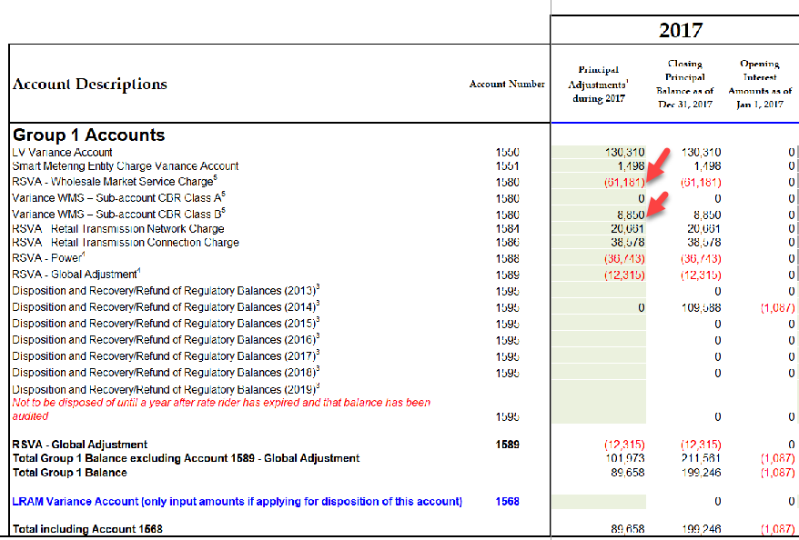
OEB staff notes that the amounts in account 1580, cell AV23, “RSVA – Wholesale Market Service Charge” and cell AV25, “Variance WMS – Sub-account CBR Class B” do not reconcile with the amounts in the 2019 IRM Rate Generator Model (Table 2).
Please reconcile differences. If the input into the Rate Generator Model is an error, please provide corrections and OEB staff will make the necessary changes to the model.

Table 2 - 2019 IRM Rate Generator Model
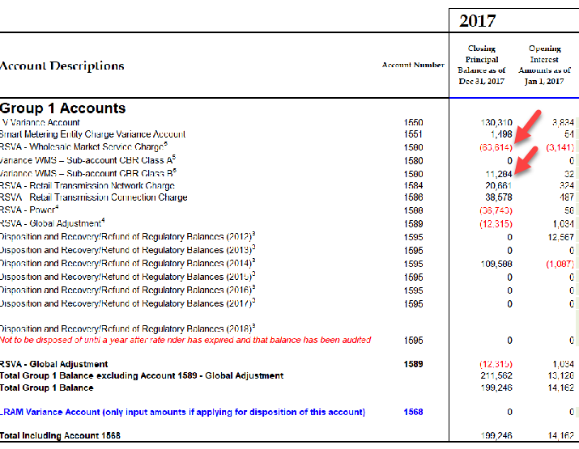

- CHEI Response: The difference is due to the “Principal adjustment during 2017” from the 2019 IRM Rate Generator Model. The amount should have been $8,567 and not $6,134. This explains the $2,434 difference.

Staff Question #2
Ref: A portion of Sheet 3 “Continuity Schedule” is reproduced below
The table from Cooperative Hydro Embrun’s 2019 IRM Decision which identified the principal and interest amounts approved for disposition, is reproduced below.

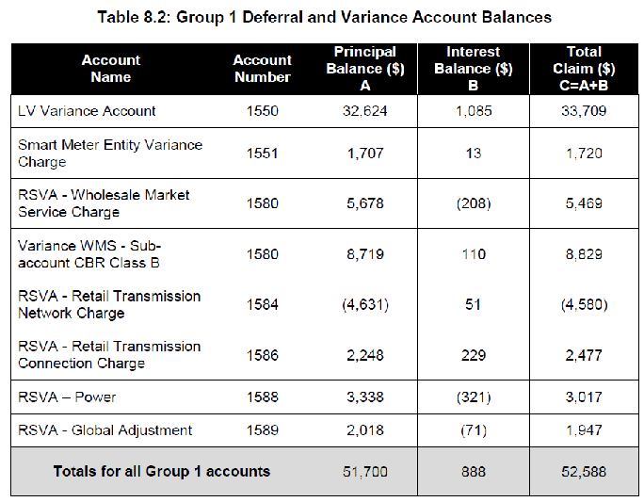

OEB staff notes that the “OEB-Approved Disposition during 2019” and interest Disposition during 2019 do not reconcile with the approved amounts in the 2019 IRM Decision (columns BM and BN).
Please reconcile differences. If the input into the Rate Generator Model is an error please provide corrections and OEB staff will make the necessary changes to the model.

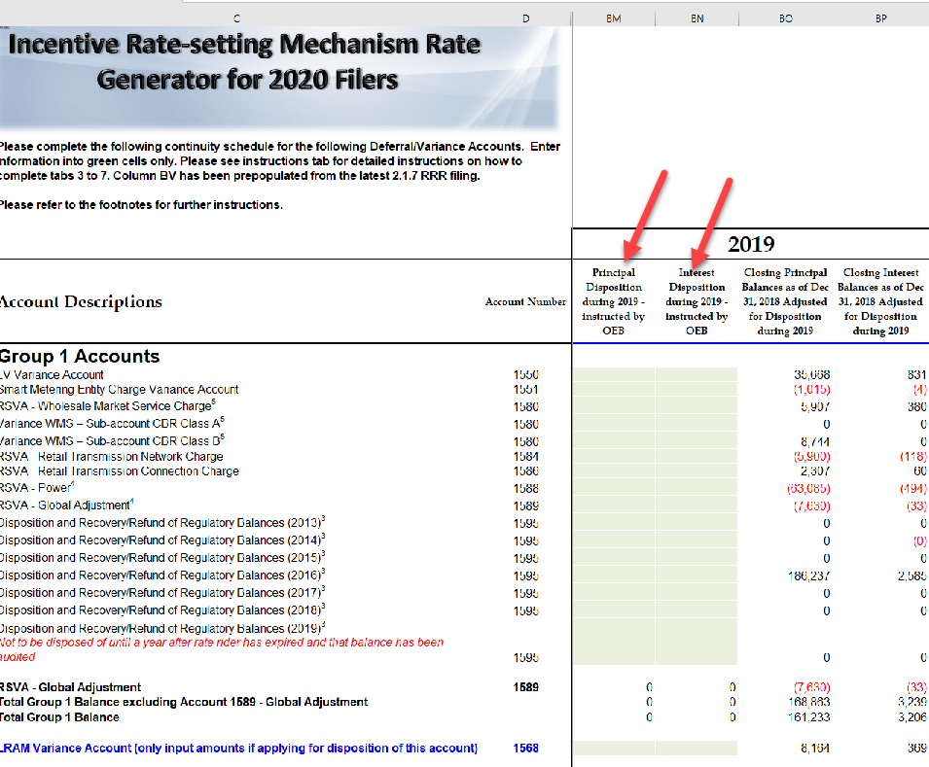

- CHEI Response: CHEI added the 2019 approved dispositions to columns BM and BN.

Staff Question #3
Ref: A portion of Sheet 3 “Continuity Schedule” is reproduced below
Board staff notes that the column BQ pertaining to the “Projected Interest from
January 1, 2019 to December 31, 2019 balance adjusted for disposition during 2019” is unpopulated.

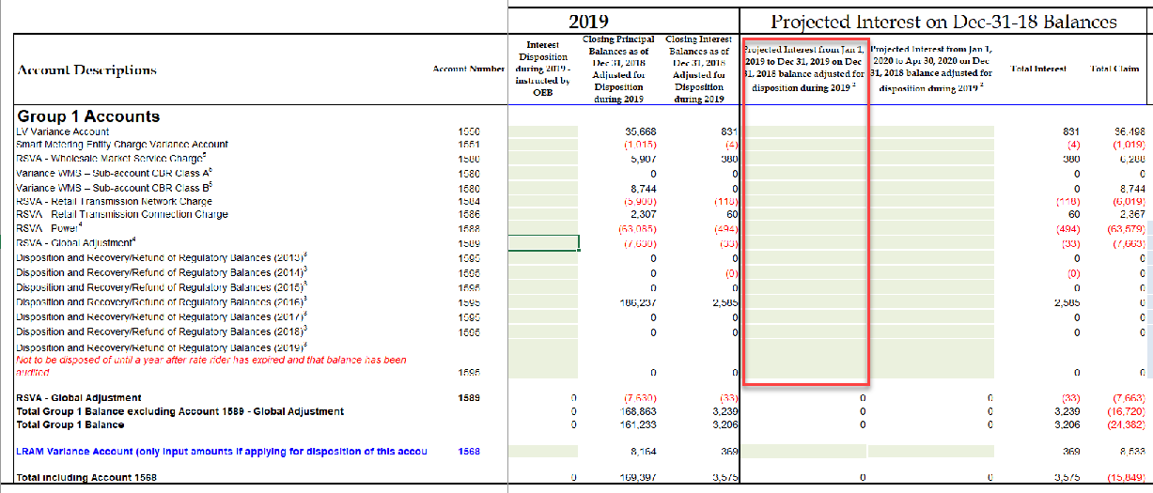

If the omission of this interest is an error, Board staff will make the relevant correction.

- CHEI Response: The omission of this interest is an error. Please have staff make the relevant correction.

Staff Question #4
Ref: GA Analysis Workform

Under Note 4 of the GA Analysis Workform, Class B Non-RPP monthly consumption totals are calculated by inputting the current month’s billed consumption (Column F), subtracting the prior month’s closing unbilled consumption (Column G), and adding the current month’s closing unbilled consumption (Column H). Cooperative Hydro Embrun’s 2018 GA Analysis Workform does not include data for columns G and H.
Please re-populate the GA Analysis Workform to include the unbilled consumption from the prior and current months (Column G and H, respectively).
- CHEI Response: CHEI only uses actual amounts. They only record an unbilled amount for the year-end financial statements, which is recorded retrospectively when they obtain the actual amounts. Column G&H do not apply since they do not make estimates.

Staff Question #5
Ref: GA Analysis Workform

The excerpt below shows the Non-RPP Class B kWh before losses.
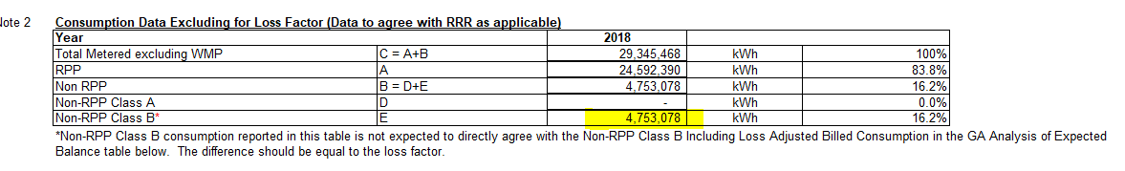

The excerpt below shows the Non-RPP Class B kWh including losses.

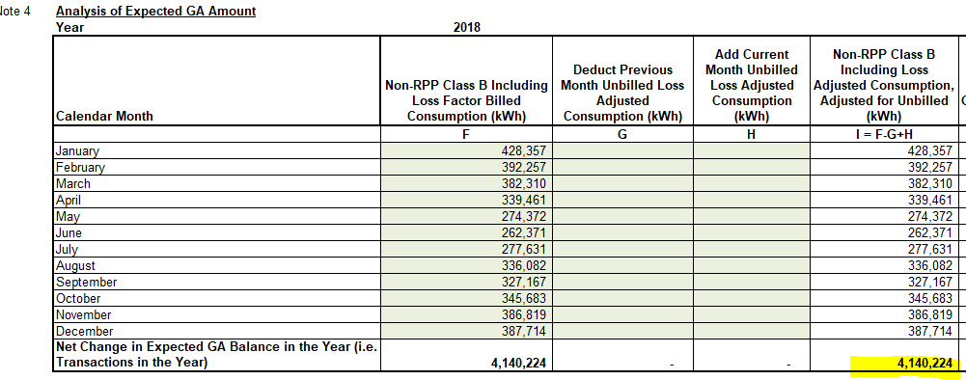

The kWh without losses should be lower than the kWh with losses. Please make the necessary corrections to the GA Workform.

- CHEI Response: Following an revision request, the amount from Note 2 should be at 3,893,178. No adjustment required to the GA Workform.

Staff Question #6
Ref: GA Analysis Workform

The net change in principal balance in the GL (transactions in the year) per Note 5 is reproduced below:

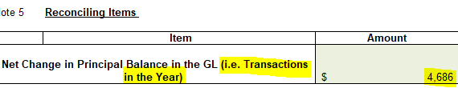

As indicated by the highlighted parts above, this amount should be the same as the transactions in the year shown on the DVA Continuity Schedule. However, the excerpt below shows that amount to be different.

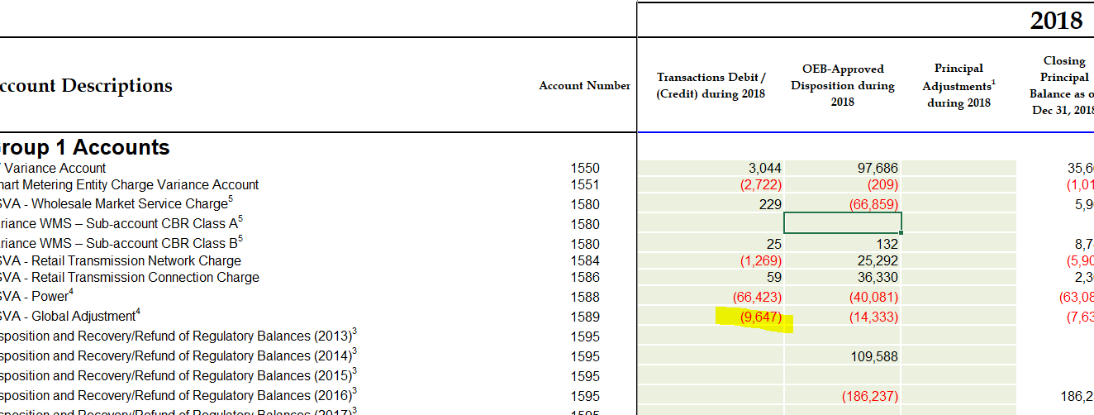

Please explain the discrepancy and provide a corrected version of the evidence.

- CHEI Response: The Net change in principal balance in the GL showed the OEB approved dispositions during 2018, which was shown on line 9 of the reconciliation. CHEI made the correcting adjustment to the DVA Continuity Schedule to only include the Transactions Debit/Credit during 2018.

Staff Question #7
Ref: Application, page 14 (lines 9 – 15)

An excerpt from the application is reproduced below:
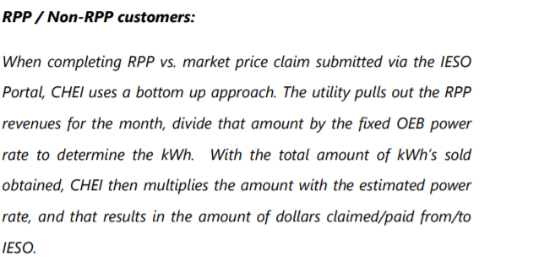
- Please explain the process for obtaining the RPP kWh at each RPP price in more detail, given that there are 5 different RPP rates.
- Please explain the process for calculating the dollars claimed or owed to the IESO for each of the 5 RPP prices, based on the respective consumption at each price.

- Please provide an example of the calculation for the sub parts a) and b) of this question.

- CHEI Response: Wording is wrong as it was copied from an older Summary. RPP kWh are based on the smart meter readings. The readings are made per cycles and types of customers. The readings are also split by OFF/MID/ON peaks automatically. Following the readings, CHEI is able to easily split the information based on the 5 different RPP rates.

- CHEI Response: Wording is wrong as CHEI does not deal with IESO. They receive an invoice from Hydro One.

- CHEI Response: Based on answers above, there is no example to give for a) and b)

Staff Question #8
Ref: Application, page 14 (lines 16 – 24)

An excerpt from the application is reproduced below:
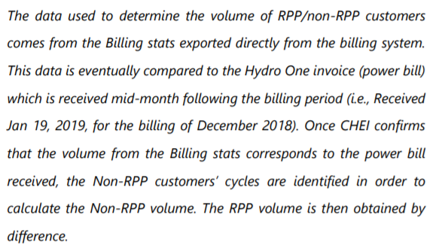
The description above appears to indicate that Cooperative Hydro Embrun uses billings completed in a month (in this example, December 2018) and not the consumption for December (which would generally not be billed in December) to determine the volume split for RPP and non-RPP.
- There appears to be a mismatch between the billing stats used and the wholesale kWh (lines 20-24).
  - Is this data used to record the initial split of CT 148 into RPP and non-RPP?
  - If yes to subpart i. above, is this split between RPP and non-RPP trued up at a later date when actual retail data becomes available?
  - Please provide a more detailed description of the process.

- CHEI Response: Yes

- CHEI Response: The split between RPP and non-RPP is only performed with actual consumptions. There is no need for a true-up since the split is not performed on estimates.

- CHEI Response: [Insert response here]

Staff Question #9
Ref: Application, page 17 (lines 9 – 12)
Please see the excerpt from application reproduced below:
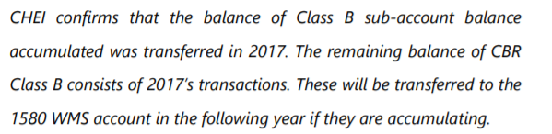
- Please explain why there is a balance related to 2017 still in Cooperative Hydro Embrun’s books, given that 2017 amounts were already disposed in 2019?

- What amount is remaining in CBR Class B that remains to be transferred to 1580 WMS in the “following year”? Please explain.

- CHEI Response: The application for disposition did not factor in adjustments to the balance of 2017. As such, this is why there is still a balance.

- CHEI Response: As shown on question a), the year-end adjustments, hence the differences noted between the balances and the request for dispositions, will be factored into the subsequent year disposition request. This is only a timing difference and the remaining full balance of 2017 will be transferred.

LRAMVA
Staff Question #10
Ref: Tab 1-a of LRAMVA workform (LRAMVA summary)
Cooperative Hydro Embrun applied to dispose of an LRAMVA debit balance of $8,533 associated with new CDM program savings from 2017 and 2018, including persisting savings from 2015 and 2016 in 2017, persisting savings from 2015 and 2017 in 2018, and carrying charges.
The LRAMVA balance calculated in Table 1-a inadvertently includes 2019 amounts that are pulled from Table 1-b. As a result, the total LRAMVA amounts in Table 1-a and Table 1-b do not match.
- In Table 1-b, please unhide rows 78 and 79 and remove the amounts in these rows as they relate to 2019 lost revenues that are not part of the claim.
- Please confirm that Table 1-a of the LRAMVA workform has been updated.

CHEI Response: Board Staff is correct in that the model incorrectly sums the LRAMVA total to include 2019. CHEI has rectified the threshold in the LRAMVA model filed in conjunction with these responses.

Staff Question #11
Ref: Tab 2 of LRAMVA workform (threshold)
EB-2017-0035, Load Forecasting Model, Tab CDM Adjustment
EB-2017-0035, Table 16 of Settlement Agreement, p. 34 of 57

In Cooperative Hydro Embrun’s 2018 cost of service proceeding, an LRAMVA threshold of 1,405,902 kWh comprised of forecast savings from 2015 to the 2018 test year was established. In the LRAMVA workform, Cooperative Hydro Embrun used an LRAMVA threshold of 1,405,719 kWh to compare forecast savings to actual savings in 2018.
- Please explain why an LRAMVA threshold of 1,405,719 kWh is used, as opposed to a threshold of 1,405,902 kWh established in the 2018 cost of service proceeding.
- Please revise Tab 2 of the LRAMVA workform, as appropriate, to ensure that the rate class breakdown of the LRAMVA threshold for 2018 aligns with what was approved in Table 16 of the Settlement Agreement.
CHEI Response: Board Staff is correct in that there is a variance of 183kWh from the model and Table 16 of the settlement agreement. CHEI has rectified the threshold in the LRAMVA model filed in conjunction with these responses.

Staff Question #12
Ref: Tab 6 of LRAMVA workform (carrying charges)
Table 6-a includes projected carrying charges up to June 30, 2019 based on the LRAMVA balances determined in Table 1-b.
- Please update Table 6 and Table 6-a of the LRAMVA workform to include projected carrying charges up to December 31, 2019.
CHEI Response: CHEI has updated the a revised LRAMVA model to include carrying charges up to December 31, 2019. The model is filed along with these responses.

Staff Question #13
- If Cooperative Hydro Embrun made any changes to the LRAMVA work form as a result of its responses to the above LRAMVA questions, please file an updated LRAMVA work form.
CHEI Response: a revised LRAMVA model is filed along with these responses.

- Please confirm any changes to the LRAMVA workform in response to these LRAMVA questions in “Table A-2. Updates to LRAMVA Disposition (Tab 2)”.
CHEI Response: Please see updated table below. A revised model is filed with these responses.
Description | Residential | GS<50 kW | GS>50-4999kW | USL | Street Lighting | Total
 | kWh | kWh | KW | kWh | kW
2017 Actuals | $7,172.13 | $7,490.37 | $0.00 | $0.00 | $0.00 | $14,662.50
2017 Forecast | ($1,863.58) | ($969.74) | ($620.88) | ($6.78) | ($113.21) | ($3,574.18)
Amount Cleared
2018 Actuals | $6,232.35 | $9,362.22 | $0.00 | $0.00 | $0.00 | $15,594.57
2018 Forecast | ($3,555.32) | ($14,963.52) | $0.00 | $0.00 | $0.00 | ($18,518.84)
Amount Cleared
Carrying Charges | $334.07 | $129.08 | ($29.17) | ($0.32) | ($5.32) | $428.35
Total LRAMVA Balance | $8,320 | $1,048 | -$650 | -$7 | -$119 | $8,592

Staff Question #14

- On February 21, 2019 the OEB issued new accounting guidance for accounts 1588 and 1589 and required the distributors to implement it by August 31, 2019. The new guidance is effective January 1, 2019. Cooperative Hydro Embrun Inc. did not indicate that it has implemented the above noted OEB’s guidance. Please indicate if Cooperative Hydro Embrun Inc. has implemented the OEB accounting guidance related to the commodity variance accounts.
CHEI Response: CHEI implemented the OEB accounting guidance on January 1, 2019 for account 1588 and 1589.
- As part of its previous IRM application (EB-2018-0026), Cooperative Hydro Embrun Inc.’s audited 2017 Group 1 DVA account balances were approved for interim disposition by the OEB. Cooperative Hydro Embrun Inc. has not indicated whether it is requesting final disposition of its 2019 rate riders. Please indicate whether Cooperative Hydro Embrun Inc. is proposing final disposition of its 2019 rate riders in this proceeding.
CHEI Response: CHEI confirms that it is requesting final disposition of its 2019 rate riders.

EB-2018-0026 issued December 13, 2018, page 11 of 24

