Niagara-on-the-Lake Hydro Inc. (Niagara-on-the-Lake Hydro)
EB-2019-0056
OEB Staff Questions
November 25, 2019

Staff Question-1
Ref: Revenue to Cost Ratio Adjustment Model
- Tab 7 of the Revenue to Cost Ratio (R/C Ratio) Adjustment Model is to allocate the revenue offsets to each rate class. Niagara-on-the-Lake Hydro has not entered the total miscellaneous revenue amount in cell F47 of Tab 7. As a result, the allocated revenue offset amounts are not captured in the calculations of this model. Please enter the total miscellaneous revenue amount in cell F47 and update later tabs of the R/C Ratio Model and Tab 16 of the IRM Model.
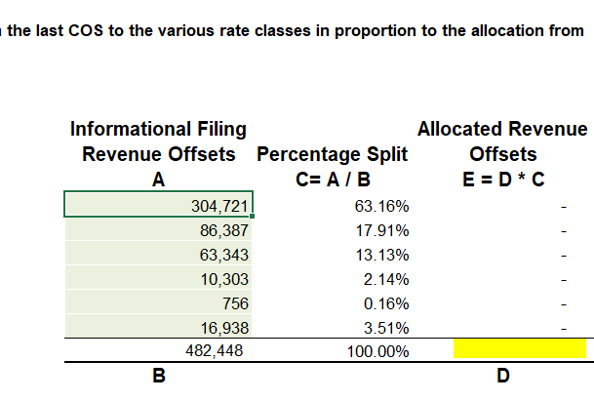
- Tab 8 of the R/C Ratio Model is to remove the transformer allowance from volumetric rates. By removing the transformer allowance from the distribution revenue, the adjusted volumetric rates (column marked with I) should be lower than the volumetric rates from tariff (column marked with F). Therefore, the transformer allowance rates entered in this tab should be with positive signs. Please correct the signs of the transformer allowance rates entered in Tab 8 and update later tabs of the R/C Ratio Model and Tab 16 of the IRM Model.
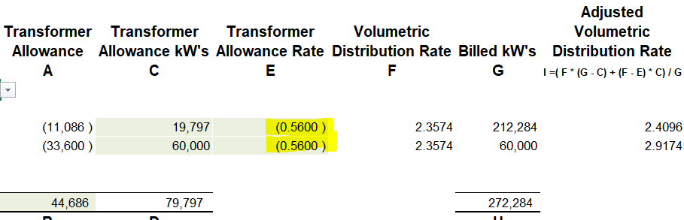

Staff Question-2
Ref: Rate Generator Model – Tab 3 Continuity Schedule – Account 1595 (2015) and Account 1595 (2016)
In the continuity schedule, Niagara-on-the-Lake Hydro entered principle adjustment and interest adjustment amounts in Account 1595 (2015) and Account 1595 (2016) in the year of 2018. Please provide explanation for the four adjustment amounts.

Staff Question-3
Ref: 2018 Class A Consumption
As noted in the Manager’s Summary and Tab 6 of the Rate Generator Model, Niagara-on-the-Lake Hydro had five customers transitioned between Class A and Class B in 2018. OEB staff calculated the total 2018 Class A consumption of these five customers to be 11,633,411 kWh using the data entered in Table 3a in Tab 6. However, Table Note 2 of the GA Analysis Workform shows that Niagara-on-the-Lake Hydro reported total Class A consumption of 18,134,723 kWh for 2018.
- Please confirm whether or not Niagara-on-the-Lake Hydro had no full-year Class A customers in 2018 and all the Class A consumption was from the five Class A/B transition customers.
- Please provide explanation for the discrepancy in Class A consumption data described above.

Staff Question-4
Ref: GA Analysis Workform, Appendix A, pages 2 and 12
Under #2, Niagara-on-the-Lake Hydro indicated it uses approach B. Under #4b, it states that this method ensures that the difference between the approved loses and actual losses are shared between RPP and non-RPP customers.
- Please confirm that Niagara-on-the-Lake Hydro is using approach B as it believes that it ensures that the difference between approved losses and actual loses are shared between RPP and non-RPP customers.
- If not confirmed, please explain why approach A (the approach in accordance with the new accounting guidance) is not used.
- If confirmed, please explain how approach B will better allocate the loss difference between RPP and non-RPP customers in comparison to approach A.
- If confirmed, please quantify the difference that would be recorded in Accounts 1588 and 1589 between the two approaches.

Staff Question-5
Ref: Manager’s Summary, page 20
Ref: GA Analysis Workform, Appendix A, page 14
On page 20 of the Manager’s Summary, it states that there is variance of $78,553 between the RRR and DVA Continuity schedule balance for Account 1589 due to the difference in estimate to actual generation submitted to the IESO in 2019 for 2016 and January to April 2017.
- Of the $78,553 variance, please confirm that $42,891 is due to the adjustment for January to April 2017.
  - Per Appendix A of the GA Analysis Workform, Account 1589 principal adjustment in the 2019 rate application included a principal adjustment of $42,891 for January to April 2017 generation estimate to actual differences. Please confirm that this adjustment was recorded in the GL in 2019 and therefore, is not a reconciling item in the 2018 GA Analysis Workform and is not a reversing principal adjustment in the 2018 balance. If not, please explain why this is not a reconciling item in the 2018 GA Analysis Workform and a reversal in 2018.
- Please confirm that the remaining variance is due to the 2016 difference in estimated to actual generation. If not, please explain what the remaining variance pertained to.
  - Please explain the year in which the 2016 difference in estimated to actual generation was recorded in the GL and in the DVA Continuity Schedule.
- Please discuss the impact to Accounts 1588 and 1589 when Niagara-on-the-Lake settled the adjustment with the IESO in 2019.

Staff Question-6
Ref: Manager’s Summary, pages 38-39
Ref: GA Analysis Workform
Niagara-on-the-Lake Hydro adjusted its billing schedule so that all customers are billed the calendar month in the month following consumption.
- Please indicate when the adjustment to the billing schedule occurred.
- In the GA Analysis Workform, the adjusted net change in the principal balance in the GL is ($37,894), please explain whether this balance accumulated prior to the change in billing schedule. If not, please explain what this balance pertains to.
- Please confirm that going forward, Account 1589 is still expected to have a balance equal to the difference in approved and actual losses for non-RPP customers.

Staff Question-7
Ref: Manager’s Summary, page 40
Niagara-on-the-Lake Hydro tested the new process by comparing the results to those achieved using the template issued by the OEB and the differences were not material. Please explain what the differences were due to.

Staff Question-8
Ref: Manager’s Summary, page 40
Niagara-on-the-Lake Hydro has considered the new accounting guidance for 2017 and 2018 balances and confirms there are no systemic issues with the account balances. Please provide further details on the review that was completed, and any summary reports available (e.g. how the review was done).

