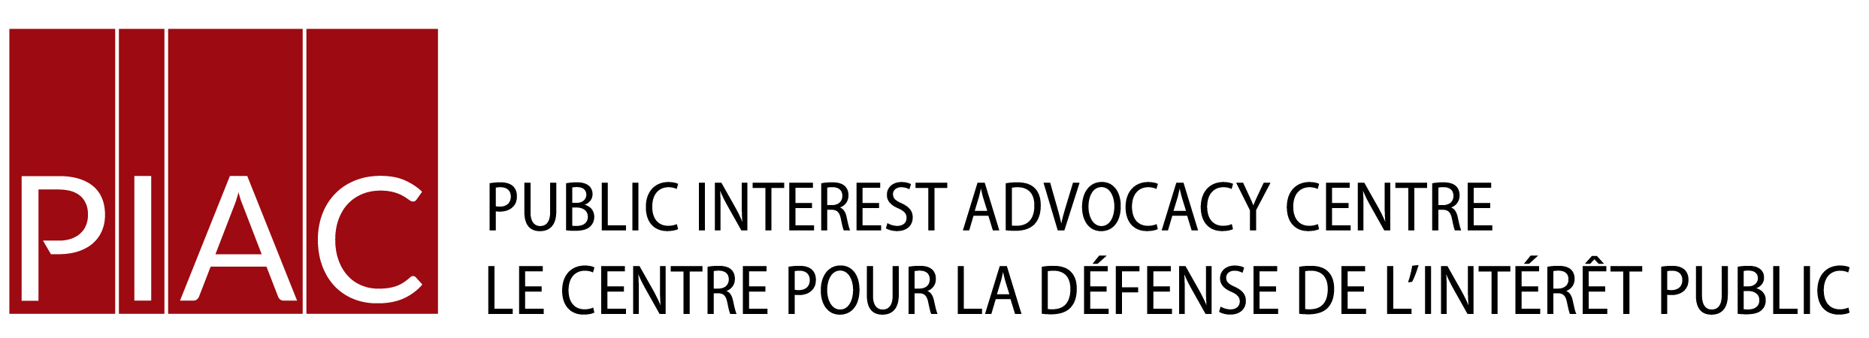
December 3, 2019 VIA E-MAIL

Christine E. Long
Registrar and Board Secretary
Ontario Energy Board
Toronto, ON

Dear Ms. Long:

Re: EB-2018-0319 Enbridge Gas Distribution Inc.
Application for approval to continue the existing financial terms associated with offering Open Bill Access services for the years 2019 and 2020
Interrogatories of the Vulnerable Energy Consumers Coalition (VECC)

Please find attached the interrogatories of VECC in the above-noted proceeding. We have also directed a copy of the same to the Applicant.

Yours truly,

Mark Garner
Consultants for VECC/PIAC

Email copy:
Mr. Joel Denomy, Technical Manager, Regulatory Initiatives
Ms. Lorraine Chiasson, Assistant Regulatory Coordinator
EGDRegulatoryProceedings@enbridge.com

REQUESTOR NAME | VECC
TO: | Enbridge Gas Inc. (EGI)
DATE: | December 3, 2019
CASE NO: | EB-2018-0319
APPLICATION NAME | Open Bill

VECC-1
Reference: Exhibit B, Tab 2, Schedule 2, pg. 1 & Attachment 3, pg.10 of 22

- Please give examples of “non-CPA” complaints/disputes received by EGI.
- Is the list provided at Attachment 3 an exhaustive list of what constitutes a CPA dispute?

VECC-2
Reference: Exhibit B, Tab 2, Schedule 2, page 2

a) Please explain how EGI determines that a customer and Biller have resolved a billing issue. Specifically, is a customer’s consent/confirmation of settlement required or does the Biller indicate resolution?

VECC-3
Reference: Exhibit B, Tab 2, Schedule 2, page 3

a) For each year 2014 through 2018 please show the total number of individual account disputes (that is remove from Table 1, the repeat account complaints).
b) For each year please show the number of accounts which registered more than one complaint.

VECC-4
Reference: Exhibit B, Tab 2, Schedule 2, Attachment 1, page 2

The Billing and Collection Services Agreement (“Billing Agreement”) states “to the extent the Biller, rather than the Company, receives notice of the Customer Billing Dispute, the Biller shall forthwith notify the Company of the existence of such Customer Billing Dispute;”
a) For each year please provide the total number of complaints forwarded to EGI from Billers. Please clarify if these complaints are included in the Total Dispute line of Table 1.
VECC-5
Reference: Exhibit B, Tab 2, Schedule 2, Attachment 1, page 3

a) For each year 2014 through 2018 please provide separately the number of CPA and non-CPA registered disputes
b) For each year 2014 through 2018 please provide (i) the number of non-CPA disputes which were not resolved within 45 days; (ii) the number of CPA disputes that were not resolved within 15 days.
c) Please provide the number of complaints in each year 2014 through 2018 in which the customer contacted EGI challenging that the Biller’s suggestion that the matter was resolved.
d) Please provide the number of “Dispute Notices” received by EGI for each of the years 2014 through 2018.

VECC-6
Reference: Exhibit B, Tab 2, Schedule 2, Attachment 2, page 2 of 17

a) Please provide a sample “daily Dispute Report” (with names of customers and biller redacted as necessary).

VECC-7
Reference: Exhibit B, Tab 2, Schedule 2, Attachment 2,

a) Please explain what a “Rate Ready Transaction” is as contrasted to other transactions.

b) What is a “Standing Request” transaction?

VECC -8
Reference: Exhibit B, Tab 2, Schedule 2, Attachment 3, page 1 of 17

a) For each of the years 2014 through 2018 please provide the number of customer who contacted EGI seeking an alternative method of payment for a third party biller.

VECC-9
Reference: Exhibit B, Tab 2, Schedule 2, Attachment 3, page 11 of 32

a) Please confirm (or correct) that customers who are in a dispute with a Biller are required to remit all requested payment to Enbridge of disputed amounts during the dispute resolution period.
b) In the case where the resolution period covers more than one billing period is the customer required to continue payment of any ongoing disputed charges?
c) What action is taken if the customer refuses to make a payment of the disputed amount?

END OF DOCUMENT

