Milton Hydro Distribution Inc.
OEB Staff Questions
EB-2019-0053

Milton Hydro Distribution Inc.
EB-2019-0053

Staff Question-1
Ref: Rate Generator Model, Tab 3 – Continuity Schedule
OEB staff notes that there was a formula error in the IRM Rate Generator Model posted on the OEB’s webpage.

On tab 3 the formula for cell BM41 is =Sum (BM39,BM40) - BM37. The last portion of the formula (i.e. – BM37) is an error.

OEB staff has made the necessary correction to the Rate Generator Model and provided it along with these questions.

Please confirm Milton Hydro’s acceptance of the revised model.

Staff Question-2
Ref: Rate Generator Model, Tab 11 – RTSRs – UTR and Sub-Tx
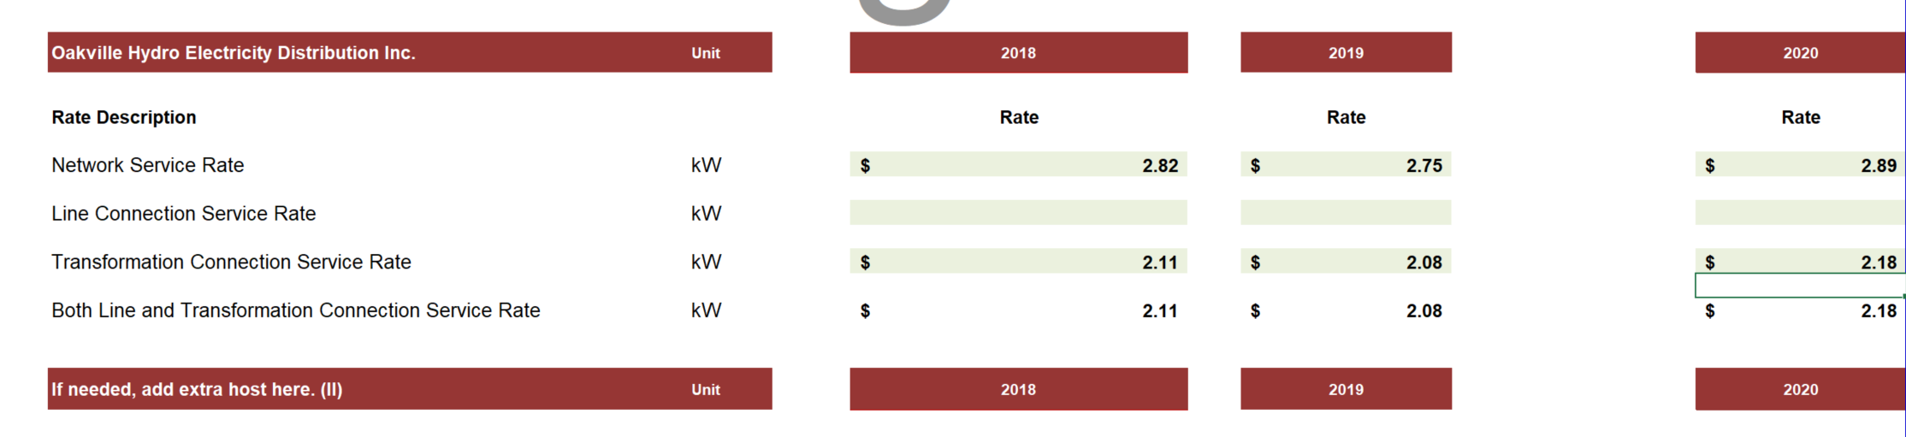
Please confirm that the 2018 and 2020 network service rates and transformation connection service rates updated by OEB staff are correct.

Staff Question-3
Ref: Rate Generator Model, Tab 3 – Continuity Schedule, Account 1588
With respect to the balance in Account 1588, given that most amounts that are recorded to this account are settled directly with the IESO, the expectation is that the ending balance of this account will be very low and close to zero (the ending balance comprising primarily of line losses). Milton Hydro has a December 31, 2018 balance of credit $1,009,391 net of dispositions approved by the OEB during 2019), which appears to be unusually large for a utility the size of Milton Hydro. To that end, please explain what comprises this balance, and also whether this balance includes the impact of any adjustments (billing, IESO, etc) that were processed during the year but relate to prior historical years.

Staff Question-4
Ref: GA Analysis Workform
Milton Hydro has presented an adjustment for a credit of $759,410 in the GA Analysis Workform to account for the true-up related to Nov-Dec 2017, that have been recorded in the G/L during 2018 and are therefore included within the transactions for the year. Please explain why this adjustment is not being presented as a principal adjustment in the DVA continuity schedule for 2018 when these amounts are included within the transaction for the year. If required, please submit an update Rate Generator Model that reflects this amount within the DVA continuity schedule.

Staff Question-5
Ref: 1595 Analysis Workform
Please confirm Milton Hydro has not submitted the 1595 Analysis Workform because it has no eligible 1595 Account balances for disposition. If Milton Hydro does have eligible balances for disposition please submit the 1595 Analysis Workform.

