December 5, 2019
Sent by Electronic Mail, RESS Electronic Filing and Courier
Ms. Kirsten Walli
Board Secretary
Ontario Energy Board
27-2300 Yonge Street
Toronto, ON M4P 1E4

Dear Ms. Walli:
Re: EB-2017-0108: Application for certificates of public convenience and necessity for Norfolk County, the County of Elgin, and the County of Middlesex
Re: Connection of Lammers’ Residence and two Cromarty Drive addresses

EPCOR Natural Gas Limited Partnership (“ENGLP”) writes to advise the Ontario Energy Board (“OEB” or “Board”) of the completion of connections for natural gas service per the OEB Decision and Order of August 15, 2019 and September 13, 2019 in this proceeding.
Pursuant to the OEB’s competitive process for natural gas service, the OEB granted Certificate of Public Convenience and Necessity (“CPCN”) rights to ENGLP for the limited purpose of supplying natural gas to the noted residences.
The Board’s Decision and Order of August 15, 2019 stated that:
The OEB expects that ENGLP will provide service to the Lammers’ residence no later than October 15, 2019 and, preferably, sooner.
ENGLP confirms that the Lammers’ residence, was ready to receive natural gas service on October 8, 2019, prior to the OEB’s stated expectation.
The Board’s Decision and Order of September 13, 2019 noted that:

ENGLP indicated that it could connect the two residences on or before
November 15, 2019, if an OEB decision were issued granting the utility the authorization to serve these customers on or before September 22, 2019.

ENGLP confirms that the two residences on Cromarty Drive, were ready to receive natural gas service on November 14, 2019, prior to ENGLP’s indicated timelines.
Please feel free to contact me if you have any questions.

Sincerely,
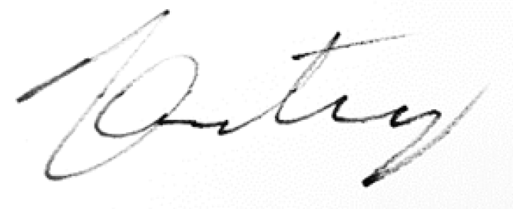
Vince Cooney, P.Eng, MBA
Senior Manager, Regulatory Affairs, Ontario
EPCOR Utilities Inc.
VCooney@epcor.com
(647) 730-0013

c. All intervenors in EB-2017-0108
Patrick McMahon/James Whittaker, Enbridge Gas Distribution Inc.
Myriam Seers/Nick Kennedy, Torys LLP
Susannah Robinson, EPCOR
Azalyn Manzano/Ritch Murray/Richard Lanni, Ontario Energy Board
Scott Lewis, OM Limited Partnership
Patrick Welsh, Osler, Hoskin & Harcourt LLP

