Milton Hydro Distribution Inc.
Milton Hydro IRRs to OEB Staff Questions
EB-2019-0053
Filed December 11, 2019
Emailed to OEB Staff December 11, 2019

Milton Hydro Distribution Inc.
EB-2019-0053

Staff Question-1
Ref: Rate Generator Model, Tab 3 – Continuity Schedule
OEB staff notes that there was a formula error in the IRM Rate Generator Model posted on the OEB’s webpage.

On tab 3 the formula for cell BM41 is =Sum (BM39,BM40) - BM37. The last portion of the formula (i.e. – BM37) is an error.

OEB staff has made the necessary correction to the Rate Generator Model and provided it along with these questions.

Please confirm Milton Hydro’s acceptance of the revised model.

Response:
Milton Hydro did not receive a copy of the Rate Generator Model with the corrections, however, Milton Hydro would note that the correction does not impact its Rate Generator Model as filed since the cell (– BM37) is blank.
Milton Hydro accepts the correction with no impact to its Application.

Staff Question-2
Ref: Rate Generator Model, Tab 11 – RTSRs – UTR and Sub-Tx
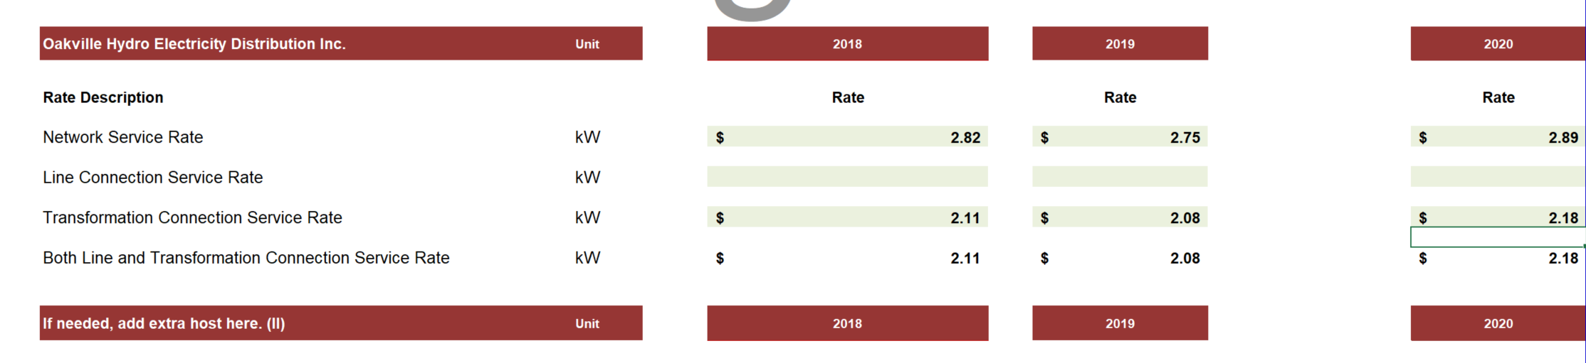
Please confirm that the 2018 and 2020 network service rates and transformation connection service rates updated by OEB staff are correct.

Response:
Milton Hydro confirms that the 2018 network service rates and transformation connection service rates updated by OEB staff are correct.
Milton Hydro agrees with the 2020 network service rates and transformation connection service rates updated by OEB staff are consistent with Oakville Hydro’s 2020 IRM Application EB-2019-0059 file August 12,2019 and yet to have an OEB Decision and Order.

Staff Question-3
Ref: Rate Generator Model, Tab 3 – Continuity Schedule, Account 1588
With respect to the balance in Account 1588, given that most amounts that are recorded to this account are settled directly with the IESO, the expectation is that the ending balance of this account will be very low and close to zero (the ending balance comprising primarily of line losses). Milton Hydro has a December 31, 2018 balance of credit $1,009,391 net of dispositions approved by the OEB during 2019), which appears to be unusually large for a utility the size of Milton Hydro. To that end, please explain what comprises this balance, and also whether this balance includes the impact of any adjustments (billing, IESO, etc) that were processed during the year but relate to prior historical years.

Response:
The balance in Account 1588 is made up of the journal entry to record the difference between energy purchases and energy sales. There are no adjustments that relate to prior years.
As stated in Milton Hydro’s letter to the OEB dated November 12, 2019, “it is Milton Hydro’s plan to complete the Commodity Model for the entire year, beginning with January 2019 (August, September and October 2019 completed) and make any required adjustments for the year end balances in 1588 and 1589 if required.”
Milton Hydro has not requested disposition of its Group 1 Accounts including Accounts 1588 and 1589 as the total of the Group 1 Accounts does not meet the EDDVAR threshold for disposition. Should any adjustments from the completion of the Commodity Model be required they will be made for the 2019 year end balances.

Staff Question-4
Ref: GA Analysis Workform
Milton Hydro has presented an adjustment for a credit of $759,410 in the GA Analysis Workform to account for the true-up related to Nov-Dec 2017, that have been recorded in the G/L during 2018 and are therefore included within the transactions for the year. Please explain why this adjustment is not being presented as a principal adjustment in the DVA continuity schedule for 2018 when these amounts are included within the transaction for the year. If required, please submit an update Rate Generator Model that reflects this amount within the DVA continuity schedule.

Response:
In 2018 Milton Hydro revised its internal model for the Global Adjustment (“GA”) true-up and in doing so the 2018 transactions included the GA true-up for October, November and December 2017 and the GA true-up for October, November and December 2018.
The GA Analysis Workform is based on calendar year data, therefore when Milton Hydro transitioned to its new model there was a timing difference in the recording of the year end 2017 GA true-up and the 2018 GA true-up both being in the same calendar year. The timing differences for the 2017 GA true-up needed to be reversed from the 2018 calendar year transactions for the purposes of the Workform only.
The reconciling amount of $759,410 is correctly included in the GL balance of $452,497 at 2018 year end with no adjustment required in the DVA continuity schedule.

Staff Question-5
Ref: 1595 Analysis Workform
Please confirm Milton Hydro has not submitted the 1595 Analysis Workform because it has no eligible 1595 Account balances for disposition. If Milton Hydro does have eligible balances for disposition please submit the 1595 Analysis Workform.

Response:
Milton Hydro’s Group 1 Deferral and Variance account balance does not meet the EDDVAR threshold for disposition. Milton Hydro has not elected to dispose of its Group 1 Deferral and Variance which would have include 1595 accounts if disposed.

