EPCOR Electricity Distribution Ontario Inc.
OEB Staff Questions
EB-2019-0027

EPCOR Electricity Distribution Ontario Inc.
EB-2019-0027

Staff Question-1
Ref: Rate Generator Model, Tab 3 – Continuity Schedule
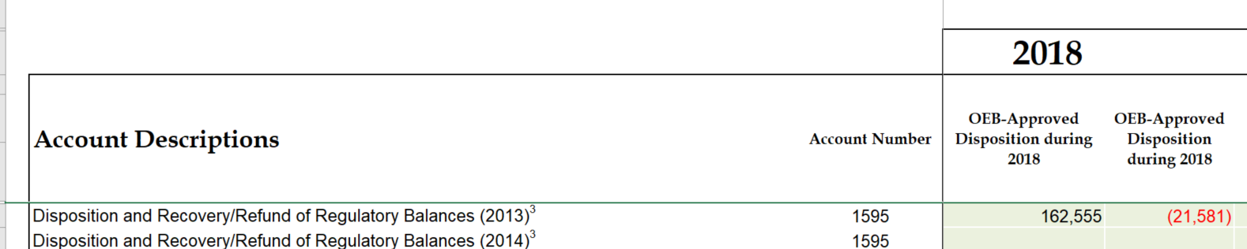

- Please explain why the 2018 OEB-Approved disposition amounts for 1595-2013 do not match the disposition amounts approved in EB-2017-0034. The amounts approved were Principal $107,477 and Interest ($5,808).
- If the amounts entered are incorrect please update the continuity schedule, otherwise please explain.

Staff Question-2
Ref: Rate Generator Model, Tab 3 – Continuity Schedule
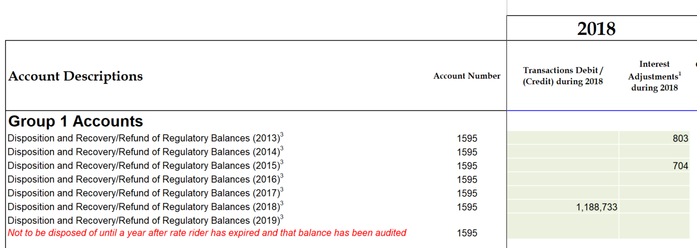
- Please explain the reason for the adjustments in column BK, for accounts 1595-2013 and 1595-2015.
- Please confirm there have been no adjustments to previously disposed of balances.

Staff Question-3
Ref: Rate Generator Model, Tab 3 – Continuity Schedule
OEB staff notes that there was a formula error in the IRM Rate Generator Model posted on the OEB’s webpage.

On tab 3 the formula for cell BM41 is =Sum(BM39,BM40) - BM37. The last portion of the formula (i.e. – BM37) is an error.

OEB staff has made the necessary correction to the Rate Generator Model and provided it along with these questions.

Please confirm EPCOR’s acceptance of the revised model.

Staff Question-4
Ref: Rate Generator Model, Tab 6. Class A Consumption Data
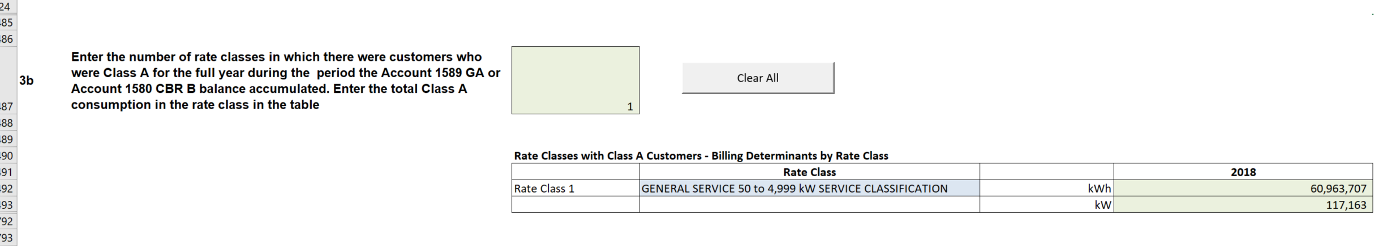
The reported RRR amounts for class A consumption is 57,347,355 kWh and 117,163 kW. The amounts EPCOR entered in the IRM Rate Generator Model on Tab 6. Class A Consumption Data do not reconcile, please see screen shot above.
Please explain why they do not reconcile or update the Rate Generator Model.

Staff Question-5
Ref: Rate Generator Model, Tab 20. Bill Impacts
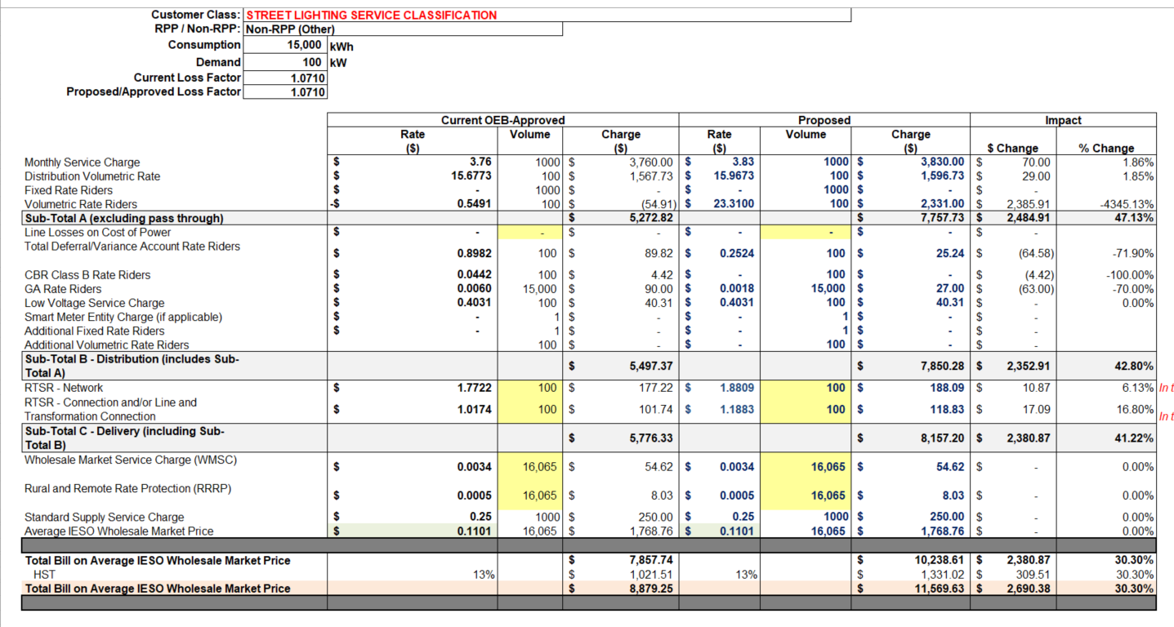
Ref: Managers Summary, Page 26
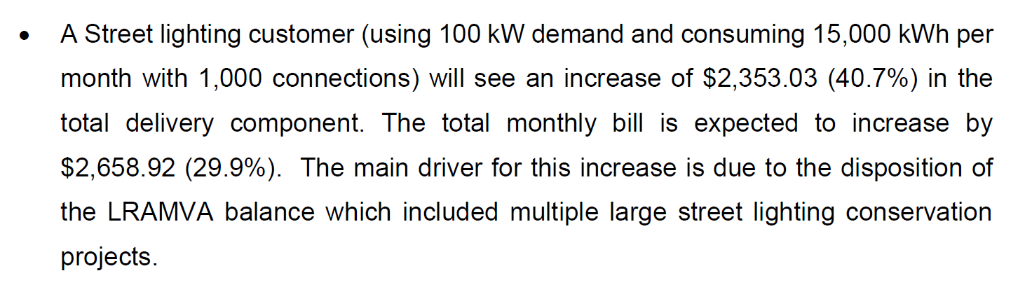
- Has EPCOR considered requesting the LRAMVA rate rider disposition period be over 36 months for the street light rate class, in order to mitigate the bill impact of greater than 10%?
- Is ECPOR’s street lighting customer aware of the large increase to their bill and if they are aware are they comfortable with such a large increase?
- If EPCOR believes that a rate mitigation proposal is not required for the street light class, please discuss why that would be appropriate.

Staff Question-6
Ref: Tab 3 of LRAMVA workform
For the residential distribution rate, it includes a tax sharing rate rider. It appears to be calculated by dividing the tax sharing amount by average consumption per customer.
- In 2016 and 2017, the tax sharing rate riders (per kWh) was derived by dividing $0.11 by 750 kWh.
- In 2018, the tax sharing rate rider (per kWh) was calculated by dividing $0.11 by 690 kWh.

Please provide the basis for using 690 kWh, instead of 750 kWh, as the average consumption per customer in 2018.

Staff Question-7
Ref: Tab 5 of LRAMVA workform (2017 and 2018 savings)
2019 Participation and Cost Report, dated April 15, 2019
OEB staff notes there are several program savings included in the LRAMVA workform, which are higher than the amounts included in the 2019 Participation and Cost Report. These programs include:
- 2017 Coupon Program
- 2017 Heating and Cooling Program (savings adjustments)
- 2018 Heating and Cooling Program

- Please confirm whether EPCOR is claiming lost revenues up to December 31, 2018. If there are exclusions, please discuss.
- Please explain why the energy savings (for the above noted programs) in the LRAMVA workform are not consistent with the program savings included in the 2019 Participation and Cost Report.
- Please provide the calculations showing the rate class allocations of the Retrofit Program savings in 2017 and 2018.

Staff Question-8
Ref: Tab 1-a of LRAMVA workform
- Please provide required documentation (such as detailed project level data) in support of the 2018 demand savings included in the LRAMVA workform.

- If EPCOR made any changes to the LRAMVA work form as a result of its responses to the above LRAMVA interrogatories, please file an updated LRAMVA work form, the revised LRAMVA balance requested for disposition, and a table summarizing the revised rate riders.

- Please confirm any changes to the LRAMVA workform in response to these LRAMVA interrogatories in “Table A-2. Updates to LRAMVA Disposition (Tab 1-a)”.

Staff Question-9
Ref: (1) Chapter 3 of the Filing Requirements for Electricity Distribution Applications Rate Applications, dated July 12, 2018, page 15

Preamble:

At the above noted first reference, it is stated that distributors must complete the GA Analysis Workform for each applicable fiscal year subsequent to the most recent year in which Accounts 1588 and 1589 were approved for disposition on a final basis by the OEB.

Questions:

- Although EPCOR has provided a GA Analysis Workform for 2018 balances, it also needs to provide a GA Analysis Workform for 2017 balances, including explanations of reconciling items. 2017 balances were approved on an interim basis in EPCOR’s 2019 proceeding. The most recent year in which Accounts 1588 and 1589 were approved for disposition on a final basis related to 2016 balances in EPCOR’s 2018 proceeding. (OEB staff also notes that EPCOR was formally known as Collus PowerStream Corp. in its 2018 proceeding.)

- Please provide a revised 2017 GA Analysis Workform.

- Alternatively, please confirm that the OEB can rely on the 2017 GA Analysis Workform filed on November 16, 2018 in EPCOR’s 2019 proceeding. If confirmed, please file this spreadsheet on the record of the current proceeding.

- The Deferral and Variance Account (DVA) Continuity Schedule, Tab 3, provided by EPCOR needs to be updated to reflect the opening DVA balances in this schedule as the closing December 31, 2016 balances, instead of the closing December 31, 2017 balances. This update needs to be done as the 2017 balances were cleared on an interim basis and will be reviewed in this proceeding. As a result, additional columns in Tab 3 will need to be populated. Please refile the DVA Continuity Schedule accordingly.

Staff Question-10
Ref: (1) Manager’s Summary, page 22
(2) Manager’s Summary, page 24
(3) Addendum to Filing Requirements For Electricity Distribution Rate Applications - 2020 Rate Applications, dated July 15, 2019, page 12 & 13

Preamble:

At the above noted first reference, EPCOR noted that in its 2017 proceeding decision and rate order, the OEB mandated a special purpose audit of its balances in Account 1588 and Account 1589. EPCOR also stated the following:

As a result of the special purpose audit, EPCOR spent extensive time reviewing and validating its process for both the IESO RPP settlement as well as the final reconciliation process. This resulted in the implementation of processes that are well aligned with the OEB accounting guidance.

At the above noted second reference, EPCOR is requesting to receive final approval on the balances that were cleared on an interim basis in its 2019 proceeding, without any modifications.

At the above noted third reference, the following is indicated:

On February 21, 2019, the OEB issued its letter entitled Accounting Guidance related to Accounts 1588 Power, and 1589 RSVA Global Adjustment as well as the related accounting guidance. The accounting guidance is effective
January 1, 2019 and is to be implemented by August 31, 2019. Distributors are expected to consider the accounting guidance in the context of historical balances that have yet to be disposed on a final basis (including the 2018 balances that may be requested for disposition in this rate application). In this application, distributors are to provide a status update on the implementation of the new accounting guidance, a review of historical balances, results of the review, and any adjustments made to account balances…

…Some utilities may have received approval for interim disposition of historical account balances or did not request disposition of account balances in the 2019 rate application due to the threshold test. If these utilities have reviewed the balances in the context of the new accounting guidance and are confident that there are no systemic issues with their RPP settlement and related accounting processes, such utilities may request final disposition of account balances. If these utilities identified errors or discrepancies that materially affect the ending account balances, utilities should adjust their account balances prior to requesting final disposition…

… Adjustments to account balances will be considered on a case by case basis.
Utilities should provide a detailed discussion on any adjustments made, including the reason for an adjustment, how the adjustment was quantified and the journal entries to adjust the balances.

Questions:

- Please describe further what EPCOR means by its processes being “well aligned with the OEB accounting guidance.” If there are any aspects that are not fully aligned with this new guidance, please explain.

- Please confirm that EPCOR has completed its review of the new Accounting Guidance and any required changes to the accounting for Account 1588 and Account 1589 have been implemented related to its 2017 and 2018 historical balances.

- Please confirm that the new accounting guidance was implemented retroactive to January 1, 2017 and that this task was completed by August 31, 2019. If this is not the case, please explain.

- Please confirm that there are no systemic issues with EPCOR’s RPP settlement and related accounting processes related to its 2017 and 2018 historical balances.

- If there are issues, please explain whether adjustments to Group 1 DVA balances that have yet to be disposed on a final basis have been quantified, including balances that have been cleared in on an interim basis or not cleared at all in a prior proceeding.

- If adjustments have not been quantified, please provide a timeline as to when the applicant expects any discrepancies to be resolved.

- If material adjustments were identified, for each adjustment please provide the following:

  - Quantification and nature of the adjustment
  - The period in which the adjustment relates to (i.e. in relation to the flow of kWh)
  - Detailed explanation of the adjustment, including how it was identified, the reason for the adjustment, the impact to each of Accounts 1588 and 1589.
  - Show how it has been included as a principal adjustment to Account 1589 in the GA Analysis Workform and Account 1588 in Appendix A GA Methodology Description Questions on Accounts 1588 & 1589, Question 1
  - Describe the steps taken to include these adjustments in the DVA Continuity Schedule and balances requested for disposition in this proceeding. Please also provide the cells in the DVA Continuity Schedule where these adjustments were made.

- Please provide further details on the review of 2017 and 2018 balances that was completed, and any summary reports available (e.g. how the review was done).

Staff Question-11
Ref: (1) GA-Analysis-Workform-Instructions-20190715.docx
(2) Manager’s Summary, page 16 Table 7.2

Preamble:

At the above noted first reference, Appendix A GA Methodology Description Questions on Accounts 1588 & 1589 (or page 15 of the document), the table in Question 1 for Account 1588 requests the “Balance December 31, 2018”.

At the above noted second reference, EPCOR has provided an analysis of its 2018 Account 1588 balance.

Questions:

- It appears that the first line of this table does not represent the Account 1588 general ledger balance as at December 31, 2018. Please update and explain.

- It appears that the last line of this table does not represent the closing principal Account 1588 balance as at December 31, 2018 in the DVA continuity schedule (cell BG28). Please update and explain.

- Please explain any differences between (i) and (ii), considering any OEB-approved dispositions that occurred in the year.

- Please also repeat steps (i), (ii), and (iii) for Account 1588 balances as at December 31, 2017.

- If the revised table shows a material change in the assessment of the Account 1588 balance, please quantify and explain.

- Please also file a similar table relating to 2017 balances for Account 1588.

Staff Question-12
Ref: (1) 2018 GA Analysis Workform
(2) EB-2018-0025 OEB Staff - 6

Preamble:

Under Note 4 of the GA Analysis Workform, Class B Non-RPP monthly consumption totals are calculated by inputting the current month’s billed consumption (Column F), subtracting the prior month’s closing unbilled consumption (Column G), and adding the current month’s closing unbilled consumption (Column H). EPCOR’s 2017 GA Analysis Workform includes data only for column H, and some of the data includes negative numbers.
At the above noted second reference, EPCOR explained that the figures in column H represent the net change in unbilled revenue from billed amounts to metered consumption for each month. EPCOR further stated that the amount of unbilled revenue cannot properly be split out between previous month deduction and current month addition. Instead the value represents the variance between what was actually billed and what was calculated to be consumed. EPCOR also stated that Column I has been populated in a way that presents the actual kWh calculated to be consumed each month.

Question:

- Can EPCOR’s explanation regarding the figures in column H and column I in the prior proceeding be applied to explain the amounts in column H and column I in the current proceeding 2018 GA Analysis Workform? Please explain.

Staff Question-13
Ref: (1) Manager’s Summary, page 19
(2) 2020 IRM Rate Generator Model, Tab 3, October 15, 2019
(3) Manager’s Summary, page 16 Table 7.2
(4) 2018 GA Analysis Workform

Preamble:

At the above noted first reference, EPCOR stated the following:

EPCOR records unbilled revenue in the accounting system monthly and reverses it in the subsequent month. Unbilled energy revenue is based on an assessment of electricity distribution services supplied to customers between the date of the last meter reading and the period ending date. The components of a customer’s most recent bill are divided by the number of days in the billing period. Then the estimated daily revenue is multiplied by the remaining days to month-end.

Prior to December 2018, the estimation technique was not used for the final month of the year. Instead, the monthly unbilled amounts for December were recorded based on actual consumption. The billing system was set-up for a rate change on January 1 with no actual change to the rates occurring. This allowed the billing system to split bills processed in January and February of the subsequent year between revenue earned before and after December 31st. Therefore, exactly correct unbilled consumption and dollars was posted for the year.

However, effective December 31, 2018 this technique could no longer be used for year-end cut-off accuracy. The estimation technique has been used for December 2018, just like all the other months of the year. EPCOR can no longer wait for subsequent year-end actual billing information to come in during January and February because of a much quicker year-end close set by the new parent company. A comparison of the accrual for unbilled revenue verses the actual billings subsequent to year-end is completed to assess the accuracy of the process.

EPCOR is currently investigating a technique to use actual smart meter data for the unbilled revenue accrual in the future to improve accuracy.

At the above noted second reference, EPCOR has inserted a 2018 Account 1588 principal adjustment of $116,480 (cell BF28) into the 2020 DVA Continuity Schedule. EPCOR has inserted a 2018 Account 1589 principal adjustment of a credit of $159,960 (cell BF29) into the 2020 DVA Continuity Schedule.

At the above noted third reference, EPCOR recorded an Account 1588 credit amount of $172,558 relating to 2018 balances which is described as “Unbilled accrued vs. billed for 2018 consumption.” This amount is incorporated into the $116,480 principal adjustment at the above noted second reference.

At the above noted fourth reference, EPCOR recorded an Account 1589 amount of $208,594 relating to 2018 balances which is described as the “GA portion of Dec 2019 unbilled revenue was under accrued by 208k.” This amount is incorporated into the $159,960 credit principal adjustment at the above noted second reference.

Questions:

- Please confirm that the Account 1589 amount of $208,594 and the Account 1588 credit amount of $172,558 relating to 2018 balances have been recorded as principal adjustments due to the change in recording unbilled revenue effective December 31, 2018. If this is not the case, please explain.

- Please confirm that a related adjustment for 2017 is not required because in the past the amounts recorded in the general ledger and the DVA Continuity Schedule reflected the actual amounts billed (i.e. reflecting actual consumption), instead of an estimated unbilled revenue amount. If this is not the case, please explain.

Staff Question-14
Ref: (1) EB-2018-0025 2019 IRM Rate Generator Model, Tab 3, March 28, 2019
(2) 2020 IRM Rate Generator Model, Tab 3, October 15, 2019

Questions:

- OEB staff notes that the December 31, 2017 Account 1588 balance in the current proceeding is $528,085, whereas in the 2019 IRM proceeding DVA Continuity Schedule this balance was $852,158, reflecting a difference of $324,073. $324,072 was shown as a 2017 principal adjustment in the 2019 IRM proceeding, but it is unclear how this adjustment was reflected in the 2020 IRM proceeding. Please explain, and include any adjustments to the 2020 DVA Continuity Schedule, if required.

- OEB staff notes that the December 31, 2017 Account 1589 balance in the current proceeding is $951,177, whereas in the 2019 IRM proceeding DVA Continuity Schedule this balance was $726,676, reflecting a difference of ($224,501). ($224,501) was shown as a 2017 principal adjustment in the 2019 IRM proceeding, but it is unclear how this adjustment was reflected in the 2020 IRM proceeding. Please explain, and include any adjustments to the 2020 DVA Continuity Schedule, if required.

Staff Question-15
Ref: (1) Manager’s Summary, page 16 Table 7.2
(2) EB-2018-0025 Tab 3, 2019 IRM Rate Generator Model, March 28, 2019
(3) 2020 IRM Rate Generator Model, Tab 3, October 15, 2019
(4) Appendix A GA Methodology Description Questions on Accounts 1588 & 1589, page 21

Preamble:

At the above noted first reference, EPCOR has recorded a net reversing amount of a credit of $67,283 relating to 2017 balances in the calculation of the claimed Account 1588 balance in this proceeding relating to 2018 balances. However, OEB staff notes that $324,072 was recorded as an Account 1588 2017 principal adjustment in cell BF28 at the second above noted reference.

OEB staff notes that at the above noted third reference, EPCOR has recorded an Account 1588 2018 principal adjustment of $116,480 (cell BF28) which reconciles to the calculated net Account 1588 2018 principal adjustments (i.e. also including a reversal of 2017 amounts) at the first noted reference.

At the above noted fourth reference, EPCOR has provided a breakdown of the total amount of principal adjustments that were approved (e.g. true-up of unbilled, true up of CT 1142, true up of CT 148 etc.) for each of Accounts 1588 and 1589 in its 2019 proceeding. This breakdown is provided below:

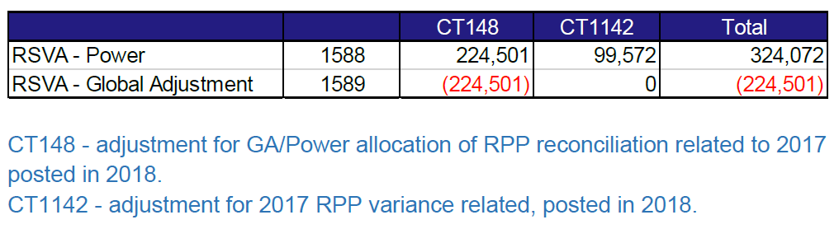

At the above noted fourth reference, EPCOR also stated that “the amounts related to 2017 have been reversed in the current proposed amount for disposition.”

Question:

- Regarding Account 1588 2017 principal adjustments, please explain why a credit of $67,283 is recorded at the first above noted reference (which would have been a debit amount of $67,283 in the 2017 principal adjustment) and $324,072 at the second above noted reference. In EPCOR’s explanation, please also consider EPCOR’s above statement that “the amounts related to 2017 have been reversed in the current proposed amount for disposition,” as well as the above noted breakdown provided by EPCOR.

Staff Question-16
Ref: (1) 2018 GA Analysis Workform
(2) 2017 GA Analysis Workform
(3) EB-2018-0025 Tab 3, 2019 IRM Rate Generator Model, March 28, 2019

Preamble:

At the above noted first reference, EPCOR has recorded a net reversing amount of a credit of $32,289 relating to 2017 balances in the calculation of the claimed Account 1589 balance in this proceeding relating to 2018 balances. However, OEB staff notes that a credit balance of $224,501 was recorded as an Account 1589 2017 principal adjustment in the GA Analysis Workform, as well as in the 2019 IRM Rate Generator Model.

Question:

- Please explain why a credit of $32,289 is recorded at the first above noted reference and a credit of $224,501 is recorded at the second and third above noted references.

EB-2018-0025
EB-2017-0034
EB-2018-0025
EB-2016-0064, March 30, 2017

