Elexicon Energy – Veridian Rate Zone
EB-2019-0252

Accounts 1588 and 1589

Staff-1

Ref: (1) Chapter 3 of the Filing Requirements for Electricity Distribution Applications Rate Applications, dated July 12, 2018, page 15
(2) Application, Manager’s Summary, page 12

Preamble:

At the above-noted first reference, it is stated that distributors must complete the GA Analysis Workform for each applicable fiscal year subsequent to the most recent year in which Accounts 1588 and 1589 were approved for disposition on a final basis by the OEB.

At the above-noted second reference, Elexicon Energy stated the following (noted below), however the December 31, 2016 balances have not been addressed in the IRM Rate Generator Model. OEB staff notes that 2017 balances were cleared on an interim basis and will be reviewed in this proceeding.

In keeping with the model instructions, the continuity starts with the balances as per the date for which approval was last received (i.e. 2017 closing balances).

Questions:

- Although Elexicon Energy has provided a GA Analysis Workform for 2018 balances, it also needs to provide a GA Analysis Workform for 2017 balances, including explanations of reconciling items. 2017 balances were approved on an interim basis in the Veridian Rate Zone’s 2019 rates proceeding. The most recent year in which Accounts 1588 and 1589 were approved for disposition on a final basis related to 2016 balances in the Veridian Rate Zone’s 2018 rates proceeding.

- Please provide a revised 2017 GA Analysis Workform.

- Alternatively, please confirm that the OEB can rely on the 2017 GA Analysis Workform filed on January 15, 2019 in Veridian’s 2019 rates proceeding. If confirmed, please file this spreadsheet on the record of the current proceeding.

- The Deferral and Variance Account (DVA) Continuity Schedule, Tab 3, provided by Elexicon Energy needs to be updated to reflect the opening DVA balances in this schedule as the closing December 31, 2016 balances, instead of the closing December 31, 2017 balances. This update needs to be done as the 2017 balances were cleared on an interim basis and will be reviewed in this proceeding. As a result, additional columns in Tab 3 will need to be populated.

Please make the required changes in Tab 1 of the 2020 IRM Rate Generator to refile the DVA Continuity Schedule accordingly.

Staff-2

Ref: (1) Application, Manager’s Summary, page 6
(2) Application, Manager’s Summary, page 13
(3) Application, Appendix F – Accounting Guidance, page 2
(4) Addendum to Filing Requirements For Electricity Distribution Rate Applications - 2020 Rate Applications, dated July 15, 2019, pages 12 & 13

Preamble:

In summary, Elexicon Energy is requesting final disposition of 2017 balances in the Veridian Rate Zone that was cleared on an interim basis in 2019 IRM. Elexicon Energy has requested that 2018 balances not be cleared in the current proceeding due to the materiality threshold not being met. Although Elexicon Energy indicated that it has used its January to June 2019 balances to review its existing processes against the accounting guidance, Elexicon Energy has not described whether its 2017 and 2018 balances have been reviewed.

At the above-noted first reference, Elexicon Energy stated that it is requesting the following:

The final approval of Group 1 disposition that was approved in EB-2018-0072 as interim.

At the above-noted second reference, Elexicon Energy stated the following:

The Group 1 Total Claim (2018 ending balances plus any identified adjustments and projected interest) does not exceed the threshold test. As a result, this application does not include a disposition request for the Total Group 1 DVA balance.

At the above-noted third reference, Elexicon Energy stated the following:

Elexicon Energy has taken time to review its existing processes against the accounting guidance for 2019 using the completed period of January to June. This was done with a specific objective to identify differences and assess and compare the final outcome of each method to determine whether, in aggregate, there are any material differences.

At the above-noted fourth reference, the following was indicated:

On February 21, 2019, the OEB issued its letter entitled Accounting Guidance related to Accounts 1588 Power, and 1589 RSVA Global Adjustment as well as the related accounting guidance. The accounting guidance is effective
January 1, 2019 and is to be implemented by August 31, 2019. Distributors are expected to consider the accounting guidance in the context of historical balances that have yet to be disposed on a final basis (including the 2018 balances that may be requested for disposition in this rate application). In this application, distributors are to provide a status update on the implementation of the new accounting guidance, a review of historical balances, results of the review, and any adjustments made to account balances…

…Some utilities may have received approval for interim disposition of historical account balances or did not request disposition of account balances in the 2019 rate application due to the threshold test. If these utilities have reviewed the balances in the context of the new accounting guidance and are confident that there are no systemic issues with their RPP settlement and related accounting processes, such utilities may request final disposition of account balances. If these utilities identified errors or discrepancies that materially affect the ending account balances, utilities should adjust their account balances prior to requesting final disposition…

… Adjustments to account balances will be considered on a case by case basis.
Utilities should provide a detailed discussion on any adjustments made, including the reason for an adjustment, how the adjustment was quantified and the journal entries to adjust the balances.

Questions:

- Please confirm that Elexicon Energy has completed its review of the new Accounting Guidance and that any required changes to the accounting for Account 1588 and Account 1589 have been implemented as it relates to its 2017 and 2018 historical balances.

- Please confirm that the new accounting guidance was implemented retroactive to January 1, 2017 and that this task was completed by August 31, 2019. If this is not the case, please explain.

- Please confirm that there are no systemic issues with the Veridian Rate Zone’s RPP settlement and related accounting processes as it relates to its 2017 and 2018 historical balances.

- If there are issues, please explain whether adjustments to Group 1 DVA balances that have yet to be disposed on a final basis have been quantified, including balances that have been cleared on an interim basis or not cleared at all in a prior proceeding.

- If adjustments have not been quantified, please provide a timeline as to when the applicant expects any discrepancies to be resolved.

- If material adjustments were identified, please provide the following for each adjustment:

  - Quantification and nature of the adjustment
  - The period in which the adjustment relates to (i.e. in relation to the flow of kWh)
  - Detailed explanation of the adjustment, including how it was identified, the reason for the adjustment, the impact to each of Accounts 1588 and 1589.
  - Show how it has been included as a principal adjustment to Account 1589 in the GA Analysis Workform and Account 1588 in Appendix A GA Methodology Description Questions on Accounts 1588 & 1589, Question 1
  - Describe the steps taken to include these adjustments in the DVA Continuity Schedule and balances requested for disposition in this proceeding. Please also provide the cells in the DVA Continuity Schedule where these adjustments were made.

- Please provide further details on the review of 2017 and 2018 balances that was completed and any summary reports available (e.g. how the review was done).

Staff-3

Ref: (1) Application, Manager’s Summary, page 15

Preamble:

At the above-noted reference, Elexicon Energy noted the following regarding changes to its methodology on the Tiered splits:

The Veridian Rate Zone’s Class B RPP claim is submitted monthly (Charge Type 1142). Consumption data for IESO Charge Type 1142 is based on actual metered RPP consumption data for the current month. The estimates for the split of TOU periods are based on the actual metered hourly data for each period. The Tier 1 and 2 split is based on the previous year’s billed split for the same rate period. Effective September 2019, and retroactive to January 2019, the Tier split is based on actual metered hourly data for each period. Effective January 2019, a process change allowed for the implementation of categorized Tiered RPP data. The previous approach used a top-down methodology to arrive at residual consumption. Analysis was conducted during the period of 2018 to compare the two approaches; the results were immaterial.

Questions:

- Elexicon Energy has described that it has performed a Tiered split analysis for 2018 but did not provide an explanation. Please provide an explanation, including how its analysis addresses the OEB’s new accounting guidance.

- Building on the questions asked above regarding Elexicon Energy’s review of the new accounting guidance, please further describe the scope of the above-noted analysis. Please confirm that the analysis was implemented retroactive to January 1, 2017 and that this task was completed by August 31, 2019. If this is not the case, please explain.

Staff-4

Ref: (1) Elexicon_Veridian RZ_2020_Acctng Guidance 2019 Analysis_20191015.XLSX
(2) OEB’s Illustrative-Commodity-Model-20190221.xlsx

Preamble:

At the above-noted first reference, tab “Final RSVA Balances,” Elexicon Energy provided calculations showing an Account 1588 balance as at December 31, 2017 of $222,256 and an Account 1589 balance as at December 31, 2017 of $3,498,002. However, OEB staff notes that the balances recorded through the RRR as at December 31, 2017 are a credit of $3,862,357 for Account 1588 and a credit of $793,539 for Account 1589.

Questions:

- Please explain the discrepancies between the Account 1588 and Account 1589 December 31, 2017 balances noted at the above-noted first reference, tab “Final RSVA Balances,” and the respective RRR 2.1.7 balances. Elexicon Energy provided calculations showing an Account 1588 balance as at December 31, 2017 of $222,256 and an Account 1589 balance as at December 31, 2017 of $3,498,002. However, OEB staff notes that the balances recorded through the RRR as at December 31, 2017 are a credit of $3,862,357 for Account 1588 and a credit of $793,539 for Account 1589.

- At the above-noted first reference, it appears that Elexicon Energy has provided a spreadsheet that is designed to mirror the OEB’s illustrative commodity model issued on February 21, 2019 (as per the above-noted second reference). However, the distributor’s model does not fully capture all elements of the OEB’s model. Please explain the deviations from the OEB’s model.

Staff-5

Ref: (1) GA-Analysis-Workform-Instructions-20190715.docx
(2) Application, Appendix E-1: GA Methodology Description – Appendix A GA Methodology Description Questions on Accounts 1588 & 1589, page 1

Preamble:

At the above-noted first reference (Appendix A GA Methodology Description Questions on Accounts 1588 & 1589, or page 15 of the document), the table in Question 1 for Account 1588 requests the “Balance December 31, 2018”.

At the above-noted second reference, Elexicon Energy has provided an analysis of its 2018 Account 1588 balance.

Questions:

It appears that Elexicon Energy has filed the “Net Change in Principal Balance in the GL (i.e. Transactions in the Year)” for Account 1588 in the first row of this table:

- Please confirm that the first line of this table or a credit of $639,483 represents the Account 1588 principal transactions in the general ledger for 2018, which ties to cell BD28 in the DVA Continuity Schedule. If this is not the case, please explain.

- Please confirm that the last line of this table or a credit of $94,330 represents the Account 1588 principal transactions and adjustments for 2018 in the DVA continuity schedule, which tie to the sum of cell BD28 and cell BF28 in the DVA continuity schedule. If this is not the case, please explain.

- Please explain any differences between (a) and (b).

- Please also repeat steps (a), (b), and (c) for 2017 Account 1588 principal transactions.

- If the revised table shows a material change in the assessment of the Account 1588 balance, please quantify and explain.

- Please also file a similar table relating to 2017 balances for Account 1588.

Staff-6

Ref:
(1) Application, Manager’s Summary, page 16
(2) 2020 IRM Rate Generator Model, Tab 3, October 15, 2019
(3) 2018 GA Analysis Workform, October 15, 2019
(4) EB-2018-0072, 2017 GA Analysis Workform, January 15, 2019

Preamble:

At the above-noted first reference, Elexicon Energy stated the following:

Adjustments for 2018 unbilled to actual billed revenue differences have been included in the continuity schedule. A true-up adjustment related to Account 1588 of $224,585 and Account 1589 ($22,333) are reflected in Tab 3 of the 2020 Rate Generator Model.

However, OEB staff could not reconcile the amounts in the above-noted first reference to any of the amounts recorded in the above-noted second, third, and fourth references. OEB staff also notes that, at the above-noted third reference, a debit amount of $22,333 is shown, instead of the credit amount described in the above-noted first reference.

At the above-noted second reference, cell BW28 and cell BW29 in Tab 3 show variances of the RRR versus the 2018 balances of $224,585 for Account 1588 and a credit of $22,332 for Account 1589.

Question:

- Please explain these above-noted variances of $224,585 for Account 1588 and a credit of $22,332 for Account 1589, including how these true-up adjustments (as described in the first above-noted reference) reconcile to the amounts in the above-noted second, third, and fourth references.

Staff-7

Ref: (1) Application, Appendix E-1: GA Methodology Description – Appendix A GA Methodology Description Questions on Accounts 1588 & 1589, page 2

Preamble:

At the above-noted reference, Elexicon Energy stated that in booking expense journal entries for Charge Type (CT) 1142 and CT 148 from the IESO invoice, it utilizes approach “b.” In approach “b” CT 148 is booked into Account 1589. The portion of CT 1142 equaling RPP minus HOEP for RPP consumption is booked into Account 1588. The portion of CT 1142 equaling GA RPP is credited into Account 1589.

Questions:

- Please explain why Elexicon Energy is using approach “b”, which is a deviation from the OEB’s methodology.

- Please explain whether Elexicon Energy plans on changing its approach to the OEB’s methodology which is approach “a”. In approach “a” CT 1142 is booked into Account 1588 (i.e. Account 4705). CT 148 is pro-rated based on RPP/non-RPP consumption and then booked into Account 1588 and 1589 respectively (i.e. Account 4705 and Account 4707).

Staff-8

Ref: (1) EB-2018-0072, 2017 GA Analysis Workform, January 15, 2019

Preamble:

At the above-noted reference, Elexicon Energy showed a credit balance of $156,497 which is to remove prior year-end unbilled to actual revenue differences (line 2a of the GA Analysis Workform).

Question:

- Please confirm that the above-noted credit balance of $156,497, which appears to be a reversal, was reflected as an offsetting debit amount in the 2016 Account 1589 balance that was cleared on a final basis in Veridian’s 2018 rates proceeding. If this is not the case, please explain.

Staff-9

Ref: (1) 2020 IRM Rate Generator Model, Tab 3, October 15, 2019
(2) 2018 GA Analysis Workform, October 15, 2019
(3) Application, Appendix E-1: GA Methodology Description – Appendix A GA Methodology Description Questions on Accounts 1588 & 1589, page 1
(4) EB-2018-0072, 2019 IRM Rate Generator Model, Tab 3, March 28, 2019
(5) EB-2018-0072, 2017 GA Analysis Workform, January 15, 2019
(6) EB-2018-0072, Veridian’s Responses to Staff-5, December 11, 2018

Preamble:

At the above-noted first reference, OEB staff noted that 2018 principal adjustments for Account 1588 of debit $545,153 (cell BF28) and Account 1589 of debit $597,153 (cell BF29) were shown. These amounts tie to reconciling amounts shown at the above-noted third reference for Account 1588 and the above-noted second reference for Account 1589.

At the above-noted fourth reference, OEB staff noted that 2017 principal adjustments for Account 1588 of a credit of $769,739 (cell BF28) and Account 1589 of a credit of $574,821 (cell BF29) were shown. The Account 1589 amount does not tie to the sum of the reconciling amounts shown at the above-noted fifth reference. OEB staff was unable to reconcile the Account 1588 amount to documents currently on the record. However, OEB staff notes that an explanation was partly provided at the above-noted sixth reference.

Question:

- Please explain and reconcile the 2017 principal adjustments for Account 1588 of a credit of $769,739 and Account 1589 of a credit of $574,821.

Staff-10

Ref: (1) Application, Appendix E-1: GA Methodology Description – Appendix A GA Methodology Description Questions on Accounts 1588 & 1589, Questions on CT 1142, pages 2 & 3

Preamble:

At the above-noted reference, Elexicon Energy provided the following table which described the basis for truing up CT 1142 for 2018 and 2019.

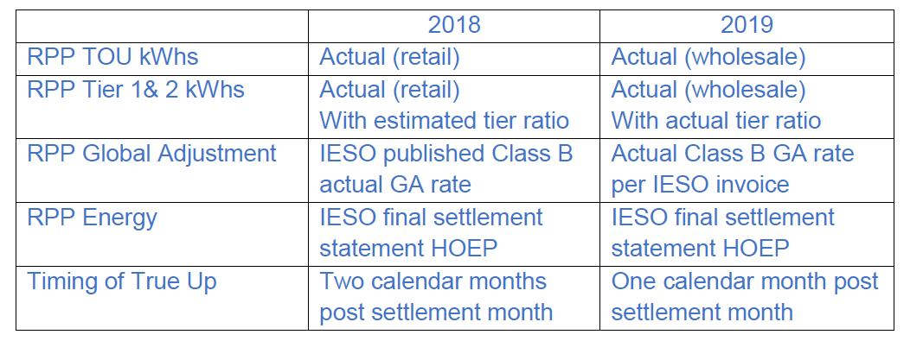
Question:

- Please update the table to show a column for 2017 and explain any additional differences. Please file an updated version of the table in response to this question.

DVA Request

Staff-11

Ref: (1) Application – Appendix G, pages 2 to 5 and Draft Accounting Order
(2) EB-2013-0174, 2014 COS Chapter 2 Appendices, App 2-H, October 31, 2013
(3) EB-2013-0174, 2014 Settlement Agreement, section 7.6, page 35

Preamble:
In the Draft Accounting Order, Elexicon Energy states that it seeks to establish a deferral account to recover lost revenues from the Collection of Account charge, effective July 1, 2019. The proposed account will be discontinued at its next rebasing application. The account is proposed to be disposed of periodically (i.e. annually) as part of the IRM rate application or as a stand-alone application. By disposing of the balance periodically, Elexicon Energy notes it will avoid the accumulation of significant balances over a ten-year period.
Appendix G (page 2, lines 16-18) indicates that the proposed variance account is intended to capture the financial impacts of OEB policy changes that have occurred, which has impacted the ability of electricity distributors to collect revenues from the Collection of Account charge.
Elexicon Energy provided the following tables:
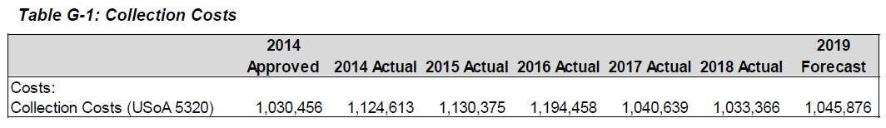
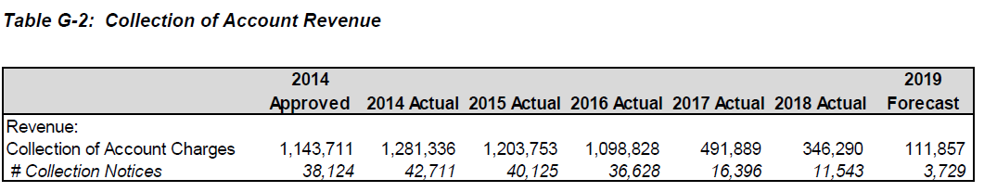
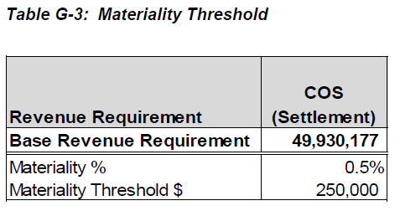
Questions:
- Please discuss the rationale for an effective date of July 1, 2019 as it pre-dates the implementation of May 1, 2020 rates, and explain the distributor’s views on rate retroactivity.

- Please confirm whether Elexicon Energy is seeking to establish a deferral account (per the Draft Accounting Order) or a variance account (per Appendix G, page 2, line 15) for the Veridian Rate Zone.

- Elexicon Energy notes that it seeks to capture lost revenue associated with the elimination of the Collection of Account charge, as well as the impact of restricting collection (or disconnection) notices during the winter moratorium.

- Please confirm that it will only record the lost revenue associated with the elimination of Collection of Account charge in the account until it next rebases.

- Based on the description provided on page 3 of Appendix G (lines 17-24), please clarify the circumstances in which the distributor will continue to issue a disconnection notice. Please also confirm that the methodology employed to derive the forecast number of collection (or disconnection) notices is consistent with the approved methodology from the 2014 COS proceeding.

- In the Draft Accounting Order, Elexicon Energy stated that it will calculate lost revenues in the deferral account as follows: “Approved Collection of Account Revenue less Actual Collection of Account Revenue”. Please confirm that the total net recovery from the charge, as well as lost revenues recorded in the account will equal the approved revenue offset.

- Please confirm that Elexicon Energy agrees to record revenues in the account based on the number of collection notices issued (or reconnections performed) and will be capped at the approved $1,143,711 amount for Collection of Account charges. If not, please discuss.

- Please update Table G-2 to show 2019 to 2029 forecast lost revenues (i.e. current year to next rebasing period) broken down by the number of collection notices issued and the cost per collection notice.

- Please explain how the number of collection notices in 2019 was determined, as there was a significant decrease in collection notices from 38,124 in 2014 to 3,729 in 2019.

- As 2019 lost revenues are forecast to be about 10% of the offset amount approved to be collected from Collection of Account charges (i.e. $111,587/ $1,143,711), please discuss whether the lost revenues can potentially be negated through the avoided costs identified in Appendix G (pages 2 and 3) and/or operational efficiencies in coming years.

- Please clarify whether Elexicon Energy seeks to record any true-up amounts for collection activity costs (as per Table G-1) in this deferral or variance account.

- If yes, please provide the rationale for doing so.

- If yes to i) above, please update Table G-1 with a breakdown of 2019 to 2029 costs (i.e. current year to next rebasing period) by the collection activities identified in Appendix G.

- Please file updates to Tables G-1 and G-2 in excel format in response to the DVA questions.

Staff-12

Ref: (1) Application – Appendix G (Table G-4)
Preamble:
Table G-4 provides a comparison of the ROE in 2017 and 2018. The following table was provided:
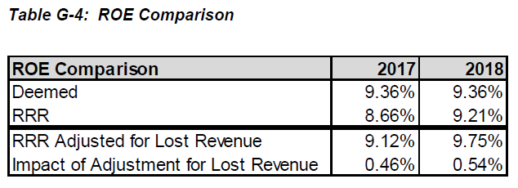
Due to the removal of the Collection of Account charge effective July 1, 2019, Elexicon Energy notes that it will increase the ROE in 2019 and 2020.
Questions:
- Please confirm that the “RRR Adjusted for Lost Revenue” under the ROE comparison heading of Table G-4 represents the ROE with lost revenues included.

- Please confirm whether the 54 basis point increase in 2018 ROE is associated with trueing up actual revenues to forecast based on the difference between $346,290 (2018 actual collection of account revenues) and $1,143,711 (2014 COS approved). If not, please explain.

- Please update Table G-4 with 2019 and 2020 ROE estimates and explain the results. Please file an updated version of the table in response to this question.

Staff-13

Ref: (1) Application – Appendix G (pages 2-3)
Preamble:
Elexicon Energy states that cost savings are expected to be below materiality threshold due to the following reasons:
- Continued incremental costs related to other forms of collection activity, including internal and external resources, collection notices, out-bound calls, field activities and collection agencies
- Continued use of a third party service for other field activities, charged at a flat daily rate, irrespective of the fact the delivery notices are no longer hand delivered.
Elexicon Energy further notes there is limited ability to separate incremental costs and cost savings by rate zone, as OM&A activities in the Whitby and Veridian Rate Zones are becoming more integrated.

Questions:
- Please quantify the cost savings in the Veridian Rate Zone based on the collection activities that are now avoided, as identified in Appendix G.

- Please clarify whether Elexicon Energy plans on recording cost savings in the deferral or variance account.

- With regards to a) above, please explain what potential actions Elexicon Energy may undertake to achieve greater operational efficiencies and cost savings in the coming years.

Staff-14

Ref: (1) Application – Appendix G, Draft Accounting Order
  - Please re-file the Draft Accounting Order to reflect any changes that may result from the above DVA questions.

IRM Questions

Staff-15

Ref: Application, page 15

Preamble:
Elexicon Energy states that it bills and records unbilled entries on the 1st estimate GA rate for Class B non-RPP GA customers, with the exception of two Class B embedded distributors for which it has a bilateral agreement to be billed on the actual GA rate.

Question:

- Please confirm that Elexicon Energy has excluded the above-noted two customers from the allocation of the 2017 and 2018 GA balances and the calculation of the resulting rate riders.

Staff-16

Ref: (1) 2020 IRM Rate Generator Model, Tab 16, October 15, 2019
(2) 2019 IRM Rate Generator Model, Tab 16, March 28, 2019

Preamble:

In the 2019 IRM Rate Generator Model, the billed consumption for the residential class was 968,772,164 kWh. However, in the 2020 IRM Rate Generator Model, it appears to be revised to 268,772,164 kWh.

Questions:

- Please explain why an update to the residential class kWh consumption is required, and confirm whether the entry in the 2020 IRM Rate Generator Model is correct (tab 16, cell F13).
- Please confirm whether there are any changes to Tab 16 and the resulting rate riders.

Staff-17

Ref: All models filed with 2020 IRM rate application
- Based on Elexicon Energy’s responses to the above questions, please re-file all applicable models, workforms and/or appendices to reflect the updates.

- Please summarize all updates to the application, model(s) and/or appendices submitted in this proceeding.

EB-2018-0072
EB-2017-0078
EB-2018-0072
EB-2017-0078
Undertaking JT1.2 referenced in the 2014 approved settlement proposal

