**Welland Hydro-Electric System Corp. (Welland Hydro)**

**EB-2019-0072**

**IRM Rate Generator**

## Staff-1

Ref: (1) Tab 20 of IRM Rate Generator (bill impacts)

Preamble:

Tab 20 of the 2020 IRM Rate Generator requires the distributor to show the total bill impact for a residential customer at the distributor’s 10th consumption percentile. This analysis was not provided in the pre-filed evidence.

Questions:

1. Please provide the bill impact scenario for a residential customer at the 10th consumption percentile, and update Tab 20 accordingly.
2. Please provide the analysis to show how the 10th consumption percentile for Welland Hydro’s residential customers was developed.
3. Please explain the reason for the change in RTSR rates (by more than 4%) for all customer classes, as requested in the bill impact tables in Tab 20.

## Staff-2

Ref: (1) Tab 6 of the IRM Rate Generator (Class A volumes)

(2) 2018 GA Analysis Workform, October 30, 2019 (cell D17)

Preamble:

In Tab 6 of the 2020 IRM Rate Generator, Class A volumes are 16,347,190 kWh. In the 2018 GA Analysis Workform, Class A volumes of 24,020,461 kWh were pulled from RRR filings as of December 31, 2018 (cell D17).

Questions:

1. Please explain why there are differences in Class A kWh volumes between Tab 6 of the IRM Rate Generator and RRR filings as of December 31, 2018.
2. Based on part a) above, please indicate whether there are changes to the 2020 IRM Rate Generator to reflect the Class A kWh volumes filed in RRR.

## Staff-3

Ref: (1) Tab 3 of 2020 IRM Rate Generator (balances for 2017 and 2019 rate years)

(2) Tab 3 of 2019 IRM Rate Generator (balances for 2017 rate year)

(3) EB-2016-0110, Settlement Proposal, Table 4-2A (2017 approvals)

(4) EB-2018-0075, Decision and Rate Order, Table 6.2 (2019 approvals)

Preamble:

In the 2020 IRM Rate Generator, the closing balances for the 2017 rate year reconcile with the closing balances in the 2019 IRM Rate Generator.

Upon further review, it appears that the balances for Account 1595 (2013) and Account 1595 (2014) entered in the 2017 rate year of the 2019 IRM Generator do not match Welland Hydro’s approved Settlement Proposal. This suggests that the Account 1595 (2017) balance of $144,002 principal and $44,703 carrying charges in the 2019 IRM Rate Generator and the 2017 closing balances need to be clarified.

2017 Approved Balances

Extract of 2017 approved balances in 2019 IRM Rate Generator:

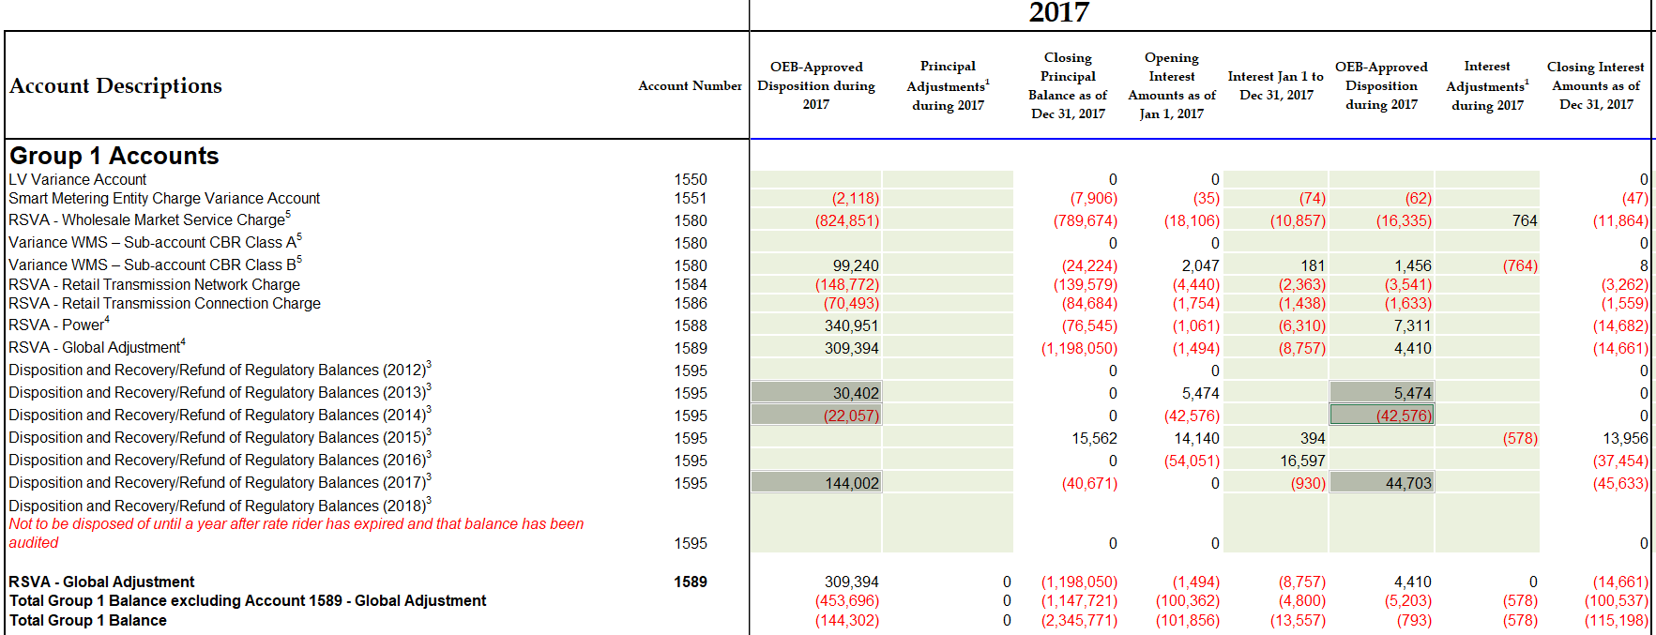

Extract of the Settlement Proposal from 2017 COS proceeding:

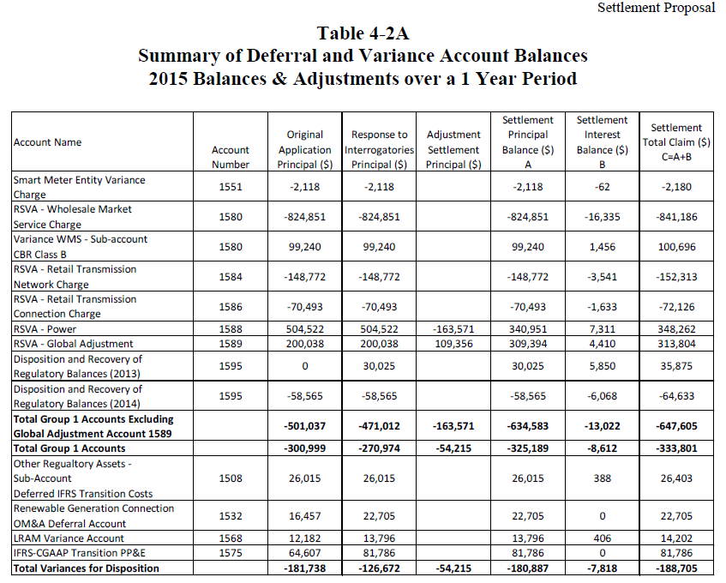

2019 Approved Balances

For the 2019 rate year in the 2020 IRM Rate Generator, the balance in Account 1595 (2019) principal and carrying charges do not match Table 6.2 of Welland Hydro’s 2019 Decision and Rate Order.

Extract of 2019 balances in the 2020 IRM Rate Generator:

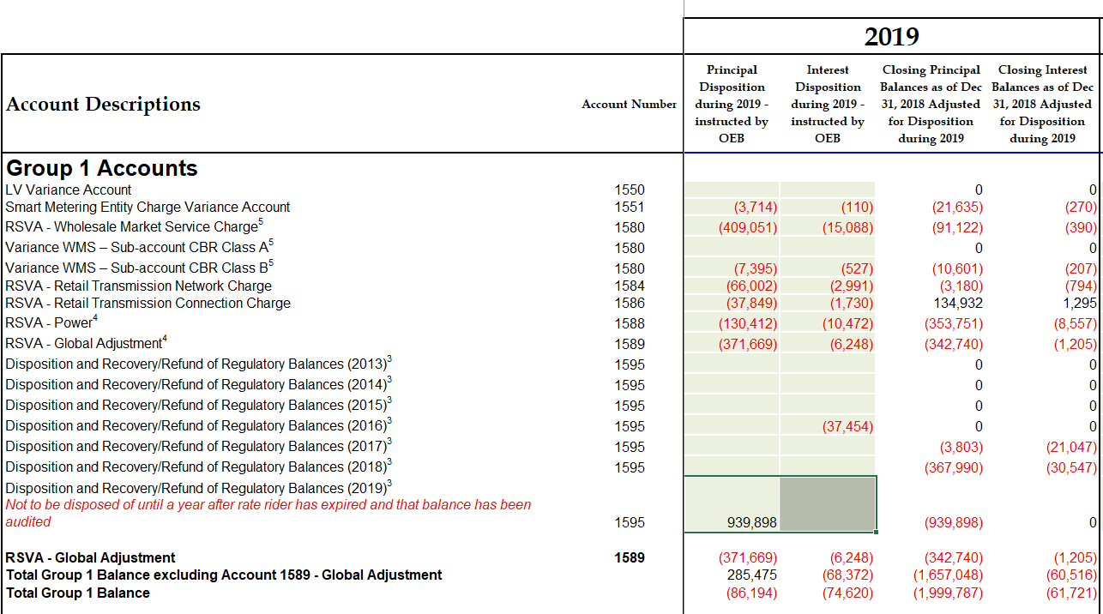

Extract of Table 6.2 of Welland Hydro’s 2019 Decision and Rate Order:

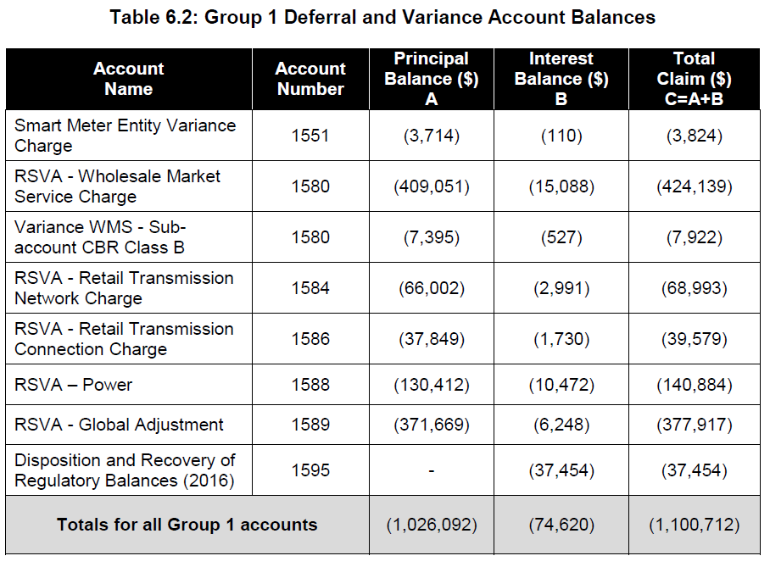

Questions:

1. Please explain why the 2017 principal balances and carrying charges for Account 1595 (2013) and Account 1595 (2014) in the 2019 IRM Rate Generator do not match Table 4-2A of the Settlement Proposal from the 2017 COS proceeding.

* Specifically, the Account 1595 (2013) principal $30,402 and carrying charges $5,474 do not reconcile with the Settlement Proposal
* Also, Account 1595 (2014) principal ($22,057) and carrying charges ($42,576) do not reconcile with the Settlement Proposal

1. Please reconcile the 2017 approved amounts in the DVA continuity schedule of $144,002 principal and $44,703 carrying charges to the amounts in the approved Settlement Proposal.
2. Please explain why the balance in Account 1575 of $81,786 was transferred to Account 1595 (2017) in the context of the March 2015 APH FAQ #6.
3. Please explain why the Account 1595 (2019) principal and carrying charges balance of $939,898 and $0 respectively in the 2020 IRM Rate Generator is inconsistent with Table 6.2 of the 2019 Decision and Rate Order, totaling ($1,026,092) and ($74,620).
4. Please confirm whether there are any revision(s) to the 2017 closing balances and Account 1595 (2019) principal and carrying charges in the 2020 IRM Rate Generator.

## Staff-4

Ref: (1) 1595 Analysis Workform (2017 vintage year), October 30, 2019

(2) Tab 3 of 2019 IRM Rate Generator

Preamble:

The residual balances in each component of the 1595 (2017) account balances are well below the 10% threshold, but the residual balance on the total approved amount for disposition is 12.4%.

Extract of 1595 (2017) workform below:

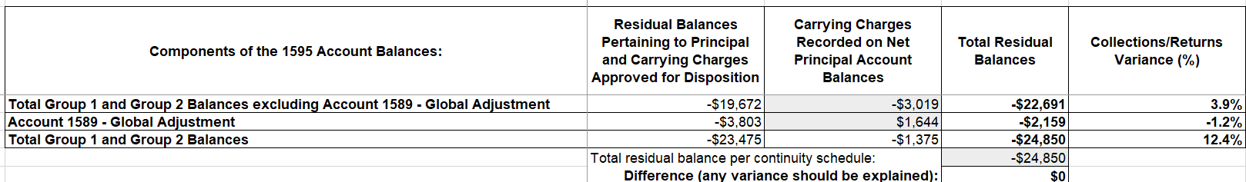

Extract of 1595 (2017) approved balances:

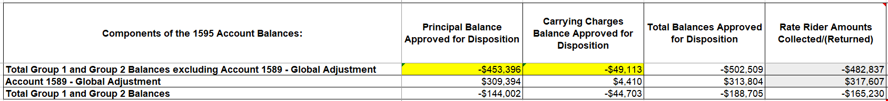

Questions:

1. Based on the above responses to Staff-3, please update the 1595 (2017) Analysis Workform and ensure that the balances reconcile back to Table 4-2A of the Settlement Proposal from the 2017 COS proceeding.
2. Please confirm accuracy of the rate rider amounts collected and/or returned in column G of the 1595 (2017) Analysis Workform in conjunction with the response to Staff-3.
3. Please ensure that the residual balance pertaining to principal and projected carrying charges in the 1595 (2017) Analysis Workform reflect the results of Staff-3, including a corrected breakdown between principal and interest.
4. Please confirm that the cell J16 entry of the 1595 (2017) Analysis Workform reflects the results of Staff-3.

**LRAMVA**

## Staff-5

Ref: (1) Chapter 3 of the Filing Requirements for Electricity Distribution Applications Rate Applications, dated July 12, 2018, p. 17

(2) Manager’s Summary, p. 27

Preamble:

Welland Hydro seeks disposition of a debit LRAMVA balance of $7,408 comprised of 2017 and 2018 balances. However, it appears that the LRAMVA amount is below materiality threshold of 0.5% of distribution revenue requirement (or $50,000 in Welland Hydro’s case). In the Chapter 3 Filing Requirements, it notes that distributors may apply for the disposition of the LRAMVA balance on an annual basis, as part of their IRM rate applications, if the balance is deemed significant by the applicant.

Question:

1. If Welland Hydro agrees that the lost revenue amount is not material, please provide supporting rationale as to why an insignificant LRAMVA balance is proposed to be disposed of through this rate proceeding.

## Staff-6

Ref: (1) Table 5-c (Tab 5) of LRAMVA workform

(2) 2019 Participation and Cost Report

(3) 2017 Final Verified Results Report

Preamble:

The 2019 Participation and Cost Report includes unverified adjustments to 2017 programs, but they are not included in Table 5-c (Tab 5 of the LRAMVA workform).

In addition, Table 5-c includes 111,780 kWh of 2017 incremental savings attributable to the Loblaws Program (at cell D460). This specific program, however, does not appear to be identified for Welland Hydro in the 2017 Final Verified Results Report.

Questions:

1. Please confirm that Welland Hydro is not seeking the recovery of 2017 unverified savings adjustments in this LRAMVA application.
2. For the 111,780 kWh of 2017 incremental savings, please confirm that the savings are attributed to the Save on Energy – Energy Performance Program, as opposed to the Loblaws Pilot. If there is a typo, please revise the entry in Table 5-c.

## Staff-7

Ref: (1) Tab 3 of LRAMVA workform (transformer allowance adjustment)

(2) Tariff of Rates and Charges (2016, 2017 and 2018 Decision and Rate Orders)

Preamble:

For the GS 50-4999 kW class, the 2016, 2017 and 2018 volumetric distribution rates have included a credit adjustment for transformer allowance. The adjustments applied to the distribution rate: -0.13861 (in 2016), -0.114 (in 2017) and -0.114 (in 2018).

Questions:

1. Please explain why the transformer allowance adjustments applicable to the GS 50-4999 kW class differ from the adjustment of -$0.7/kW approved in Welland Hydro’s Tariff of Rates and Charges.
2. Please explain in greater detail how the credit adjustments for transformer allowance were calculated for GS 50-4999 kW class in 2016, 2017 and 2018.

## Staff-8

1. If Welland Hydro made any changes to the LRAMVA workform as a result of its responses to the above LRAMVA questions, please file an updated LRAMVA workform, the revised LRAMVA balance requested for disposition, and a table summarizing the revised rate riders.
2. Please confirm any changes to the LRAMVA workform in response to these LRAMVA questions in “Table A-2. Updates to LRAMVA Disposition (Tab 1-a)”.

**Account 1588 and Account 1589**

## Staff-9

Ref: (1) Chapter 3 of the Filing Requirements for Electricity Distribution Applications Rate Applications, dated July 12, 2018, p. 15

Preamble:

At the above-noted reference, it states that distributors must complete the GA Analysis Workform for each applicable fiscal year subsequent to the most recent year in which Accounts 1588 and 1589 were approved for disposition on a final basis by the OEB.

Questions:

1. Although Welland Hydro has provided a GA Analysis Workform for 2018 balances, it also needs to provide a GA Analysis Workform for 2017 balances, including explanations of reconciling items. 2017 balances were approved on an interim basis in Welland Hydro’s 2019 proceeding.[1] The most recent year in which Accounts 1588 and 1589 were approved for disposition on a final basis related to 2016 balances in Welland Hydro’s 2018 proceeding.[2]
2. Please provide a revised 2017 GA Analysis Workform and explain any difference(s) versus the 2017 GA Analysis Workform filed on November 26, 2018, as described in (ii) below.
3. Alternatively, please confirm that the OEB can rely on the 2017 GA Analysis Workform filed on November 26, 2018 in Welland Hydro’s 2019 proceeding.[3] If confirmed, please file this spreadsheet on the record of the current proceeding.
4. The Deferral and Variance Account (DVA) Continuity Schedule, Tab 3, provided by Welland Hydro needs to be updated to reflect the opening DVA balances in this schedule as the closing December 31, 2016 balances, instead of the closing December 31, 2017 balances. This update needs to be done as the 2017 balances were cleared on an interim basis and will be reviewed in this proceeding. As a result, additional columns in Tab 3 will need to be populated, as well as updates to Tab 1. Please refile the DVA Continuity Schedule accordingly.

## Staff-10

Ref: (1) EB-2017-0081, 2018 Decision and Rate Order, March 22, 2018, pp. 7 & 8

(2) Manager’s Summary, p. 19

(3) Manager’s Summary, p. 20

Preamble:

At the above-noted first reference, the OEB stated the following:

The OEB notes that in its GA Analysis Workform, Welland Hydro indicates adjustments for 2015 and 2016 year end unbilled to actual revenue differences of $533,174 and $162,028 respectively. Moreover, in its GA Analysis Workform, Welland Hydro explains that the cause of the differences is different GA rates to calculate unbilled revenue accruals when compared to the GA rates used for billing purposes. For example, when a utility uses the 1st estimate to bill its customers, then it should use the 1st estimate to accrue unbilled revenue. The OEB notes that although Welland Hydro was able to reconcile the GA account for 2016, the OEB encourages Welland Hydro to consider how to improve its accounting and billing processes to minimize the impacts to account

1589 – RSVA GA going forward.

OEB staff notes that Welland Hydro has provided some information on its unbilled revenue below.

At the above-noted second reference, Welland Hydro stated the following:

Welland Hydro bills its Class B non-RPP customers using the IESO’s 1st estimate for GA for the month. For billing cycles that span more than one month, consumption is prorated by month and the IESO’s 1st Estimate GA rate for each month is applied to the prorated consumption. Welland Hydro records unbilled GA revenue from January to November based on estimated kWh at the GA 1st estimate rate. Unbilled revenue for December is based on actual kWh at the GA 1st estimate rate.

At the above-noted third reference, Welland Hydro stated the following:

Welland Hydro also confirms that the GA rate that is used is applied consistently for all billing and unbilled revenue transactions for non-RPP Class B customers in each customer class.

Questions:

1. Please confirm and explain whether Welland Hydro has considered the OEB’s concerns regarding how to improve its accounting and billing processes to minimize the impacts to Account 1589. Please describe when any such changes to Welland Hydro’s accounting and billing processes were made, including retroactive to which month and year.
2. If this is not the case, please explain.

## Staff-11

Ref: (1) Manager’s Summary, p. 24

(2) Tab 3 of 2020 IRM Rate Generator (cells BD28, BD29, BF28, BF29)

(3) Reporting and Record Keeping Requirements (RRR) 2.1.7

(4) Addendum to Filing Requirements For Electricity Distribution Rate Applications - 2020 Rate Applications, July 15, 2019, p. 18

Preamble:

At the above-noted first reference, Welland Hydro indicated it is seeking clearance of 2017 and 2018 balances in Account 1588 and Account 1589 on a final basis in this proceeding. Welland Hydro stated the following:

As the same settlement and accounting processes were used in 2017 and 2018 Welland Hydro is requesting final disposition of account balances for both the 2017 (approved on an interim basis in the 2019 IRM, EB-2018-0075) and 2018 years.

OEB staff has prepared the following table based on data provided at the above-noted second and third references. OEB staff notes that the percentage of Account 1588 2018 principal transactions divided by 2018 cost of power is high at -1.5%.

**OEB Staff Table 1 – Analysis of Large 2018 Balance in Account 1588**



At the above-noted fourth reference, the OEB described the following regarding material discrepancies for Account 1589:

Unexplained discrepancies should be calculated separately for each calendar year and any unexplained discrepancy for each year greater than +/- 1% of total annual IESO GA charges will be considered material.

Although the above-noted fourth reference relates to Account 1589, OEB staff has used the same materiality threshold of +/- 1% in analyzing the Account 1588 balance.

Questions:

1. Please confirm whether Welland Hydro is in agreement with OEB staff’s calculations in the above-noted OEB Staff Table 1.
2. If this is not the case, please explain.
3. Please provide additional analysis to support Welland Hydro’s claim that the Account 1588 2018 balance should be cleared on a final basis in this proceeding, considering the high computed ratio of -1.5% noted in OEB Staff Table 1. A high-level line loss variance analysis may also be helpful to support the claim.

## Staff-12

Ref: (1) Manager’s Summary, pp. 23 & 24

Preamble:

In summary, Welland Hydro does not have the information required at a level detailed enough to apply the revised accounting model to the 2017 balances, due to changes in its billing system in 2018. Welland Hydro notes that since its detailed review of the 2018 balances proved an immaterial variance between the current and new method, it is confident that there are no significant issues with its RPP settlement and related accounting processes. Welland Hydro has concluded that as the same settlement and accounting processes were used in 2017 and 2018, it is requesting final disposition of both the 2017 and 2018 balances.

At the above-noted reference, Welland Hydro stated the following:

Welland Hydro implemented the new accounting guidance in July 2019, retroactive to January 1, 2019. Welland Hydro uses a modified version of the Excel based Model provided by the OEB in the Accounting Guidance dated February 21, 2019 for all monthly settlements and true-ups with the IESO beginning January 1, 2019, as well as for accounting entries related to Account 1588 and 1589.

Welland Hydro has performed a thorough review of its 2018 balances under the new accounting guidance. Welland Hydro has applied the new model to the entire 2018 year and has concluded that the difference between what was reported under the current process and that of the new model is immaterial. The comparison can be seen in Table 10 below.

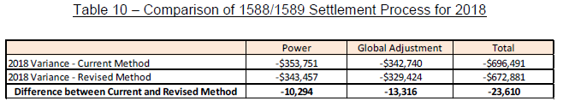

Welland Hydro implemented changes to its billing system in 2018 in order to provide more detailed information on a timelier basis. Welland Hydro does not have the information required at a level detailed enough to apply the revised model to the 2017 year. Welland Hydro used the same settlement processes and procedures for both the 2017 and 2018 years. As a result of the detailed review done for the 2018 year which proved an immaterial variance between the current and new method, Welland Hydro is confident that there are no significant issues with its RPP settlement and related accounting processes. As the same settlement and accounting processes were used in 2017 and 2018 Welland Hydro is requesting final disposition of account balances for both the 2017 (approved on an interim basis in the 2019 IRM (EB-2018-0075)) and 2018 years.

Questions:

1. Please provide further details on the review that was completed, and any summary reports available (e.g. how the review was done).
2. Please provide more information to support Welland Hydro’s analysis that was performed on its 2018 balances. Specifically, please provide more information regarding its conclusion that there are no significant issues with its processes, considering the high computed ratio of -1.5% noted in OEB Staff Table 1 regarding the 2018 Account 1588 balance.
3. Please explain why the findings of Welland Hydro’s analysis of 2018 balances should be generally “extrapolated” to its 2017 balances, considering the high computed ratio of -1.5% noted in OEB Staff Table 1 regarding the 2018 Account 1588 balance.
4. Please explain the nature of the differences in Welland Hydro’s Table 10 of the preamble of this question.

## Staff-13

Ref: (1) Appendix A GA Methodology Description Questions on Accounts 1588 & 1589, pp. 133 & 134 (of PDF p. 156)

Preamble:

At the above-noted reference, “Appendix A GA Methodology Description Questions on Accounts 1588 & 1589”, the table in Question 1 for Account 1588 requests an analysis of the applicant’s 2018 Account 1588 balance. This analysis was not performed by Welland Hydro. The following response was included by Welland Hydro:

Welland Hydro has not made any principal adjustments on the DVA Continuity

Schedule for Account 1588.

Questions:

1. Please complete the table in Question 1 of Appendix A for 2018 balances.
2. Please confirm that the first line of this table represents the Account 1588 general ledger balance as at December 31, 2018.
3. Please confirm that last line of this table represents the closing principal Account 1588 balance as at December 31, 2018 in the DVA continuity schedule (cell BG28).
4. Please explain any differences between (b) and (c), considering any OEB-approved dispositions that occurred in the year.
5. Please also repeat steps (a), (b), (c), and (d) for Account 1588 balances as at December 31, 2017, in a similar table, considering any OEB-approved dispositions that occurred in the year.
6. Please quantify and explain any large amounts shown in these tables relating to either a 2017 or 2018 balance.

## Staff-14

Ref: (1) Accounting-Guidance-on-Accounts-1588-1589-QA-20190711, Q6

(2) Accounting-Guidance-on-Accounts-1588-1589-QA-20190711, Q30

(3) EB-2018-0075, Response to Staff Question-9 (November 26, 2018)

Preamble:

At the above-noted first reference, the OEB stated that distributors should use the best data available for recording unbilled revenues. Whether a distributor records unbilled revenue at year end based on estimates as a journal entry would depend on a utility’s timing and practices. The key is that any estimated revenue is ultimately trued up to actuals.

At the above-noted second reference, the OEB stated that not truing up estimated revenues to actuals and not truing up RPP settlements would fall in the category of systemic issues. The OEB noted that distributors must assess whether these issues have resulted in material errors or discrepancies.

At the above-noted third reference, Welland Hydro confirmed that unbilled GA revenue recorded as of December 31, 2017 is based on actual unbilled consumption rather than estimated unbilled consumption.

Questions:

1. Please describe Welland Hydro’s treatment of unbilled revenue.
2. Please explain whether any amounts related to unbilled revenue need to be included in line 2 of the GA Analysis Workform as a reconciling item, as well as principal adjustments to Account 1588 and Account 1589 in the DVA Continuity schedule.

## Staff-15

Ref: (1) Manager’s Summary, p. 19

(2) 2018 GA Analysis Workform, October 30, 2019

(3) EB-2018-0075, Response to Staff Question-10 (November 26, 2018)

(4) EB-2018-0075, 2017 GA Analysis Workform, November 26, 2018

Preamble:

At the above-noted first reference, Welland Hydro stated the following:

In 2018 there was a difference between the average billed loss factor of 1.0476 and the actual loss factor of 1.0384. An adjustment of $107,116 was made to account for the difference between the loss factor used to bill and the actual loss factor to reflect the associated favorable variance.

OEB staff notes that the $107,116 amount has been recorded on line 7 of the 2018 GA Analysis Workform, as per the above-noted second reference.

At the above-noted third reference, Welland Hydro provided supporting calculations for an adjustment of $267,931 shown on the 2017 GA Analysis Workform.

OEB staff notes that the $267,931 amount has been recorded on line 7 of the 2017 GA Analysis Workform, as per the above-noted fourth reference.

Questions:

* 1. Please explain how the average billed loss factor of 1.0476 is calculated.
  2. Please explain how the actual loss factor of 1.0384 is calculated.
  3. Please explain how Welland Hydro calculated the adjustment of $107,116.

## Staff-16

Ref: (1) EB-2017-0081, 2016 GA Analysis Workform, February 14, 2018

(2) EB-2018-0075, 2017 GA Analysis Workform, November 26, 2018

(3) EB-2018-0075, Tab 3 of 2019 IRM Rate Generator (cell BF29)

(4) EB-2018-0075, 2019 IRM Welland Hydro_Appendix A_GA Methodology Description_20181015.DOCX, pp. 5 & 6

Preamble:

At the above-noted first reference (2016 GA Analysis Workform), Welland Hydro reported on line 2b current year-end unbilled to actual revenue differences of $162,028. However, this amount was not shown as a reversal (i.e. a credit of $162,028) on line 2a at the above-noted second reference (2017 GA Analysis Workform), or as a principal adjustment on the 2019 IRM Rate Generator Model, at the above-noted third reference.

OEB staff notes that the following explanation was provided at the above-noted fourth reference (pages 5 and 6, respectively) for the true-up amount of $162,028 as follows:

…The second amount was an adjustment of $162,028 which represented a GA true-up for unbilled revenues to actual revenues for the 2016 year…

…The variance related to unbilled revenues was reversed in the GL in the 2017 year. There was no adjustment required for the unbilled GA revenue accrual for 2017.

Question:

1. Please explain why a reversal of the debit balance of $162,028 shown in the 2016 GA Analysis Workform (reconciling item 2b) is not shown in the following:
   1. under reconciling item 2a on the 2017 GA Analysis Workform as a credit balance of $162,028, and
   2. as a 2017 principal adjustment of a credit balance of $162,028 on Tab 3 of the IRM Rate Generator Model

## Staff-17

Ref: (1) Manager’s Summary, p. 20, Table 9 – IESO Settlement Process

(2) Manager’s Summary, p. 21

(3) Accounting-Guidance-on-Accounts-1588-1589-QA-20190711, Q20

Preamble:

At the table at the above-noted first reference describing its settlement process, Welland Hydro indicates that it “pays the IESO Actual GA.”

At the above-noted second reference, Welland Hydro stated the following:

Welland Hydro pays the IESO Class B GA based on its actual Class B volume at the actual Class B rate. No further settlement with the IESO is required. Any difference between GA revenues and GA costs are recorded in the GA variance account to be recovered from or repaid to Class B non-RPP customers based on consumption…

…Welland Hydro verifies the amount of Class B GA invoiced by the IESO using the kWh calculated above multiplied by the actual GA rate for the month.

At the above-noted third reference, the OEB confirmed that the GA price used for RPP settlements should be the invoiced GA price. However, the OEB noted that the invoiced GA price should generally equal the posted price, except in some circumstances.

Questions:

1. Please confirm that Welland Hydro performs its final RPP settlements based on the invoiced GA price, as opposed to the final posted GA rate.
2. If this is not the case, please explain.

## Staff-18

Ref: (1) Accounting-Guidance-on-Accounts-1588-1589-QA-20190711, Q22

Preamble:

At the above-noted reference, the OEB confirmed that the total volumes used in the RPP settlement process are based on wholesale volumes. The OEB noted that the IESO invoice is based on wholesale volumes, therefore, the RPP settlement is also to be completed based on wholesale volumes. However, the OEB stated that the proportions between the tiers and time-of-use periods are based on retail volumes.

Questions:

1. Please confirm that Welland Hydro has reflected the above-noted OEB requirements in its settlement processes.
2. If this is the case, please describe which month and year these OEB requirements were made effective in Welland Hydro’s settlement processes.
3. If this is not the case, please explain.

1. EB-2018-0075
2. EB-2017-0081
3. EB-2018-0075