Fort Frances Power Corporation

OEB Staff Questions

EB-2019-0036

**Fort Frances Power Corporation (Fort Frances Power)**

**EB-2019-0036**

**Staff Question-1**

**Ref: A portion of Sheet 3 “Continuity Schedule” is reproduced below**

The table from Fort Frances Power’s 2017 IRM Decision[1] which identified the principal and interest amounts approved for disposition, is reproduced below.

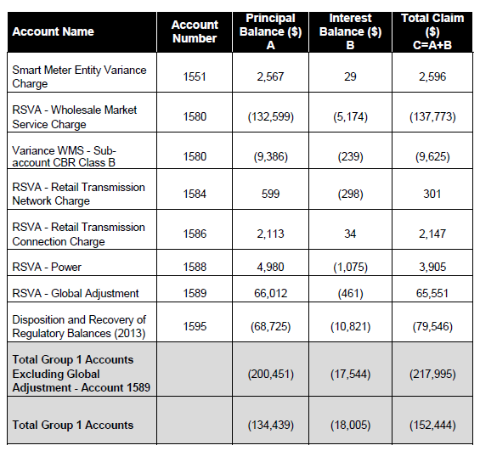

OEB staff notes that the “OEB-Approved Disposition during 2017 (Cells BJ & BJ) do not reconcile with the approved amounts in the 2018 IRM decision.

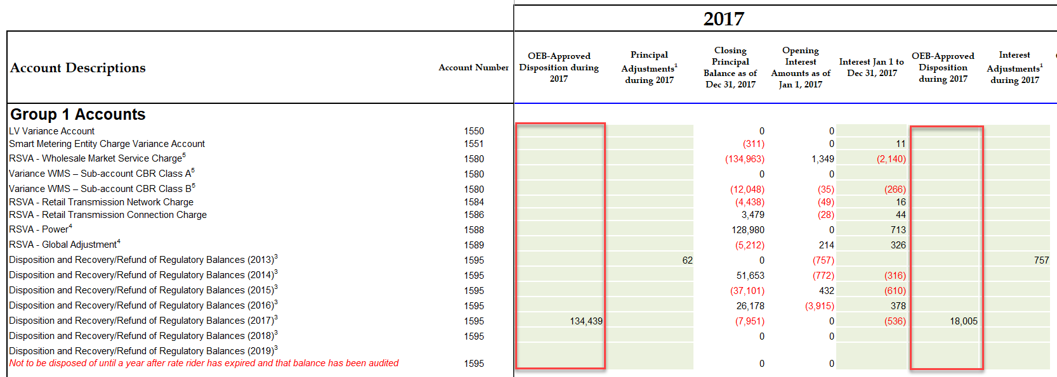

1. Please reconcile differences. If the input into the Rate Generator Model is an error please provide corrections and OEB staff will make the necessary changes to the model.

The Group 1 Accounts approved for disposition as part of Rate Order EB-2016-0071 for disposal effective May 1, 2017 correspond to 2015 balances. In the Rate Generator Model on Tab 1, when an LDC selects “2016” as “DVAs last approved for disposition”, the Generator in turn locks out the ability to enter 2015 balances for disposal.

Without the ability to enter 2015 balances, the disposition of 2017 Group 1 Accounts do not have an offsetting value which in turn creates a variance in the final disposition amounts.

**Staff Question-2**

**Ref: A portion of Sheet 3 “Continuity Schedule” is reproduced below**

The table from Fort Frances Power’s 2018 IRM Decision[2] which identified the principal and interest amounts approved for disposition, is reproduced below.

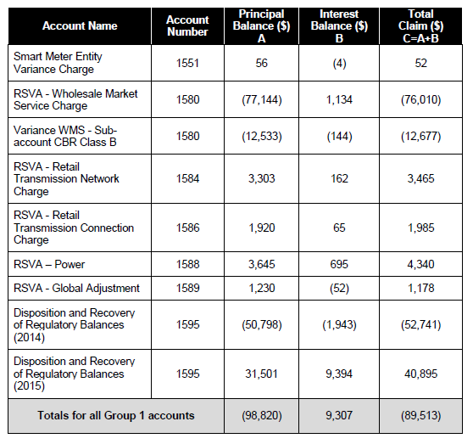

OEB staff notes that the “OEB-Approved Disposition during 2018 (Cells BJ & BJ) do not reconcile with the approved amounts in the 2019 IRM decision. Also, the amount inputted in Cell should be 695 instead of 53.

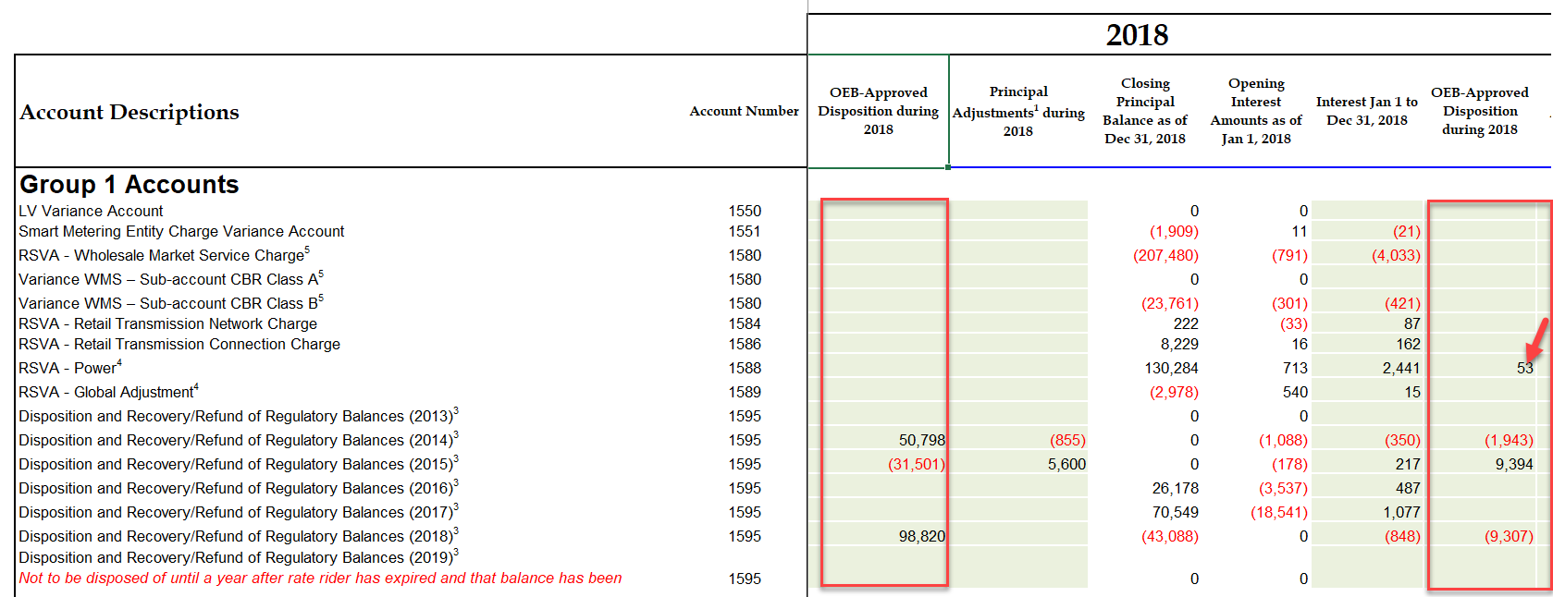

1. Please reconcile differences. If the input into the Rate Generator Model is an error please provide corrections and OEB staff will make the necessary changes to the model.

The Group 1 Accounts approved for disposition as part of Rate Order EB-2017-0041 for disposal effective May 1, 2018 correspond to 2016 balances. In the Rate Generator Model on Tab 1, when an LDC selects “2016” as “DVAs last approved for disposition”, the Generator in turn locks out the ability to enter 2016 balances for disposal.

Without the ability to enter 2016 balances, the disposition of 2018 Group 1 Accounts do not have an offsetting value which in turn creates a variance in the final disposition amounts.

The value of “$53” should be moved to Cell BK28 as a small interest adjustment.

**Staff Question-3**

**Ref: A portion of Sheet 3 “Continuity Schedule” is reproduced below**

OEB staff notes that Fort Frances Power has not calculated projected interest on its Group 1 balances for the period from January 1, 2019 to December 31, 2019 and from January 1, 2020 to April 30, 3020.

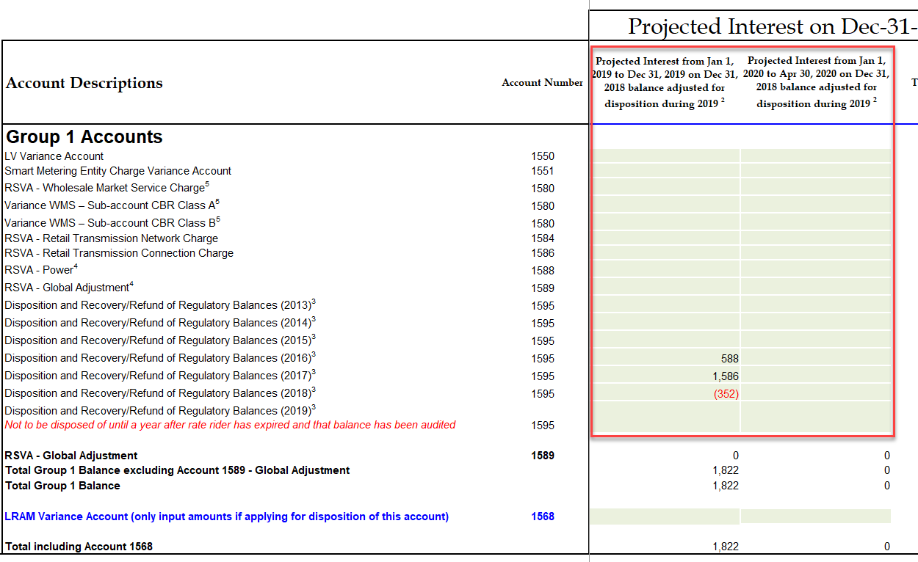

1. Please calculate carrying charges for the periods noted above, and provide these amounts for each account. OEB staff will update the model accordingly.

FFPC experiences multiple Excel crashes while working in the Rate Generator Model, during which previously inputted values did not save. FFPC notes that this issue was an oversight while attempting to recover an autosaved copy of the Generator Model upon crashing. We apologize for this oversight.

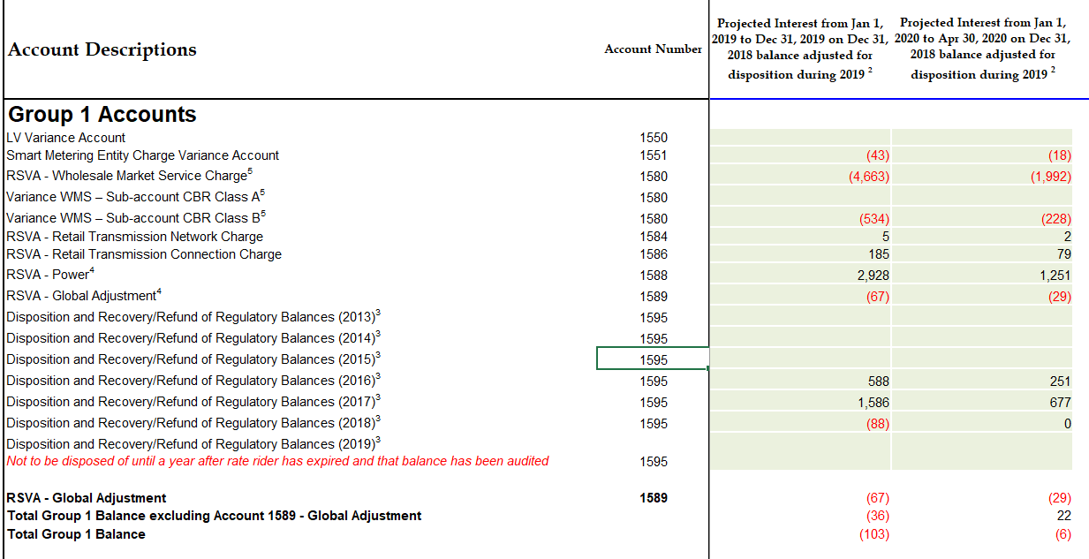

1. Please confirm if the disposition threshold continues to be met when the amounts in 1a), 2a) and 3a) are applied to these accounts. If the disposition threshold as calculated by Fort Frances Power does not continue to be met, please confirm that Fort Frances Power will not seek disposition of its Group 1 Deferral and Variance Account balances.

FFPC confirms that the projected interest of $109 does not impact the disposition threshold calculation. FFPC continues to not meet the disposition threshold and will not be making a claim.

**Staff Question-4**

**Ref: Rate Generator Model, Tab 3 Continuity Schedule, Account 1595 (2017)**

In Tab 3 of the IRM Model, Fort Frances Power selected “yes” with respect to whether Account 1595 (2017) is being requested for disposition.

As stated in Chapter 3 Filing Requirements “Applicants are expected to request disposition of residual balances in Account 1595 Sub-accounts for each vintage year only once, on a final basis. Distributors are expected to seek disposition of the audited account balances a year after a rate rider’s sunset date has expired. No further transactions are expected to flow through the Account 1595 Sub-accounts once the residual balance has been disposed.”

As per the 2020 IRM Webinar Q&A #4, August 7, 2019:

“1595 sub-account residual balances are eligible for disposition when one year has passed since the expiry of the associated rate riders and any balance that remains after that one-year period has been audited. Therefore, if a rate rider ends on December 31, 2018, one year after the expiry of the rider would be December 31, 2019, and the account would be eligible for disposition when December 31, 2019 audited balances are brought forth in a 2021 rate application.”

1. Please explain why Fort Frances Power meets the above criteria. Please confirm in particular that the balance requested for disposition has been audited. If necessary, please update the 2020 continuity schedule.

FFPC is of the understanding that the disposition eligibility criteria have been met using the following rationale:

FFPC account 1595 (2017) rate rider expired April 30, 2018. The one-year expiry anniversary of April 30, 2019 requirement has been met.

FFPC account 1595 (2017) balance has been audited up to December 31, 2018, which is 8 months following the one-year expiry.

FFPC rates run May 1 – April 30 and not calendar year as per the example provided.

FFPC does not meet the threshold test and is not applying for disposition.

**Staff Question-5**

**Ref: Account 1595 Workform**

Fort Frances incorrectly billed its customers for its account 1589 Global Adjustment rate rider for the Street Lighting and GS >50 kW rate classes as Fort Frances billed KW rather than kWh for 2017.

1. Please provide the impact of this differential.

|  |  |  |  |  |
| --- | --- | --- | --- | --- |
|  | As billed | | Revised | |
|  | Calculated Variance | | Calculated Variance | |
| Class | $ | % | $ | % |
| Streetlights | 1,291 | 99.8% | (43) | 8.0% |
| GS>50 | 62,205 | 99.7% | 4,963 | -3.3% |

1. Please state how Fort Frances Power would propose to deal with this error.

FFPC proposes to recover the uncollected amounts from the affected customers using equal monthly billing adjustment s over a one-year period.

OEB staff notes that in the 1595 Analysis Workform, the variance on this account is shown as 96.9% which significantly exceeds the 10% threshold. Fort Frances Power should re-calculate this amount using the correct billing approach.

Updating the billing approach reduces the variance to 8% and 3.3%. The 1595 Analysis workform is attached with the revision for the bill correction.

**Staff Question-6**

**Ref: Retail Transmission Service Rates (RTSRs)**

In the OEB’s 2020 IRM Rate Generator Model for Tab 20-Bill Impacts, if the bill impacts of the RTSR-Network Service Rate (the Network Charge) or the RTSR-Line and Transformation Connection Service Rate (the Connection Charge) exceeds a 4% increase, the Model will show an instruction in red text asking the applicant to discuss the reasons for the change in RTSRs.

Fort Frances Power’s RTSR bill impacts exceed 4% when the Rate Generator Model is updated for the proposed 2020 Network Charge.



1. Please quantify the reason for the increase, i.e. price and volume contributors explaining causes for each of the reasons for the increase, provide a table by rate class outlining the drivers of the proposed increase to network RTSRs.

As noted in the manager’s summary FFPC is using the most current rates as approved by the Board EB-2019-0164. The main reason for the increase in the approved Uniform Transmission Rates which saw increases of 6%.

**Staff Question-7**

**Ref: Rate Generator Model, Tab 16 Rev2Cost GDPIPI, Tab 17 Regulatory Charges and Tab 20 Bill Impacts**

OEB staff has made the following updates to the Rate Generator Model for Fort Frances Power:

1. Tab 16 – Updated Price Cap Index parameters to zero as stated in Manager Summary, page 6 of 19
2. Tab 17 – Updated Inflation factor of 2% for the Retail Service Charges and the Wireline Pole Attachment charge and RPP data as of November 1, 2019
3. Tab 20 - New Ontario Electricity Rebate (31.8%).

Please confirm Fort Frances Power’s acceptance of the revised model.

FFPC confirms acceptance.

**Staff Question-8**

**Ref: Rate Generator Model, Tab 19 - Proposed Tariff of Rates and Charges**

As per the Rate Order in EB-2017-0183, OEB staff will update the tariff at the decision and rate order stage of this proceeding for the following changes to Non-Payment of Account Service Charges:

1. Removal of all “Install/Remove Load Control Device” charges
2. Change any reference of “Disconnect/Reconnect” to “Reconnection”
3. Alter the “Late Payment – per month” charge to “Late Payment – per month” (effective annual rate 19.56% per annum or 0.04896% compounded daily rate)

Please confirm Fort Frances Power’s acceptance of the above.

FFPC confirms acceptance of the above.

**Staff Question-9**

**Ref: Manager’s Summary, p. 13**

Fort Frances Power indicates that it has reviewed and analyzed historic balances in the context of the OEB’s new February 21, 2019 accounting guidance related to accounts 1588 and 1589 and notes that this review did not result in any changes to the booked balances.

1. Please confirm that the review of historic balances in the context of the OEB’s new accounting guidance was completed for both years 2017 and 2018 as those years have yet to be disposed.

FFPC confirms the review of the 2017 and 2018 years.

1. Please confirm that in conducting such an analysis, Fort Frances Power went back to each IESO settlement completed in 2017 and 2018 and re-performed each settlement based on the OEB’s February 21, 2019 accounting guidance for accounts 1588 and 1589.

FFPC confirms re-preforming each settlement.

1. Fort Frances Power indicates that no adjustments resulted, does this mean that there were adjustments however they were not material, or that there were not adjustments at all (zero value).

FFPC notes that there were no adjustments at all (zero value). FFPC bills on true monthly billing, which in turn results in no estimates needing to be made for billing periods that span more than one month. Therefore customers are charged on first estimate and the true up is made to final estimate on 100% of all billed consumption.

1. If the resulting adjustments were not material, please provide the dollar value of these immaterial adjustments by account and by year.

FFPC did not require adjustments due to the change in accounting guidance.

**Staff Question-10**

**Ref: Manager’s Summary, p. 13**

Fort Frances Power indicates that FFPC has consulted with Board Staff and received confirmation to proceed with its current accounting and settlement practices.

1. Does this mean that Fort Frances Power’s current accounting practices do not align with the OEB’s February 21, 2019 accounting guidance? And that Fort Frances intends to continue with such practices notwithstanding the new OEB guidance?

FFPC’s accounting practices are aligned with the spirit of the OEB’s accounting guidance and result in identical outcomes. The guidance provided assumes that LDCs are not capable of billing all customers on a True Monthly Basis, thereby requiring reliance on estimated values for settlement purposes. FFPC intends to continue with its current billing and true up processes that were confirmed by OEB staff as meeting the spirit of the guidance provided. Avoidance of using unnecessary GA estimates for LDCs capable of True Monthly Billing results in a much cleaner settlement process with a reduced margin for error.

1. Based on the discussions in Staff Question-9 above, is Fort Frances Power indicating that although it doesn’t follow the OEB’s February 21, 2019 accounting guidance, its current practices result in the same outcome as demonstrated by the fact that no adjustments were necessary when Fort Frances Power reviewed its historical balances ()2017 and 2018) in the context of the OEB new accounting guidance for accounts 1588 and 1589.

Yes

**Staff Question-11**

**Ref: Appendix A: GA Methodology Description**

In the response to Questions on CT 1142, and specifically question a. to that section, Fort Frances Power indicates that GA settlement to IESO is based on actual metered consumption, which creates a lag in reporting, however FFPC’s books are left open to record all accruals in the proper fiscal year (to ensure January through December expenses are recorded in the correct period).

1. Does this mean that Fort Frances Power does not settle consumption on the 4th day following the month end (i.e. it doesn’t settle January consumption on February 4th, February consumption on March 4th, and so on. Please explain.

Yes, January metered customer consumption is billed in February, and trued up with the IESO on March 4th.

1. Is Fort Frances Power aware that the requirement to settle consumption on the fourth day following month-end (i.e. January consumption settled on February 4th, etc.) is not an OEB mandated rule but rather a settlement rule mandated by the IESO? If so, has Fort Frances Power informed the IESO of their intention to continue with such practices?

Yes, the IESO is aware of FFPC’s unique settlement processes. FFPC’s settlement processes are further complicated by the 1905 Historic Power Agreement, which is sited Ontario Regulation 398-10 Global Adjustment.

1. Would the actual metered data that is used by Fort Frances Power for IESO settlement purposes be available by the fourth day following month-end (i.e. is January metered consumption available by Feb 4th)? If not, is that the reason for the lag that Fort Frances Power currently uses for IESO settlement purposes?

The actual metered data that is used by FFPC for IESO settlement purposes is not available by the fourth day following month-end. Yes, this is the reason for the lag.

**Staff Question-12**

**Ref: GA Analysis Workform 2017 and 2018**

As required by the OEB’s filing requirements, Fort Frances Power has completed and submitted a GA Analysis Workform related to each year since its last disposition of account 1589.

1. As part of Note 5 of each GA Analysis Workform, Fort Frances Power has not quantified the dollar impact related to the difference between the OEB approved and actual loss factors (i.e. Adjustment 7 in Note 5 of each GA Analysis Workform). Please update each GA Analysis Workform to reflect the impact of the difference. 2017 $3,840.00, 2018 $528.00
2. The balances input in cell C64 of each Workform has been input incorrectly. The balances that are input in this cell must correspond to the transaction recorded during the year as presented in the DVA continuity schedule. Please compare and update each GA Analysis Workform accordingly (the signs are currently incorrect). Please note that FFPC has not changed how this workform was completed and believes that these inputs are correct.
3. In regards to adjustment 9 of Note 5 in the 2018 GA Analysis Workform, what month did this error occur in?
   * 1. Was the IESO settlement actually completed with the incorrect data? The settlement month was March 2018 consumption – May 2018 reporting
     2. What month did the IESO process the correction? IESO processed the adjustment June 2018
     3. What period/year was the correction actually recorded in the G/L? FFPC recorded the adjustment in March 2018
     4. Shouldn’t the correction of this error be presented as part of the December 31, 2018 closing balance in account 1589 in order for it to be accurate? FFPC discovered that the recording of the error had a variance after the 2018 audit was completed, therefore did not include the adjustment in the 2018 balance. The variance is recorded in 2019 after the additional adjustment.

1. EB-2016-0071
2. EB-2017-0041