Rideau St. Lawrence Distribution Inc.

OEB Staff Questions

EB-2019-0066

**Rideau St. Lawrence Distribution Inc. (Rideau St. Lawrence)**

**EB-2019-0066**

**Staff Question-1**

**Ref: (1) Response to Incomplete Letter, November 21, 2019, page 4**

**(2) Manager’s Summary, page 25**

At the above noted first reference Rideau St. Lawrence stated the following:

The result of the review of our previous RPP true-up process and historical balances in Accounts 1588 and 1589 further confirmed the accuracy and completeness of the balances in Accounts 1588 and 1589 for the years 2017 and 2018. RSL, therefore, is of the view that the 2017 balances of Accounts 1588 and 1589, which were approved for disposition on an interim basis in its 2019 IRM proceeding, should be deemed final disposition. RSL is also confirming its request as made in the original submission for a final disposition of its 2018 balances of Accounts 1588 and 1589.

At the above noted second reference Rideau St. Lawrence stated the following:

The guidance was effective January 1, 2019, and was to be implemented by August 31, 2019. RSL has complied with the guidance, using the model provided by the OEB. The 2019 transactions recorded in the general ledger reflect the changed process.

**Questions:**

1. Please confirm that the new accounting guidance was implemented retroactive to January 1, 2017 and that this task was completed by August 31, 2019.
2. If this is not the case, please explain.

**Staff Question-2**

**Ref: (1) Response to Incomplete Letter, November 21, 2019, page 3**

**(2) 2018 Global Adjustment (GA) Analysis Workform, November 4, 2019**

**(3) EB-2018-0065, Staff-4 Interrogatories**

At the above noted first reference Rideau St. Lawrence stated the following:

We have reviewed our previous process and the historical balances of Accounts 1588 and 1589, and have determined that the only difference between our previous process and the new accounting guidance is the reconciliation data basis of RPP billing volume (prior method) vs. RPP wholesale volume (new method).

At the above noted second reference, Rideau St. Lawrence described a debit amount of $39,311 that was included on line 6 of the 2018 GA Analysis Workform as a reconciling item. Rideau St. Lawrence stated the following:

During the 2019 *[sic]* IRM preparation we found errors in reporting *[sic]* of Class A and Microfit kWh which had caused higher GA charges on IESO invoices for period 2017 - 2018. As instructed by the IESO, an adjustment was made to 2018 December actual Class A and Microfit kWh to fix previous incorrect reporting. The GA rate variance contributed $39,311 to the difference of actual 1589 and expected 1589.

At the above noted third reference, Rideau St. Lawrence discussed an error it made where it “reported Class A kWh to the IESO one month behind and the non-loss adjusted kWhs were used incorrectly.”

**Questions:**

1. Building on the response in the above noted interrogatory, please confirm that Rideau St. Lawrence has completed its review of the new Accounting Guidance and any required changes to the accounting for Account 1588 and Account 1589 have been implemented related to its 2017 and 2018 historical balances.

Please explain if there are any systemic issues with the RPP settlement or related accounting processes for Group 1 DVAs have been identified from the review of the new accounting guidance issued on February 21, 2019. In Rideau St. Lawrence’s response, in addition to its treatment of retail volume kWh versus wholesale volume kWh, please also consider:

its error described at the above noted second reference

whether this error described at the above noted second reference is the same as the error described at the above noted third reference

its treatment of unbilled revenue which is explored at an interrogatory below

its treatment of the invoiced GA price which is explored at an interrogatory below

any other factors

If there are systemic issues, please explain whether adjustments to Group 1 DVA balances that have yet to be disposed on a final basis have been quantified, including balances that have been cleared in on an interim basis or not cleared at all in a prior proceeding.

If adjustments have not been quantified, please provide a timeline as to when the applicant expects any discrepancies to be resolved.

If material adjustments were identified, for each adjustment please provide the following:

Quantification and nature of the adjustment

The period in which the adjustment relates to (i.e. in relation to the flow of kWh)

Detailed explanation of the adjustment, including how it was identified, the reason for the adjustment, the impact to each of Accounts 1588 and 1589.

Show how it has been included as a principal adjustment to Account 1589 in the GA Analysis Workform and Account 1588 in Appendix A, Question 1

Describe the steps taken to include these adjustments in the DVA Continuity Schedule and balances requested for disposition in this proceeding. Please also provide the cells in the DVA Continuity Schedule where these adjustments were made.

1. Please provide further details on the review of 2017 and 2018 balances that was completed, and any summary reports available (e.g. how the review was done).

**Staff Question-3**

**Ref: (1) Response to Incomplete Letter, November 21, 2019, page 3**

**(2) 2018 GA Analysis Workform, November 4, 2019**

**(3) EB-2018-0065, 2017 GA Analysis Workform, October 15, 2018**

**Preamble:**

At the above noted first reference Rideau St. Lawrence stated the following:

We have reviewed our previous process and the historical balances of Accounts 1588 and 1589, and have determined that the only difference between our previous process and the new accounting guidance is the reconciliation data basis of RPP billing volume (prior method) vs. RPP wholesale volume (new method).

The difference in volume for 2017 is 187,643 kWh, which would affect our 2017 annual RPP true-up amount by approximately $3,574. This variance accounts for 0.05% of RSL’s annual Cost of Power as recorded in Accounts 1588 and 4705.

The difference in volume for 2018 is 56,722 kWh, which would affect our 2018 annual RPP true-up amount by approximately $1,780. This variance accounts for 0.03% of RSL’s annual Cost of Power as recorded in Accounts 1588 and 4705.

Both years are much lower than the 0.5% of the annual Cost of Power threshold as per the OEB’s Guidance, Q&A’s for Accounting Guidance on Accounts 1588 and 1589, Q29. No adjustments related to the new Accounting Guidance are required. The detailed calculation is shown in the following table.

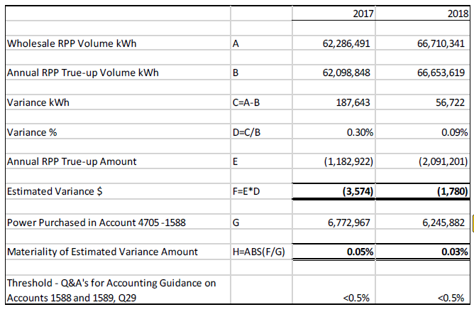

OEB staff has prepared the following table based on data provided at the above noted three references.

**OEB Staff Table 1 – Differences in RPP Retail kWh**



At the above noted first reference, Rideau St. Lawrence provided Account 4705 balances as at December 31, 2017 and 2018, however, these balances do not reconcile to the amounts reported to the OEB in the Reporting and Record Keeping Requirements (RRR) 2.1.7. Although the differences do not materially change the outcomes listed in the “Response to Incomplete Letter,” OEB staff has listed these discrepancies below:

**OEB Staff Table 2 – Discrepancies in Account 4705**



**Questions:**

1. Please confirm whether Rideau St. Lawrence is in agreement with OEB staff’s calculations in the above noted OEB Staff Table 1 and OEB Staff Table 2.
2. If this is not the case, please explain.
3. Please explain the kWh reported at line “B” of the table provided by Rideau St. Lawrence at the above noted first reference, as it does not reconcile to the RPP kWh recorded on a retail basis shown in OEB Staff Table 1.
4. Please provide supporting analysis to explain how the analysis in the table provided by Rideau St. Lawrence at the above noted first reference is reasonable, considering the discrepancies shown in OEB Staff Table 1.
5. If the table provided by Rideau St. Lawrence at the above noted first reference needs to be restated, please consider the discrepancies noted at the above OEB Staff Table 2.

**Staff Question-4**

**Ref: (1) Accounting-Guidance-on-Accounts-1588-1589-QA-20190711, Q6**

**(2) Accounting-Guidance-on-Accounts-1588-1589-QA-20190711, Q30**

**Preamble:**

At the above noted first reference, the OEB stated that distributors should use the best data available for recording unbilled revenues. Whether a distributor records unbilled revenue at year end based on estimates as a journal entry would depend on a utility’s timing and practices. The key is that any estimated revenue is ultimately trued up to actuals.

At the above noted second reference, the OEB stated that not truing up estimated revenues to actuals and not truing up RPP settlements would fall in the category of systemic issues. The OEB noted that distributors must assess whether these issues have resulted in material errors or discrepancies.

**Questions:**

1. Please describe Rideau St. Lawrence’s treatment of unbilled revenue.
2. Please explain whether any amounts related to unbilled revenue need to be included in line 2 of the GA Analysis Workform as a reconciling item, as well as principal adjustments to Account 1588 and Account 1589 in the DVA Continuity schedule.

**Staff Question-5**

**Ref: (1) Chapter 3 of the Filing Requirements for Electricity Distribution Applications Rate Applications, dated July 12, 2018, page 15**

**Preamble:**

At the above noted first reference, it is stated that distributors must complete the GA Analysis Workform for each applicable fiscal year subsequent to the most recent year in which Accounts 1588 and 1589 were approved for disposition on a final basis by the OEB.

**Questions:**

1. Although Rideau St. Lawrence has provided a GA Analysis Workform for 2018 balances, it also needs to provide a GA Analysis Workform for 2017 balances, including explanations of reconciling items. 2017 balances were approved on an interim basis in Rideau St. Lawrence’s 2019 proceeding.[1] The most recent year in which Accounts 1588 and 1589 were approved for disposition on a final basis related to 2016 balances in Rideau St. Lawrence’s 2018 proceeding.[2]
2. Please provide a revised 2017 GA Analysis Workform and explain any difference between the 2017 GA Analysis Workform described below.
3. Alternatively, please confirm that the OEB can rely on the 2017 GA Analysis Workform filed on October 15, 2018 in Rideau St. Lawrence’s 2019 proceeding.[3] If confirmed, please file this spreadsheet on the record of the current proceeding.
4. The Deferral and Variance Account (DVA) Continuity Schedule, Tab 3, provided by Rideau St. Lawrence needs to be updated to reflect the opening DVA balances in this schedule as the closing December 31, 2016 balances, instead of the closing December 31, 2017 balances. This update needs to be done as the 2017 balances were cleared on an interim basis and will be reviewed in this proceeding. As a result, additional columns in Tab 3 will need to be populated, as well as updates to Tab 1. Please refile the DVA Continuity Schedule accordingly.

**Staff Question-6**

**Ref: (1) 2020 IRM Rate Generator Model, Tab 3, November 4, 2019**

**(2) EB-2018-0065 2019 IRM Decision and Rate Order, Tab 3, March 28, 2019, page 9**

**Preamble:**

At the above noted first reference, Rideau St. Lawrence has included a credit balance of $55,862 in cell BM28, representing the Account 1588 principal balance cleared in 2019 IRM. However, at the above noted second reference, the OEB approved a debit balance of $55,862 and not a credit balance.

**Questions:**

1. Please explain whether Rideau St. Lawrence agrees that a debit balance and not a credit balance of $55,862 was approved in 2019 IRM.
2. Please update Tab 3 of the 2020 IRM Rate Generator Model to rectify the above noted discrepancy, as required.

**Staff Question-7**

**Ref: (1) 2020 IRM Rate Generator Model, Tab 3, November 4, 2019**

**(2) EB-2018-0065 2019 IRM Rate Generator Model, Tab 3, March 28, 2019**

**Preamble:**

At the above noted first reference, Rideau St. Lawrence has shown closing December 31, 2017 balances for Account 1588 of $51,141 in cell AV28 and Account 1589 of $67,847 in cell AV29. However, at the above noted second reference, Rideau St. Lawrence has shown closing December 31, 2017 balances for Account 1588 of $14,964 in cell BG28 and Account 1589 of $104,024 in cell BG29.

**Questions:**

1. Please explain whether Rideau St. Lawrence agrees that the closing December 31, 2017 balances shown in the 2020 IRM Rate Generator Model (Tab 3) should reflect an Account 1588 balance of $14,964 and an Account 1589 balance of $104,024.
2. Please update Tab 3 of the 2020 IRM Rate Generator Model to rectify the above noted discrepancies, as required.

**Staff Question-8**

**Ref: (1) RSL_Appendix_A_to_GA_Workform_20191121_20191122, page 1**

At the above noted first reference, Appendix A GA Methodology Description Questions on Accounts 1588 & 1589, page 1, the table in Question 1 for Account 1588 requests the “Balance December 31, 2018”. Rideau St. Lawrence has provided an analysis of its 2018 Account 1588 balance.

**Questions:**

1. Please confirm that the first line of this table represents the Account 1588 general ledger balance as at December 31, 2018.
2. OEB staff has confirmed that last line of this table represents the closing principal Account 1588 balance as at December 31, 2018 in the DVA continuity schedule (cell BG28).
3. OEB staff has confirmed that the difference between (a) and (b), relates to an offsetting $36,177 principal credit adjustment shown on the 2018 GA Analysis Workform.
4. Please also repeat steps (a), (b), and (c) for Account 1588 balances as at December 31, 2017, in a similar table, considering any OEB-approved dispositions that occurred in the year.
5. Please quantify and explain any large amounts shown in these tables relating to a 2017 balance.
6. If the table needs to be revised and shows a material change in the assessment of the Account 1588 balance, please quantify and explain.

**Staff Question-9**

**Ref: (1) Chapter 3 of the *Filing Requirements for Electricity Distribution Applications Rate Applications*, dated July 12, 2018, page 13**

**(2) Manager’s Summary, page 13**

**(3) Manager’s Summary, page 23**

**Preamble:**

As per the above noted first reference, distributors that settle GA costs with Class A customers on the basis of actual GA prices, shall allocate no GA variance balance to these customers for the period that customers were designated Class A.

At the above noted second reference, Rideau St. Lawrence stated that “uses the 1st estimate GA rate estimate when billing its customers in all rate classes.”

At the above noted third reference, Rideau St. Lawrence stated that its Class A “customers are billed specific Class A GA costs and have therefore not contributed to any of the balance accumulated in 1589 RSVA GA for the period they were Class A customers.”

**Questions:**

1. Please confirm that the Class A customers were billed at the actual GA rate, versus the 1st estimate GA rate.
2. If this is not the case, please explain.

**Staff Question-10**

**Ref: (1) RSL_Appendix_A_to_GA_Workform_20191121_20191122, page 3**

**(2) Accounting-Guidance-on-Accounts-1588-1589-QA-20190711, Q20**

**Preamble:**

At the above noted first reference, Rideau St. Lawrence stated the following:

In the third month, there is a final true up, using the actual RPP and non-RPP billings, the actual energy cost, and the final GA rate.

At the above noted second reference, the OEB confirmed that the GA price used for RPP settlements should be the invoiced GA price. However, the OEB noted that the invoiced GA price should generally equal the posted price, except in some circumstances.

**Questions:**

1. Please confirm that Rideau St. Lawrence performs its RPP settlements based on the invoiced GA price, versus the final posted GA rate.
2. If this is not the case, please explain.

## Staff Question-11

**Ref: (1) RSL_Appendix_A_to_GA_Workform_20191121_20191122, page 2**

**(2) RSL_Appendix_A_to_GA_Workform_20191121_20191122, page 3**

**Preamble:**

At the above noted first reference, Rideau St. Lawrence confirmed that it uses approach “A”, where CT 1142 is booked into Account 1588. CT 148 is then pro-rated based on RPP/non-RPP consumption and then booked into Account 1588 and 1589 respectively.

OEB staff notes that in approach “B” CT 148 is booked into Account 1589. The portion of CT 1142 equaling RPP minus HOEP for RPP consumption is booked into Account 1588. The portion of CT 1142 equaling GA RPP is credited into Account 1589.

At the above noted second reference, Rideau St. Lawrence stated the following:

From the IESO invoice, CT 148 is recorded to account 1589. We estimate the amount of the billings related to RPP and non-RPP, and record an adjustment from account 1589 to 1588 for the estimated RPP portion.

**Questions:**

1. Please confirm that Rideau St. Lawrence is actually using approach “B”, which is a deviation from the OEB’s methodology (i.e. approach “A”).
2. If this is not the case, please explain.
3. Please explain whether Rideau St. Lawrence plans on changing its approach to the OEB’s methodology which is approach “A”.

**Staff Question-12**

**Ref: Rate Generator Model, Tab 3 Continuity Schedule**

Rideau St. Lawrence has entered a debit balance of debit balance of $292 as interest adjustment in year 2018 and a credit of $749 in account 1595 (2017) in year 2018.

1. Please provide explanation for the adjustment amounts.

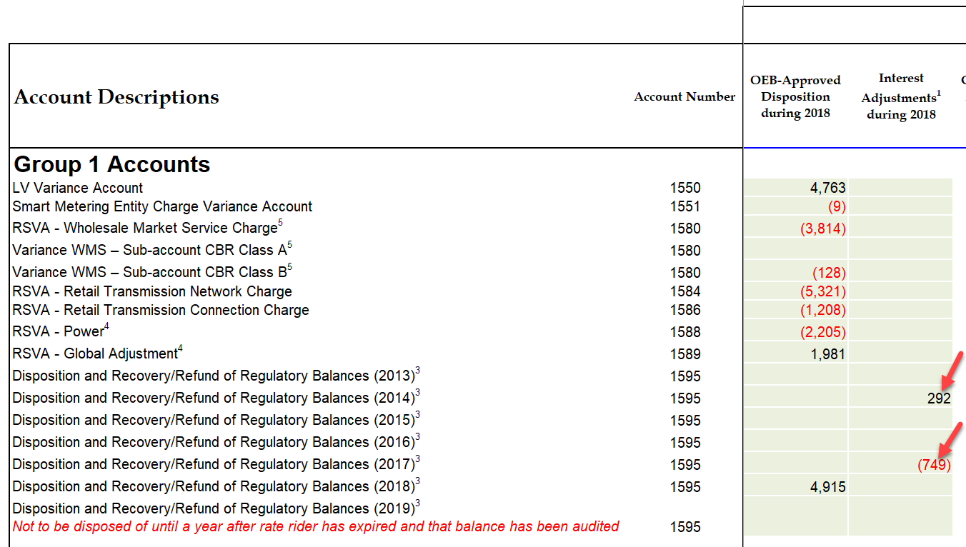

**Staff Question-13**

**Ref: Rate Generator Model, Tab 3 Continuity Schedule, Account 1595 (2017)**

In Tab 3 of the IRM Model, Rideau St. Lawrence selected “yes” with respect to whether Account 1595 (2017) is being requested for disposition.

As stated in Chapter 3 Filing Requirements “Applicants are expected to request disposition of residual balances in Account 1595 Sub-accounts for each vintage year only once, on a final basis. Distributors are expected to seek disposition of the audited account balances a year after a rate rider’s sunset date has expired. No further transactions are expected to flow through the Account 1595 Sub-accounts once the residual balance has been disposed.”

As per the 2020 IRM Webinar Q&A #4, August 7, 2019:

“1595 sub-account residual balances are eligible for disposition when one year has passed since the expiry of the associated rate riders and any balance that remains after that one-year period has been audited. Therefore, if a rate rider ends on December 31, 2018, one year after the expiry of the rider would be December 31, 2019, and the account would be eligible for disposition when December 31, 2019 audited balances are brought forth in a 2021 rate application.”

1. Please confirm that Rideau St. Lawrence agrees not to dispose of its Account 1595 (2017) in this application. If Rideau agrees, please update Tab 3 accordingly. If not, please explain.

**Staff Question-14**

**Ref: Rate Generator Model, Tab 3 – Continuity Schedule**

OEB staff notes that there was a formula error in the IRM Rate Generator Model posted on the OEB’s webpage.

On tab 3 the formula for cell BM41 is =Sum(BM39,BM40) - BM37. The last portion of the formula (i.e. – BM37) is an error.

OEB staff has made the necessary correction to the Rate Generator Model and provided it along with these questions.

Please confirm Rideau St. Lawrence’s acceptance of the revised model.

**Staff Question-15**

**Ref: Rate Generator Model, Tab 19 - Proposed Tariff of Rates and Charges**

As per the Rate Order in EB-2017-0183, OEB staff will update the tariff at the decision and rate order stage of this proceeding for the following changes to Non-Payment of Account Service Charges:

1. Removal of all “Collection of Account” charges
2. Removal of all “Install/Remove Load Control Device” charges
3. Change any reference of “Disconnect/Reconnect” to “Reconnection”
4. Alter the “Late Payment – per month” charge to “Late Payment – per month” (effective annual rate 19.56% per annum or 0.04896% compounded daily rate)

Please confirm Rideau St. Lawrence’s acceptance of the above.

**Staff Question-16**

**Ref: Rate Generator Model, Tab 3 Continuity Schedule, Tab 16 Rev2Cost GDPIPI and Tab 17 Regulatory Charges**

OEB staff has made the following updates to the Rate Generator Model for Rideau St. Lawrence:

1. Tab 3 – Updated RRR data of 1595 (2018) in the amount of $(50,295) in the “2.1.7 column”
2. Tab 16 – Updated Price Escalator 2%
3. Tab 17 – Updated Inflation factor of 2% for the Retail Service Charges and the Wireline Pole Attachment charge

Please confirm Rideau St. Lawrence’s acceptance of the revised model.

Tab 3 – Continuity Schedule

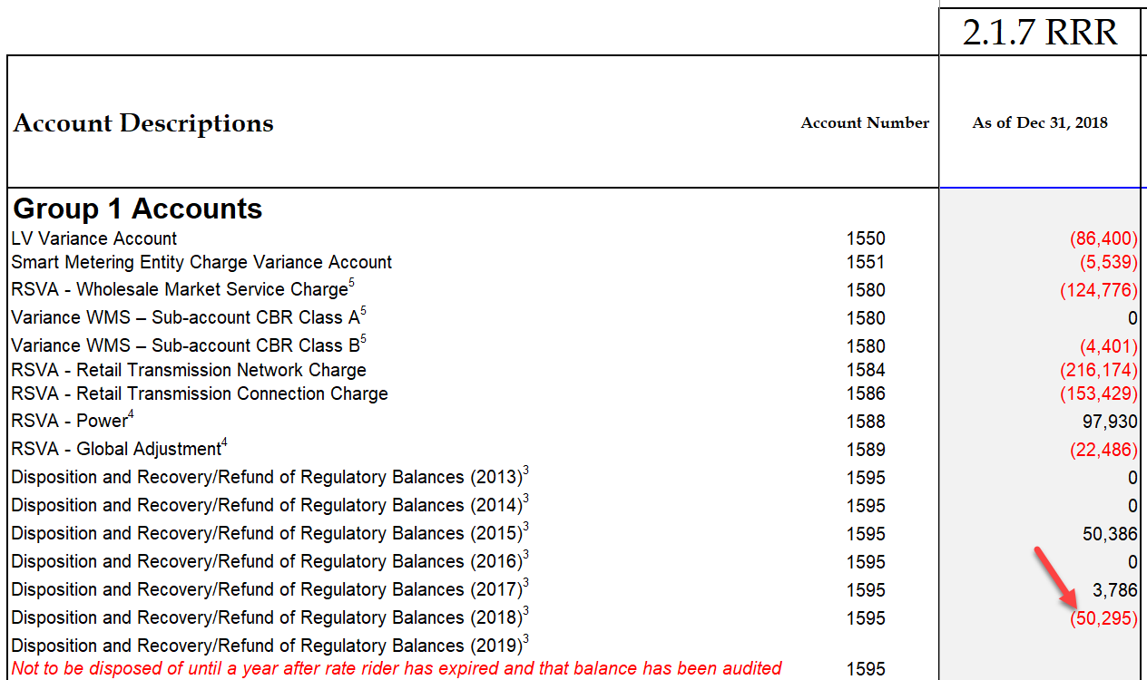

1. EB-2018-0065
2. EB-2017-0265
3. EB-2018-0065