Sioux Lookout Hydro Inc. (Sioux Lookout)
EB-2019-0067
OEB Staff Questions
January 17, 2020

Staff Question-1
Ref: Rate Generator Model Tab 3 Continuity Schedule

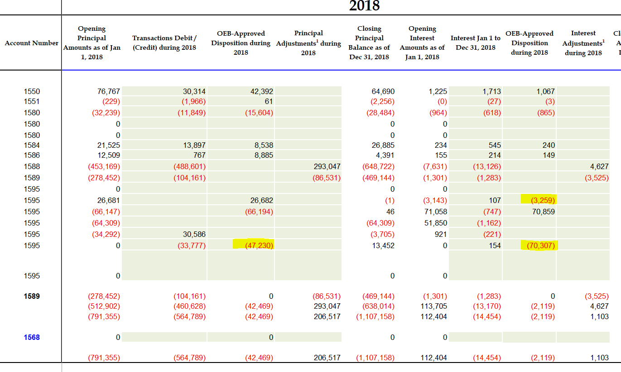
- In the continuity schedule, Sioux Lookout entered a credit of $3,259 as the OEB-approved interest disposition in Account 1595 (2014) in 2018. As shown in the DVA Continuity Schedule model issued with the Draft Rate Order in Sioux Lookout’s 2018 cost of service proceeding, the interest amount approved for disposition in Account 1595 (2014) is a credit of $3,064. Please provide explanation for the above noted discrepancy. Or please make necessary update in the current continuity schedule for the disposition balance.
Response: Staff Question 1(a)
SLHI agrees that the amount entered for Account 1595 (2014) in the OEB-Approved disposition during 2018 should be a credit of $3,064. And amount of $(195) was erroneously included in the “Interest to December 31, 2019 instead of the amount approved for disposition. SLHI has updated the continuity schedule to reflect the correct amounts.

- As shown in the continuity schedule, the total Group 1 principal disposition approved for 2018 is a debit of $4,760. And according to the 2018 DVA Continuity Schedule model, the total Group 2 principal disposition approved for 2018 is a debit of $36,393. Therefore the total Group 1 and Group 2 principal disposition for 2018 should be a debit of $41,153. However, in the current continuity schedule, Sioux Lookout entered a credit of $47,230 in Account 1595 (2018). This amount cannot be reconciled with the total Group 1 and Group 2 principal disposition amount approved for 2018. Please explain what this $47,230 amount is pertaining to.
Response: Staff Question 1(b)
SLHI has included the amount approved for disposition of LRAM Account 1568 of $6,077 in the total( $41,153 + $6,077= 47,230). In addition, the amount was entered as a credit since the formula in the continuity schedule subtracts the amount from the transactions during the year instead of adding to come up with the closing balance at the end of the year. Therefore the amount has to be entered as the opposite sign of the amount approved for disposition. This is consistent with all 1595 accounts.

- Similar to the above question 2 part b), please provide the breakdown information for the credit amount of $70,307 that Sioux Lookout entered in Account 1595 (2018) for the total interest disposition.
Response: Staff Question 1(c)
Similar to the response to 1(b), SLHI included the interest approved for disposition of LRAM Account 1568 of $(47). The amount of $70,354 was approved for Group 1 and 2 accounts. The total entered is a credit of $70,307 (70,354 – 47= 70,307) consistent with the above response.

- Similar to the question 2 part b), please provide the breakdown information for the debit amount of $825,134 that Sioux Lookout entered in Account 1595 (2019) for the total principal disposition.
Response: Staff Question 1(d)
The amount of $825,134 is the amount approved for Group 1 disposition of a principle balance of $(822,940) and the amount approved for the Shared Tax Savings of $(2,194).(822,940 + 2,194= 825,134) As with the above questions, the amount is entered as a debit in order to reflect the correct balance in the closing balances column.

- As shown in the continuity schedule, there are immaterial balances in Accounts 1595 (2014), 1595 (2015) and 1595 (2016). These accounts have been disposed of in previous rate proceedings. In the manager’s summary, Sioux Lookout noted that there are no residual balances from prior years being requested for disposition. Please confirm whether or not Sioux Lookout will write off the immaterial balances in these 1595 accounts.
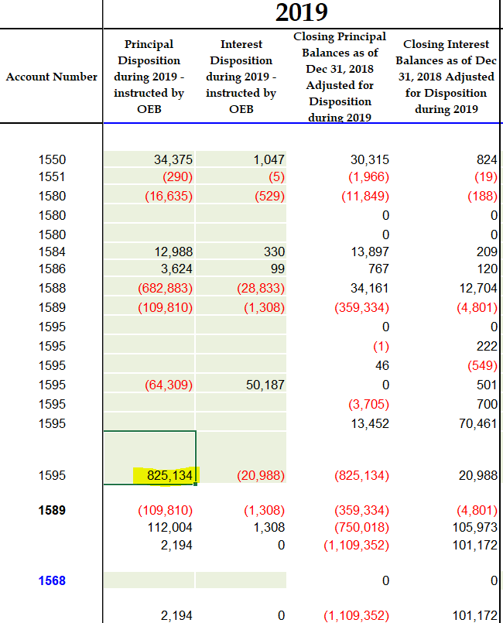
Response: Staff Question 1(e)
SLHI confirms that the immaterial amounts in 1595(2014), 1595(2015) and 1595(2016) will be written off.
Staff Question-2
Ref: Manager’s Summary, pp. 6-9
At the above reference, Sioux Lookout Hydro has provided Tables 4-9 which summarize the adjustments to the balances in Accounts 1588 and 1589 for the period 2016-2018 as a result of implementing the OEB’s February 21, 2019 accounting guidance related those accounts.
- For the adjustments made to Account 1588 in each year, they are characterized as either “Adjustment to Global Adjustments to Implement OEB Accounting Guidance” or “Adjustment to 1142 to Implement OEB Accounting Guidance”.
    - For clarification purposes please confirm that the “Adjustment to Global Adjustments to Implement OEB Accounting Guidance” relates to the fact that previously Sioux Lookout Hydro would split the CT 148 charge between RPP and Non-RPP consumption (accounts 4505 and 4507) based on retail consumption kWh, whereas the OEB accounting guidance requires that calculation to be done based on wholesale consumption amounts.
Response: Staff Question 2(a) i
SLHI confirms that the adjustments are due to changing the methodology from using retail consumption kWh to wholesale consumption kWh.
    - For each of the years 2016-2018, the resulting GA adjustment to account 1589 is a credit to the account (and a debit to 1588). In the context of the methodology that Sioux Lookout previously utilized to split CT 148 between RPP and Non-RPP consumption (or between account 4505 and 4507), please explain why the implementation of the OEB’s accounting guidance results in a credit to Account 1589 in each year (and a debit to 1588).
Response: Staff Question 2(a) ii
The OEB’s accounting guidance uses proportional allocation rather than actual retail kWh. SLHI used actual Non-RPP retail kWh when determining the split (GA rate multiplied by retail Non-RPP kWh) and therefore since these were higher due to the line loss issue, resulted in more allocated to Account 1589 GA. Once SLHI recalculated based on the proportionate split between RPP and Non-RPP wholesale kWH, the proportion of GA Allocated to Non-RPP was smaller.
- For each of the years 2016-2018 the “Adjustment to 1142 to implement OEB Accounting Guidance” resulted in a debit adjustment to Account 1588. In the context of Sioux Lookout Hydro’s monthly 1142 settlement for each of the years and the resulting adjustment from implementing the OEB’s accounting guidance, please confirm that this means that Sioux Lookout Hydro’s 1142 settlement had historically been a credit (i.e. refund from IESO), which was overstated because the calculated amount was based on retail consumption instead of wholesale consumption (with wholesale consumption being consistently lower than retail), therefore resulting in amounts having to be returned to the IESO by Sioux Lookout Hydro upon implementation of the OEB’s guidance.
Response: Staff Question 2(b)
SLHI confirms that the above statements are correct.

Staff Question-3
Ref: EB-2018-0066 Decision and Rate Order, p. 10
The above reference indicates that as a result of difference between Sioux Lookout Hydro’s approved and actual loss factors, it has caused a significant over-collection from customers compared to what has been purchased, resulting in the large credit variance (refund to customers) in Account 1588 as at December 31, 2017, which was expected to continue in 2018 since an updated loss factor was not put in place until May 1, 2019.
- Based on the above, the OEB was expecting to see a credit balance within Account 1588 as at December 31, 2018. Please explain why this is not the case (i.e. the balance in Account 1588 is a debit of $47,881 at December 31, 2018).
Response: Staff Question 3(a)
The balance is a debit due to the adjustments made to 1588 for 2016 and 2017 to implement the OEB Accounting Guidance. SLHI received interim disposition of account 1588 in its 2019 application EB-2018-0066 to December 31, 2017. The adjustments from Table 4 and Table 5 in the current application page 6, which are not included in EB-2018-0066 total $234,022.
2016 – 1588 | Adj not included in EB-2018-0066
Principal | Interest
69,684 | 213
60,973 | -217
2017 – 1588
98,959 | 2620
98 | 1692

The total transactions and adjustments for 2018 total $(204,053). The difference in these two amounts is fairly close to the amount claimed and also a debit amount. If SLHI did not restate the 2016 and 2017 to conform to the new accounting guidance, then the amount claimed would be a credit.

