Wellington North Power Inc.
OEB Staff Questions
EB-2019-0073

Wellington North Power Inc.
EB-2019-0073

Staff Question-1
Ref: Rate Generator Model, Tab 3 – Continuity Schedule
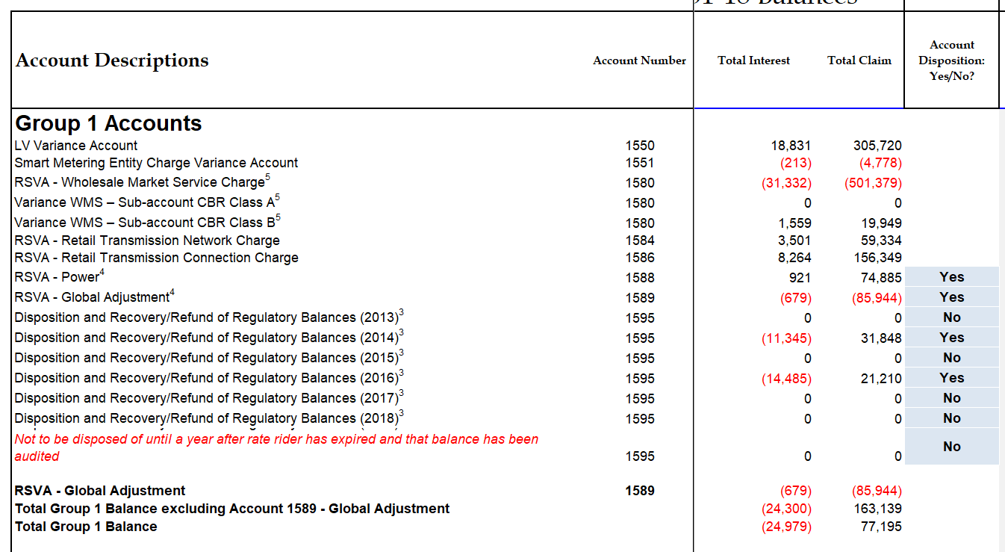

OEB staff have updated Tab 3 – Continuity Schedule to include Accounts 1588, 1589 1595 – 2014 and 1595 – 2016 in the total claim. OEB staff notes this changes the debit claim from $35,196 to a debit claim of $77,195, which still does not exceed the threshold test of +/- .0010 Please confirm these accounts are all eligible for disposition, if not please explain.

Staff Question-2
Ref: 1595 Analysis Workform
Please complete step 2 and 3 on the 1595 Analysis Workform for year 2014.

Staff Question-3
Ref: GA Analysis Workform Instructions
Rate Generator Model, Tab 3 – Continuity Schedule
GA Analysis Workform
The GA Analysis Workform Instructions states that
Input the Net Change in Principal Balance in the GL:

This should equal the GA flow-through transactions recorded in Account 1589 for the year. [N.B.: Please do not include dispositions in this number]

Staff prepares a table below to compare the Net change in Principal balances on the GA analysis workform to the transactions debit/(credit) during the year on the DVA continuity schedule of the IRM rate generator model:

 | 2015 | 2016 | 2017 | 2018
Transaction Debit/(Credit) during the year per the DVA Continuity Schedule | 351,521 | (215,229) | (425,982) | (38,476)
Net Change in Principal Balance in the GL per the GA Analysis Workform | 351,521 | (362,650) | (424,982) | 203,424
Difference | 0 | 147,421 | (1,000) | (241,900)

- Please explain the differences noted in the table above for the years of 2016 to 2018.

Staff Question-4
Ref: GA Analysis Workform
Rate Generator Model, Tab 3 – Continuity Schedule
Staff summarized one reconciling item – Differences in GA Unbilled, on the GA analysis workform as below:
$ | 2015 | 2016 | 2017 | 2018
Differences in GA Unbilled | (221,740) | 58,474 | 405,166 | (241,900)

Staff notes that the cumulative difference in GA unbilled, calculated as the sum of all differences, is nil.
Staff summarized the principal adjustments during the years of 2015 to 2018 on the DVA continuity schedule of the IRM rate generator model as below:
$ | 2015 | 2016 | 2017 | 2018
Principal Adjustments During the year of | (221,740) | 58,474 | 164,266 | 241,900

Staff notes that the sum of the above principal adjustments of 2015 to 2018 as per the continuity schedule is $242,900.
- Please confirm whether or not the reconciling item of Differences in GA unbilled on the GA Analysis Workform is the only item that should be included in the Principal Adjustments on the DVA continuity schedule?
- If a) is confirmed, please explain the differences noted between the above two tables for the years of 2017 and 2018.
- If a) is confirmed, please explain why the sum of the principal adjustments during the years of 2015 to 2018 on the DVA continuity schedule (i.e., the sum of the table 2) is not nil.
- If a) is not confirmed, please explain which reconciling items on the GA analysis workform are included as principal adjustments on the DVA continuity schedule and provide the reasons.

Staff Question-5
Ref: GA Analysis Workform

Staff summarized the reconciling items # 6 and #7 on the GA Analysis Workforms of 2015 to 2018 as below:

# |  | 2015 | 2016 | 2017 | 2018
6 | Differences in GA IESO posted rate and rate charged on IESO invoice | 22,735 | 27,663 | 40,019 | 22,638
7 | Differences in actual system losses and billed TLFs |  |  | 39,319

- Please provide the supporting calculations for the reconciling item #6 for the years of 2015 to 2018.
- Please explain why only 2017 has the reconciling item for the line loss difference?
- Please provide the supporting calculation for the 2017 line loss difference of $39,319.

Staff Question-6
Ref: Rate Generator Model, Tab 3 – Continuity Schedule
Staff summarized the principal adjustments during the year on the DVA continuity schedule of the IRM rate generator as follows:
$ | 2015 | 2016 | 2017 | 2018
Account 1588 Power – Principal Adjustments during the year of | 182,816 | (26,827) | (156,989) | (150,650)
Account 1589 GA - Principal Adjustments during the year of | (221,740) | 58,474 | 164,266 | 241,900

- Please list each principal adjustment in 2015 to 2018 for Account 1588 and explain the nature of these adjustments.
- Please explain why the principal adjustments for Account 1588 is not reciprocal of the principal adjustments for Account 1589?

Staff Question-7
Ref: Application, page 26

Wellington North Power provided the reconciliation for the 2018 reconciliation for Account 1588 as below:

Staff notes that the $72,586 provided on the first row (balance December 31, 2018) represents the closing principal balance plus the closing interest balance as at December 31, 2018. In addition, the principal adjustment of (150,650) in 2018 and prior year principal adjustments were not listed and reconciled in the table.

- Please re-perform the reconciliation for Account 1588 for the years of 2015 to 2018 for the principal balance only (the first row of the table is changed to the principal balance in the GL and the last row in the table is changed to the principal balance on the DVA continuity schedule for the year).

