Hearst Power Distribution Company Limited
OEB Staff Questions
EB-2019-0040

Hearst Power Distribution Company Limited
EB-2019-0040
Staff Question-1
Ref: IRM Model, Tab 1
In Tab 1 of the IRM Model (cell F45), Hearst Power indicated this it is fully embedded within Hydro One Networks’ distribution system. Please confirm whether this is correct or if Hearst Power is only partially embedded within Hydro One Networks’ distribution system as was indicated in Hearst Power’s 2019 rate application.

Staff Question-2
Ref: IRM Model, Tab 6 and Tab 6.1GA
In Tab 6.1GA of the IRM Model, the Non-Metered Consumption for Current Class B Customers in column I shows a negative balance of 3,936,563 kWh for the Intermediate Service Class. Please confirm that this amount is correct by confirming that the kWh in columns E and G (that are pulled from the data input into Tab 6) are the correct total metered consumption amounts.
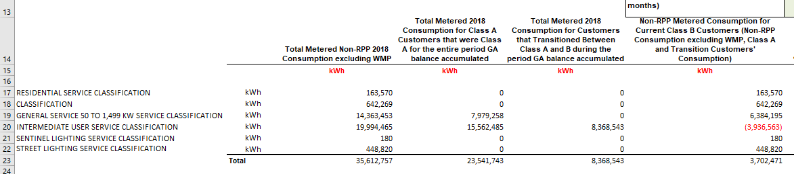

Staff Question-3
Ref: Manager’s Summary, page 12
Hearst Power confirmed that it complies with the new accounting policies and does not report any adjustments. The new accounting guidance was effective January 1, 2019 and to be implemented by August 31, 2019.
- Please confirm that Hearst Power implemented the accounting guidance by August 31, 2019. If not, please explain when the accounting guidance was implemented.
- Please confirm that the accounting guidance was implemented retroactive to January 1, 2019. If not please explain when the retroactive implementation will be completed.

Staff Question-4
Ref: Manager’s Summary, page 12
Hearst Power indicated that it does not report any adjustments as a result of the new accounting policies. Q&A’s for Accounting Guidance on Accounts 1588 and 1589 #28 and 29 set out certain expectations regarding the review of historical balances not disposed on a final basis.
- Please confirm that Hearst Power has reviewed its 2017 balance approved on an interim basis, in the context of the new accounting guidance.
- Please provide further details on the review that was completed, and any summary reports available (e.g. how the review was done).
- Please confirm that there are no systemic issues with the Hearst Power’s RPP settlement and related accounting processes noted during the review.
- If not confirmed, please explain the systemic issues, describe and quantify any adjustments identified and provide an assessment on the materiality of the adjustments.

Staff Question-5
Ref: Manager’s Summary, page 11
Hearst Power is seeking disposition if its 2018 Group 1 accounts. Q&A’s for Accounting Guidance on Accounts 1588 and 1589 #28 discusses the expectation for final disposition requests.
- Please explain whether Hearst Power is seeking interim or final disposition for the 2018 balances.
- Please explain whether Hearst Power is seeking final disposition for its 2017 balances approved on an interim basis in its 2019 rate application.

Staff Question-6
Ref: Manager’s Summary, page 17
It states “Global Adjustment revenue, which is billed directly to the non-RPP customers, is posted directly to account 4707 – Global Adjustment…”. Please explain why GA revenues are posted into an expense account and not revenue accounts as per the Accounting Procedures Handbook.

Staff Question-7
Ref: Manager’s Summary, page 14, 22
- Regarding the second table on page 22, please confirm that this is for the May true-up, included in the July 4th submission. If not, please explain what consumption month the true-up is for.
- The “actual consumption” in the second table for the true-up is the same as the consumption used in the first table for the estimated June consumption. Please explain whether Hearst Power’s process is to use the prior month’s actual consumption (e.g. May) as the current’s month estimated consumption (i.e. June).
  - If not, please explain why the consumption is the same for May and June.
  - If yes, please explain how this reconciles with the settlement description on page 14, where Hearst Power uses a top-down approach starting with monthly wholesale metering data, which would be different than the prior month’s actual consumption.

Staff Question-8
Ref: Manager’s Summary, page 24
Under #4d, it states that the data used to determine the volume of RPP and non-RPP comes from the billing system reports and are actuals. It appears that there is no true-up for the CT 148 split between Accounts 1588 and 1589.
Using the June submission submitted on July 4th as an example, when Hearst Power files its initial submission, Hearst Power does not have the billing data for June yet and will not know the June RPP vs. non-RPP consumption split. Therefore, the GA RPP used in the settlement is an estimated amount and is trued-up in a later month.
- Please explain when Hearst Power receives its IESO and Hydro One invoices for the consumption month of June.
- At the time the invoices are received, please explain whether Hearst Power would have the actual June billing data to determine the RPP and non-RPP consumption split for CT 148.
- If not, please explain what month’s actual RPP and non-RPP billed consumption split is used for the June CT 148.
- If a prior month’s RPP and non-RPP actual billed consumption split is used, please explain why there is no true-up needed.
- If a true-up is needed, please quantify the true-up for the 2018 Account 1588 and Account 1589 balances.

Staff Question-9
Ref: Manager’s Summary, page 24
From Hearst Power’s 2019 rate application, there is a principal adjustment to Account 1588 of ($55,878) in 2017.
- Please confirm that of this adjustment, ($33,083) was due to a correction to July 2017 and September 2017 consumption, and ($22,794) was due to the December 2017 true-up that was recorded in January 2018.
  - If not confirmed, please provide a breakdown of the adjustment.
  - Please confirm that these adjustments were recorded in the 2018 GL. If not, please explain which year each of the adjustments were recorded in.
- In the current DVA Continuity Schedule for 2018 balances, there are no adjustments in the “Principal Adjustments during 2018” column for the reversal. The amount in the “Transactions” column should agree the total amount recorded in the GL for the year, which would include the adjustments recorded in 2018 as referenced in part a above. If the reversal has been included in the “Transactions” column, please separate it into the “Principal Adjustments” column. Otherwise, please explain where the reversal is recorded in the DVA Continuity Schedule.

