**Welland Hydro-Electric System Corp. (Welland Hydro)**

**EB-2019-0072**

**IRM Rate Generator**

## Staff-1

Ref: (1) Tab 20 of IRM Rate Generator (bill impacts)

Preamble:

Tab 20 of the 2020 IRM Rate Generator requires the distributor to show the total bill impact for a residential customer at the distributor’s 10th consumption percentile. This analysis was not provided in the pre-filed evidence.

Questions:

1. Please provide the bill impact scenario for a residential customer at the 10th consumption percentile, and update Tab 20 accordingly.

**Response**

**Welland Hydro has updated Tab 20 to include the bill impact scenario for a residential customer at the 10th percentile. A summary is included in the table below:**



**The bill impact for a Residential 10th percentile customer with 325 kWh monthly consumption is 1.56% or $0.98. The bill impact is well below the 10% threshold and therefore no mitigation is required.**

1. Please provide the analysis to show how the 10th consumption percentile for Welland Hydro’s residential customers was developed.

**Response:**

**In order to determine the kWh consumed at the 10th percentile, Welland Hydro reviewed residential consumption data from the 2018 calendar year. Only data with 12 monthly bills and a minimum of 50 kWh per month were used to determine the 10th percentile point. The data produced a sample size of 18,877 out of 21,399 residential customers. From the data, a 10th percentile consumption point was determined to be 325 kWh per month before loss factor.**

1. Please explain the reason for the change in RTSR rates (by more than 4%) for all customer classes, as requested in the bill impact tables in Tab 20.

**Response:**

**The Uniform Transmission Rates increased by 5.7% for Network Service Rate and 3.4% for combined Line Connection and Transformation Connection. This would account for the majority of the increases in Welland Hydro’s RTSR rates. However, year over year RTSR rates can also be impacted by two additional factors. The first being that Welland Hydro is billed on peak demand (kW) within a month whereas Welland Hydro bills customer classes in both kWh and kW. A month where the peak demand is confined to a short period could have an impact on RTSR rates year over year as a result of differences in kWh consumed by customers. In addition, Welland Hydro has approximately 14 MW of solar generation within its grid which is a material percentage of load in the summer months. This will impact the amount of transmission required to flow through the Hydro One transmission station (amount billed to Welland Hydro). As a result, year over year solar generation can impact RTSR rates. The analysis required to go beyond the mechanistic methodology of setting RTSR rates is outside the scope of an IRM Rate Application.**

## Staff-2

Ref: (1) Tab 6 of the IRM Rate Generator (Class A volumes)

(2) 2018 GA Analysis Workform, October 30, 2019 (cell D17)

Preamble:

In Tab 6 of the 2020 IRM Rate Generator, Class A volumes are 16,347,190 kWh. In the 2018 GA Analysis Workform, Class A volumes of 24,020,461 kWh were pulled from RRR filings as of December 31, 2018 (cell D17).

Questions:

1. Please explain why there are differences in Class A kWh volumes between Tab 6 of the IRM Rate Generator and RRR filings as of December 31, 2018.

**Response:**

**Class A kWh volumes reported in Section 3b of Tab 6 of the IRM Rate Generator represent Class A consumption for the two customers who were Class A for the full year. Consumption for the three Class A transition customers was entered in Section 3a of Tab 6. The sum of July to December kWh (Class A) in Section 3a and the kWh in Section 3b equals the volume of 24,020,461 kWh reported on the 2018 GA Analysis workform.**



**Tab 6.1a of the IRM Rate Generator correctly calculates total Class B consumption as follows:**



1. Based on part a) above, please indicate whether there are changes to the 2020 IRM Rate Generator to reflect the Class A kWh volumes filed in RRR.

**Response:**

**As indicated in part a) above, the Class A kWh reported on Tab 6 and the calculation of total Class B kWh on Tab 6.1a are correct. As a result, there are no changes to the 2020 IRM Rate Generator related to Class A kWh volumes.**

## Staff-3

Ref: (1) Tab 3 of 2020 IRM Rate Generator (balances for 2017 and 2019 rate years)

(2) Tab 3 of 2019 IRM Rate Generator (balances for 2017 rate year)

(3) EB-2016-0110, Settlement Proposal, Table 4-2A (2017 approvals)

(4) EB-2018-0075, Decision and Rate Order, Table 6.2 (2019 approvals)

Preamble:

In the 2020 IRM Rate Generator, the closing balances for the 2017 rate year reconcile with the closing balances in the 2019 IRM Rate Generator.

Upon further review, it appears that the balances for Account 1595 (2013) and Account 1595 (2014) entered in the 2017 rate year of the 2019 IRM Generator do not match Welland Hydro’s approved Settlement Proposal. This suggests that the Account 1595 (2017) balance of $144,002 principal and $44,703 carrying charges in the 2019 IRM Rate Generator and the 2017 closing balances need to be clarified.

2017 Approved Balances

Extract of 2017 approved balances in 2019 IRM Rate Generator:

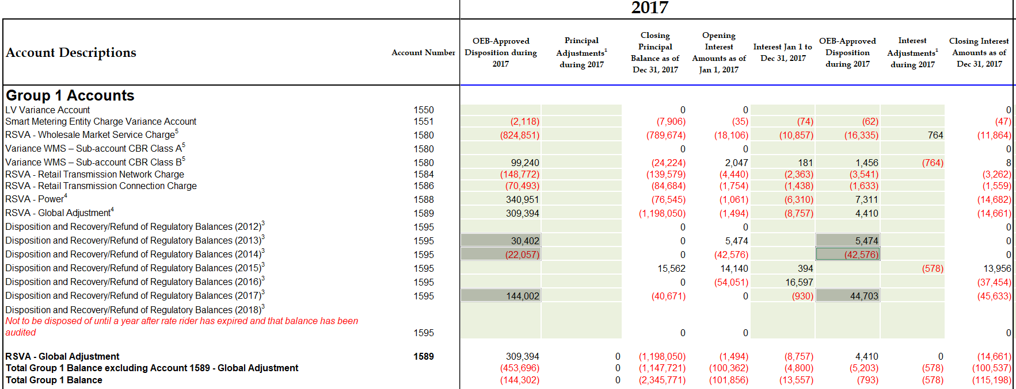

Extract of the Settlement Proposal from 2017 COS proceeding:

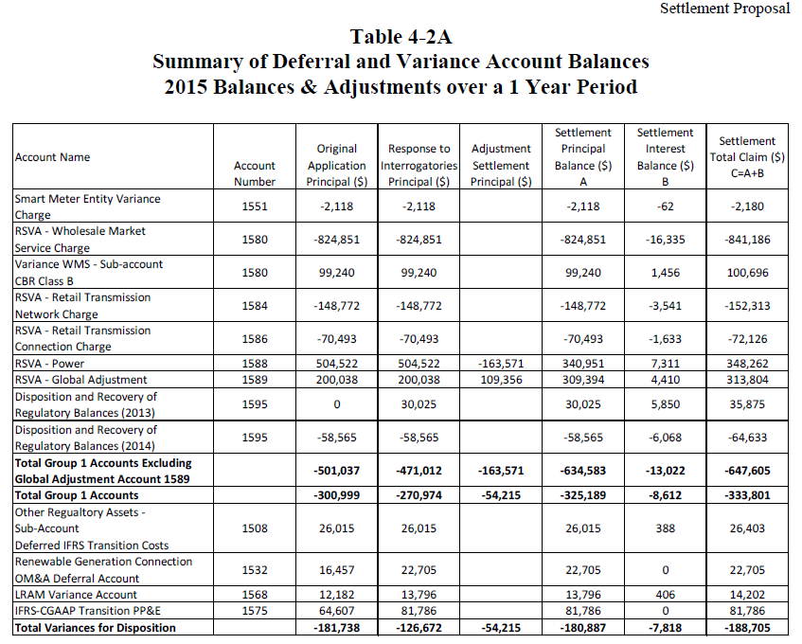

2019 Approved Balances

For the 2019 rate year in the 2020 IRM Rate Generator, the balance in Account 1595 (2019) principal and carrying charges do not match Table 6.2 of Welland Hydro’s 2019 Decision and Rate Order.

Extract of 2019 balances in the 2020 IRM Rate Generator:

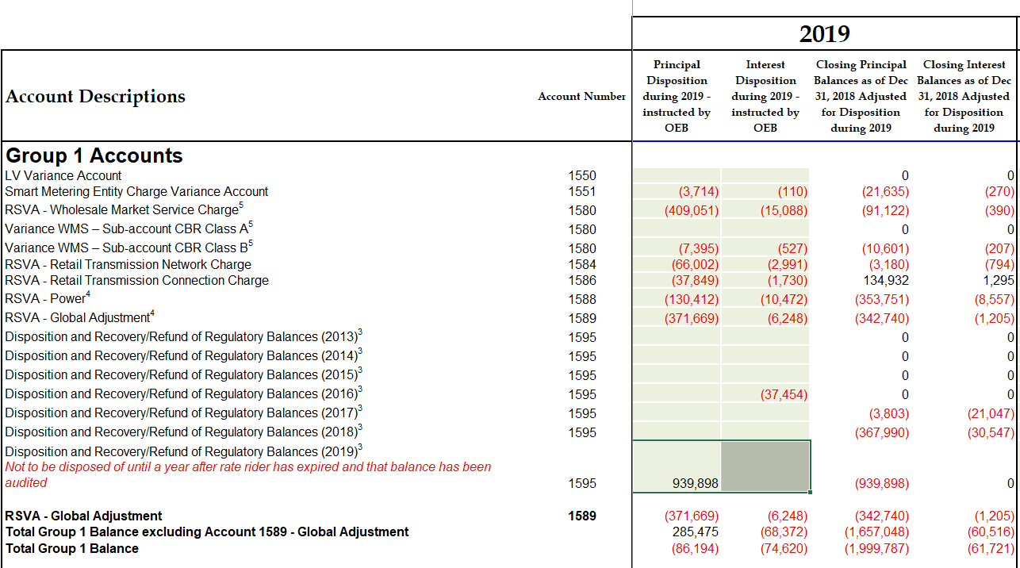

Extract of Table 6.2 of Welland Hydro’s 2019 Decision and Rate Order:

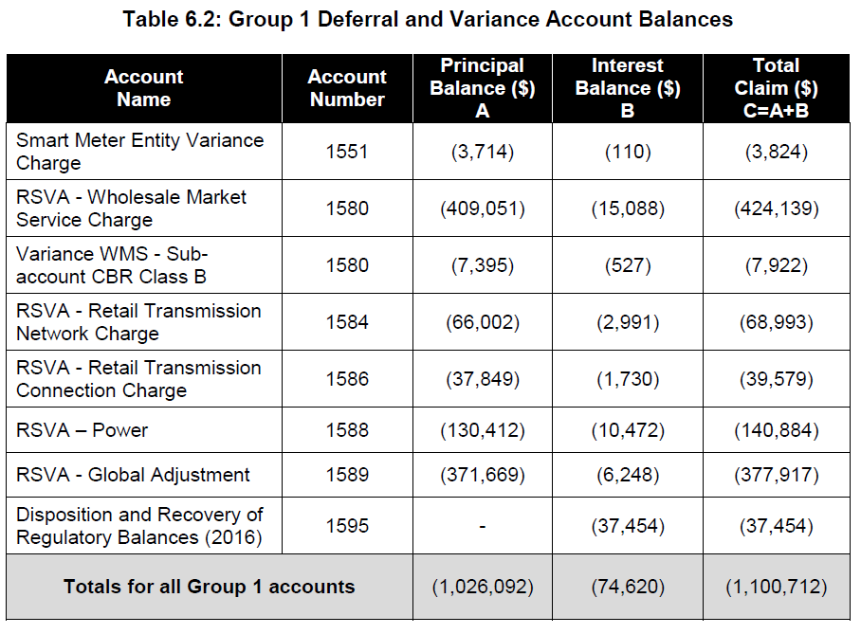

Questions:

1. Please explain why the 2017 principal balances and carrying charges for Account 1595 (2013) and Account 1595 (2014) in the 2019 IRM Rate Generator do not match Table 4-2A of the Settlement Proposal from the 2017 COS proceeding.

* Specifically, the Account 1595 (2013) principal $30,402 and carrying charges $5,474 do not reconcile with the Settlement Proposal
* Also, Account 1595 (2014) principal ($22,057) and carrying charges ($42,576) do not reconcile with the Settlement Proposal

**Response:**

**The total amount approved for disposition in the OEB’s Settlement Proposal EB-2016-0110 for Account 1595 (2013) and Account 1595 (2014) was $35,875 and $(64,633) respectively. Welland Hydro had not separated the principal and interest amounts in EB-2016-0110. As a result of OEB Staff Questions filed November 29, 2017 (EB-2017-0081), Welland Hydro adjusted the principal and interest amounts on Schedule 3 of the IRM Rate Generator. The total amount approved for disposition by the OEB did not change. Welland Hydro now correctly separates principal and interest amounts on the DVA Continuity Schedule.**



1. Please reconcile the 2017 approved amounts in the DVA continuity schedule of $144,002 principal and $44,703 carrying charges to the amounts in the approved Settlement Proposal.

**Response:**

**The total variances in the approved Settlement Proposal are Principal of $(180,887) and Interest of $(7,818) for a total settlement of $(188,705). As explained in the response to (a above, Welland Hydro adjusted the allocation of Account 1595 (2013) and Account 1595 (2014) between principal and interest on the DVA continuity schedule. The differences between principal and interest can be seen in the table below.**



**As a result of the adjustments above, the 2017 approved amounts reported on the DVA continuity schedule were also revised between principal and interest, however, the total amount approved for disposition of $(188,705) remained the same. The reconciliation can be seen in the table below:**



1. Please explain why the balance in Account 1575 of $81,786 was transferred to Account 1595 (2017) in the context of the March 2015 APH FAQ #6.

**Response:**

**The 2017 COS decision contained a separate rate rider for the disposal of account balances in 1575 for premature asset failures from 2014 to 2017. Welland Hydro’s 2017 COS did not contain a rate rider for balances in account 1576 (changes in useful lives and overhead capitalization). Account 1576 was reflected in reduced Distribution Rates in the 2013 COS decision. These impacts were removed from Distribution rates in the 2017 COS decision.**

**Welland Hydro collected a total of $82,492 from customers as a result of the separate rate rider for Account 1575 from the 2017 COS. The over collection in the amount of $706 is included as part of the Account 1595 (2017) balance requested for disposal in the 2020 IRM Rate Application. Welland Hydro’s 2017 COS contained an amount for future premature asset failure expense as a reduction to Other Revenue.**

**Although the accounting may not have reflected the methodology detailed in the March 2015 APH FAQ #6 it has not had any impact on amounts charged to customers.**

1. Please explain why the Account 1595 (2019) principal and carrying charges balance of $939,898 and $0 respectively in the 2020 IRM Rate Generator is inconsistent with Table 6.2 of the 2019 Decision and Rate Order, totaling ($1,026,092) and ($74,620).

**Response:**

**Welland Hydro has revised Tab 3 DVA Continuity Schedule, cells BM37 and BN37 to reflect a Principal disposition of ($1,026,092) and Interest of ($74,620).**

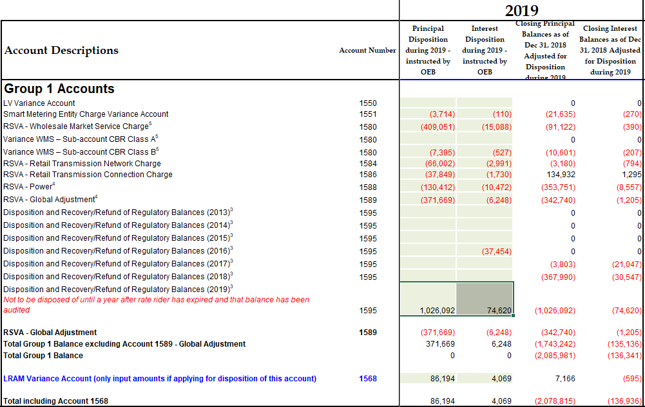

1. Please confirm whether there are any revision(s) to the 2017 closing balances and Account 1595 (2019) principal and carrying charges in the 2020 IRM Rate Generator.

**Response:**

**Welland Hydro has revised the Principal and Interest Disposition on Tab 3 DVA Continuity Schedule to match the approved amounts in the 2019 IRM Rate Application (EB-2018-0075). No revisions have been made to the 2017 closing balances.**

## Staff-4

Ref: (1) 1595 Analysis Workform (2017 vintage year), October 30, 2019

(2) Tab 3 of 2019 IRM Rate Generator

Preamble:

The residual balances in each component of the 1595 (2017) account balances are well below the 10% threshold, but the residual balance on the total approved amount for disposition is 12.4%.

Extract of 1595 (2017) workform below:

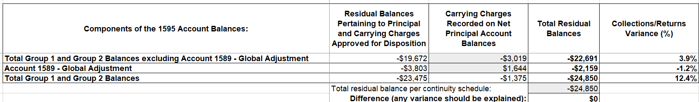

Extract of 1595 (2017) approved balances:

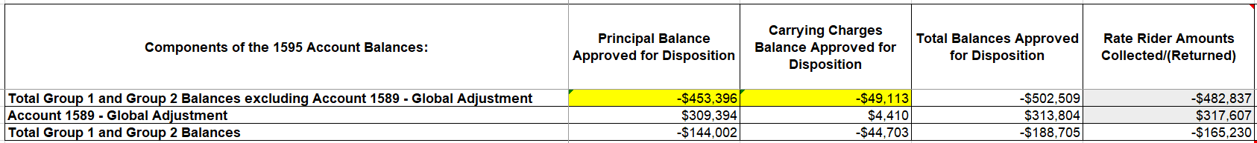

Questions:

1. Based on the above responses to Staff-3, please update the 1595 (2017) Analysis Workform and ensure that the balances reconcile back to Table 4-2A of the Settlement Proposal from the 2017 COS proceeding.

**Response:**

**Based on the response to Staff-3(a), no updates are required to the 1595 (2017) Analysis Workform. The total balance approved for disposition is ($188,705).**

1. Please confirm accuracy of the rate rider amounts collected and/or returned in column G of the 1595 (2017) Analysis Workform in conjunction with the response to Staff-3.

**Response:**

**Welland Hydro has reviewed the rate rider amounts collected and/or returned in Column G of the 1595 (2017) Analysis Workform in conjunction with the response to Staff-3 and confirms that they are accurate.**

1. Please ensure that the residual balance pertaining to principal and projected carrying charges in the 1595 (2017) Analysis Workform reflect the results of Staff-3, including a corrected breakdown between principal and interest.

**Response:**

**Welland Hydro has reviewed and confirms that the residual balance pertaining to principal and projected carrying charges in the 1595 (2017) Analysis Workform reflect the results of Staff-3 and include the correct breakdown between principal and interest.**

1. Please confirm that the cell J16 entry of the 1595 (2017) Analysis Workform reflects the results of Staff-3.

**Response:**

**Welland Hydro confirms that cell J16 of the 1595 (2017) Analysis Workform reflects the results of Staff-3.**

**LRAMVA**

## Staff-5

Ref: (1) Chapter 3 of the Filing Requirements for Electricity Distribution Applications Rate Applications, dated July 12, 2018, p. 17

(2) Manager’s Summary, p. 27

Preamble:

Welland Hydro seeks disposition of a debit LRAMVA balance of $7,408 comprised of 2017 and 2018 balances. However, it appears that the LRAMVA amount is below materiality threshold of 0.5% of distribution revenue requirement (or $50,000 in Welland Hydro’s case). In the Chapter 3 Filing Requirements, it notes that distributors may apply for the disposition of the LRAMVA balance on an annual basis, as part of their IRM rate applications, if the balance is deemed significant by the applicant.

Question:

1. If Welland Hydro agrees that the lost revenue amount is not material, please provide supporting rationale as to why an insignificant LRAMVA balance is proposed to be disposed of through this rate proceeding.

**Response:**

**Welland Hydro agrees that the lost revenue amount is not material and will defer its request for disposition of the LRAMVA balance of $7,408 to a future year. Welland Hydro will monitor its LRAMVA balance on an annual basis and will request disposition of the current $7,408 variance when the cumulative amount becomes material. Tab 3 DVA continuity schedule of the 2020 IRM Rate Generator has been updated to remove the LRAMVA claim from the current rate application.**

## Staff-6

Ref: (1) Table 5-c (Tab 5) of LRAMVA workform

(2) 2019 Participation and Cost Report

(3) 2017 Final Verified Results Report

Preamble:

The 2019 Participation and Cost Report includes unverified adjustments to 2017 programs, but they are not included in Table 5-c (Tab 5 of the LRAMVA workform).

In addition, Table 5-c includes 111,780 kWh of 2017 incremental savings attributable to the Loblaws Program (at cell D460). This specific program, however, does not appear to be identified for Welland Hydro in the 2017 Final Verified Results Report.

Questions:

1. Please confirm that Welland Hydro is not seeking the recovery of 2017 unverified savings adjustments in this LRAMVA application.

**Response:**

**As indicated above, Welland Hydro is deferring disposal of LRAMVA balances in this rate application. Welland Hydro will take into account Staff’s questions concerning the LRAM Application when filing for recovery in a future rate application.**

1. For the 111,780 kWh of 2017 incremental savings, please confirm that the savings are attributed to the Save on Energy – Energy Performance Program, as opposed to the Loblaws Pilot. If there is a typo, please revise the entry in Table 5-c.

**Response:**

**As indicated above, Welland Hydro is deferring disposal of LRAMVA balances in this rate application. Welland Hydro will take into account Staff’s questions concerning the LRAM Application when filing for recovery in a future rate application.**

## Staff-7

Ref: (1) Tab 3 of LRAMVA workform (transformer allowance adjustment)

(2) Tariff of Rates and Charges (2016, 2017 and 2018 Decision and Rate Orders)

Preamble:

For the GS 50-4999 kW class, the 2016, 2017 and 2018 volumetric distribution rates have included a credit adjustment for transformer allowance. The adjustments applied to the distribution rate: -0.13861 (in 2016), -0.114 (in 2017) and -0.114 (in 2018).

Questions:

1. Please explain why the transformer allowance adjustments applicable to the GS 50-4999 kW class differ from the adjustment of -$0.7/kW approved in Welland Hydro’s Tariff of Rates and Charges.

**Response:**

**As indicated above, Welland Hydro is deferring disposal of LRAMVA balances in this rate application. Welland Hydro will take into account Staff’s questions concerning the LRAM Application when filing for recovery in a future rate application.**

1. Please explain in greater detail how the credit adjustments for transformer allowance were calculated for GS 50-4999 kW class in 2016, 2017 and 2018.

**Response:**

**As indicated above, Welland Hydro is deferring disposal of LRAMVA balances in this rate application. Welland Hydro will take into account Staff’s questions concerning the LRAM Application when filing for recovery in a future rate application.**

## Staff-8

1. If Welland Hydro made any changes to the LRAMVA workform as a result of its responses to the above LRAMVA questions, please file an updated LRAMVA workform, the revised LRAMVA balance requested for disposition, and a table summarizing the revised rate riders.

**Response:**

**As indicated above, Welland Hydro is deferring disposal of LRAMVA balances in this rate application. Welland Hydro will take into account Staff’s questions concerning the LRAM Application when filing for recovery in a future rate application.**

1. Please confirm any changes to the LRAMVA workform in response to these LRAMVA questions in “Table A-2. Updates to LRAMVA Disposition (Tab 1-a)”.

**Response:**

**As indicated above, Welland Hydro is deferring disposal of LRAMVA balances in this rate application. Welland Hydro will take into account Staff’s questions concerning the LRAM Application when filing for recovery in a future rate application.**

**Account 1588 and Account 1589**

## Staff-9

Ref: (1) Chapter 3 of the Filing Requirements for Electricity Distribution Applications Rate Applications, dated July 12, 2018, p. 15

Preamble:

At the above-noted reference, it states that distributors must complete the GA Analysis Workform for each applicable fiscal year subsequent to the most recent year in which Accounts 1588 and 1589 were approved for disposition on a final basis by the OEB.

Questions:

1. Although Welland Hydro has provided a GA Analysis Workform for 2018 balances, it also needs to provide a GA Analysis Workform for 2017 balances, including explanations of reconciling items. 2017 balances were approved on an interim basis in Welland Hydro’s 2019 proceeding.[1] The most recent year in which Accounts 1588 and 1589 were approved for disposition on a final basis related to 2016 balances in Welland Hydro’s 2018 proceeding.[2]
2. Please provide a revised 2017 GA Analysis Workform and explain any difference(s) versus the 2017 GA Analysis Workform filed on November 26, 2018, as described in (ii) below.

**Response:**

**Welland Hydro has filed a revised 2017 GA Analysis Workform. As explained in Staff-16, Welland Hydro has revised the “net change in principal balance in the GL” to exclude a reversing 2016 accrual related to unbilled revenue. The revised 2017 GA Analysis workform includes the reversing accrual as reconciling item 2a. No changes to ending balances has been made.**

1. Alternatively, please confirm that the OEB can rely on the 2017 GA Analysis Workform filed on November 26, 2018 in Welland Hydro’s 2019 proceeding.[3] If confirmed, please file this spreadsheet on the record of the current proceeding.

**Response:**

**Please see i) above.**

1. The Deferral and Variance Account (DVA) Continuity Schedule, Tab 3, provided by Welland Hydro needs to be updated to reflect the opening DVA balances in this schedule as the closing December 31, 2016 balances, instead of the closing December 31, 2017 balances. This update needs to be done as the 2017 balances were cleared on an interim basis and will be reviewed in this proceeding. As a result, additional columns in Tab 3 will need to be populated, as well as updates to Tab 1. Please refile the DVA Continuity Schedule accordingly.

**Response:**

**Welland Hydro has revised Tabs 1 and 3 in the 2020 IRM Rate Generator Model to reflect opening DVA balances as the closing December 31, 2016 balances instead of the closing December 31, 2017 balances. The IRM Rate Generator has been re-filed with the responses to these Staff questions.**

## Staff-10

Ref: (1) EB-2017-0081, 2018 Decision and Rate Order, March 22, 2018, pp. 7 & 8

(2) Manager’s Summary, p. 19

(3) Manager’s Summary, p. 20

Preamble:

At the above-noted first reference, the OEB stated the following:

The OEB notes that in its GA Analysis Workform, Welland Hydro indicates adjustments for 2015 and 2016 year end unbilled to actual revenue differences of $533,174 and $162,028 respectively. Moreover, in its GA Analysis Workform, Welland Hydro explains that the cause of the differences is different GA rates to calculate unbilled revenue accruals when compared to the GA rates used for billing purposes. For example, when a utility uses the 1st estimate to bill its customers, then it should use the 1st estimate to accrue unbilled revenue. The OEB notes that although Welland Hydro was able to reconcile the GA account for 2016, the OEB encourages Welland Hydro to consider how to improve its accounting and billing processes to minimize the impacts to account

1589 – RSVA GA going forward.

OEB staff notes that Welland Hydro has provided some information on its unbilled revenue below.

At the above-noted second reference, Welland Hydro stated the following:

Welland Hydro bills its Class B non-RPP customers using the IESO’s 1st estimate for GA for the month. For billing cycles that span more than one month, consumption is prorated by month and the IESO’s 1st Estimate GA rate for each month is applied to the prorated consumption. Welland Hydro records unbilled GA revenue from January to November based on estimated kWh at the GA 1st estimate rate. Unbilled revenue for December is based on actual kWh at the GA 1st estimate rate.

At the above-noted third reference, Welland Hydro stated the following:

Welland Hydro also confirms that the GA rate that is used is applied consistently for all billing and unbilled revenue transactions for non-RPP Class B customers in each customer class.

Questions:

1. Please confirm and explain whether Welland Hydro has considered the OEB’s concerns regarding how to improve its accounting and billing processes to minimize the impacts to Account 1589. Please describe when any such changes to Welland Hydro’s accounting and billing processes were made, including retroactive to which month and year.

**Response:**

**Welland Hydro has considered the OEB’s concerns regarding how to improve its accounting and billing processes to minimize the impacts to Account 1589 and has made improvements to its accounting and billing processes as follows:**

* **December 2017 unbilled GA revenue was based on actual kWh at the GA 1st estimate rate which was an improvement compared to 2016 year-end unbilled which used estimates for both kWh and rate.**

* **Starting in January 2018, Welland Hydro began recording monthly unbilled revenue related to GA based on estimated kWh at the GA 1st estimate rate. As was the case in 2017, December 2018 unbilled GA revenue was based on actual kWh at the GA 1st estimate rate.**
* **Welland Hydro has recently purchased RSVA Manager software from Utilismart. This software will provide more accurate unbilled data for both GA and Power based on actual meter reads and actual rates. As result, the accuracy of monthly variances in both 1588 and 1589 will be significantly improved moving forward. This new software has been implemented beginning with the December 2019 unbilled revenue.**
* **Welland Hydro made changes to its billing system in 2018 to be able to identify consumption and revenue between fiscal years 2018 and 2019 and then implemented these changes on a monthly basis in 2019. As a result, Welland Hydro will have a verification process of the unbilled revenue going forward.**

1. If this is not the case, please explain.

**Response:**

**Welland Hydro has made improvements to its accounting and billing processes as described in (a above.**

## Staff-11

Ref: (1) Manager’s Summary, p. 24

(2) Tab 3 of 2020 IRM Rate Generator (cells BD28, BD29, BF28, BF29)

(3) Reporting and Record Keeping Requirements (RRR) 2.1.7

(4) Addendum to Filing Requirements For Electricity Distribution Rate Applications - 2020 Rate Applications, July 15, 2019, p. 18

Preamble:

At the above-noted first reference, Welland Hydro indicated it is seeking clearance of 2017 and 2018 balances in Account 1588 and Account 1589 on a final basis in this proceeding. Welland Hydro stated the following:

As the same settlement and accounting processes were used in 2017 and 2018 Welland Hydro is requesting final disposition of account balances for both the 2017 (approved on an interim basis in the 2019 IRM, EB-2018-0075) and 2018 years.

OEB staff has prepared the following table based on data provided at the above-noted second and third references. OEB staff notes that the percentage of Account 1588 2018 principal transactions divided by 2018 cost of power is high at -1.5%.

**OEB Staff Table 1 – Analysis of Large 2018 Balance in Account 1588**



At the above-noted fourth reference, the OEB described the following regarding material discrepancies for Account 1589:

Unexplained discrepancies should be calculated separately for each calendar year and any unexplained discrepancy for each year greater than +/- 1% of total annual IESO GA charges will be considered material.

Although the above-noted fourth reference relates to Account 1589, OEB staff has used the same materiality threshold of +/- 1% in analyzing the Account 1588 balance.

Questions:

1. Please confirm whether Welland Hydro is in agreement with OEB staff’s calculations in the above-noted OEB Staff Table 1.

**Response:**

**Welland Hydro confirms that it is in agreement with OEB staff’s calculations in the above-noted OEB Staff Table 1.**

1. If this is not the case, please explain.

**Response:**

**See response to a) above.**

1. Please provide additional analysis to support Welland Hydro’s claim that the Account 1588 2018 balance should be cleared on a final basis in this proceeding, considering the high computed ratio of -1.5% noted in OEB Staff Table 1. A high-level line loss variance analysis may also be helpful to support the claim.

**Response:**

**Welland Hydro’s process improvements in 2017 and 2018 focused primarily on GA (1589). Unbilled Power (1588) Revenue was still largely based on estimates for 2017 and 2018 which could lead to timing differences in variances from year to year as unbilled revenue is a reversing entry. As indicated above, software has been purchased and implemented in December, 2019 to significantly improve the unbilled power revenue and reduce any potential timing difference year over year.**

**Welland Hydro has reviewed its unbilled power revenue accruals for December 2017 and December 2018. December 2017 unbilled power revenue was understated by $423,871 and reversed in January 2018. December 2018 unbilled power revenue was understated by $258,268 and reversed in January 2019. The table below summarizes the impact these unbilled revenue differences had on 2018 balances.**



**Welland Hydro has recalculated the percentage of total cost of power expense based on the net impact of the unbilled revenue adjustments above. The result can be seen in the Table below:**



**Welland Hydro has included a Principal Adjustment – Power 1588 on Tab 3 DVA Continuity Schedule for 2018 (cell BF28) in the amount of -$258,268 to adjust December 2018 unbilled power revenue accrual to actual.**

**Timing issues impact both the previous and current year (opening unbilled) and the current and subsequent year (ending unbilled). As a result, no adjustment is proposed for the timing issue related to the December 2017 actual versus unbilled Power 1588. Therefore, Welland Hydro proposes to deem 2017 variance as final.**

**As indicated above, December 2019 unbilled power revenue will be significantly more accurate than previous unbilled amounts. As a result, timing differences caused by unbilled should no longer be material.**

## Staff-12

Ref: (1) Manager’s Summary, pp. 23 & 24

Preamble:

In summary, Welland Hydro does not have the information required at a level detailed enough to apply the revised accounting model to the 2017 balances, due to changes in its billing system in 2018. Welland Hydro notes that since its detailed review of the 2018 balances proved an immaterial variance between the current and new method, it is confident that there are no significant issues with its RPP settlement and related accounting processes. Welland Hydro has concluded that as the same settlement and accounting processes were used in 2017 and 2018, it is requesting final disposition of both the 2017 and 2018 balances.

At the above-noted reference, Welland Hydro stated the following:

Welland Hydro implemented the new accounting guidance in July 2019, retroactive to January 1, 2019. Welland Hydro uses a modified version of the Excel based Model provided by the OEB in the Accounting Guidance dated February 21, 2019 for all monthly settlements and true-ups with the IESO beginning January 1, 2019, as well as for accounting entries related to Account 1588 and 1589.

Welland Hydro has performed a thorough review of its 2018 balances under the new accounting guidance. Welland Hydro has applied the new model to the entire 2018 year and has concluded that the difference between what was reported under the current process and that of the new model is immaterial. The comparison can be seen in Table 10 below.

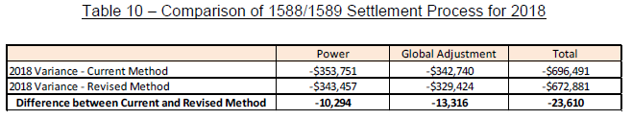

Welland Hydro implemented changes to its billing system in 2018 in order to provide more detailed information on a timelier basis. Welland Hydro does not have the information required at a level detailed enough to apply the revised model to the 2017 year. Welland Hydro used the same settlement processes and procedures for both the 2017 and 2018 years. As a result of the detailed review done for the 2018 year which proved an immaterial variance between the current and new method, Welland Hydro is confident that there are no significant issues with its RPP settlement and related accounting processes. As the same settlement and accounting processes were used in 2017 and 2018 Welland Hydro is requesting final disposition of account balances for both the 2017 (approved on an interim basis in the 2019 IRM (EB-2018-0075)) and 2018 years.

Questions:

1. Please provide further details on the review that was completed, and any summary reports available (e.g. how the review was done).

**Response:**

**Welland Hydro completed a detailed review of its 2018 settlements and true-ups with the IESO. Welland Hydro re-calculated settlements with the IESO for all of 2018 using the updated accounting guidance and model provided by the OEB. The results of the calculations were compared to actual settlements made with the IESO for 2018. A summary of the results can be seen in the table below:**



**The primary difference in GA and Power shown above is a result of Welland Hydro using billed kWh instead of wholesale kWh in IESO settlements in 2018.**

**In 2018 Welland Hydro estimated the impact that the difference between billed (retail) and wholesale kWh had on GA costs related to RPP consumption. The amount of $190,365 was reallocated from GA to Power expense in the 2018 year. Based on the results of the detailed analysis done for 2018, the actual impact is $203,681. This difference in the amount of $13,316 would impact both the GA and Power variances in opposite directions.**

**The following table summarizes the impact of the results above.**



1. Please provide more information to support Welland Hydro’s analysis that was performed on its 2018 balances. Specifically, please provide more information regarding its conclusion that there are no significant issues with its processes, considering the high computed ratio of -1.5% noted in OEB Staff Table 1 regarding the 2018 Account 1588 balance.

**Response:**

**As explained in Staff-11, the high computed ratio is largely related to unbilled revenue accruals. These accruals have an impact on the timing of balances only. As indicated in Staff-11, Welland Hydro has made an adjustment to the DVA Continuity Schedule in 2018 related to December 2018 unbilled revenue. December 2019 unbilled revenues will be more accurate as previously explained.**

**Question 29 of section “Questions Pertaining to Adjustments” of the “Q & A’s for Accounting Guidance on Accounts 1588 and 1589” describes what is considered a material adjustment that would require an adjustment to historical balances. It states that the materiality threshold to be used is 0.5% of annual GA (Account 4707 charges) or annual Cost of Power (Account 4705).**

**Welland Hydro applied the new guidelines to accounts 1588 and 1589 for 2018. As can be seen in the table below, Welland Hydro is below the 0.5% threshold for both GA and Cost of Power and as a result is not proposing any adjustments.**



1. Please explain why the findings of Welland Hydro’s analysis of 2018 balances should be generally “extrapolated” to its 2017 balances, considering the high computed ratio of -1.5% noted in OEB Staff Table 1 regarding the 2018 Account 1588 balance.

**Response:**

**As explained in Staff-11, the high computed ratio is largely related to unbilled power revenue accruals. These accruals only impact the timing of variances year over year. When unbilled power revenue accruals for 2018 are adjusted to actual unbilled power revenue, the revised computed ratio is -0.80%.**

**The analysis of 2018 balances done by Welland Hydro using the updated accounting guidance relates to settlement procedures with the IESO. As seen in a) above, the net impact on settlements with the IESO using the updated accounting guidance compared to the current methodology is immaterial at $23,610. The impact on Power and GA balances in 2018 is also immaterial as can be seen in b) above.**

1. Please explain the nature of the differences in Welland Hydro’s Table 10 of the preamble of this question.

**Response:**

**The differences reported in Table 10 of the preamble to this question represent the results of the analysis explained in a) above. Table 10 has been recreated to show the details of the adjustments.**

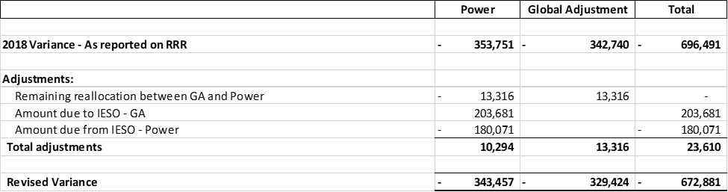

## Staff-13

Ref: (1) Appendix A GA Methodology Description Questions on Accounts 1588 & 1589, pp. 133 & 134 (of PDF p. 156)

Preamble:

At the above-noted reference, “Appendix A GA Methodology Description Questions on Accounts 1588 & 1589”, the table in Question 1 for Account 1588 requests an analysis of the applicant’s 2018 Account 1588 balance. This analysis was not performed by Welland Hydro. The following response was included by Welland Hydro:

Welland Hydro has not made any principal adjustments on the DVA Continuity

Schedule for Account 1588.

Questions:

1. Please complete the table in Question 1 of Appendix A for 2018 balances.

**Response:**

**Welland Hydro has completed the table in Question 1 of Appendix A for 2018 balances and filed the updated response with these Staff questions.**

1. Please confirm that the first line of this table represents the Account 1588 general ledger balance as at December 31, 2018.

**Response:**

**Welland Hydro confirms that the first line of this table ($-484,163) represents the principal (excluding interest) Account 1588 general ledger balance as at December 31, 2018.**

1. Please confirm that last line of this table represents the closing principal Account 1588 balance as at December 31, 2018 in the DVA continuity schedule (cell BG28).

**Response:**

**Welland Hydro confirms that the last line of this table ($-742,431) represents the closing principal (excluding interest) Account 1588 balance as at December 31, 2018 in the DVA continuity schedule (cell BG28).**

1. Please explain any differences between (b) and (c), considering any OEB-approved dispositions that occurred in the year.

**Response:**

**Welland Hydro has included a principal adjustment in the DVA continuity schedule related to 2018 unbilled revenue adjustments. Please refer to the response for Staff-11.**

1. Please also repeat steps (a), (b), (c), and (d) for Account 1588 balances as at December 31, 2017, in a similar table, considering any OEB-approved dispositions that occurred in the year.

**Response:**

1. **Welland Hydro completed a similar table for Account 1588 balances as at December 31, 2017**
2. **Welland Hydro confirms that the first line of this table ($-76,545) represents the principal (excluding interest) Account 1588 general ledger balance as at December 31, 2017.**
3. **Welland Hydro confirms that the last line of this table ($-76,545) represents the closing principal (excluding interest) Account 1588 balance as at December 31, 2017 in the DVA continuity schedule of the 2020 IRM Rate Generator (cell AW28).**
4. **Welland Hydro confirms that there are no differences between (b) and (c).**
5. Please quantify and explain any large amounts shown in these tables relating to either a 2017 or 2018 balance.

**Response:**

**Welland Hydro included a principal adjustment in the 2018 table related to the difference between unbilled power revenue accruals and actual unbilled power revenue. Unbilled power revenue in 2019 will be based on actuals and these large adjustments related to unbilled revenue will not occur in future years.**

## Staff-14

Ref: (1) Accounting-Guidance-on-Accounts-1588-1589-QA-20190711, Q6

(2) Accounting-Guidance-on-Accounts-1588-1589-QA-20190711, Q30

(3) EB-2018-0075, Response to Staff Question-9 (November 26, 2018)

Preamble:

At the above-noted first reference, the OEB stated that distributors should use the best data available for recording unbilled revenues. Whether a distributor records unbilled revenue at year end based on estimates as a journal entry would depend on a utility’s timing and practices. The key is that any estimated revenue is ultimately trued up to actuals.

At the above-noted second reference, the OEB stated that not truing up estimated revenues to actuals and not truing up RPP settlements would fall in the category of systemic issues. The OEB noted that distributors must assess whether these issues have resulted in material errors or discrepancies.

At the above-noted third reference, Welland Hydro confirmed that unbilled GA revenue recorded as of December 31, 2017 is based on actual unbilled consumption rather than estimated unbilled consumption.

Questions:

1. Please describe Welland Hydro’s treatment of unbilled revenue.

**Response:**

**Welland Hydro records unbilled GA revenue based on estimated consumption at the GA 1st estimate rate. For December 2017 and 2018, GA unbilled revenue is based on actual consumption at the GA 1st estimate rate.**

**Welland Hydro recorded unbilled Power revenue in 2017 and 2018 based on estimated consumption and estimated rates. Welland Hydro is proposing to adjust 2018 unbilled to actual in this rate application.**

**Starting with December 2019 unbilled revenue, Welland Hydro will use its new RSVA Manager Software to determine the unbilled GA and Power revenue amounts based on actual meter reads and actual rates.**

1. Please explain whether any amounts related to unbilled revenue need to be included in line 2 of the GA Analysis Workform as a reconciling item, as well as principal adjustments to Account 1588 and Account 1589 in the DVA Continuity schedule.

**Response:**

**Welland Hydro confirms that no amounts related to unbilled revenue need to be included in line 2 of the GA Analysis Workform as a reconciling item. Unbilled GA revenue for December 2017 and December 2018 was based on actual GA revenue. As described in Staff-11, an adjustment related to unbilled power revenue for 2018 has been included as a principal adjustment to Account 1588 in the DVA Continuity Schedule.**

## Staff-15

Ref: (1) Manager’s Summary, p. 19

(2) 2018 GA Analysis Workform, October 30, 2019

(3) EB-2018-0075, Response to Staff Question-10 (November 26, 2018)

(4) EB-2018-0075, 2017 GA Analysis Workform, November 26, 2018

Preamble:

At the above-noted first reference, Welland Hydro stated the following:

In 2018 there was a difference between the average billed loss factor of 1.0476 and the actual loss factor of 1.0384. An adjustment of $107,116 was made to account for the difference between the loss factor used to bill and the actual loss factor to reflect the associated favorable variance.

OEB staff notes that the $107,116 amount has been recorded on line 7 of the 2018 GA Analysis Workform, as per the above-noted second reference.

At the above-noted third reference, Welland Hydro provided supporting calculations for an adjustment of $267,931 shown on the 2017 GA Analysis Workform.

OEB staff notes that the $267,931 amount has been recorded on line 7 of the 2017 GA Analysis Workform, as per the above-noted fourth reference.

Questions:

* 1. Please explain how the average billed loss factor of 1.0476 is calculated.

**Response:**

**Welland Hydro’s loss factor for a Secondary Metered Customer is 1.0476. As most of Welland Hydro’s customers are Secondary Metered Customers, the impact of Primary Metered Customers would be negligible and therefore have been ignored for the purpose of calculating the billed loss factor.**

* 1. Please explain how the actual loss factor of 1.0384 is calculated.

**Response:**

**Welland Hydro reported the following amounts on 2.1.5 of the 2018 RRR Reporting:**

1. **Supply:**
2. **Total kWh of electricity that has flowed into the distributors distribution system from IESO-controlled grid including long-term load transfer supplied, or flowed into the distribution system of a host distributor: 371,676,518 kWh**
3. **Total kWhs of electricity that has flowed into the distributor’s distribution system from all embedded generation facilities: 21,991,558 kWh**
4. **Delivery:**
5. **Total kWh of electricity delivered to all customers in the distributor’s licensed service area to any embedded distributor’s: 379,090,833 kWh**
6. **Total kWhs of electricity delivered on long-term load transfer arrangements: 0 kWh**

**Total Supply ( A(i) + A(ii) ) = 393,668,076 kWh**

**Total Delivery ( B(i) + B(ii) ) = 379,090,833 kWh**

**Actual Loss Factor: Total Supply / Total Delivery**

**(393,668,076 / 379,090,833) = 1.0384**

* 1. Please explain how Welland Hydro calculated the adjustment of $107,116.

**Response:**

**Welland Hydro calculated the loss factor adjustment as follows:**

**Total Class B Non-RPP kWh excluding WMP**

**(not including losses) 127,567,036**

**Total Class B Metered kWh excluding WMP**

**And Class A, including loss at:**

1. **Billed Loss Factor: 127,567,036 x 1.04760 = 133,639,227**
2. **Actual Loss Factor: 127,567,036 x 1.03845 = 132,472,393**

**Difference in kWh = 1,166,834**

**Average 2018 GA Rate = $0.091801**

**GA $ difference due to loss factor adjustment = $107,116**

## Staff-16

Ref: (1) EB-2017-0081, 2016 GA Analysis Workform, February 14, 2018

(2) EB-2018-0075, 2017 GA Analysis Workform, November 26, 2018

(3) EB-2018-0075, Tab 3 of 2019 IRM Rate Generator (cell BF29)

(4) EB-2018-0075, 2019 IRM Welland Hydro_Appendix A_GA Methodology Description_20181015.DOCX, pp. 5 & 6

Preamble:

At the above-noted first reference (2016 GA Analysis Workform), Welland Hydro reported on line 2b current year-end unbilled to actual revenue differences of $162,028. However, this amount was not shown as a reversal (i.e. a credit of $162,028) on line 2a at the above-noted second reference (2017 GA Analysis Workform), or as a principal adjustment on the 2019 IRM Rate Generator Model, at the above-noted third reference.

OEB staff notes that the following explanation was provided at the above-noted fourth reference (pages 5 and 6, respectively) for the true-up amount of $162,028 as follows:

…The second amount was an adjustment of $162,028 which represented a GA true-up for unbilled revenues to actual revenues for the 2016 year…

…The variance related to unbilled revenues was reversed in the GL in the 2017 year. There was no adjustment required for the unbilled GA revenue accrual for 2017.

Question:

1. Please explain why a reversal of the debit balance of $162,028 shown in the 2016 GA Analysis Workform (reconciling item 2b) is not shown in the following:
   1. under reconciling item 2a on the 2017 GA Analysis Workform as a credit balance of $162,028, and

**Response:**

**In the 2017 GA Analysis Workform Welland Hydro included the reversal of the debit balance of $162,028 in the “net change in principal balance in the GL” amount of $(371,670). Welland Hydro has revised the net change in principal balance to exclude this reversal and has included the reversal of the accrual under reconciling item 2a of the 2017 GA Analysis Workform. No changes have been made to ending balances. A revised 2017 GA Analysis Workform has been filed with the responses to these Staff questions.**

* 1. as a 2017 principal adjustment of a credit balance of $162,028 on Tab 3 of the IRM Rate Generator Model

**Response:**

**Welland Hydro included the reversal of the 2016 principal adjustment in cell AT29, “Transactions Debit/(credit) during 2017” of Tab 3 of the 2020 IRM Rate Generator. Welland Hydro has revised cell AT29 to exclude the reversal of the 2016 principal adjustment and has included the reversal in cell AV29, “Principal Adjustments during 2017.” Welland Hydro has not made any changes to ending balances with this revision.**

## Staff-17

Ref: (1) Manager’s Summary, p. 20, Table 9 – IESO Settlement Process

(2) Manager’s Summary, p. 21

(3) Accounting-Guidance-on-Accounts-1588-1589-QA-20190711, Q20

Preamble:

At the table at the above-noted first reference describing its settlement process, Welland Hydro indicates that it “pays the IESO Actual GA.”

At the above-noted second reference, Welland Hydro stated the following:

Welland Hydro pays the IESO Class B GA based on its actual Class B volume at the actual Class B rate. No further settlement with the IESO is required. Any difference between GA revenues and GA costs are recorded in the GA variance account to be recovered from or repaid to Class B non-RPP customers based on consumption…

…Welland Hydro verifies the amount of Class B GA invoiced by the IESO using the kWh calculated above multiplied by the actual GA rate for the month.

At the above-noted third reference, the OEB confirmed that the GA price used for RPP settlements should be the invoiced GA price. However, the OEB noted that the invoiced GA price should generally equal the posted price, except in some circumstances.

Questions:

1. Please confirm that Welland Hydro performs its final RPP settlements based on the invoiced GA price, as opposed to the final posted GA rate.

**Response:**

**Beginning in January 2019 Welland Hydro performs its final RPP settlements based on the invoiced GA price, as opposed to the final posted GA rate. Prior to 2019, Welland Hydro performed its final RPP settlements based on the final posted GA rate.**

1. If this is not the case, please explain.

**Response:**

**Please see Staff-17(a).**

## Staff-18

Ref: (1) Accounting-Guidance-on-Accounts-1588-1589-QA-20190711, Q22

Preamble:

At the above-noted reference, the OEB confirmed that the total volumes used in the RPP settlement process are based on wholesale volumes. The OEB noted that the IESO invoice is based on wholesale volumes, therefore, the RPP settlement is also to be completed based on wholesale volumes. However, the OEB stated that the proportions between the tiers and time-of-use periods are based on retail volumes.

Questions:

1. Please confirm that Welland Hydro has reflected the above-noted OEB requirements in its settlement processes.

**Response:**

**Welland Hydro implemented the above-noted OEB requirements in its settlement processes effective January 1, 2019.**

1. If this is the case, please describe which month and year these OEB requirements were made effective in Welland Hydro’s settlement processes.

**Response:**

**Please see Staff-18 a).**

1. If this is not the case, please explain.

**Response:**

**Please see Staff-18 a).**

1. EB-2018-0075
2. EB-2017-0081
3. EB-2018-0075