**Synergy North Responses to OEB Staff Questions**

**2020 Electricity Distribution Rates Application**

**Synergy North Corporation (****Synergy North)**

**EB-2019-0068**

**January 16, 2020**

**Staff Question - 1**

**Ref: Rate Generator Model, Tab 16 - 19 – GDP-IPI, Regulatory Charges and Final Tariff – Thunder Bay and Kenora Rate Zones**

OEB staff has made the following updates to the Rate Generator Model for the Thunder Bay Rate Zone as well as the Kenora Rate Zone:

1. Tab 16 – Updated Price Escalator 2%
2. Tab 17 – Updated Inflation factor of 2% for the Retail Service Charges and the Wireline Pole Attachment charge
3. Tab 17 – RPP data as of November 1, 2019
4. Tab 3 – Cell BV25 WMS – CBR Sub-Account total $(47,254).

Please confirm Synergy North’s acceptance of the revised models.

**Synergy North Response:**

Synergy North confirms it accepts the revised models for the adjustments as above.

**Staff Question - 2**

**Ref: Rate Generator Model, Tab 3 – Continuity Schedule – Thunder Bay Rate Zone**

OEB staff notes that there was a formula error in the IRM Rate Generator Model posted on the OEB’s webpage.

On tab 3 the formula for cell BM41 is =Sum(BM39,BM40) - BM37. The last portion of the formula (i.e. – BM37) is an error.

OEB staff has made the necessary correction to the Rate Generator Model and provided it along with these questions.

Please confirm Synergy North’s acceptance of the revised model.

**Synergy North Response:**

Synergy North confirms it accepts the Board Staff revised models.

**Staff Question - 3**

**Ref: GA Analysis Workform – GA 2018 – Kenora Rate Zone**

As per Synergy North’s request in section 3.1.3 of the Manger’s Summary, OEB staff updated consumption data in the GA model for the Kenora Rate Zone as follows:



Please confirm the accuracy of the data and update cell C21 on tab GA 2018.

**Synergy North Response:**

Synergy North confirms the accuracy of the data and update cell C21 on Tab GA 2018.

**Staff Question - 4**

**Ref: Rate Generator Model, Tab 4 – Billing Det. for Def-Var – Kenora Rate Zone**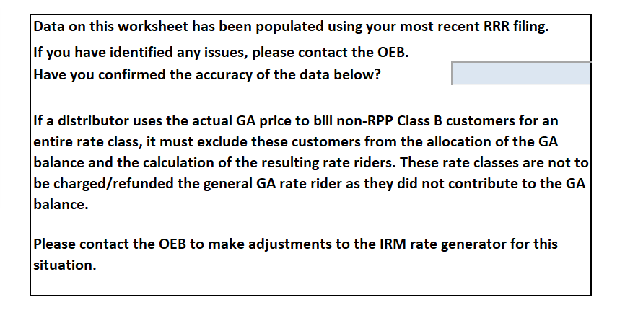

Please state that Synergy North has confirmed the accuracy of the data on Tab 4 – Billing Det. for Def-Var. Once confirmed please update Tab 4.

**Synergy North Response:**

Synergy North confirms it accepts the accuracy of the data on Tab 4 Billing Det. For Def- Var model.

**Staff Question - 5**

**Ref: IRM Rate Generator Model, Tab 3**

The Kenora Rate Zone last disposed 2016 balances. Please revise the DVA Continuity Schedule to start from 2017.

**Synergy North Response:**

Synergy North confirms it has revised the Kenora model to start from 2017.

**Staff Question - 6**

**Ref: Manager’s Summary, page 15**

Synergy North is requesting disposition of its Group 1 accounts for both the Thunder Bay and Kenora Rate Zones. Please explain whether

1. Final disposition is requested for the 2017 balances approved on an interim basis for the Thunder Bay Rate Zone.
2. Interim or final disposition is requested for the 2018 balances for the Thunder Bay Rate Zone.
3. Interim or final disposition is requested for the 2018 balances for the Kenora Rate Zone.

**Synergy North Response:**

1. Synergy North is requesting Final Disposition for the 2017 balances approved on an interim basis for Thunder Bay Rate Zone.
2. Synergy North is requesting Final Disposition for the 2018 Group 1 Account balances (excluding Account 1595) for the Thunder Bay Rate Zone.
3. Synergy North is requesting Final Disposition for the 2018 Group 1 Account balances (excluding Account 1595) for the Kenora Rate Zone.

**Staff Question - 7**

**Ref: Manager’s Summary, page 15**

Per the OEB’s Q&A’s for Accounting Guidance on Accounts 1588 and 1589, dated February 21, 2019, answer #19 states:

Utilities that did not receive approval for disposition of historical account balances due to concerns noted in the decision of their rate application should apply the accounting guidance to those balances as well as the 2018 balance and adjust the balances as necessary, prior to requesting final disposition.

Please explain whether the new accounting guidance was applied to the 2017 and 2018 balance as per the Q&A’s. If not, please explain if and when it will be applied.

**Synergy North Response:**

Synergy North believes that OEB staff intended to refer to #28 section (2) of the Q&A issued July 11th 2019.

Synergy North confirms that the new accounting guidance was applied to the 2017 and 2018 balance as per the Q&As for both Kenora and Thunder Bay Rate Zones.

**Staff Question – 8**

**Ref: Manager’s Summary, pages 19-20**

An internal review was performed for the 2017 and 2018 account 1588 and 1589 balances for the Kenora Rate Zone.

1. Prior to 2017, there was no true-up mechanism in place for the RPP portion of the monthly IESO claim.
   1. Please explain when the true-up mechanism for the RPP portion of the monthly IESO claim was implemented.
   2. Synergy North stated the GA portion of the RPP settlement claim was performed correctly. Please confirm that there were different processes in determining the RPP consumption for the GA portion and the RPP-HOEP portion of the claim. In particular, the consumption related to the GA portion of the claim was based on calendar month but the consumption related to the RPP-HOEP portion of the claim was based on billed consumption for the month.
2. An adjustment for 2017 of $105,089 was identified. Please provide the analysis performed and any summary reports available.
3. It states that the adjustment amount was settled with the IESO and recorded in the GL in 2018. If the adjustment is related to unbilled consumption, please explain why this isn’t just a timing cut-off issue that would be captured in the next RPP settlement. Please explain why an actual adjustment is needed.
4. Please explain why there was no similar adjustment identified for 2018.
5. On page 20, it states that there were no estimations used for claims for either revenue or the cost of that commodity as this information was based on billed data. However, page 20 also states that a review of the new accounting guidance determined that RPP pricing of the RPP settlement claims required a true-up and claim from the IESO for 2017. These two statements appear to contradict. Please explain why the RPP pricing required true up if RPP revenues and HOEP was based on actuals billed.

**Synergy North Response:**

8 a)i. Beginning with the 2017 year, following the OEB’s Accounting Guidance, Kenora Hydro reviewed the process for Account 1588.

The annual process for recording the RPP-HOEP portion of the monthly IESO claim into the correct year end (referred to as a true-up of the annual IESO claims) was implemented beginning with the 2017 year end. Calculations were done and recorded in the general ledger for the 2017 and 2018 years, at the end of 2018.

8 a) ii. The monthly processes used for calculating GA and RPP-HOEP claims with the IESO were the same, claims were both based on the same monthly billed data. The difference in process related to the methods used for the true-ups.

* The GA claim was trued-up monthly, claims submitted to the IESO on a quarterly basis:
  + - A billing query captured calendar month consumption adjusted for monthly unbilled impacts. The difference between the original GA filing kWh based on billed consumption, and the query results for adjusted calendar month consumption, is one component of the GA true-up.
    - The differences between the estimated GA rate used in monthly filings, versus the actual GA charged to LDC for that month, is the other component to the true-up for GA.
    - The resulting calculation of calendar month kWh and actual GA rate, compared to original billed kWh and estimated GA rate used for filing, was claimed/paid quarterly with the IESO.

* The procedure in place for Kenora Hydro’s RPP-HOEP process did not require the same true-up procedure as the GA. The RPP-HOEP procedure required the use of unbilled revenue data and allocating the RPP-HOEP claims into the correct year. This was done from actual kWh and HOEP as provided by the unbilled revenue process.

8 b) Actual RPP - HOEP for the year was determined using the following approach:

* Monthly IESO claims based on actual monthly billed RPP – HOEP.
* Unbilled RPP – HOEP are tracked in the year end unbilled revenue working paper, used to accumulate billings post year end and split the revenue to the correct year based on meter read dates for each billing cycle. Revenue (and HOEP associated) was allocated as a percent by days in the year, so if a cycle had one day of a thirty day read belonging to 2017, the cycle was prorated to have 1/30 of each revenue line moved to 2017.



8 c) The 2017 unbilled revenue adjustment for the RPP-HOEP of $105,089 was not posted in the general ledger to a balance sheet account to recover from the IESO, it erroneously flowed through the income statement and to Account 1588.

The total payable to the IESO for the calendar year 2017 should have been $4,769,579, while actuals paid to the IESO were $4,874,668. There would have been an excess Debit of $105,089 posted to account 1588 in the general ledger, representing the receivable from the IESO. If a correcting entry is not done in the general ledger, the amount would remain embedded in account 1588, and will never be claimed as a receivable from the IESO.

8 d) There is no adjustment specifically noted for 2018 as the required reallocation of claim into the correct year for RPP – HOEP (as a result of the unbilled revenue calculation) was correctly recorded in the Due to/from IESO Balance Sheet account. It was not erroneously posted to Account 1588 as it was in 2017.

8 e) The statement on Page 20 is correct, there were no estimations for the RPP kWh or HOEP performed in the monthly claims to the IESO for RPP-HOEP, as they were filed using actual billed data.

* Actual billed revenue minus actual billed HOEP was claimed each month based on the revenue reports.
* Year end entries to adjust for unbilled impacts on the RPP-HOEP were calculated using actual billing data.

**Staff Question - 9**

**Ref: Manager’s Summary, page 24**

**Ref: GA Analysis Workform, Appendix A**

Regarding RPP settlement true ups

1. There seems to be inconsistencies in what the RPP kWh is trued up to:
   1. Page 24 under “Process for providing consumption estimates to IESO” seems to indicate that Synergy North changed its process for determining RPP-HOEP portion of the RPP settlement claim from being based on billed consumption to that described on page 24 (total kWh sold for the month – Non-RPP kWh for the month).
   2. Page 24 under “Process for providing consumption estimates to IESO” states that the true-up process uses the monthly non-RPP billed consumption with losses, as reported in the GA Analysis Workform.
   3. The GA Analysis Workform, Appendix A #2, indicates that the RPP settlement is trued up to the billed amount of RPP kWh and TOU and tiered pricing amounts, with the corresponding weighted average HOEP.

Please clarify what RPP consumption is being trued up to. If it is not billed RPP kWh for the month plus unbilled RPP kWh for the remainder of the month to derive total calendar month RPP consumption, please explain why calendar month consumption is not used.

1. If there was a process change in determining RPP consumption as per ai above, please explain when this change was implemented.
2. If a ii above is accurate, please explain why non-RPP consumption is used in the RPP settlement true-up.

**Synergy North Response:**

1. Synergy North RPP consumption is being trued up to calendar month RPP consumption. There are no inconsistencies or changes in the 3 references quoted above.
2. Synergy North confirms that there has not been a process change in determining RPP Consumption.
3. Synergy North directs Board Staff to the paragraph on page 24, which is “Describe the True-Up process to reconcile estimates of RPP and Non-RPP consumption, once actuals are known”.

The formula and relationship for the RPP-HOEP true up is summarized as:

Total kWh Purchased Monthly (=) RPP Consumption (+) Non RPP Consumption. RPP consumption is derived from removing the Non-RPP consumption from the total kWh purchased.

**Staff Question - 10**

**Ref: Manager’s Summary, page 25**

**Ref: GA Workform Appendix A**

Regarding the new accounting guidance,

1. Please confirm that Synergy North implemented the new accounting guidance by August 31, 2019.
2. Please confirm that Synergy North implemented the new accounting guidance retroactive to January 1, 2019.
3. It states that Synergy North confirms it has been following the guidance and truing up its settlement claims on a quarterly basis. The new accounting guidance trues up RPP settlements on a monthly basis. Please explain why Synergy North is not performing monthly true ups. Please explain whether Synergy North plans to implement monthly true ups.
4. Distributors are expected to consider the accounting guidance in the context of their historical balances that were approved on an interim basis. A review was done for the Kenora Rate Zone. Please explain whether this review has been completed for the Thunder Bay Rate Zone for the 2017 balance approved on an interim basis and the 2018 balance requested for disposition in this application.
   1. If yes, please discuss the results of the review.
   2. If no, please explain when the review will be completed.
   3. If the review has been completed, please indicate whether there were systemic issues related to the Thunder Bay Rate Zone’s RPP settlement and related accounting processes.
   4. Please also discuss and quantify any adjustments required.
5. In the GA Analysis Workform Appendix A #1, Synergy North used approach B for all years where variances are proposed for disposition. Please confirm that Synergy North now uses approach A, in accordance with the new accounting guidance. If not, please explain why Synergy North does not use approach A and explain whether Synergy North plans to revise its approach to A.

**Synergy North Response:**

1. Synergy North confirms it has implemented the new accounting guidance by August 31, 2019.
2. Synergy North confirms it has implemented the new accounting guidance retroactive to January 1, 2019.
3. Synergy North, in its process, trues up IESO settlement claims on a monthly basis to actuals. To clarify, Synergy North does not make the true-up settlement request with the IESO until its quarterly financial data has been reviewed and approved. True-Up Analysis is done on a monthly basis in the supporting schedule documentation, claims are submitted to the IESO quarterly.
4. Yes, Synergy North has reviewed both Kenora and Thunder Bay Rate Zones. Additionally, Kenora Rate Zone has agreed to do so in its 2019 IRM EB-2018-0046. The review has been completed and there were no systemic issues related to Thunder Bay Rate Zone’s RPP settlement and related accounting processes. Therefore no adjustments were required to the Thunder Bay Rate Zone.
5. Synergy North confirms that as a result of its review process, no adjustments are required to adopt approach (A). Synergy North confirms that it is using approach (A) in the board’s 1588 & 1589 accounting guidance related to Commodity Pass Through Accounts Journal Entry #6 and Tables 15 & 19.

**Staff Question - 11**

**Ref: Manager’s Summary, page 20**

It states that there were no changes to the GA claim process required for Kenora on merger with Synergy North. The processes are the same for both utilities.

1. Please explain whether the RPP-HOEP portion of the settlement claim for both Rate Zones are the same.
2. Please explain
3. An adjustment was needed for unbilled revenues for the Kenora Rate Zone. Please discuss whether the same issue applied to the Thunder Bay Rate Zone. If not, please discuss Thunder Bay Rate Zone’s RPP settlement process and how it differed from Kenora Rate Zone’s processes.

**Synergy North Response:**

1. Synergy North maintains separate Rate Zones for its Kenora and Thunder Bay districts. Synergy North is also invoiced and settles separately for both Rate Zones. This will be maintained until the time of rebasing. Therefore the RPP-HOEP portions of the settlement claim are specific to the Rate Zone it is directly related to. The calculations for settlement claims are the same for both zones.
2. Synergy North uses the same process for settlement claims for both zones, however has not combined the GA Claim process for Kenora and Thunder Bay zones, and maintains two filings which are Rate Zone specific.
3. Synergy North did not require any adjustment to unbilled revenues for Thunder Bay Rate Zone. Prior to merging with Thunder Bay Hydro, Kenora Hydro had discovered and corrected a posting issue with the unbilled revenue in 2017, which impacted Account 1588. The correction to the unbilled posting for RPP-HOEP occurred in Kenora Hydro, pre-merger, and was a one-time correction from the 2017 year end.

**Staff Question - 12**

**Ref: Ref: GA Analysis Workform – GA 2018 – Thunder Bay Rate Zone**

**Ref: IRM Rate Generator, Tab 3, DVA Continuity Schedule**

Regarding the GA Analysis Workform for the Thunder Bay Rate Zone,

1. The calculated loss factor on Thunder Bay’s GA Analysis Workform is 1.1851. The approved loss factor for secondary metered customer from Synergy North’s 2019 rate application is 1.0394. There is a difference of 0.1457. Please explain the difference and revise the GA Analysis Workform as needed.
2. There is a reconciling item 9 for “not all customers are on calendar month billing”.
   1. Please explain what this reconciling item is for. In particular, please explain whether this is the same as the reconciling item for unbilled revenues.
   2. If yes, please explain why this would be a reconciling item as the consumption numbers in the Analysis of Expected GA Amount table should be based on calendar month consumption as explained in section 3.2.5.3.1 of the Manager’s Summary.
3. The GA Analysis Workform shows reconciling items that would be principal adjustments. There are no corresponding principal adjustments in the DVA Continuity Schedule for the 2018 principal. Please explain why not and revise the DVA Continuity Schedule as needed.

**Synergy North Response:**

|  |  |  |  |
| --- | --- | --- | --- |
|  | **2018 kWh** | **Loss Factor** | **Difference** |
| Non RPP Class B Without Losses (in the RRR filing) | 253,489,298 |  |  |
| Non RPP Class B With Losses from GA Workform | 300,402,205 |  |  |
| Calculated Loss (GA Workform to RRR filing) | 46,912,907 | 1.1851 |  |
| Approved Loss Factor (Secondary) |  | 1.0394 | 0.1457 |



Synergy North notes that the loss factor difference is due to having two methodologies for preparing and reporting the “2018 RRR Year End Statistics” and reporting the “Non -RPP Class B GA” used for Global Adjustment analysis and settlement.

Whereas stated above in question #9 and as per OEB 1588/1589 Guidance Synergy North uses actual monthly consumption data for its GA Analysis Work form settlement. The Non-RPP report extracts from the system kwh consumed for Non-RPP classified customers throughout the year.

During Synergy North’s analysis for Board Staff question #12 Synergy North has performed a data review of its RRR Year End system report and has discovered two anomalies that have occurred in the 2018 report that we would like to address.

These two corrections will reallocate kWh between RPP and Non-RPP reported and correct the loss factor calculation to a reasonable figure.

1. Class A Transition Customer adjustment: Cnsumption data in the amount of 1,681,344 kWh and 2,064 kW for customer #1 was categorized at year end incorrectly as “Class B – Non RPP” in the system report. Synergy North has updated Tab 6. Class A Consumption Data from:

As Filed:

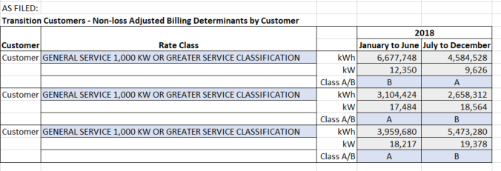

Revised in Red:

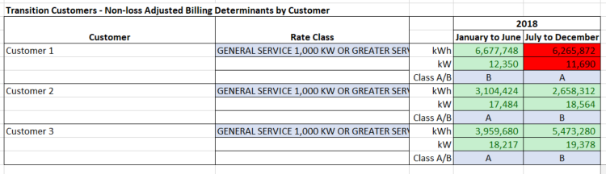

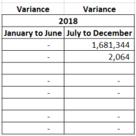

The impact of this movement is very minimal and a reallocation of GA disposition of ($2,497) from Class A customers to Class B Non-RPP customers.

1. Customers Movement from RPP to Non RPP Adjustment:

Throughout the year customers will move on and off RPP pricing.

During Synergy North’s data review, it was discovered that the methodology used for RRR year end reporting had captured customer records from retailer billing as SS in the amount of 38,541,747 kWh. Although Total Metered kWh remains the same, the distribution of Metered kWh for Non-RPP customers was reported too low at year end because the consumption for those customers that opted out of Non-RPP pricing were categorized as RPP for customer pricing status.

This discovery will require an RRR revision to its year end record to reallocate the kWh between RPP and Non-RPP customer pricing categories.

Synergy North asks that Board Staff update it IRM Rate Generator Tab “4. Billing Det. For Def-Var” column “E”

As Filed in Green:

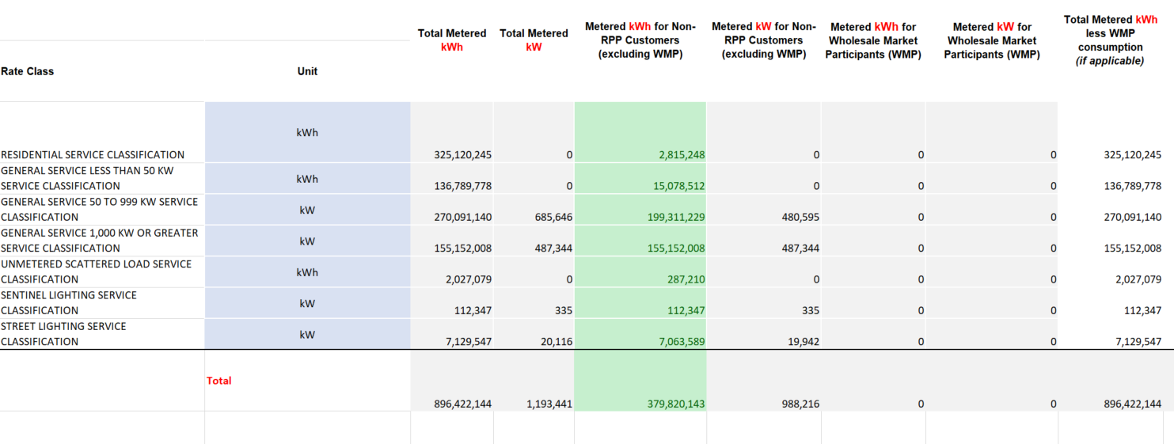

Revised in Red:

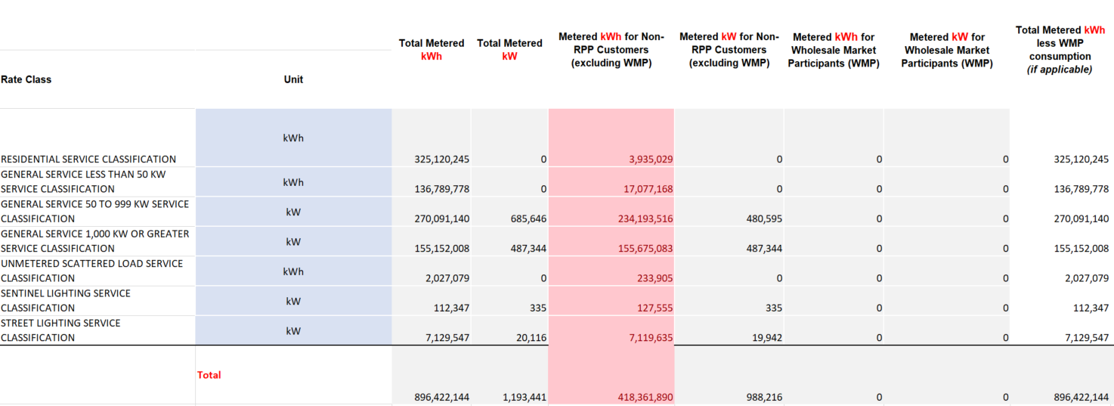

The impact of this variance is very minimal and the increase in Non-RPP consumption results in a rate change of the Class B GA rate rider from (0.0013)/kwh to (0.0011)/kwh and increase of 0.0002/kwh.

Synergy North is unable to update the GA Analysis Work form and also requests that Board Staff update the figures in the GA Analysis Work form Tab “GA 2018” :

As Filed in Green:

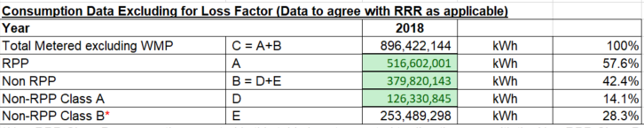

Revised in Red:

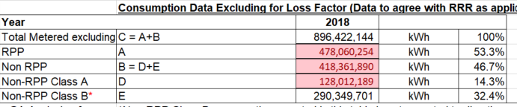

Following the correction to the RRR Year End Data it is now observed that the proper allocation of the Class A and Non RPP consumption results in a reasonable loss factor of 1.034.

The RRR year end reporting adjustments do not impact the Global Adjustment Settlement Process.

* 1. i) Synergy North’s billing system does not split the consumption for billing between overlapping months. Therefore, those customers which do not have monthly billing cycles are billed on a weighted average GA pricing which is calculated in the system using the monthly GA. Synergy North, (and other utilities) billing system does not have the capability to split the GA pricing and apply it to the daily consumption. Synergy North’s billing cycles are too large to move all customers to calendar billing.

ii)These are reconciling items because the model attempts to apply the actual monthly consumption directly to the monthly GA rate on a calendar month basis. As explained above, the system is incapable of billing customers who’s bills overlap a month end.

* 1. Both reconciling items are not considered to be principle adjustments. Synergy North, inadvertently selected “Yes” in column “I” of the GA Analysis work form and has adjusted this to “No”. Synergy North’s explanation is these are regular activities which are accounted for in the regular process and have been identified as reconciling items by performing an analysis of activities in the system. No outside adjustments are booked or necessary for these items in the DVA Continuity Schedule.

**Staff Question - 13**

**Ref: GA Analysis Workform, Appendix A**

1. Synergy North has not completed the GA Analysis Workform, Appendix A table - reconciliation for Account 1588. Please complete this reconciliation for Thunder Bay for 2018, Kenora for 2017 and 2018. When completing the table, please revise the first line “Balance December 31, 201X” to “Net change in principal balance in 201X”.
2. The GA Analysis Workform, Appendix A #2b indicates that the true-up of CT 148 includes a quantity true-up to the actual billed Non-RPP Class B consumption data. Please explain why the consumption true-up is not the actual consumption for non-RPP consumption in the month, which would be comprised of billed and unbilled non-RPP consumption. Please quantify adjustments to the account balances and DVA Continuity Schedule as necessary.

**Synergy North Response:**

1. Please see the tables below for the reconciliation of Account 1588 Principle Change.

Thunder Bay Rate Zone:

|  |  |  |
| --- | --- | --- |
| **Reconciliation of Account 1588 - 2018** |  |  |
|  |  |  |
|  | **Principal Adjustments** | **Was the amount a "Principal Adjustment" in the previous year? (Y/N)** |
| Net change in principal balance in 2018 | 0 |  |
| **Reversals of Principal Adjustments - previous year** | | |
| 1. Reversal of Cost of Power accrual from previous year | 0 |  |
| 1. Reversal of CT 1142 true-up from the previous year | 0 |  |
| 1. Unbilled to billed adjustment for previous year | 0 |  |
| 1. Reversal of RPP vs. Non-RPP allocation | 0 |  |
| **Sub-Total Reversals from previous year (A):** | 0 |  |
|  |  |  |
| **Principal Adjustments - current year** | | |
| 1. Cost of power accrual for 2018 vs Actual per IESO bill | 0 |  |
| 1. True-up of CT 1142 for 2018 consumption recorded in 2019 GL | 0 |  |
| 1. Unbilled accrued vs. billed for 2018 consumption | 0 |  |
| 1. True-up of RPP vs. Non-RPP allocation of CT 148 based on actual 2018 consumption | 0 |  |
| 1. Other | 0 |  |
| **Sub-Total Principal Adjustments for 2018 consumption (B)** | 0 |  |
| **Total Principal Adjustments shown for 2018 (A + B)** | 0 |  |
| **Bal. For Disposition - 1588 (should match Total Claim column on DVA Continuity Schedule** | 0 |  |
|  |  |  |

Synergy North Thunder Bay Rate Zone has not made any principal adjustments in 2018.

Kenora Rate Zone:

|  |  |  |
| --- | --- | --- |
| **Reconciliation of Account 1588 - 2017** |  |  |
|  |  |  |
|  | **Principal Adjustments** | **Was the amount a "Principal Adjustment" in the previous year? (Y/N)** |
| Net change in principal balance in 2017 **Balance December 31, 2017** | (34,676) |  |
| **Reversals of Principal Adjustments - previous year** | | |
| 1. Reversal of Cost of Power accrual from previous year |  |  |
| 1. Reversal of CT 1142 true-up from the previous year |  |  |
| 1. Unbilled to billed adjustment for previous year |  |  |
| 1. Reversal of RPP vs. Non-RPP allocation |  |  |
| **Sub-Total Reversals from previous year (A):** |  |  |
|  |  |  |
| **Principal Adjustments - current year** | | |
| 1. Cost of power accrual for 2017 vs Actual per IESO bill |  |  |
| 1. True-up of CT 1142 for 2017 consumption recorded in 2018 GL |  |  |
| 1. Unbilled accrued vs. billed for 2017 consumption |  |  |
| 1. True-up of RPP vs. Non-RPP allocation of CT 148 based on actual 2017 consumption |  |  |
| 1. Other = Correcting of posting between GA and Power | (34,676) |  |
| **Sub-Total Principal Adjustments for 2017 consumption (B)** |  |  |
| **Total Principal Adjustments shown for 2018 (A + B)** |  |  |
| **Bal. For Disposition - 1588 (should match Total Claim column on DVA Continuity Schedule** | (34,676) |  |
|  |  |  |

Kenora Rate Zone:

|  |  |  |
| --- | --- | --- |
| **Reconciliation of Account 1588 - 2018** |  |  |
|  |  |  |
|  | **Principal Adjustments** | **Was the amount a "Principal Adjustment" in the previous year? (Y/N)** |
| Net change in principal balance in 2018 | (105,089) |  |
| **Reversals of Principal Adjustments - previous year** | | |
| 1. Reversal of Cost of Power accrual from previous year |  |  |
| 1. Reversal of CT 1142 true-up from the previous year |  |  |
| 1. Unbilled to billed adjustment for previous year |  |  |
| 1. Reversal of RPP vs. Non-RPP allocation |  |  |
| **Sub-Total Reversals from previous year (A):** |  |  |
|  |  |  |
| **Principal Adjustments - current year** | | |
| 1. Cost of power accrual for 2018 vs Actual per IESO bill |  |  |
| 1. True-up of CT 1142 for 2018 consumption recorded in 2019 GL |  |  |
| 1. Unbilled accrued vs. billed for 2018 consumption |  |  |
| 1. True-up of RPP vs. Non-RPP allocation of CT 148 based on actual 2018 consumption |  |  |
| 1. Other | (105,089) |  |
| **Sub-Total Principal Adjustments for 2018 consumption (B)** |  |  |
| **Total Principal Adjustments shown for 2018 (A + B)** | (105,089) |  |
| **Bal. For Disposition - 1588 (should match Total Claim column on DVA Continuity Schedule** | (105,089) |  |
|  |  |  |

1. Synergy North performs its true up to the actual monthly consumption for non-RPP (as later stated in the reference). This includes unbilled. No adjustment calculation is necessary.

**Staff Question - 14**

**Ref: GA Analysis Workform – GA 2017 +2018 – Kenora Rate Zone**

Regarding the GA Analysis Workform for the Kenora Rate Zone:

1. In the 2017 GA Analysis Workform for the Kenora Rate Zone, the RRR data is indicated to be incorrect. Please provide the corrected RRR data and calculate the loss factor. Please compare the loss factor to the approved loss factor for secondary metered customer < 5,000 kW and explain the variance, if significant.
2. In 2017, there is a reconciling item #9 of $34,676 to correct a posting error. Please provide further details on this posting error.

**Synergy North Response:**

14 a) Pre-populated data in original model:



*Correct data, from 2019 IRM*:



|  |  |  |  |  |
| --- | --- | --- | --- | --- |
|  | **2017 kWh** | **Loss Factor** | **Difference** |  |
| Non RPP Class B (RRR) | 37,133,821 |  |  |  |
| Non RPP Class B With Losses from GA Workform | 38,519,217 |  |  |  |
| Calculated Loss Factor | 1,385,396 | 1.0373 |  |  |
| Approved Loss Factor |  | 1.0430 | 0.0057 | Less than 1% |

The difference in loss factor is not material.

14 b) The error was noted during preparation of the last IRM for Kenora Hydro Corporation, the 2019 IRM model prepared in 2018. There was an unexplained difference in the GA Analysis Workform and on review of the detailed general ledger activity, the error was noted.

The original error was made when accumulating the monthly revenues from the general ledger for use in the monthly variance account posting. One of the revenue lines for GA was accidentally included as an amount for Power revenue instead of GA revenue. This meant that the GA and Power RSVA accounts were both incorrect at that month end by that amount. This error in posting was noted by the auditors and I corrected in the RSVA accounts at that time. When completing the 2019 Rate application GA working papers, there was an unexplained variance in the working paper for 2017. It was noted that the reversal was impacting the final GA balance expected in the Model. The mechanism to calculate the required RSVA monthly general ledger adjustment reverses the entire balance to date and takes the cumulative revenues and expenses ‘fresh’ each month. This ”error” noted by the auditor should not have been corrected in the general ledger in 2017. The routine process of posting cumulative differences between revenue and expenses each month means that this error would have already corrected itself when posting the RSVA accounts in the next month. The cumulative GA revenue and cumulative Power revenue were both correctly picked up and included in the corresponding variance calculations in the next month.