Chapleau Public Utilities Corporation (Chapleau Public Utilities)
EB-2019-0026
OEB Staff Questions
February 4, 2020

Staff Question-1
Ref: Continuity Schedule
- In the continuity schedule, the 2019 principal and interest disposition amounts that Chapleau Public Utilities entered in control Account 1580 do not match the amounts in the final DVA Continuity Schedule filed with the 2019 settlement proposal (EB-2018-0087). Please review and make necessary updates to the current continuity schedule. Otherwise, please provide explanation for the discrepancies.
CPUC Response:
At the time of the Draft Rate Order, CPUC found an error in the mechanics of the DVA model. This issue was brought up during the process, but it was too late and the balance too immaterial to warrant a change to the model since the decision had already been issued.
The error was in the calculation of the Rate Riders at Tab 7 where the 1580 Sub-Account CBR Class B is being removed from the control account which already includes the effects of the sub account. The model essentially removes the balance twice.
While populating the IRM model, Chapleau opted to use it’s actual balances instead of the incorrect balance created in Tab 7 of the 2019 Board Approved DVA model. Hence the slight difference between the settlement agreement and inputs in the IRM model.
.
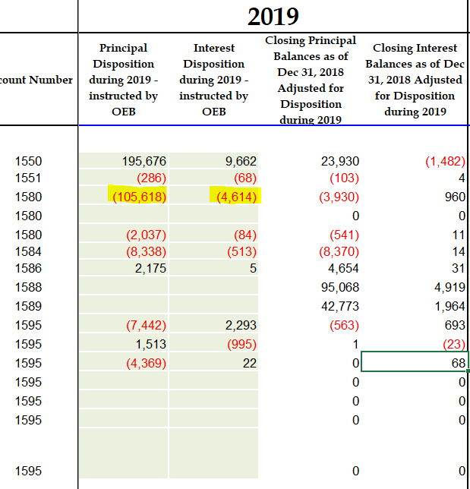
- As shown in the continuity schedule, there are immaterial balances in Accounts 1595 (2013), 1595 (2014) and 1595 (2015) at the end of 2018. These accounts have been disposed of in the previous rate application. Please confirm whether or not Chapleau Public Utilities will write off the immaterial balances in the three 1595 accounts.
CPUC Response: CPUC confirms that it will write off the immaterial balances and the 3 1595 accounts.

Staff Question-2
Ref: Rate Generator Model - RTSRs
On Tab 12 RTSR Historical of the IRM model, Chapleau Public Utilities entered the wholesale monthly billing information for Network charge and Line Connection charge sections in the IESO table and Hydro One table.
- With respect to the Connection charge, please confirm that Chapleau Public Utilities is charged by IESO and Hydro One only for the Line Connection. (i.e. There’s no Transformation Connection charge paid to IESO or Hydro One.)
CPUC Response: CPUC confirms that above statement to be accurate.
- As shown in the screenshot below, based on the “Units Billed” and “Amount” billing information entered, the Hydro One – Network rates and Hydro One – Line Connection rates (for 9 months) are highlighted in red in the model. This means these rates do not match Hydro One sub-transmission rates approved for the time period (2018). Please check the billing data entered to ensure accuracy. If the data has been entered correctly, please provide explanation for the discrepancies in rates.
CPUC Response: CPUC confirms that the data entered is accurate and that it consistently charged throughout the year $3.19420 for Network and $0.77100 for Line Connection. The issue is rounding in the model.

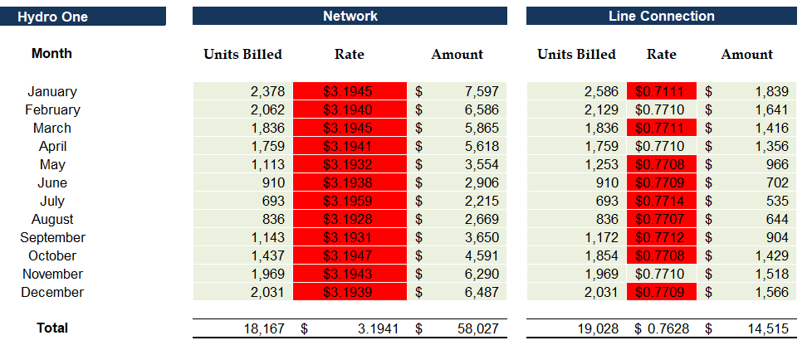
CPUC Response:

Staff Question-3
Ref: Residential Rate Design, Rate Generator Model Tab 16
As stated in the settlement proposal of Chapleau Public Utilities’ 2019 cost of service application (EB-2018-0087), the utility was approved for five-year transition to fully fixed residential rate.
- Based on the above information, please review the information that Chapleau Public Utilities entered in Tab 12 of the IRM model (see the first screenshot below). Other than the # of Customers cell, OEB staff notes that information entered in the other three green cells are incorrect. Thus, OEB staff made corrections to the answers to the three questions (effective year, billed kWh and OEB-approved # of transition years) based on the settlement proposal (see the second screenshot). Please review and confirm if Chapleau Public Utilities agrees with the corrections made. If not, please provide explanation.
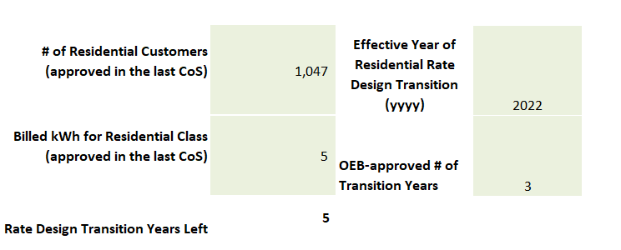

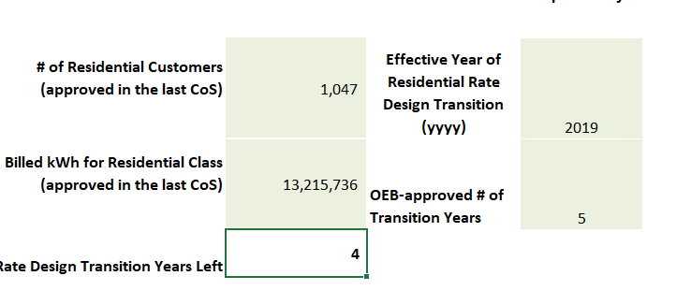
CPUC Response: Chapleau Hydro agrees with Board Staff’s corrections.

Staff Question-4
Ref: Revenue to Cost Ratio Adjustment Model
- Tab 7 of the Revenue to Cost Ratio (R/C Ratio) Adjustment Model is to allocate the revenue offsets to each rate class. Chapleau Public Utilities has not entered the total miscellaneous revenue amount in cell F47 of Tab 7. As a result, the allocated revenue offset amounts are not captured in the calculations of this model. Please enter the total miscellaneous revenue amount in cell F47 and update later tabs of the R/C Ratio Model and Tab 16 of the IRM Model (MFC and DVR adjustments for the three classes).
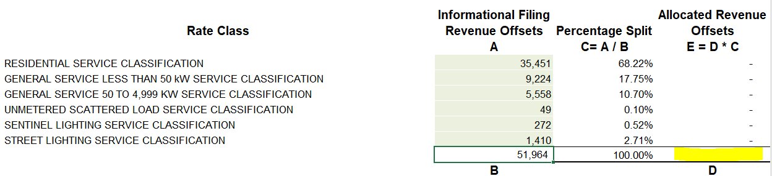
CPUC Response: Chapleau Hydro has updated both models accordingly. Both are being filed along with these responses.

