Regulated Price Plan Roadmap Pilot Program Final Impact Evaluation
  - Appendix I: Participant Engagement Tools and Strategy
2020-04-21

  - Prepared for:

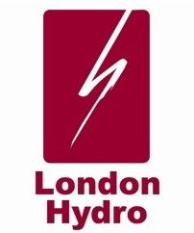

  - Prepared by:

Peter Steele-Mosey, Associate Director

Navigant Consulting, Ltd.
First Canadian Place
100 King St. W. Suite 4950
P.O. Box 64
Toronto, ON, M5X 1B1
416.777.2440
navigant.com

iNTRODUCTION
This appendix has been prepared to provide the reader with additional detail regarding: the mobile application (the “app”) available to participants during the pilot, London Hydro’s customer engagement activities, CPP participant disconnection issues, and CPP event over-rides. The contents of this appendix have been developed in part by London Hydro.

This appendix is divided into three more sections:
- “Trickl” App Functionality
- Education and Customer Engagement
- Disconnection Issues
- CPP Event Overrides

“Trickl” App Functionality
Trickl’s functionality is based on a role-based design. The screens a user can see and interact with are dependent on the role(s) assigned to the customer’s account. Roles are typically assigned based on the availability of data and hardware of an account.

The key elements of the app are outlined in the sections below:
- Real Time Dashboard
- Device Control
- Goal Reporting
- CPP Event Flow and Report
- Notification Preferences and Support
- Daily dashboard

Real Time Dashboard
Availability: RT-only and CPP/RT participants.
Features: Sub-minute data based on current in-home demand and LH calculated insights inclusive of real time energy costs.
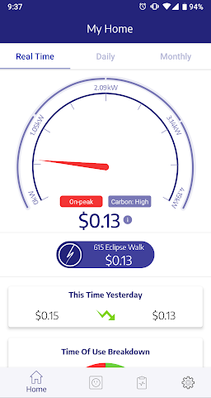

Device Control
Availability: CPP and CPP/RT participants.
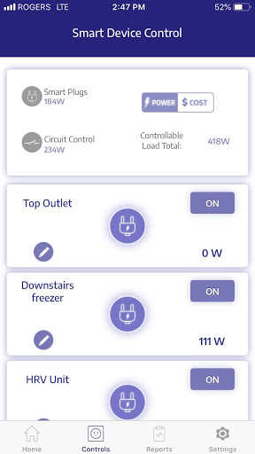
Features: Device renaming, toggling (on/off) and real-time device power reading and associated energy costs.

Goal Reporting
Availability: All users
Features: LH calculates a personalized daily goal for each user based on their own historical patterns. Users can benchmark their actual performance against their goal.
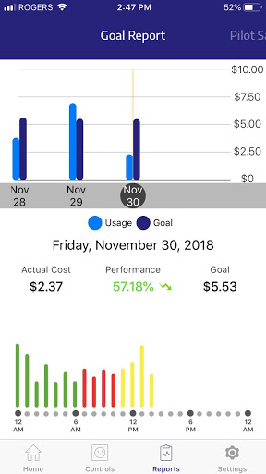

CPP Event Flow and Report
Availability: CPP and CPP/RT participants
Features: 15 min prior to a CPP event, user will receive an app, SMS and/or email notification based on their preference informing them of an upcoming event. The app will display yellow event countdown banner during this time. User has the option to override automated device shutdown by selecting the Override” option in app

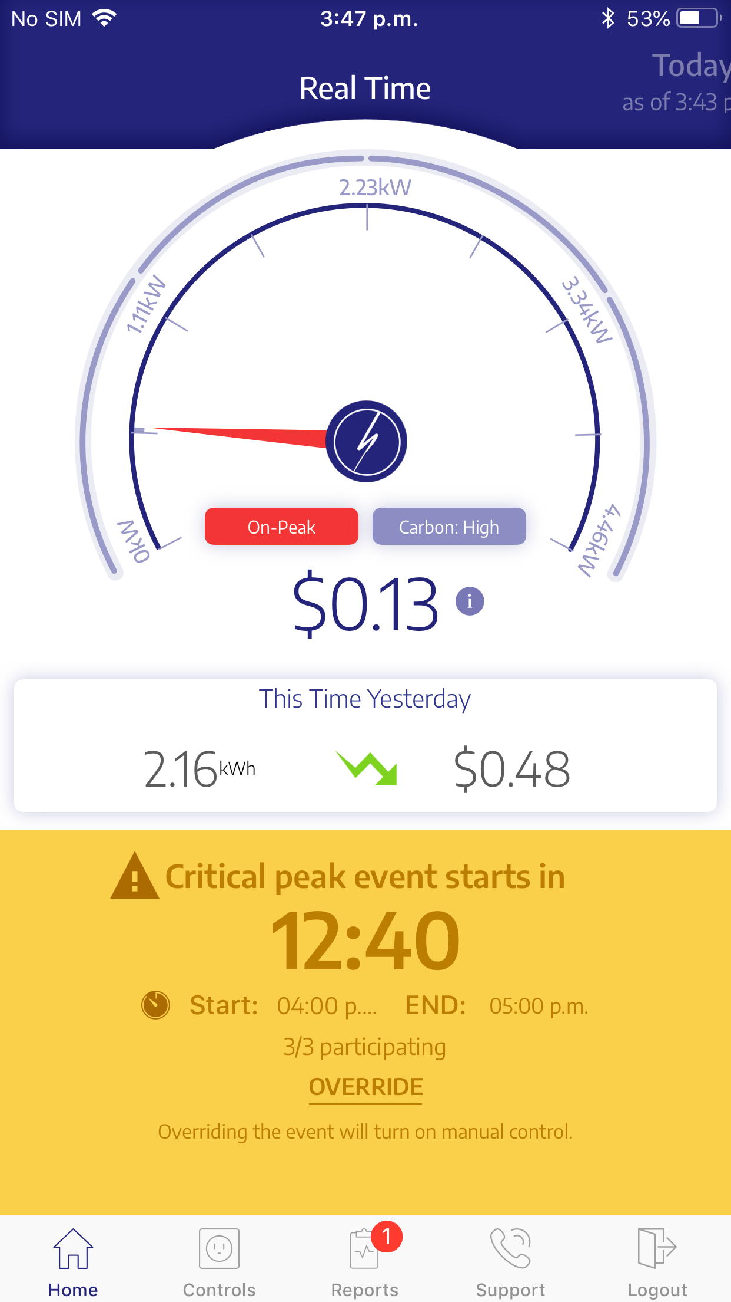

During the event, the yellow banner becomes red and a countdown counts down to the end of the event. Those who have not overridden still have the option to do so.
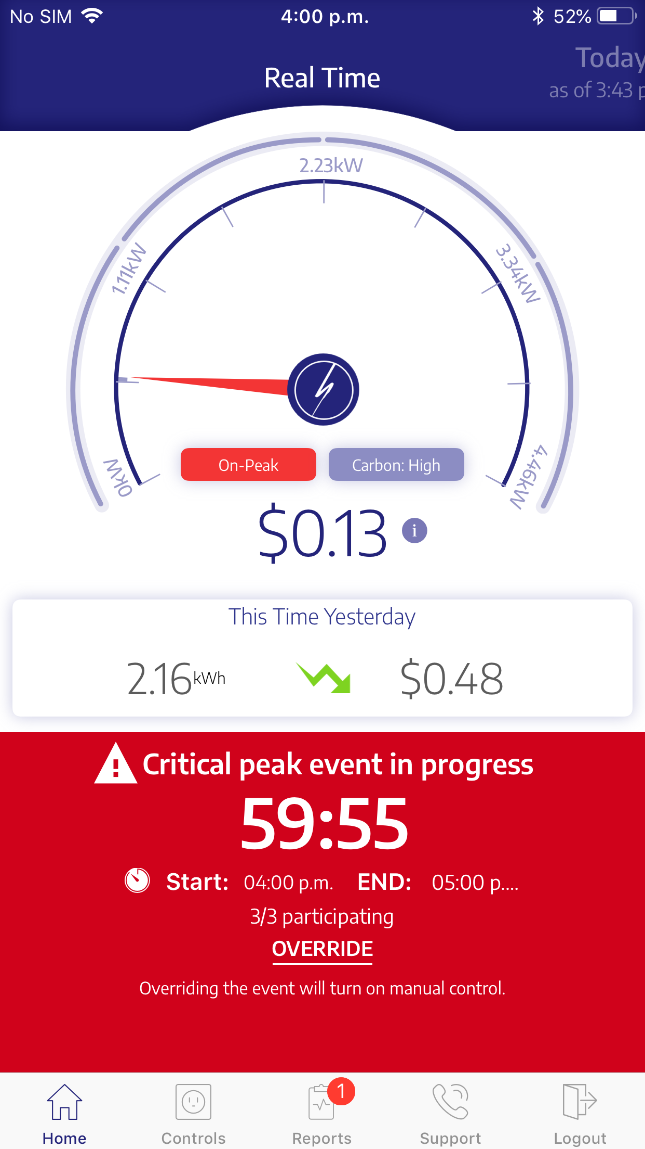

Once the event is completed, power is restored and user is directed to the critical peak event report

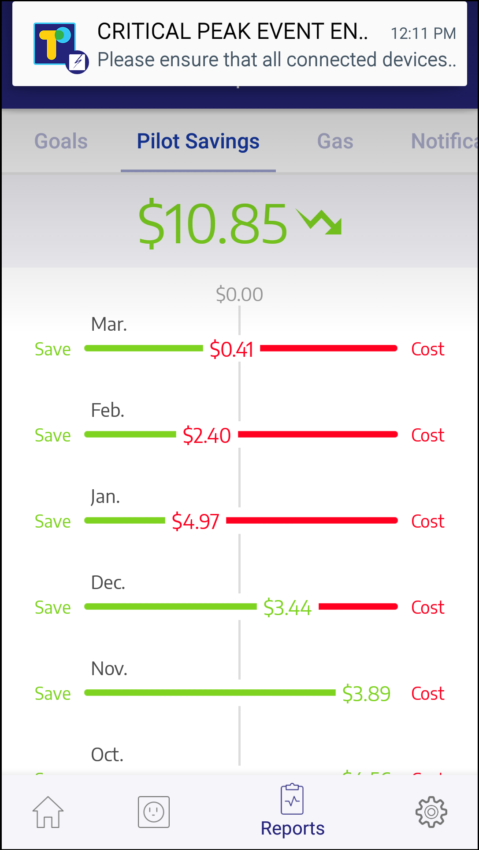

Notification Preferences and Support
Availability: All users
Features: Users can engage app support via app form or phone call. Users can also configure their notification preferences based on notification type and channel
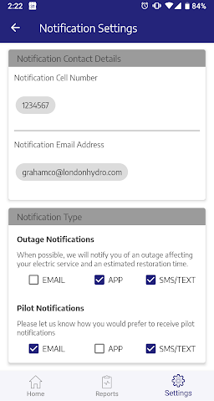

Daily dashboard
Availability: All users
Features: Hourly historical data as a bar chart and LH calculated insights
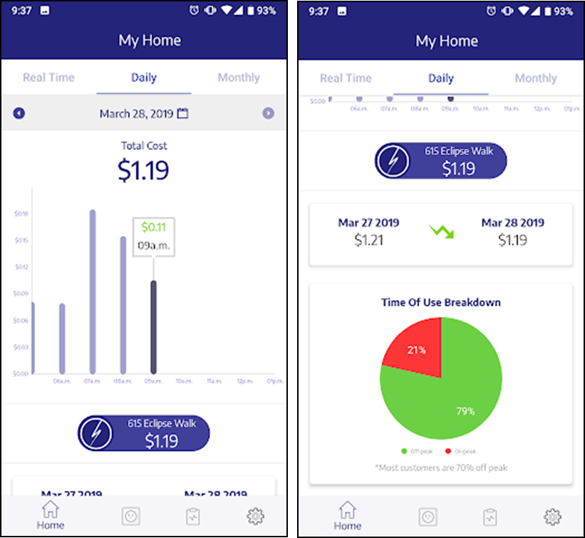

Education and Customer Engagement
London Hydro believes that the positive customer engagement experienced during both the initial registration process and sustained through actions during the pilot period were primarily a result of the customer engagement / community outreach programs used. This section will describe some of those programs employed, when they were used and some of the results realized.
This section is divided into three sub-sections:
- Pre-Pilot Customer Engagement: Marketing Strategies
- On-Boarding Customer Engagement
- Ongoing Pilot Customer Engagement

Pre-Pilot Customer Engagement: Marketing Strategies
The target for pilot participation was 1,600 participants broken down as follows:
- 1,000 participants for the Real Time (RT) pilot
- 300 for the Critical Peak Price (CPP) pilot
- 300 for the combined CPP + RT

The Marketing campaign was initiated in July 2017. Between July 2017 and May 2018 (Pilot go-live), 4,250 people expressed interest in participating, and 2,991 people registered on the Pilot website:

Website Registration
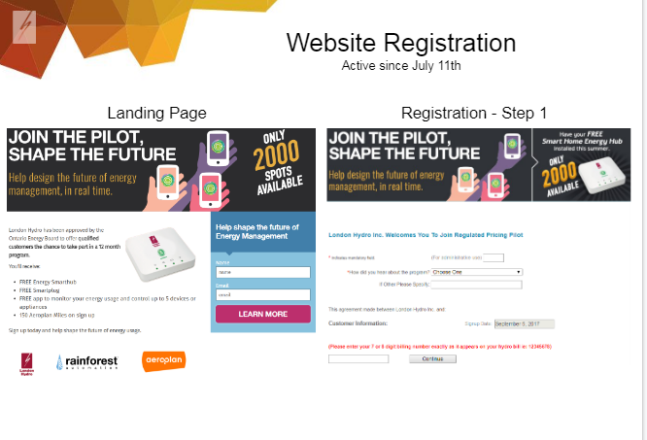

London Hydro’s marketing strategy including multi-channel campaigns.

The following chart illustrates the marketing media used and the effectiveness of each channel. Aeroplan Loyalty points (150) were offered as an incentive for customers registering for the pilot.
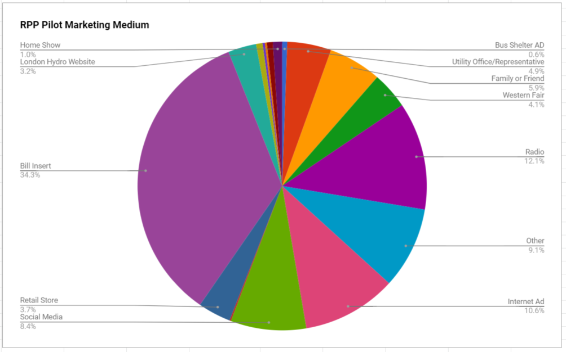

Marketing Collateral / Activity Examples

In-Person Activations
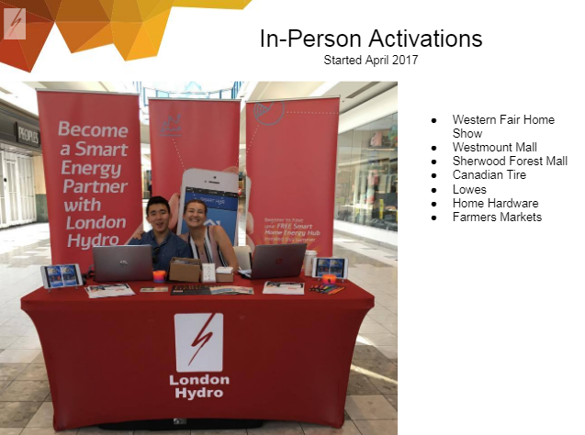

Bus Shelter Ads

London Hydro Website Carousel

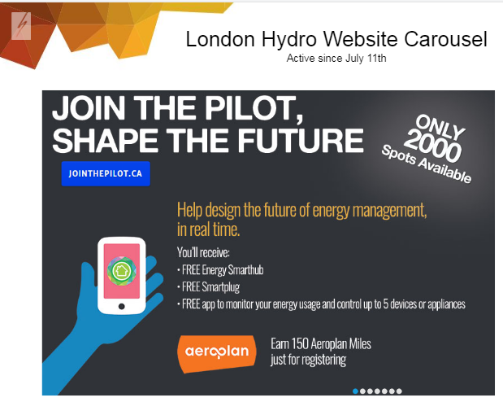

Digital Campaign
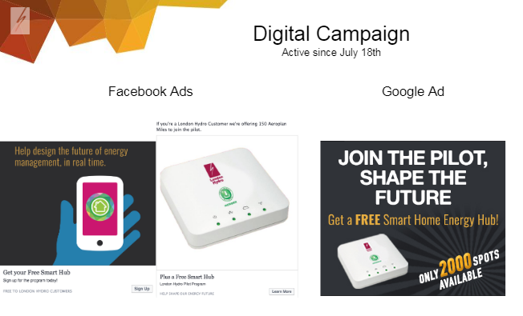

Bill Insert

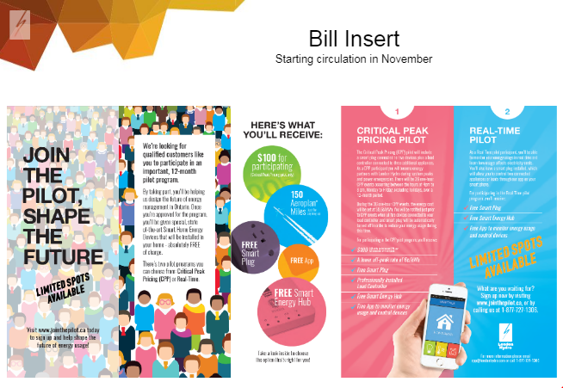

On-Boarding Customer Engagement
The LH RPP Project team believed that maintaining interest, engagement and ongoing participation from all participants – but especially those subject to CPP events – throughout the project were essential components of a successful pilot.

LH’s overall strategy for RT participants was to:
- Ensure that they understand the objectives of the pilot (e.g. no financial impact) and the importance of their participation
- Ensure that they understand the functionality of their devices and app
- Ensure their devices were working
- Have regularly scheduled “touch points” to encourage continued engagement and to give them an opportunity to have connectivity or app issues resolved and to hear use cases from other participants

LH’s overall strategy for CPP participants was somewhat different since there may be situations where there was a financial impact during a CPP event i.e. the electricity charges during the CPP event may not be covered by the reduced off-peak rate. The strategy for this group was to:
- Provide a $100 incentive ($25 at the beginning of the pilot and $75 upon pilot completion) to cover any financial impact from participating in the CPP events, and to sustain enrolment and engagement throughout the pilot period.
- Ensure that participants understand the objectives of the pilot and the importance of their participation
- Ensure that participants understand the functionality of their devices and app
- Ensure their devices were connected and working
- Have regularly scheduled “touch points” to encourage continued engagement and to give them an opportunity to have connectivity or app issues resolved and to hear use cases from other participants

The on-going touch points were a key component of the pilot’s customer engagement strategy. These were designed to maximize participant engagement on an on-going basis. Ongoing connections with customers allowed LH to help address customer concerns proactively, minimizing potential participant frustration in early stages and ensuring continued engagement with the program treatments. These touch-points are described in greater detail below.

Ongoing Pilot Customer Engagement
The following events were held during the pilot:

Event | When | Objective | Results
Breakfast Events (2) | Mar 2018 | - Create a sense of community  - Give an overview of the pilot  - Encourage participation  - Conduct on-line voting survey (“Menti”)  - Solicit volunteers for “ambassador role”  - Schedule home visits to resolve connectivity issues  - Door prizes | Attended by ~ 500 guests
Ambassador Focus groups | May 2018 | - Create a sense of community and “co-creation”  - Give “sneak peek” at new Trickl functionality  - Solicit input on ranking of new features  - Door prizes | Attended by ~ 60 guests
Door to Door Campaign | May Jun 2018 | - Troubleshoot connectivity issues at customer homes  - HW replacement | ~125 appointments made during this campaign.
Family picnic (“pizza in the park”) | Aug 2018 | - Create a sense of community  - Provide games and activities for kids and parents  - Solicit pilot feedback via survey | Attended by ~220 guests
3-Month Survey | Aug 2018 | - Pilot feedback  - Trickl Features survey | Trickl Survey results
Ambassador End of Year touchpoint | Dec 2018 | - Share some early pilot results  - Create a sense of community and “co-creation”  - Give “sneak peak” at new Trickl functionality  - Solicit input on ranking of new features  - Door prizes | Attended by 40 guests
Open House Events (6) | Jun - Mar 2019 | - Help customers with any questions or issues related to hardware or mobile application  - Book troubleshooting appointments | Attended by 94 customers
Support Channels | During Pilot | Support tickets via Trickl  Emails (rpp@londonhydro.com)  Support Calls (1-877-727-1306) | As of 30 Mar 2019:  # of tickets: 1106  # of emails: 1057  # of Calls : 220

The following slide summarizes the events held and the results achieved:

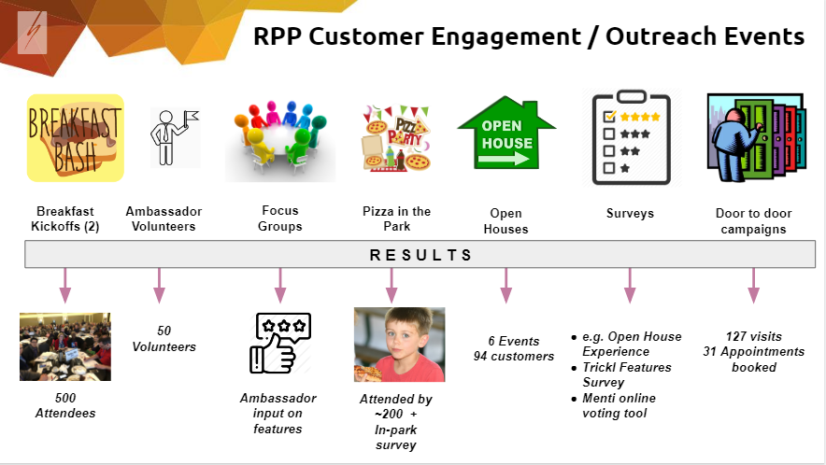

Breakfast Events : (2 events attended by ~ 500 people)
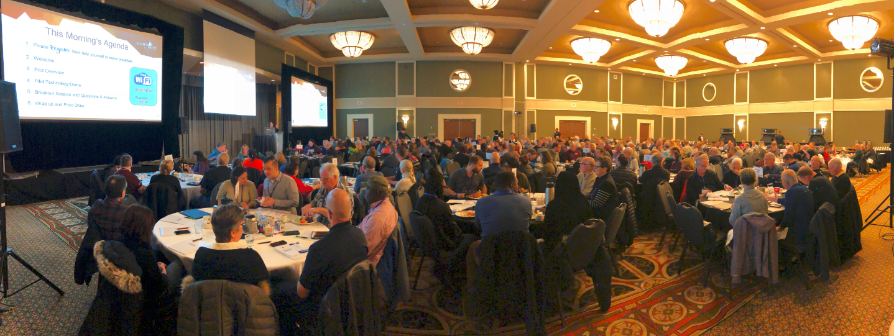
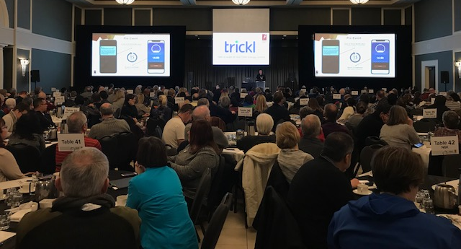

Sample Feedback from Ambassador Sessions

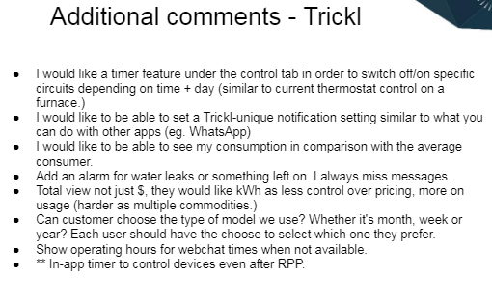

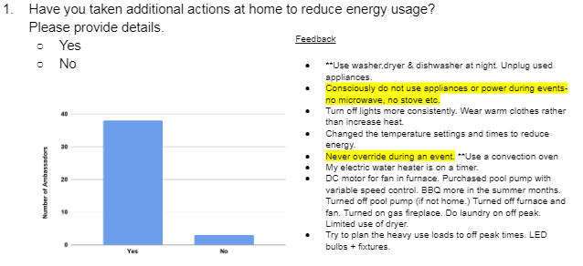

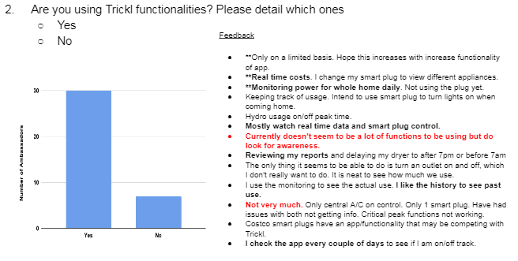

Sample “Menti” Online voting Tool / Results (used during Breakfast and Ambassador sessions)

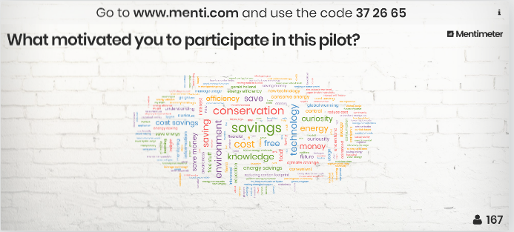

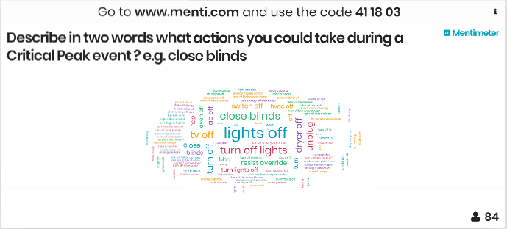

Disconnection Issues
Following its review of Navigant’s interim impact evaluation of the LH RPP pilot, the OEB requested that Navigant and London Hydro respond to the following:
Please provide a more in-depth discussion of the disconnection issues e.g. why were customers disconnected? What was done to remedy the disconnection?

The text below was developed by both London and Hydro and Navigant.

Cause of Disconnection
Why were customer switches and smart plugs disconnected from the smart hubs that controlled them?

London Hydro’s RPP Pilot groups subject to automatic control (CPP, CPP/RT) consists of different combinations of the following multi-vendor equipment:
- “Eagle” smart hubs
- 2 socket smart plugs
- Load controllers (installed on electrical panel by a certified electrician)

Challenge:
Each piece of equipment comes with its own communication protocols, firmware versions / version updates / patches, and interoperability issues / reliability. Added to the complexity of maintaining reliable communication connections in the face of these issues are customer-initiated actions, and real-world field deployment limitations.
Customers initiated actions:
- Eagle hub is offline (e.g. unplugged) due to customer action
- Other in-home devices are offline (e.g. smart plug was used as connection bridge to load controller and is unplugged, now causing all load control devices to be offline)
- Improperly configured customer router
- Homeowners broadband modem / WiFi is unstable or has been changed
- Homeowners have changed WiFi Password
- Homeowners frequently plugging and unplugging devices
- Customers have moved equipment so that the in-home WiFi signal is compromised
- Customers have existing ZigBee home devices such as Samsung smart lights hub and is causing interference with Eagle home hub
- Customers have not informed us when there is a connectivity issue e.g. abandoned the pilot
- Customers have not responded to specific requests for “rebooting” equipment
- Customers have not scheduled an in-home visit, so LH staff can resolve observed/reported connectivity issue

Field deployment limitations:
- Hubs intermittently cycling between online and offline
- Hub, Smart Plug and Load Control devices lose network connections
- Equipment firmware version issues
- Network interference issues

All enabling technologies that automate demand response are subject to connectivity issues. Connectivity rates are rarely published as part of evaluation reports, either because they are not available (in the case of one-way communications) or because the administrating entity regards them as irrelevant (average per-participant impacts, when estimated over a representative group of participants, will implicitly account for the effects of disconnections).

Remedial Actions to Reduce Disconnection Rate
What remedial actions has London Hydro undertaken to reduce disconnections?

Typically, an attempt would be made to remotely determine and resolve customer connection issues (e.g. attempt to contact a customer to reset device). Should that fail, a service call would be arranged, and a support tech would visit the customer’s home. These home visits would be up and beyond the original visit for the initial install.

As of March 1, 2019, there have been 1,100 extra home visits

Shortly after the RPP projected went live and the team had a sense as to the sustained effort that would be required to maintain customer connectivity, the project team (in consultation with the OEB and our EM&V partner Navigant), made a conscious decision to make connectivity (especially for the CPP participants) a project priority to ensure a high number of participation during CPP events in order to drive meaningful results. As a result of extra home visits London Hydro had maintained an average of 85% connectivity for 36 events over a 12-month period.

For the purposes of pilot evaluation, the existing disconnection rate may be regarded as a fortunate accident. The apparently random nature of the disconnections provides a natural experiment enabling the robust estimation of the purely behavioural impact of CPP pricing. This natural experiment allowed Navigant to reject its initial hypothesis that, given the very short notification period, DR impacts would be entirely technology-driven.

This finding is one of the most important of this evaluation. Equipment procurement, deployment, and maintenance is costly. If a well-supported opt-in CPP rate can deliver an average of 0.2 kW per event absent any technology, it markedly improves the cost-effectiveness of deploying such a rate at the provincial level.

CPP Event Overrides
LH RPP Pilot participants subject to the CPP treatment had the ability to override automatic control of their devices (the switch mounted on their panel and the smart plug) either in the 15 minutes prior to event starting, or at any time throughout the event.

Participant over-rides are an entirely separate category from disconnections. A participant might receive an alert of an event and choose to override that event. If that participant’s devices are disconnected, the end result is the same – there is no automatic curtailment. If that participant’s devices are connected and the participant elects to over-ride, their load is not automatically curtailed. A participant may override and would still be considered connected.

Overrides were sufficiently few that Navigant did not control for them explicitly in its regression equation. The average impacts estimated implicitly include (likely extremely small) overall average impact of overrides on event impacts. The count of overrides per event is shown in Figure 1, below.

Figure 1: Number of Participant Overrides per Event
Event Date | Number of Overrides
2018-06-01 | 4
2018-06-18 | 3
2018-06-29 | 7
2018-07-03 | 4
2018-07-04 | 4
2018-07-05 | 2
2018-07-16 | 4
2018-07-17 | 3
2018-07-24 | 6
2018-08-07 | 5
2018-08-15 | 4
2018-08-16 | 4
2018-08-17 | 1
2018-08-20 | 4
2018-08-27 | 4
2018-09-05 | 7
2018-09-06 | 0
2018-09-17 | 3

The average connectivity rate for the 18 summer events was slightly more than 80%.

