Exhibit 1 - Administration
Custom Incentive Rate-Setting Framework
Specific Relief Requested
1-Staff-1
Ref: Updated Exhibit 1/Tab 1/Schedule 4/pp. 12-14
Exhibit 8/Tab 10/Schedule 1/Attachment A
Exhibit 8/Tab 10/Schedule 1/Attachment B
Preamble:
In section 16 of Exhibit 1/Tab 1/Schedule 4, Hydro Ottawa lists the specific approvals that it is seeking in this application (the Application). The first three of these are:
- Approval of 2021-2025 revenue requirement, as proposed in UPDATED Exhibit 6-1-1: Calculation of Revenue Deficiency or Sufficiency;
- Approval of 2021 distribution rates and charges, effective January 1, 2021, as proposed in UPDATED Exhibit 8-10-1: Current and Proposed Tariff of Rates and Charges;
- Approval of the Custom IR rate-setting formula and related elements for 2022-2025 distribution rates and charges, as proposed in UPDATED Exhibit 1-1-10: Alignment with the Renewed Regulatory Framework;
…
In its Application, Hydro Ottawa has forecasted the OM&A adjustment factor, all parameters of the cost of capital, the capital expenditures and capital additions, and the load forecast for each year of the plan, and is seeking approval of these as filed with no updates during the term of the plan.
As Hydro Ottawa is seeking approval of all elements of its base and service revenue requirements for each year of the plan, as well as the load forecast which serves as the billing determinants for determining distribution rates, base distribution rates would be established if Hydro Ottawa’s application is approved as filed.
Hydro Ottawa has provided the draft Tariff of Rates and Charges for 2021 in Exhibit 8/Tab 10/Schedule A, and draft Tariffs of Rates and Charges for each of 2022 to 2025 in Attachment B of the same exhibit.

Question(s):
- Please explain the reason for only seeking approval of the 2021 Tariff of Rates and Charges in this Application.

- Does Hydro Ottawa contemplate that it will be filing a rate application each year to deal with matters such a Group 1 Deferral and Variance Account balances and dispositions?
- If not, please explain why not.

- If Hydro Ottawa does contemplate filing annual rate applications, please identify what rate-setting matters would be reviewed in those applications.

- If Hydro Ottawa will be making annual rate applications, please explain the rationale for approving and fixing the OM&A expense factor with the forecasted inflation estimates for each year in this application.

1-Staff-2
Ref: Updated Exhibit 1/Tab 1/Schedule 8
Updated Exhibit 1/Tab 1/Schedule 10
Preamble:

Hydro Ottawa has proposed a Custom IR plan where, after rebasing in 2021, the revenue requirement and rates for each of 2022 to 2025 would be calculated by:

- Capital is passed through annually by updating the rate base for capital additions and removals each year, and recalculating the capital-related revenue requirement (return of capital – depreciation/amortization, return on capital and associated taxes)
- Aggregate OM&A expenses are updated via a Custom Price Escalator Factor (CPEF) annually for inflation less productivity plus a growth component, with:
  - Inflation being a custom inflation index with weights for labour and non-labour (i.e., materials) reflecting the revenue requirement weights for OM&A; other than that, the inflation factor uses the same methodology as is current used for other inflation factors that the OEB has approved for electricity and gas incentive rate-setting mechanism (IRM) rate regulation
  - The X-factor, for productivity, is composed of a base productivity factor of 0%, as used by the OEB for electricity distribution (and other energy sector) IRM rate regulation, and a stretch factor. Hydro Ottawa has proposed a 0.15% stretch factor, based on the total cost benchmarking analysis of Clearspring Energy Consultants Inc. (Clearspring), as documented in the Appendix to Clearspring’s evidence, excluding the two “generational” (capital) projects of Facilities Renewal and the Cambrian municipal transformer station (MTS). This is in contrast to Clearspring’s analysis and recommendation of a 0.30% stretch factor, and a 0.45% stretch factor based on the forecast from the OEB-issued PEG cost benchmarking model.
  - Growth (“g”) is based on Hydro Ottawa’s forecasted average annual increase in the number of metered customers over the plan term, altered by a factor of 0.35 to account for economies of scale in OM&A expenses due to customer growth. The scaling is indicated to be analogous to scaling adjustments approved in other Canadian jurisdictions.
  - Hydro Ottawa has forecasted inflation for each year, and proposes to fix the X-factor (both the base productivity and the stretch factor) for the plan term, and has calculated a 2.51% OM&A annual adjustment for each year from 2022 to 2025.
- Hydro Ottawa has forecasted the cost of capital parameters (Return on Equity (ROE), long-term debt rates and short-term debt rate and its portfolio of long-term debt for each year of the plan, as follows:
  - Hydro Ottawa proposes to use the OEB’s deemed capital structure of 40% equity, 56% long-term debt and 4% short-term debt.
  - The deemed short-term debt rate is proposed to be fixed at 2.75%, as issued by the OEB for the 2020 rate year, with no updates.
  - Hydro Ottawa has calculated forecasted 10-year and 30-year long term debt rates. The principal-weighted average cost of long-term debt would be based on the portfolio of existing and forecasted long-term debt and the actual or forecasted debt rate for each debt instrument.
  - Hydro Ottawa has forecasted the ROE for each year of the plan to be used in calculating the return on capital for the updated rate base in each year. This would also impact on the grossed-up tax expense.
- Hydro Ottawa has forecasted the number of customers, kWh and kW, by customer class, for each year of the plan, and proposes no further updates. The updated load forecast for each year will be used in the cost allocation to allocate the revenue requirement between customer classes, and then used as the billing determinants to determine fixed and variable distribution rates (and for deferral and variance account (DVA) rate adders and retail transmission service rates (RTSRs)).
Question(s):
- Please confirm or correct the above summary of Hydro Ottawa’s Custom IR plan for adjusting its revenue requirement for each of 2022-2025, following rebasing in 2021.

- Please identify any precedents that Hydro Ottawa is relying on to fix the OM&A adjustment at the outset and not update the adjustment with the most current Statistics Canada data each year. As is necessary, where precedents are for other jurisdictions, please provide the cited references.

- As OEB staff understands Hydro Ottawa’s proposal, the utility is not proposing to update the inflation forecasts for each year, which it has estimated at an annual rate of 2.26% for 2022-2025 even at the decision and draft rate order stage this year (i.e., for 2021 rates).
  - Please confirm or correct OEB staff’s understanding.
  - If confirmed, and assuming Hydro Ottawa’s Application is approved as filed, please explain the basis for not updating the inflation factor at the draft rate order stage, when more current information will be available.

- As OEB staff understands Hydro Ottawa’s proposal, the utility is not proposing to update the cost of capital forecasts for each year, including 2021, at the decision and draft rate order stage this year (i.e., for 2021 rates).
  - Please confirm or correct OEB staff’s understanding.
  - If confirmed, and assuming Hydro Ottawa’s Application is approved as filed, please explain the basis for not updating the cost of capital data at the draft rate order stage, when more current information will be available. Please identify any precedents that Hydro Ottawa is relying on in support of its proposal.

1-Staff-3
Ref: Updated Exhibit 1/Tab 1/Schedule 8
Updated Exhibit 1/Tab 1/Schedule 10
Decision and Order EB-2017-0049, March 7, 2019
Decision and Order EB-2018-0165, December 19, 2019

Preamble:

Hydro Ottawa has proposed a Custom IR plan which is similar to its first Custom IR plan, in that only OM&A expenses are adjusted via an inflation less productivity (which including an overall stretch factor) plus growth (I – X + g) formula, while capital expenditures (capital additions) are fully passed through via the annual updating of the rate base and, hence, the capital-related revenue requirement. Hydro Ottawa has also forecasted the OM&A adjustment formula, as well as the cost of capital parameters, for each year of the plan, and proposes that the forecasted OM&A adjustment and cost of capital parameters be set and fixed for each year of the plan for 2022 to 2025.

Subsequent to the issuance of the Rate Handbook on October 13, 2016, the OEB has approved 5-year Custom IR plans for Hydro One Networks distribution (EB-2017-0049) and Toronto Hydro (EB-2018-0265). For each of these plans, the Custom IR plan as proposed was essentially of a price cap index form, whereby the rate adjustment formula applied to both OM&A and the capital-related revenue requirement. Incremental capital needs were factored into the formula via a capital factor (C-factor), such that the price cap adjustment formula (beyond the rebasing year) becomes I – X + C. The OEB, in its decisions on these recent Hydro One Networks distribution and Toronto Hydro Custom IR plans, approved the general price cap approaches proposed but also determined that an incremental stretch factor (S-factor) on capital was appropriate to incentivize further productivity on the capital budget in the plan. Further, the OEB determined that there would be no updating of the cost of capital beyond the rebasing year during the plan term, and that the inflation adjustment would be done annually based on published Statistics Canada data, as is done for price cap and revenue cap adjustment formulae for other electricity distributors, transmitters, Ontario Power Generation, and Enbridge Gas Distribution.

Question(s):

- Please provide Hydro Ottawa’s rationale for not proposing an S-factor in order to incentivize further cost efficiencies and productivity gains with respect to capital beyond what the utility has forecasted in the capital plan in its distribution system plan (DSP), similar to what the OEB determined should be included in the recently approved Custom IR plans for Toronto Hydro and Hydro One distribution.

- In light of the OEB’s policy for no cost of capital updates during the plan term, and the OEB’s decisions for the recent Hydro One Networks distribution and Toronto Hydro Custom IR plan providing for no cost of capital updates during the Custom IR plan term, please explain the rationale for Hydro Ottawa’s proposal to forecast at the outset of the five-year plan the cost of capital for each year of the Custom IR plan.

1-Staff-4
Ref: Updated Exhibit 1/Tab 1/Schedule 8
Exhibit 1/Tab 1/Schedule 10
Handbook for Utility Rate Applications, October 13, 2016, pp. 25-26

Preamble:

Subsequent to the approval of Hydro Ottawa’s first Custom IR plan for 2016-2020, the OEB issued the Handbook for Utility Rate Applications (Rate Handbook) on October 13, 2016. The Rate Handbook extended the Renewed Regulatory Framework to rate-regulated utilities, in order to establish greater consistency is rate-setting methodologies to the extent possible and appropriate. The Rate Handbook also added greater clarification on the OEB’s policies, principles and expectations with respect to rate-setting options, including for the Custom IR; a section is devoted to the Custom IR option. The Rate Handbook states, on pages 25-26:
Index for the Annual Rate Adjustment: The annual rate adjustment must be based on a custom index supported by empirical evidence (using third party and/or internal resources) that can be tested. Custom IR is not a multi-year cost of service; explicit financial incentives for continuous improvement and cost control targets must be included in the application. These incentive elements, including a productivity factor, must be incorporated through a custom index or an explicit revenue reduction over the term of the plan (not built into the cost forecast).
The index must be informed by an analysis of the trade-offs between capital and operating costs, which may be presented through a five-year forecast of operating and capital costs and volumes. If a five-year forecast is provided, it is to be used to inform the derivation of the custom index, not solely to set rates on the basis of multi-year cost of service. An application containing a proposed custom index which lacks the required supporting empirical information may be considered to be incomplete and not processed until that information is provided.
It is insufficient to simply adopt the stretch factor that the OEB has established for electricity distribution IRM applications. Given a utility’s ability to customize the approach to rate-setting to meet its specific circumstances, the OEB would generally expect the custom index to be higher, and certainly no lower, than the OEB-approved X factor for Price Cap IR (productivity and stretch factors) that is used for electricity distributors.
OEB staff have compiled the following table of cohorts and stretch factors for Hydro Ottawa for the period from 2014 to 2020, based on the annual Ontario distributor benchmarking. These are based on the annual reports for the study conducted by Pacific Economics Research Group LLC (PEG), as commissioned by the OEB. The studies are publicly available on the OEB’s website.
Table 1-Staff-4-1:
Hydro Ottawa’s Cohort Ranking and Stretch Factor by Year
Rate Year | 3-year data range | Cohort | Stretch Factor
2014 | 2010-12 | 3 | 0.30%
2015 | 2011-13 | 3 | 0.30%
2016 | 2012-14 | 3 | 0.30%
2017 | 2013-15 | 4 | 0.45%
2018 | 2014-16 | 4 | 0.45%
2019 | 2015-17 | 4 | 0.45%
2020 | 2016-18 | 4 | 0.45%
Question(s):
- Please confirm or correct Hydro Ottawa’s cohort ranking and stretch factor for each year from 2014 to 2020, as shown in the above table.
- Since Hydro Ottawa’s proposed Custom IR plan only applies the (inflation-less-productivity-plus-growth) adjustment to OM&A expenses, while capital additions are passed-through through the annual rate base and capital-related revenue requirement update, please explain how Hydro Ottawa’s proposed Custom IR plan satisfies the Rate Handbook expectation that the “incentive elements, including a productivity factor, must be incorporated through a custom index or an explicit revenue reduction over the term of the plan (not built into the cost forecast)”.

- Hydro Ottawa is proposing a stretch factor lower than what the PEG model would forecast or has been Hydro Ottawa’s stretch factor for the period 2014-2020. Please explain how Hydro Ottawa’s proposal is consistent with the OEB’s general expectation that “the custom index to be higher, and certainly no lower, than the OEB-approved X factor for Price Cap IR (productivity and stretch factors) that is used for electricity distributors”.

Custom Price Escalator Factor Forecast
1-Staff-5
Ref: Updated Exhibit 1/Tab 1/Schedule 10/pp. 12-17
FORTISBC Inc. Multi-Year Performance Based Ratemaking Plan For 2014 Through 2018, Decision, September 15, 2014
FORTISBC Energy Inc. Multi-Year Performance Based Ratemaking Plan For 2014 Through 2018, Decision, September 15, 2014
Preamble:
On pages 12 to 16 of this exhibit, Hydro Ottawa documents its calculation of the CPEF and its components of inflation (I), X (base productivity and stretch) and growth (g). On pages 15-16, tables for the forecasted inflation for the CPEF are provided:
On page 17, Hydro Ottawa states that:
Hydro Ottawa does not intend to update the inflation factor over the course of its 2021-2025 rate term.
Question(s):
- For which years are data actuals as opposed to forecasts?

- For Tables 4 and 5, the source identified is the Conference Board of Canada. Are all data from the Conference Board of Canada? If not, please identify the source for each datum.

- Please provide the source of the Conference Board of Canada forecast, and the date of the forecast.

- In Table 4, what is the derivation of the Adjusted GDP-IPI shown in the right-most column?

- In Table 5, what is the derivation of the Adjusted AWE shown in the right-most column?

- In Table 6, OEB staff observes that it is the Adjusted GDP-IPI and Adjusted AWE which are used to calculate the inflation factor. Why has Hydro Ottawa used the adjusted data rather that the unadjusted data? Also, what is the formula for calculating the inflation factor shown in the right-most column?

- On an assumption that 2017 and 2018 data are actuals, OEB staff has prepared the following table comparing the (unadjusted) GDP-IPI and AWE from Tables 4 and 5 against the same variables as published by Statistics Canada and used in the calculation of the distribution Input Price Index for 2020 IRM and Custom IR applications. The Statistics Canada data were downloaded on September 13, 2019.
Table 1-Staff-5-1
Year | Hydro Ottawa’s data from  Tables 4 and 5 |  | Statistics Canada data used for OEB 2020 IPI Calculation
Year | GDP-IPI | AWE | GDP-IPI | AWE
Year | Annual % Change
2017 | 2.50% | 0.82% | 1.4% | 1.9%
2018 | 1.67% | 3.40% | 1.6% | 2.9%

On page 14 of this exhibit, Hydro Ottawa documents that it is using the same series as the OEB uses for the Input Price Index calculations:
GDP-IPI (FDD) is the annual Implicit Price Index for (national) Gross Domestic Product.
AWE (Ontario) is the annual Average Weekly Earnings for Ontario, all businesses except unclassified, including overtime.
Please explain why Hydro Ottawa’s data vary so much from the published Statistics Canada data used by the OEB in its IPI calculations.
- In support of its growth factor, Hydro Ottawa references decisions from British Columbia, Alberta, and Québec. One of the referenced decisions was a British Columbia Utilities Commission (BCUC) decision for FortisBC Inc.’s (Fortis BC’s) 2014-2019 Performance-Based Regulation (PBR) plan. In that application, FortisBC was proposing to forecast inflation for the coming rate year as part of the annual rate update. In its decision, the BCUC panel stated in its determinations, with respect to the utility’s proposal to forecast inflation over the plan term:
From the evidence presented it is clear there is no perfect way to determine the I-Factor. Therefore, the best that can be expected is to derive a proxy that best estimates the impact of inflation on the Companies for the full PBR period.
The problem with the forecast approach proposed by Fortis is that there will almost always be a variance between forecast and actual. Fortis has not disputed this but has argued that its actual costs are very much influenced by forecast as they often make binding commitments in advance of a given year and these take into account forecasted inflation. The Commission Panel accepts that this may be the case but it is not unique to Fortis as actual inflation measures reflect this spending behaviour on a broader basis. BCPSO makes a similar point as it observes that “actual inflation differs from forecast inflation and therefore actual increases are not driven by forecasts.” In the view of the Panel, a significant problem with Fortis’ proposed reliance on forecast rates of inflation lies in the fact that any variances which do occur are compounded each year. This may not be too serious where there is some assurance that over time these forecast errors will balance out. However, this is not the case. Instead, it is reasonable to assume that over the PBR period future forecasts may be significantly skewed either up or down relative to actuals and, as stated by BCPSO, wins or losses may have little to do with gains or losses in efficiency. Considering the potential for a significant impact on the I-X formula resulting from this, the Commission Panel denies Fortis’ proposal to rely on forecast data in the determination of the I-Factor. [Emphasis in original.]
A similar determination on forecasting inflation was made by the BCUC for FortisBC Energy Inc.’s PBR plan for 2014-2019.
While acknowledging the lag in using actual data, the OEB, and other regulators have generally relied on using actual historical data from accredited sources such as national statistical agencies, for estimating inflation for rate adjustment formulae.
Hydro Ottawa is proposing to forecast inflation for each year of the whole plan term in this Application, and is seeking approval in this Application with no updates in annual rate applications for 2022 to 2025. Please explain why Hydro Ottawa believes that its proposal does not raise similar concerns of forecasting error and possible bias as the BCUC has noted in the referenced decisions, in light of the extended forecasting period.
X-factor
1-Staff-6
Ref: Updated Exhibit 1/Tab 1/Schedule 10/page 17
Decision and Order EB-2017-0049, March 7, 2019
Decision and Order EB-2018-0165, December 19, 2019
Preamble:

Hydro Ottawa has proposed to adopt the base X (base productivity) factor of 0%, as established by the OEB for electricity distribution incentive regulation most recently in the Supplemental Report of the Board on Rate Setting Parameters and Benchmarking under the Renewed Regulatory Framework for Ontario’s Electricity Distributors (EB-2010-0379), and which the OEB has reaffirmed in recent decisions for custom IR plans. Hydro Ottawa has noted that this base X factor is based on analyses of Total Factor Productivity (TFP) for the electricity distribution sector.

Hydro Ottawa specifically references the Hydro One Networks distribution Custom IR plan for 2018-2022 and the OEB’s decision in that case reaffirming the 0% base X-factor.
Question(s):
- Please confirm Hydro Ottawa’s understanding that TFP analyses relate to productivity growth for all outputs (products and services produced and offered by the firm) relative to all inputs (capital, labour and materials) used in the production and delivery of those products and services.

- Please confirm that the approved Hydro One Networks’ distribution Custom IR plan uses an adjustment formula that applies to all inputs (i.e., capital, including capitalized labour, and expensed labour and materials).

- Please confirm that the Custom IR plan more recently approved for Toronto Hydro-Electric System Limited (Toronto Hydro), similar uses an adjustment formula that applies to all inputs (i.e., capital, including capitalized labour, and expensed labour and materials).

- Please confirm that Hydro Ottawa’s proposed Custom IR plan differs from both the Hydro One Networks distribution and Toronto Hydro Custom IR plans in that Hydro Ottawa proposes that the adjustment formula only apply to OM&A. If not confirmed, please explain.

- Does Hydro Ottawa consider that partial factor productivity (PFP) with respect to OM&A and all outputs would be equal to TFP? Please explain your response.
- Please provide all evidence that Hydro Ottawa has on its PFP with respect to OM&A.

- Please explain the rationale for Hydro Ottawa’s assertion that the base X-factor of 0% used by the OEB is appropriate for an OM&A adjustment formula.

Growth Factor
1-Staff-7
Ref: Updated Exhibit 1/Tab 1/Schedule 10/pp. 20-24
Preamble:
Hydro Ottawa has incorporated a growth factor (g) into its proposed OM&A adjustment formula, so that the CPEF (Custom Price Escalation Factor) is of the form:
$$CPEF=I-\left(X+stretch_{factor}\right)+g$$
A growth factor was also incorporated into the formula for Hydro Ottawa’s current Custom IR plan for 2016-2020.
Hydro Ottawa has assumed a 1.34% average annual growth in number of customers from 2012 to 2020 (forecasted). Hydro Ottawa has then applied a factor to account for economies of scale; the factor used is 0.35, which OEB staff would interpret as the elasticity of customer growth for OM&A expenses. Based on this, Hydro Ottawa then proposes a g-factor of 0.40%, which Hydro Ottawa then assumes for all years that the CPEF is applied (i.e., 2022 to 2025).
Hydro Ottawa references precedents with respect to an Enbridge Gas Distribution plan in 2007, and more recent decisions in British Columbia, Québec, and Alberta on utility incentive rate-setting plans.
Question(s):
- In Table 7 (Exhibit 1/Tab 1/Schedule 10/page 20), are the data shown for 2019 actuals or estimates? If estimates please update Table 7 with 2019 actuals.

- Please calculate the average annual growth in customers based on actuals for 2012-2019, based on Table 7, including any update in a).

- Please provide further details, and data used, in deriving the estimate of 0.35 for the customer growth elasticity of OM&A expenses.
- Does Hydro Ottawa also agree that there are economies of scale with respect to capital additions? In other words, there would, all else being equal, normally be less than a 1% growth in capital for a 1% growth in number of customers. In other words, both OM&A expenses and capital are inelastic with respect to customer growth. Please explain your reasons.

- In the FortisBC and FortisBC Energy decisions that OEB staff have referenced in 1-Staff-5 and which Hydro Ottawa references in this exhibit of its application, the BCUC determined that an adjustment factor (i.e., customer growth elasticity of capital additions) of 0.5 should apply. Hydro Ottawa has proposed no adjustment should apply to the capital additions it has forecasted per its DSP and proposes by approved in this application for the whole of the five year Custom IR plan.
Considering that it is relying on these precedents for its OM&A growth adjustment, please explain, with reasons, why Hydro Ottawa has not proposed a similar growth adjustment, including an economies of scale factor, for its forecasted capital budget as documented in its DSP.

Earnings Sharing Mechanism
1- Staff-8
Ref: Updated Exhibit 1/Tab 1/Schedule 8/pp. 29-30
Updated Exhibit 1/Tab 1/Schedule 10/pp. 26-27
Updated Exhibit 9/Tab 1/Schedule 3/pp. 3, 17
Exhibit 9/Tab 2/Schedule 1/pp. 6-8
EB-2015-0004, Decision and Rate Order, December 22, 2015
Preamble:
In this Application, Hydro Ottawa is proposing an asymmetrical Earnings Sharing Mechanism (ESM) with a deadband of +150 basis points above the allowed Return on Equity (ROE).
In its current Custom IR plan for 2016-2020, Hydro Ottawa is subject to an ESM with no deadband; all earnings above the allowed ROE on a regulated basis are to be shared 50:50 between shareholders and ratepayers. This ESM was part of the settlement proposal for Hydro Ottawa’s Custom IR, which settlement proposal was accepted by the OEB in its Decision and Rate Order EB-2015-0004, issued December 22, 2015.
In Exhibit 9/Tab 2/Schedule 1, on pages 6-7, Hydro Ottawa states:
If the utility’s actual Return on Equity (“ROE”) differs from the approved ROE, Hydro Ottawa proposes returning any excess earnings based on the following (which is consistent with the OEB’s recent Decision and Order on THESL’s [Toronto Hydro’s] 2020-2024 rate application⁷):
- Under earning – borne entirely by the shareholder
- 0 - 150 basis points – fully retained by shareholder
- Above 150 basis points – 50:50 sharing between ratepayer/shareholder
The above would be based on overall earnings at the end of the Custom IR rate term (i.e. end of 2025), as per the direction signaled in the OEB’s Handbook for Utility Rate Applications.⁸
7 Ontario Energy Board, Decision and Order, EB-2018-0165 (December 19, 2019), pages 42-43.
8 Ontario Energy Board, Handbook for Utility Rate Applications (October 13, 2016), page 28.
For both the 2016-2020 Custom IR plan and the proposed 2021-2025 plan, any overearnings are tracked in Account 1508 sub-account Earnings Sharing Mechanism, as noted in Exhibit 9/Tab 1/Schedule 1.
In its Decision and Order EB-2018-0165, the OEB approved Toronto Hydro’s ESM with a threshold of 100 basis points:
The OEB approves a cumulative, asymmetrical ESM using an ROE-based calculation with all earnings in excess of 100 basis points over the approved ROE shared 50:50 with ratepayers.
Question(s):
- Why is Hydro Ottawa proposing a different ESM from its 2016-2020 Custom IR plan?

- Please confirm that Hydro Ottawa’s ESM proposal is consistent with what the OEB approved for Toronto Hydro in the EB-2018-0165 Decision and Order with the exception of the threshold of 150 basis points proposed by Hydro Ottawa. If there are other differences, please identify and document them and the reasons for the differences.

- What is the basis for the deadband threshold of 150 basis points above the allowed ROE? This should also address why Hydro Ottawa is proposing a different deadband threshold than that proposed by and approved by the OEB for, Toronto Hydro in that distributor’s 2020-2024 Custom IR plan.

- As documented under the Custom IR plan and further detailed in Exhibit 5, Hydro Ottawa has forecasted the cost of capital parameters, including the ROE for each year of the plan. For 2025, Hydro Ottawa has forecasted an ROE of 9.46%. Please confirm that Hydro Ottawa’s Custom IR proposal is that the ESM would be triggered if the achieved ROE, on a regulated basis, exceeds each year’s forecasted ROE by over 150 basis points. In other words, under Hydro Ottawa’s proposals in its Application, for 2025, the ESM would only be triggered if actual ROE on a regulated basis was over 10.96% (= 9.46% + 150 b.p.).

1- Staff-9
Ref: Updated Exhibit 1/Tab 1/Schedule 8
Updated Exhibit 1/Tab 1/Schedule 10
Updated Exhibit 9/Tab 1/Schedule 1/page 9
Exhibit 9/Tab 1/Schedule 3/pp. 4, 17-18
EB-2015-0004, Decision and Rate Order, December 22, 2015
Preamble:
Hydro Ottawa had an Efficiency Adjustment Mechanism (EAM) as part of its current 2016-2020 Custom IR plan. The purpose of the EAM was to track any over-recoveries of the revenue requirement through distribution rates for any year(s) in that plan when Hydro Ottawa’s efficiency ranking dropped below cohort 3, which was assumed for all years in the 2016-2020 plan.
Over-recoveries were recorded and tracked in an EAM sub-account of Account 1508, and the balance to be disposed at the end of the plan term. In Updated Exhibit 9/Tab 1/Schedule 1, at page 9 and on pages 17-18 of Exhibit 9/Tab 1/Schedule 3, Hydro Ottawa discusses continuation of the 2016-2020 EAM, as final audited actuals for 2020 would only be known at the time of, and disposition applied for in, Hydro Ottawa’s 2022 rate application.
OEB staff’s reading of Hydro Ottawa’s proposed 2021-2025 Custom IR plan, in Exhibit 1/Tab 1/Schedules 8 and 10 indicates that Hydro Ottawa is not proposing an EAM for the 2021-2025 Custom IR plan.
Question(s):
- Please confirm that Hydro Ottawa’s proposal to “continue” with Account 1508 sub-account Efficiency Adjustment Mechanism is solely with respect to allow for tracking of the final account balances and subsequent disposition of 2020 balances of the EAM for the 2016-2020 Custom IR plan. In the alternative please explain.

- Please confirm that Hydro Ottawa is not proposing an EAM as part of the 2021-2025 Custom IR plan.

- Please provide detailed reasons as to why Hydro Ottawa is not proposing an EAM for its 2021-2025 Custom IR plan.
- If Hydro Ottawa is proposing to continue with an EAM as part of the 2021-2025 plan, please provide details on how Hydro Ottawa proposes that it would operate.

Clearspring Total Cost and Reliability Benchmarking
1-Staff-10
Ref: Exhibit 1/Tab 1/Schedule 12/Attachment A/p. 1
Preamble:
In the Overview provided on page 1 of its study, Clearspring states:
The benchmarking study evaluates Hydro Ottawa’s historical and projected total cost amounts. It also evaluates the Company’s historical system reliability metrics: the system average interruption frequency index (“SAIFI”), and the customer average interruption duration index (“CAIDI”).

Question(s):
- Please confirm Clearspring’s understanding that, consistent with its previously approved Custom IR plan for the term 2016-2020, Hydro Ottawa has proposed a plan that is a pass-through of forecasted budgeted capital costs (capital additions), subject to a Capital Variance Account (CVA), and applies a price cap-like (actually revenue cap-like) “inflation less productivity plus growth” (I – X + g) annual adjustment to aggregate OM&A expenses. When was Clearspring made aware of Hydro Ottawa’s proposal that the incentive adjustment mechanism would only apply to OM&A expenses?

- Why does Clearspring believe that the results of its benchmarking of Hydro Ottawa’s total costs with comparator U.S. and Ontario utilities is appropriate for establishing the stretch factor for OM&A expenses alone? Please elaborate on the conceptual basis that would justifies this assumption.

1-Staff-11
Ref: Exhibit 1/Tab 1/Schedule 12/Attachment A/pp. 10-11
Exhibit 1/Tab 1/Schedule 12/Attachment C
Preamble:
At p.10 of its study, Clearspring describes the sample of 81 U.S. utilities and 7 Ontario distributors, including Hydro Ottawa, which Clearspring has used for its total cost benchmarking model. Table 4 on p. 11 of the study lists these along with the 2017 number of customers served by each utility.
In Exhibit 1/Tab 1/Exhibit 12/Attachment C, Hydro Ottawa provides its own benchmarking of its performance with respect to certain cost category metrics, service quality and reliability and certain financial metrics. In its analysis, Hydro Ottawa has benchmarked itself against eleven other Ontario distributors; these distributors are mostly larger distributors. These are:
- Alectra Utilities Corporation
- Burlington Hydro Inc.
- EnWin Utilities Ltd.
- Hydro One Networks Inc.
- Kitchener-Wilmot Hydro Inc.
- London Hydro Inc.
- Oakville Hydro Electricity Distribution Inc.
- Thunder Bay Hydro Electricity Distribution Inc.
- Toronto Hydro-Electric System Limited
- Veridian Connections
- Waterloo North Hydro Inc.
The six Ontario distributors whose names are italicized above are included in Clearspring’s sample, but the other five distributors are not.
Question(s):
- Was Clearspring aware of the Ontario distributors that Hydro Ottawa had itself selected as a peer group for Hydro Ottawa’s own benchmarking?

- If yes to a), please explain why Clearspring did not also include the other five Ontario distributors in its data set.

1-Staff-12
Ref: Exhibit 1/Tab 1/Schedule 12/Attachment A
EB-2018-0165, Exhibit 1/Tab 4/Schedule 2/p. 26/Table 5
2006 and 2017 Yearbooks, OEB Website
Preamble:
On page 10, in describing its sample of U.S. and Canadian utilities for the total cost benchmarking analysis, Clearspring states:
The sample includes Ontario and U.S. utilities that, individually, serve more than 59,806 customers.¹⁰
Footnote 10 states:
10 This specific cut-off was used for the Ontario distributors so that it would be consistent with the U.S. sample. The smallest customer count in the U.S. sample is from Black Hills Power, which served 59,807 customers in 2002.
OEB staff has also provided, as an attachment, Table 5 from the evidence of PSE, Mr. Fenrick’s former employer, in its evidence filed in Toronto Hydro’s 2020-2024 Custom IR plan. This table lists the firms included in the total cost benchmarking report filed in that application.
OEB staff has populated the following table of certain Ontario distributors from the 2006 and 2017 Yearbooks, available on the OEB’s website at https://www.oeb.ca/utility-performance-and-monitoring/natural-gas-and-electricity-utility-yearbooks:
Table 1-Staff-12-1:
Customers for Selected Ontario Electricity Distributors
Ontario Distribution Utility | 2006 Number of Customers | 2017 Number of Customers
Burlington Hydro | 60,749 | 67,122
Energy+ (Cambridge and North Dumfries Hydro + Brant County Power) | 57,903 (48,619 + 9284) | 64,724
Guelph Hydro | 58,941 | 55,239
Oakville Hydro | 58,220 | 70,491
Veridian Connections | 107,231 | 120,457
Veridian Connections + Whitby Hydro | 142,178 (107,231 + 34,947) | 162,955 (120,457 + 42,498)
Question(s):
- Was the 59,807 customer limit applied for all years and for each utility?

- Since the Ontario distributors included have a time frame of 2006 to 2018, how was the 59,807 customers served threshold used to identify what Ontario distributors to include in the sample.

- Please confirm that, for U.S. utilities, DTE Electric Company and MDU Resources Group Inc., that were included in the sample in the Toronto Hydro Study, have been omitted from the current study in this case. Please explain why these two utilities have been removed.

- Please confirm the following differences with respect to Ontario distributors that have been included in the total cost benchmarking sample for this current Hydro Ottawa sample, versus the sample for PSE’s study in the Toronto Hydro Custom IR application:
  - Alectra has been included, replacing predecessor utilities of Enersource Hydro Mississauga and Horizon Utilities.
    - Please confirm the definition of Allectra used in the current study – does its composition include Enersource Hydro Mississauga, PowerStream, Horizon Utilities, Hydro One Brampton Networks and Guelph Hydro-Electric System or just the previous four utilities?
    - Please explain how Clearspring combined the data of the predecessor utilities, including how the Congested Urban variable was updated for this utility.
  - Hydro One Networks was added to Ontario distributors.

- For the changes to Ontario distributors identified in d) above, please provide the reasons for the changes.

- From the table provided above with respect to Ontario distributors not included in Clearspring’s sample, please explain the reasons for why these distributors were not included:
  - Burlington Hydro, which grew from 60,749 customers in 2006 to 67,122 customers in 2017
  - Energy+, formed from Cambridge and North Dumfries Hydro and Brant County Power, with a combined number of customers served 57,9034 in 2006 to 64,724 in 2017
  - Oakville Hydro, with 58,220 customers in 2006 increasing to 70,491 in 2017
  - Veridian Connections, with or without Whitby Hydro, with which it merged in 2019 under the new name Elexicon Energy Inc. Veridian Connections alone had 107,231 customers in 2006, increasing to 120,457 in 2016. Combined, Veridian Connections and Whitby Hydro has 142,178 customers in 2006 and 162,955 in 2017.

1-Staff-13
Ref: Exhibit 1/Tab 1/Schedule 12/Attachment A
Preamble:
On pages 7-8 of its study, Clearspring provides its recommendation for the stretch factor for Hydro Ottawa, stating on page 8:
Our total cost study findings for Hydro Ottawa show that during the Custom IR period, the Company’s total cost benchmarking score is -7.1%. Based on the 4th Generation IR stretch factors, this suggests a stretch factor of 0.30%. The reliability benchmarking results provide no clear evidence that Hydro Ottawa is producing this better than average cost performance at the expense of reliability outcomes. Therefore, Clearspring Energy’s recommended stretch factor for Hydro Ottawa’s Custom IR application is 0.30%.⁹
Footnote 9 states:
The company requested Clearspring Energy examine how the total cost benchmarking results would change if the “once in a generation” Facilities Renewal Program and the South Nepean Municipal Transformer Station projects had not been pursued. In that hypothetical, the average 2021-2025 score would be -12.5%. This would have changed our stretch factor recommendation from 0.3% to 0.15%. Please see the Appendix for more background and the benchmarking scores with and without these project investments.
In its proposed Custom IR plan as documented in Exhibit 1/Tab 1/Schedules 8 and 10, Hydro Ottawa is proposing a stretch factor of 0.15% (i.e., excluding the impacts of the Facilities Renewal Program and the Cambrian MTS capital projects).
Questions:
- Please explain, with reasons, why Clearspring is recommending the 0.30% stretch factor.

- Please confirm that the Facilities Renewal and Cambrian MTS projects are in large part, capital projects.

- Since the Facilities Renewal and Cambrian MTS projects are largely capital in nature, please explain, conceptually, why inclusion or exclusion of these projects should have any impact on the proposed stretch factor for the OM&A expense adjustment formula.

- For the analysis excluding the Facilities Renewal and Cambrian MTS projects documented in the Appendix of Clearspring’s report, please identify whether Clearspring undertook to also identify and exclude similar material “generational” projects for the other 81 U.S. utilities and six Ontario distributors in the total cost benchmarking analysis.
  - If exclusions were made for other utilities in the sample, please provide detailed documentation identifying the utility, the time period involved and the magnitude of the adjustments via a suitable metric (i.e., percentage change in rate base).
  - If exclusions were not made for other utilities in the sample, does not Clearspring consider that making such exclusionary adjustments only for Hydro Ottawa biases the total cost benchmarking results in favour of Hydro Ottawa? Please explain your reasons.
1-Staff-14
Ref: Exhibit 1/Tab 1/Schedule 12/Attachment A
Distribution Rate Application Filing Requirements – Chapter 2
Exhibit 3/Tab 1/Schedule 1/Attachment C/p. 5
Preamble:
On page 18 of its study, Clearspring provides the following short summary of the temperature variable included in its total cost benchmarking model:
The temperature variable measures the amount of cooling degree days over a base of 80 degrees Fahrenheit (26.667 degrees Celsius) plus the number of heating degree days over a base of 10 degrees Fahrenheit (-12.222 degrees Celsius) in each year of the sample. As extreme weather increases, we would expect costs to also increase.
The OEB’s own filing requirements for electricity distributors recognizes the importance of heating degree days (HDD) and cooling degree days (CDD), and most utilities include HDD and CDD variables (for weather normalization) in their load forecast models filed in support of cost of service and Custom IR applications to rebase rates. The OEB provides the following guidance in Chapter 2 of its filing requirements:
Explanation of the weather-normalization methodology proposed including:
- If monthly Heating Degree Days (HDD) and/or Cooling Degree Days (CDD) are used to determine normal weather, the monthly HDD and CDD based on: a) 10-year average and b) a trend based on 20-years. If the applicant proposes an alternative approach, it must be supported.
- Definitions of HDD and CDD, including:
- Climatological measurement point(s) (i.e. identification of Environment Canada weather station(s)) and why these are appropriate for the distributor’s service territory
- Identification of base degrees from which HDDs and CDDs are measured (e.g. 18° C or other)
- In addition to the proposed test year load forecast, the load forecasts based on 10-year average and 20-year trends in HDD and CDD
- Rationale to support the weather-normalization methodology chosen
The distributor identifies the thresholds for HDD and CDD, and these are often different. In its load forecast provided in Exhibit 3 in this Application, Hydro Ottawa has used 13°C for HDD and 18°C for CDD.
Question(s):
- OEB staff observes that the thresholds of 80°F (26.667°C) for CDD and 10°F (-12.222°) for HDD used by Clearspring are at the extremes of thresholds that Ontario distributors have used. Please explain how Clearspring identified the HDD and CDD thresholds chosen.

- OEB staff also observe, based on experience with cost of service and rebasing applications, IESO system demand data and forecasts, and Ontario’s electricity Conservation and Demand Management programs over the years, that energy consumption and demand for heating and for cooling purposes are generally quite different. Further, most distributors in Ontario are either clearly winter-peaking or summer-peaking; OEB staff would expect that this would generally also hold for most electric utilities in the U.S. and Canada.
  - What U.S. utilities in the sample are winter peaking?
  - With a threshold of 10°F for HDD, it would seem that HDD would provide little contribution for utilities serving more southerly latitudes, including utilities in much of California, Arizona, Nevada, Texas, New Mexico, Oklahoma, Georgia, Florida and the Carolinas. In contrast, more northerly states would have a greater mix of CDD and HDD. What is the rationale for summing HDD and CDD into a single “weather” variable rather than maintaining as separate variables?

- Clearspring also using ratcheted peak demand (D) as an “output” variable to explain a utility’s total costs. D and D² are both regressor variables in Clearspring’s total cost model. Ratcheted peak demand is defined as the maximum peak system demand in the year or any year prior to it, on the basis that the utility has constructed and operates the system to accommodate at least that peak and, once built as such, the assets are sunk. Please explain why the ratcheted system peak demand does not overlap and mask the effect of Clearspring’s HDD+CDD variable in explaining a firm’s total costs.

1-Staff-15
Ref: Exhibit 1/Tab 1/Schedule 12/Attachment A/pp. 5-6, 26-32
Preamble:
Clearspring provides its analysis and summary tables of reliability benchmarking on pages 26 to 31 of its report.
Table 9 on page 28 provides summary estimated coefficient statistics of the SAIFI model, and Clearspring indicates that the model has an adjusted R² of 0.462:
Table 10 on page 29 provides similar estimated coefficient statistics for the CAIDI model, and the adjusted R² is stated to be 0.440:
Question(s):
- Please provide full regression model summary tables for each of Tables 9 and 10, showing statistics such as the F-statistic, Durbin-Watson, etc.
- OEB staff observe that, while some of the variables in the SAIFI and CAIDI models are also used in the total cost benchmarking model, others are not. Clearspring has not provided definitions for the additional variables.
For each of the following variables used only in the SAIFI and/or CAIDI models please provide definitions of the variable, including identification of the source, the scale of the variable, whether it is expressed in logarithmic or untransformed form, whether the variable is a binary (indicator) variable, and whether the variable is based on a snapshot in time for each utility, or whether it varies over time as well as across utilities (for example, OEB staff understand that the Congested Urban variable is based on a recent snapshot in time, and thus has the same value for a specific utility for all years, despite the fact that some utilities, like Toronto Hydro, Commonwealth Edison, and Consolidated Edison may see changes over the sample period):
  - % Plant Underground
  - Average Wind Speeds Above 20 MPH
  - IEEE MED [Major Event Day] Definition

- What other variables did Clearspring test in its analyses for the SAIFI and CAIDI reliability models?

- Clearspring does not include any factors related to system age, unitized OM&A expenditures, or other utility characteristics that are under the firm’s control, other than %Underground and %AMI in its reliability models. Please explain why Clearspring does not consider operational and system characteristics that are under the control of utility’s management, as explanatory variables for differences of utilities’ reliability performance over time and across utilities.

- Please describe Clearspring’s methodology for testing various model specifications and variables for its reliability modelling. How has Clearspring satisfied itself that the variables included in its final models are the best clear drivers of SAIFI and CAIDI performance, and, both individually and in combination, proxy other business condition and utility operational and system characteristics (of the sampled utilities) that the included variables may be correlated with?

- For the SAIFI model, %Underground has a positive and statistically significant coefficient estimate. Ceteris paribus, this would imply that the average frequency of sustained service interruptions (i.e., of 1 minute or more) increases (i.e., poorer reliability performance) with more undergrounding. This would seem counter-intuitive, since one of the reasons for undergrounding, which is more expensive to install and replace, is to improve reliability by reducing tree, animal, and human contact, and protect the infrastructure from many weather-related factors. Please explain the rationale for the positive % Undergrounding coefficient.

- On pages 5-6, and again on pages 30 and 32, Clearspring summarizes the results of the reliability benchmarking, stating the Hydro Ottawa is 11.3% above the benchmark (i.e., poorer performance) for SAIFI but 13.7% below the benchmark (i.e., superior performance) for CAIDI, and that both results are converging towards the benchmark.
  - Does Clearspring have any other conclusions or recommendations based on its reliability model analysis? If so, please provide.
  - Did Clearspring use the results of the reliability modelling in its conclusions and recommendations for Hydro Ottawa’s Custom IR proposal including the recommended stretch factor? If so, please explain.
  - How has Hydro Ottawa taken account of the results of Clearspring’s reliability modelling into:
    - Hydro Ottawa’s operational and capital planning;
    - Hydro Ottawa’s Custom IR plan, and capital and operational plans and budgets as proposed in this Application?

1-Staff-16
Ref: Exhibit 1/Tab 1/Schedule 12/Attachment A/pp. 10
Preamble:
Clearspring notes on the cover page that its report was completed on September 30, 2019, with some updating in November 2019. On p. 10, Clearspring notes that the data range for the 81 U.S. utilities is 2002-2017 and that for the six other Ontario distributors is 2006-2017. For Hydro Ottawa, 2018 actuals and 2019-2025 forecasts are also used.
Question(s):
- Please explain why Clearspring has not updated the dataset with 2018 actuals for U.S. and Ontario distributors other than Hydro Ottawa.

- Based on the utilities sampled, and certain variables such as Congested Urban, % Forestation, etc., it appears that the data set and total cost model is an update of PSE’s evidence as filed in and considered in the Toronto Hydro 2020-2024 Custom IR application in 2019 (EB-2018-0165). Please confirm this. In the alternative, please explain the differences.

- With the exception of utility inclusions and exclusion, for which information is requested in other interrogatories, please document any changes in data, variable definitions and variable construction that Clearspring has made from the data set used in its total cost benchmarking from that used in the recent Toronto Hydro Custom IR application.

1-Staff-17
Ref: Exhibit 1/Tab 1/Schedule 12/Attachment A
EB-2018-0165 Exhibit 1/Tab 4/Schedule 2
Preamble:
OEB staff has prepared Table 1-Staff-17-1: Total Cost Model Estimates from PSE’s Total Cost Benchmarking and Reliability Benchmarking report filed in Toronto Hydro’s 2020-2024 Custom IR application below. The counterpart is Table 6 on page 23 of Clearspring’s report filed in Attachment A of Exhibit 1/Tab 1/Schedule 12. The table compares the model specifications, coefficient estimates and t-statistics as filed in the two applications.

Table 1-Staff-17-1:
Comparison of Toronto Hydro and Hydro Ottawa
Total Cost Benchmarking Analyses
Application | Toronto Hydro 2020-24 Custom IR |  | Hydro Ottawa 2021-25 Custom IR
 | EB-2018-0165 |  | EB-2019-0261
Data Range (for estimation) | 2002-2016 (U.S. utilities)  200-2016 (Canadian distributors) |  | 2002-2016 (U.S. utilities)  200-2016 (Canadian distributors)
Variable | Coefficient | t-statistic | Coefficient | t-statistic
Constant | 12.780 | 535.646 | 13.012 | 615.256
Number of Customers (N) | 0.715 | 67.903 | 0.567 | 66.513
N² | 0.213 | 15.334 | 0.991 | 8.097
Ratcheted Peak Demand (D) | 0.261 | 24.040 | 0.442 | 43.586
D² | 0.145 | 25.346 | 1.164 | 7.478
N × D | -0.308 | -23.501 | -2.120 | -7.461
% Electric Customers (of Gas and Electric) (%E) | 0.407 | 17.431 | 0.080 | 3.193
%E² | 0.348 | 10.766
Standard Deviation of Elevation (El) | 0.102 | 6.816 | 0.030 | 9.80
El² | -0.007 | -3.942
% Forestation (%F) | 0.081 | 18.163 | 0.043 | 16.081
%F² | 0.007 | 12.977
% Congested Urban (%CU) | 160.845 | 19.0382 | 25.912 | 6.650
%CU² | -5664.714 | -12.751 | -763.329 | -5.286
% AMI (Customers with smart meters) | 0.109 | 2.581 | 0.040 | 2.786
%AMI² | -0.029 | -0.642
% Underground (%UG) | -0.077 | -4.676
%UG² | -0.002 | -0.482
%UG × %CU (UGU) | 104.843 | 10.564
UGU² | 6080.017 | 7.620
Rural Density (RD) |  |  | 0.082 | 26.049
RD² |  |  | 0.029 | 15.834
Temperature (HDD + CDD) |  |  | 0.000 | 3.193
Ontario (Binary Variable) | -0.304 | -35.592
Trend | -0.005 | -8.463 | -0.004 | -4.211
The blacked-out cells indicate that the variable was omitted in the final model in each study.
OEB staff observes that there are several differences between the total cost benchmarking models from the Toronto Hydro Custom IR and that in Clearspring’s evidence filed in this Application.

Question(s):
      - Please re-file Table 6 in this proceeding with a standard regression table format, including summary statistics such as F-statistic, R², adjusted R², Durbin-Watson statistic, etc.

      - Please confirm or correct the table above.

      - The Temperature variable, contained only in the total cost benchmarking model filed in this Application, has an estimated coefficient of 0.000, but is statistically significant.
        - What is the value of the estimated coefficient expressed in scientific notation? (i.e., X.XXX × 10^{y})?
        - What is the unit of measurement, and is the variable transformed in the estimated total cost benchmarking model?

      - Undergrounding was contained in the Toronto Hydro model, but has been dropped in the current model; this also includes quadratic and cross-product terms (i.e., interaction with congested urban). This seems counter-intuitive, as undergrounding of distribution services increases capital costs, but should also, intuitively, result in increased reliability and lower OM&A. Also, in recent decades (e.g. from the 1970s or 1980s), many municipalities have undergrounding requirements (for at least new developments) also for aesthetic reasons. OEB staff observes that Clearspring has retained the undergrounding variable in the SAIFI and CAIDI reliability models. Please explain why Clearspring has omitted %Undergrounding from its total cost benchmarking model.

      - % Congested Urban had an estimated coefficient of 160.845 in PSE’s total cost model filed in EB-2018-0165, but the coefficient estimate has decreased to 25.912. Based on the estimated standard deviations, the change in the coefficient estimate would appear to be material. Quadratic and cross-product terms of %Congested Urban have been omitted from the model filed in this Application. Please provide an explanation for the change in variable specification (i.e. omission of quadratic and cross-product terms for %Congested Urban) and the change in the estimated coefficient.

1-Staff-18
Ref: Exhibit 1/Tab 1/Schedule 12/Attachment A
EB-2017-0049, Decision and Order, March 7, 2019
Preamble:
Clearspring has included Hydro One Networks in its sample. This utility was not in the sample for PSE’s total cost and reliability benchmarking evidence filed in Toronto Hydro’s recent Custom IR application (EB-2018-0165). However, PSE did file similar total cost benchmarking evidence for Hydro One Networks’ Custom IR plan for distribution rates for 2018-2022 considered by the OEB in EB-2017-0049. The OEB issued its decision on March 7, 2019.
Hydro One Networks’ data was, for obvious reasons, part of the sample for the total cost benchmarking in EB-2017-0049. OEB staff and its consultant, PEG, raised a concern in that proceeding with respect to the service territory documented for Hydro One Networks being larger than the land are for the province of Ontario, and also noted that there were extensive areas in northern Ontario, as well as large park areas in the province not serviced by Hydro One Networks. The OEB, in Decision and Order EB-2017-0049, noted:
One issue of concern raised by PEG and OEB staff was the use by PSE of service area as a business condition variable for the benchmarking analysis. PEG highlighted a threshold issue of “whether the territory is the area which the utility must stand ready to serve if demand arises or the (often much smaller) area it actually serves”.⁵⁵ OEB staff noted that “Hydro One is claiming huge unserved areas of the province as its service territory in spite of the fact that there is no electrification and no likelihood of electrification in the foreseeable future”. OEB staff submitted that a better parameter to use would be density expressed as customers per km of line. OEB staff however, agreed with PEG’s assessment that there is not enough information to suggest a stretch factor other than 0.45%. OEB staff submitted that Hydro One should be directed to improve its information on its actual served territory. QMA supported OEB staff’s submission.⁵⁶
55 Exhibit M1, page 23.
56 QMA, op. cit., pp. 7-8.
The OEB stated, in its findings:
There are large areas of the province in which there is no electricity distribution system and the OEB agrees that this unserved service area is an issue when using service area as a business condition variable for benchmarking. The extent to which this is also an issue for the comparator distributors used by PSE, which included U.S. investor-owned utilities and rural electric cooperatives, is unknown. There is also no evidence on the record on the accuracy of reported data for circuit-kilometres of line.
Concerns have been expressed by parties about both potential variables, service area and density. The OEB has the benefit of two different econometric analyses, one that used service area and the other circuit-kilometres of line. Both of these reports recommended a productivity factor of 0% and a stretch factor of 0.45%. It is not necessary at this time for the OEB to make a determination on the appropriate business condition variables to use for TFP and benchmarking analyses. [Emphasis added]
Question(s):
      - What revisions has Clearspring made to Hydro One Networks’ data included in this study relative to the data used in total cost benchmarking study filed in EB-2017-0049?

      - Clearspring is still using service territory as a business condition variable through the Rural Density variable, defined as square kilometres of service area per customer. Has, and if so, how has Clearspring addressed the concerns acknowledged by the OEB in the EB-2017-0049 Decision and Order regarding unserved territory for Hydro One Networks (and possibly other utilities).

1-Staff-19
Ref: Exhibit 1/Tab 1/Schedule 12/Attachment A
On page 20 of its evidence, Clearspring notes that the total cost model uses a translog function form, expressed mathematically as:
Clearspring has included a Rural Density variable in its model. On page 17, this is defined as:
The rural density variable measures the amount of square kilometers served per customer. As the amount of service territory increases, assets become more spread out and drive times increase. We would expect that costs would increase as the amount of service territory per customer increases. Similar to the congested urban variable, we also included a quadratic term for this variable, because as the rural density becomes more extreme, cost impacts accelerate.
As OEB staff would understand it, the rural density variable is thus defined as:
$$RD=\frac{A}{N}$$
where A is the square kilometers of service territory and N is the number of customers.
Clearspring includes N, N², RD and RD² as explanatory business condition variables in its model.
Question(s):
- On page 17 of its evidence, Clearspring states that, in the translog function form shown above, “α's and β's are model parameters”. Please confirm that the coefficients γ’s for the business condition variables are also estimated model coefficients. In the alternative, please explain.

- Please confirm or correct OEB staff’s understanding that rural density variable is constructed as $=\frac{A}{N}$ .
- Assuming b) is confirmed, OEB staff note the following mathematical specification of Clearspring’s model, with respect to the N and RD variables and the quadratic forms (i.e., ignoring all other terms):

$$\ln\left(C\right)=…+{ γ}_{1}\ln\left(N\right)+γ_{2}\ln^{2}\left(N\right)+γ_{3}\ln\left(RD\right)+ γ_{4}\ln^{2}\left(RD\right)+…$$
$$=…+ { γ}_{1}\ln\left(N\right)+γ_{2}\ln^{2}\left(N\right)+γ_{3}\ln\left(A/N\right)+ γ_{4}\ln^{2}\left(A/N\right)+…$$

$$=…+ { γ}_{1}\ln\left(N\right)+γ_{2}\ln^{2}\left(N\right)+γ_{3}[ln\left(A)-ln⁡(N\right)]+ γ_{4}{[ln⁡(A)-ln⁡(N)]}^{2}+…$$

$$=…+γ_{1}\ln\left(N\right)+γ_{2}\ln^{2}\left(N\right)+γ_{3}\ln\left(A\right)-γ_{3}\ln\left(N\right)+γ_{4}×\left[\ln^{2}\left(A\right)-2×\left(\ln\left(A\right)×\ln\left(N\right)\right)+\ln^{2}\left(N\right)\right)+…$$
$$=\left(γ_{1}-γ_{3}\right)\ln\left(N\right)+\left(γ_{2}+γ_{4}\right)\ln^{2}\left(N\right)+γ_{3}\ln\left(A\right)+γ_{4}\ln^{2}\left(A\right)-2γ_{4}\left(\ln\left(A\right)×\ln\left(N\right)\right)+…$$

In other words, the inclusion of N and RD and associated quadratic terms is essentially equivalent to including N (the number of customers), A (the service territory of the utility) and the interaction between the two terms. The only explicit addition is the cross-product of ln(A) and ln(N). Please confirm or correct OEB staff’s understanding of Clearspring’s model specification. If confirmed, please explain why Clearspring preferred its model specification as opposed to entering N and A as separate variables in the model.

- With the functional form estimated, the parameter coefficients for these variables correspond with the elasticities. Based on this and Table 1-Staff-12-1 (from interrogatory 1-Staff-12, please confirm or correct that the estimated customer elasticity of total costs is 0.567 – 0.082 = 0.485.

1-Staff-20
Ref: Exhibit 1/Tab 1/Schedule 12/Attachment A/ pp. 10-12
Preamble:
On page 10 of its study, Clearspring states:
There are 81 U.S. utilities and 7 Ontario distributors in the sample. The sampled years for the U.S. observations include 2002 through 2017. The sampled years for the Ontario observations include 2006 through 2017 except for Hydro Ottawa which has observations through 2025.
In footnotes on page 10 of its study, Clearspring states:
¹¹ We began the U.S. sample in 2002 because this was the starting period used in the prior Hydro Ottawa sample and the latest Toronto Hydro benchmarking study that our team conducted. Beginning in 2002 provides a sufficiently large sample size, while providing observations that are more contemporary than observations from the 1990s.
¹² Given the definition of the ratcheted peak demand variable as the highest peak demand for the utility in the last five years, 2006 becomes the first available year for the variable, since the peak demand data for Ontario distributors is available starting in 2002. Hydro Ottawa’s data is actual through 2018 and then projected from 2019 to 2025.
On page 12 of its study, Clearspring states:
Pension and benefit costs have remained in the cost definition, because these costs appear to not be accurately disaggregated for the Ontario distributors.
Question(s):
- Please discuss the rationale for the Ontario utilities that Clearspring chose to add to the sample for the econometric total cost and reliability benchmarking work. Doesn’t the accuracy of an econometric cost model prediction depend on the diversity of data used in model estimation as well as on the similarity of the business conditions of the subject utility to sample norms? What is the consequence for the ranking of Hydro Ottawa of adding data for these Ontario distributors to the sample?

- Please confirm that the inclusion of data for additional Ontario distributors has the disadvantage of constraining the definition of cost and the array of available business condition variables to those that are feasible for the Ontario distributors?

- Did the sample selection process take into account large transfers of utility plant from transmission to distribution and vice versa, for some of the U.S. utilities in the sample? Would the perpetual inventory method for calculating distributor capital cost include plant formerly classified as transmission? If so, please explain.

- In what year does the calculation of the ratcheted peak demand variable for the US utilities begin?

1-Staff-21
Ref: Exhibit 1/Tab 1/Schedule 12/Attachment A/page 12
Preamble:
On page 12 of its study, Clearspring states:
Pension and benefit costs have remained in the cost definition, because these costs appear to not be accurately disaggregated for the Ontario distributors.
PEG seeks some additional information regarding Hydro Ottawa’s accounting for pensions and other benefits. PEG is seeking a reasonable method for controlling for differences between the level of benefits provided by Hydro Ottawa vs. typical US distributors.
Question(s):
- In the context of other projects for the OEB, PEG has found that some distributors put all pension and benefit expenses into A&G accounts and some fully distribute them to individual OM&A accounts to “fully load” labor costs in these categories. Which method does Hydro Ottawa use in its accounting?
- Are total company contributions to OMERS and/or other pension funds associated with OM&A labour (i.e. not capitalized) available? If so, please provide for the sample period. If this is not possible, please provide for a recent year.
- Are total company contributions to health and other insurance policies associated with OM&A labour available? If so, please provide for the sample period. If this is not possible, please provide for a recent year.
- What is Hydro Ottawa’s understanding as to how the per-employee level of pensions and other (both current and post-employment) benefits that it provides differs from that of U.S. investor-owned electric utility norms?

1-Staff-22
Ref: Exhibit 1/Tab 1/Schedule 12/Attachment A/ pp. 10-12
Preamble:
On page 12 of its study, Clearspring states:
Clearspring Energy began with the benchmark-based cost definition used by the Board Staff’s consultant (“PEG”) in the 4GIR proceeding. To be consistent with the U.S. sample, we then added high-voltage expenses to the cost definition for the Ontario distributors.
Question(s):
- Please discuss the high voltage operations and related expenses of Hydro Ottawa which are addressed by the cost benchmarking study, and explain the dividing line between the operations and assets of Hydro Ottawa and Hydro One.

1-Staff-23
Ref: Exhibit 1/Tab 1/Schedule 12/Attachment A
Preamble:
On pages 13-14 of its study, Clearspring states:
The capital quantity index (XK) is constructed based on the value of net plant in a benchmark year, and on gross plant additions in years subsequent to the capital benchmark year. We use 1989 for all U.S. sampled utilities as the capital benchmark year because this is the first available year of publicly available data from SNL Energy. Years prior to 1989 would require extensive effort and could not be easily verified or replicated by another consultant. We used 2002 as the capital benchmark year for the Ontario sampled utilities because this is the first year where data can be readily verified.
Question(s):
- Mr. Fenrick has done numerous electric utility benchmarking studies using U.S data and, in these studies, has developed many business condition variables that are not easily verified or replicated by another consultant. Please explain then why the development of an earlier benchmark year, such as those used by NERA and Christensen Associates as well as PEG, is uniquely unwarranted because it “would require extensive effort” and face review challenges.

1-Staff-24
Ref: Exhibit 1/Tab 1/Schedule 12/Attachment A
Preamble:
Clearspring states on pp. 15-16 of their report that
The labour component [of the OM&A input price index] is calculated by taking wage levels of numerous job occupations and weighting them based on the U.S. Bureau of Labor Statistics (“BLS”) estimates of job occupation weights in the Electric Power Generation, Transmission, and Distribution Industry. We then escalated labour prices for U.S. utilities using BLS employment cost indexes for the utility sector and escalated Ontario prices using the Ontario average weekly earnings estimates. The non-labour component of the OM&A input price uses the U.S. gross domestic product price index for the U.S. utilities. The Ontario non-labour component uses the same GDP-PI in each year, but adjusted for the purchasing power parity (“PPP”) index. This translates the non-labour input price component into Canadian dollars. To construct the overall OM&A input price we weighted each index using a 70% labour and a 30% non-labour rate. This was the same weighting used by PEG in its 4GIR benchmarking research. Using the capital and OM&A cost shares, Clearspring Energy calculated a total input price index.
Question(s):
- Why were the weights on the OM&A input price index fixed 70/30 for all utilities in the econometric sample when time-varying weights for U.S. utilities, which account for the majority of data in the sample, are readily available and the OM&A cost shares of Hydro Ottawa were quite different from 2016 to 2020? Is it possible to construct Company-specific weights for Hydro Ottawa for all years of the sample period? If so, please provide these calculations.
- Why was the American GDPPI used to construct the material and service input price index for the sampled Ontario distributors when Ontario IRMs commonly use the gross domestic product implicit price index for final domestic demand [“GDP-IPI (FDD)”] as an inflation measure for these inputs, and Clearspring uses an Ontario-specific labor price index in its calculations?.
- Is the Ontario labor price index [“AWE (Ontario)”] designed to track pension and benefit prices as well as salary and wage prices?

1-Staff-25
Ref: Exhibit 1/Tab 1/Schedule 12/Attachment A
Preamble:
Clearspring states on p. 16 of their report that
Beyond the two output variables and input prices, the model also contains business condition variables that provide cost adjustments for given service territory conditions…
The standard deviation of elevation variable is calculated based on geographic information system (“GIS”) elevation topography maps...
The percentage of forestation variable is based on GIS land cover maps.
Question(s):
- Please prepare a table that compares the 2018 values of each variable in Clearspring’s model to the U.S., Canadian, and full sample means.
- Please provide step by step explanations of how the forestation and elevation variables were constructed, with sufficient detail that a consultant can replicate them.
- How is forestation treated in urban areas, where trees may or may not line the streets and lines may or may not be undergrounded?
- Is this variable computed without regard to how population is clustered in the service territory?

1-Staff-26
Ref: Exhibit 1/Tab 1/Schedule 12/Attachment A/p. 17 and Clearspring Working Papers
Preamble:
In its review of Clearspring’s Working Papers, PEG noticed some oddities in the calculation of the percentage of smart meters variable. For example, Clearspring’s working papers indicate that five utilities (Alabama Power, Pennsylvania Power, Gulf Power, PP&L Electric Utilities, and Black Hills Power) have each undertaken a nearly complete (e.g., 95% or higher) smart meter deployment in the course of a single year. Clearspring’s working papers also show that a sixth utility, Southern California Edison, managed to deploy more than 3.75 million smart meters in a single year.
On page 4 of its petition in Pennsylvania Public Utilities Commission Docket No. M-2009-2123945, PP&L Electric Utilities stated:
In the Spring of 2002, PPL Electric implemented an advance meter pilot to approximately 10,000 customers in the Allentown/Bethlehem, Pennsylvania area. Under the pilot, PPL Electric tested the technical capabilities of its smart meter equipment and established procedures for system-wide deployment of its AMI system.
Later in 2002, PPL began full scale deployment of its AMI system, and by September 2004 had installed smart meters for all of its metered customers. The PPL Electric AMI system consists of meters, communications, infrastructure, computer services and applications that allow the Company to remotely read the meters for all of its customers.
Question(s):
- How did Clearspring differentiate between smart meter deployment and automated meter deployment?
- Did Clearspring rely on any information beyond the data reported in the EIA-861 (e.g., Institute for Energy Efficiency’s periodic reports on smart meter deployments, plans, and proposals, utility smart meter filings with regulators or the federal government, or utility press releases on smart meter deployments)? If so, please provide this supplemental information.
- Was Clearspring aware that PP&L Electric Utilities Corporation had completely deployed AMI as of 2004? If it was aware, why didn’t Clearspring report a value other than zero for this utility for years prior to 2007? Is Clearspring aware of any other sampled utilities that had undertaken sizable smart meter deployments prior to 2007? What is the impact on the AMI parameter estimate of these inaccurate zeros?
- For each of the other utilities listed in the preamble, please verify that these rapid smart meter deployments are reasonable and provide any evidence that supports your assessment.

1-Staff-27
Ref: Exhibit 1/Tab 1/Schedule 12/Attachment A
Preamble:
Clearspring states on page 17 of their report that
The congested urban variable measures the percentage of a utility’s service territory that consists of a major urban load center that is “congested.”
The OEB commented on page 29 in the December 19, 2019 decision and order in EB-2018-0165 that it had reservations about the Congested Urban variable. It stated:
“An updated, improved, congested urban variable was introduced by PSE and used by PEG. As noted by SEC, this variable significantly improved Toronto Hydro’s cost benchmarking performance. The OEB accepts that a well-constructed congested urban variable may be appropriate for Toronto Hydro. However, the OEB concludes that the congested urban variable needs further research and refinement before it can be accepted as a meaningful adjustment to the assessment of cost benchmarking performance.”
Question(s):
- Please discuss any improvements to the congested urban variable made since the study filed in the EB-2018-0165 case for Toronto Hydro.

- If not already provided, please provide the estimated congested urban area for all sampled distributors.

- To inform the panel, please perform a variation on the cost benchmarking work that removes the Congested Urban variables and prepare tables analogous to 6 and 7 from the Clearspring report.

1-Staff-28
Ref: Exhibit 1/Tab 1/Schedule 12/Attachment A/p.17-18
Preamble:
On pages 17-18 of its study, Clearspring states:
“The rural density variable measures the amount of square kilometres served per customer. As the amount of service territory increases, assets become more spread out and drive times increase. We would expect that costs would increase as the amount of service territory per customer increases. Similar to the congested urban variable, we also included a quadratic term for this variable, because as the rural density becomes more extreme, cost impacts accelerate.
The temperature variable measures the amount of cooling degree days over a base of 80 degrees Fahrenheit (26.667 degrees Celsius) plus the number of heating degree days over a base of 10 degrees Fahrenheit (-12.222 degrees Celsius) in each year of the sample. As extreme weather increases, we would expect costs to also increase.”
Question(s):
- What is the source of the area measure for US and Ontario distributors?

- Please explain the origin and calculation of the variables pctsubic, pctpark, pctrural, pctsubrc, pcturban, pctcore that are found in the Clearspring working papers. Are these variables suitable for use in benchmarking? If not, why not?

- What shares of the area that Hydro Ottawa serves can be considered urban, suburban, and rural?

- What are the sources for the degree day data for US and Ontario distributors?

- Please briefly describe how weather stations were assigned to distributors. If multiple stations were assigned, please describe how the data were weighted to arrive at a single value for each distributor.

- Please provide working papers for the temperature variable including the mapping of weather stations if not already provided.

1-Staff-29
Ref: Exhibit 1/Tab 1/Schedule 12/Attachment A
Preamble:
On pp. 20-21 of its study Clearspring states
Two common issues arise in multivariate regression using real world data: heteroscedasticity and autocorrelation. Neither of these issues cause the coefficient values to be biased. This is important because it means the researcher does not need to worry about correcting the coefficient values: they are not misleading. However, both conditions render the statements about precision problematic. Specifically, the problem with heteroscedasticity and autocorrelation is that they increase the regression variance calculations, which means the researcher is less confident in the calculated coefficient values.
For decades, the standard correction procedure involved trying to figure out the nature of each problem and strategically weighting the regression to render heteroscedasticity and autocorrelation less of a problem. One key issue with this strategy is that the researcher may have a hard time truly understanding how to reweight the regression. Additionally, the coefficient values will be different after the reweighting.
More recent treatments for dealing with heteroscedasticity and autocorrelation focus the correction procedures on methods that do not alter the regression or the coefficient values. Instead of reweighting the regression itself, these strategies leave the regression unaltered and focus on altering the way the variances of the coefficients are calculated. These procedures are systematic and do not depend on understanding the underlying reason for the heteroscedasticity and autocorrelation.
For our analysis, we have chosen to estimate the precision of our coefficients using Driscoll-Kraay standard errors. Driscoll-Kraay standard errors have been coded and available in the STATA software suite since 2007. The computer software calculates information crucial to understanding whether each relationship as described by each coefficient can be supported statistically.
Question(s):
- Please confirm that autocorrelation reduces the efficiency of parameter estimates and explain what efficiency means in this context, ideally with the aid of a figure.

- Is efficiency an important criterion for choosing an estimation procedure as well as bias?

- Please confirm that an estimator being unbiased means that the expected value is the true value of the coefficient:
E(b) = β
- Amongst linear unbiased estimators, aren’t those with minimum variance (i.e. more efficiency) often called the best linear unbiased estimators (or BLUEs) in econometric textbooks?

- While an estimator may be unbiased, if it is not a BLUE, then it means that there is a wider distribution (i.e., variance) of the estimate. Using a BLUE would yield an unbiased estimate with a tighter distribution around the true value. In this case, why does Clearspring assert that, if using any unbiased estimator, it is reasonable to say that “it means the researcher does not need to worry about correcting the coefficient values: they are not misleading”?

- Isn’t it fair to say that, in developing distributor cost benchmark models, “the researcher may have a hard time truly understanding” how to model the impact of weather or urban congestion?

- Millo (2017) suggests that Driscoll-Kraay standard errors are accurate only in large samples. Is Clearspring’s sample sufficiently large to produce reliable standard errors?

- Were the parameters of the model used to benchmark Hydro Ottawa estimated with a sample that included Hydro Ottawa data?

1-Staff-30
Ref: Exhibit 1/Tab 1/Schedule 12/Attachment A and Clearspring Working Papers
Preamble:
PEG is concerned about the shift to MIFRS accounting for Ontario distributors in the previous decade when U.S. utilities did not face similar accounting changes.

Question(s):
- Please discuss how the shift to MIFRS accounting has affected Hydro Ottawa’s cost data.

- In Clearspring’s view, should Ontario data be restricted to post-MIFRS years? Please explain your response.

1-Staff-31
Ref: Exhibit 1/Tab 1/Schedule 12/Attachment A and Clearspring Working Papers
Preamble:
PEG seeks additional data to facilitate alternative benchmarking approaches.

Question(s):
Please provide the following data for Hydro Ottawa.
- Gross plant value, gross plant additions, and accumulated depreciation for as many years as available.

1-Staff-32
Ref: Exhibit 1/Tab 1/Schedule 8
Preamble:
PEG seeks some additional information regarding Hydro Ottawa’s expected capital costs related to new additions during the proposed plan in order to determine if an incremental capital supplemental stretch factor is appropriate.

Question(s):
- Please confirm the values for gross plant additions and the total capital-related annual revenue requirement in each year in the table below, which is similar to one we have used to calculate S factors in recent proceedings. If these data are incorrect, please provide the correct values and references to the sources for the correct values.

- Please provide the missing data related to the costs of these new additions in the table below for the years 2022-2025 in Excel format, using the spreadsheet also being filed as an attachment to this interrogatory.

1-Staff-33
Ref: Exhibit 1/Tab 1/Schedule 8
Preamble:
Hydro Ottawa’s capex has been markedly higher on average since 2012.

Question(s):
- Please provide data on Hydro Ottawa’s targeted and actual return on equity, total capex, and the number of customers served for as many years as are available.

- For the years for which data are available, please decompose the capex into the four categories that are requested in the OEB’s DSP guidelines.

1-Staff-34
Ref: Exhibit 1/Tab 1/Schedules 8/page 8
Exhibit 1/Tab 1/Schedule 10/page 20
Preamble:
On page 8 of the first reference, Hydro Ottawa states that:
[t]he company requested Clearspring Energy examine how the total cost benchmarking results would change if the “once in a generation” Facilities Renewal Program [FRP] and the South Nepean Municipal Transformer Station projects had not been pursued. In that hypothetical, the average 2021-2025 score would be -12.5%. This would have changed our stretch factor recommendation from 0.3% to 0.15%.
Hydro Ottawa also states on p. 20 of the second reference, that:
[s]eeing as the FRP is not of a recurring nature, and a new MTS requiring a major transmission upgrade is a rare investment, it is Hydro Ottawa’s position that these projects should be excluded for purposes of determining the utility’s stretch factor.
Question(s):
  - Hydro One’s net plant value has grown much slower than its gross plant value, due in part to rapid growth in its accumulated depreciation. As the years of apparent high capex continue, please confirm that large amounts of accumulated depreciation and the enlarged rate base will place a material drag on continued rapid capital cost growth.

  - If customers must fully compensate Hydro Ottawa for rising capital cost when productivity growth is unusually slow due to a capex surge, why should they not by some means enjoy slower revenue growth when it is completed?

1-Staff-35
Ref: Exhibit 2/Tab 4/Schedule 3
Preamble:
Hydro Ottawa provides an extensive discussion of its system age in its distribution system plan, stating on p. 136 that “19% of all assets have reached their expected service life and now pose a higher risk of failure.” In work for various clients, PEG is developing the capability to consider asset age in its cost models.
Question(s):
- Please provide a detailed explanation of how the summary statistics on the prevalence of older assets and poorly-performing assets are computed.

- Figures like 6.4 in the DSP suggest that Hydro Ottawa has a detailed knowledge of the age of its system components. We would like to estimate the size of the Company’s plant additions in each year between 1950 and 1983, including those that have already been replaced, for the following major asset categories if available: station transformers (including high voltage), wood poles, overhead distribution cables, underground cables, underground transformers, and services.”
  - Please provide these data if available.
  - In the alternative, please provide the available data for the earliest year for which a figure like Figure 6.4 can be constructed (e.g. 2015).

1-Staff-36
Ref: Exhibit 1/Tab 1/Schedule 8
Preamble:
Hydro Ottawa lists an “expanding customer base” and “continued growth across the City of Ottawa” as rationales for a Custom IR plan and “significant levels of capital investment”.
Question(s):
- The number of customers served by Hydro Ottawa averaged 1.4% annual growth from 2012 to 2020 but was forecasted to average 0.88% growth during the plan even before the onset of the Coronavirus recession. PEG found in a recent study of U.S. power distributor productivity that customer growth averaged 0.93% in the 1997-2017 period. How does Hydro Ottawa’s expected customer growth warrant special ratemaking treatment of growth-related capex?

- Would the Hydro Ottawa spend the same amount on growth-related capex in the next five years if the budget for such capex was not effectively preapproved and accorded variance account treatment?

- Do utilities serving rapidly growing metro areas tend to have faster or slower productivity growth?

- Couldn’t some of Hydro Ottawa’s growth-related capex (e.g., those associated with new streetcar lines or highway construction) be addressed through the ICM or the Z-factor mechanism?

1-Staff-37
Ref: Exhibit 1/Tab 1/Schedule 8 p. 1
Exhibit 1/Tab 1/Schedule 10/pp. 7-9
Preamble:
Hydro Ottawa has requested a Custom IR plan for the second time in a row.
Question(s):
  - When does Hydro Ottawa expect its capex to fall to normal levels on a real per customer basis?

  - When does Hydro Ottawa expect that it will no longer need the Custom IR form of regulation?

  - Is it a goal of Hydro Ottawa to eventually operate without Custom IR? If not, why not?

1-Staff-38
Updated Revenue Requirement Work Form (RRWF) and Models

Upon completing all interrogatories from Ontario Energy Board (OEB) staff and intervenors, please provide an updated RRWF in working Microsoft Excel format with any corrections or adjustments that the Applicant wishes to make to the amounts in the populated version of the RRWF filed in the initial applications. Entries for changes and adjustments should be included in the middle column on sheet 3 Data_Input_Sheet. Sheets 10 (Load Forecast), 11 (Cost Allocation), 12 (Residential Rate Design) and 13 (Rate Design) should be updated, as necessary. Please include documentation of the corrections and adjustments, such as a reference to an interrogatory response or an explanatory note. Such notes should be documented on Sheet 14 Tracking Sheet, and may also be included on other sheets in the RRWF to assist understanding of changes.

In addition, please file an updated set of models that reflects the interrogatory responses.

UMS Unit Cost Benchmarking Study
1-Staff-39
Ref: Exhibit 1/Tab 1/Schedule 12/Attachment B/page 3
Preamble:
On page 3 of its study, UMS states that: “[i]n addition, with respect to our assessment of the Company’s [i.e., Hydro Ottawa’s] unit costing practices, we adopted an industry-wide perspective (i.e.; not constrained by those of the Peer Group Panel).
Question(s):
- Please explain what UMS means by this statement, how this was done, and how it shows up in the results of UMS’ unit cost benchmarking analyses.

1-Staff-40
Ref: Exhibit 1/Tab 1/Schedule 12/Attachment B/pp. 12-13/Figures B-1 and B-2
Preamble:
In UMS’ Unit Cost Benchmarking Study, Figure B-1 is labelled as US Vegetation Density. Figure B-2 is labelled as Canadian Vegetation Density.
Question(s):
- What is the scale shown for Figure B-1 in the bottom left-hand corner, with ranges of 0-100m, 100-200m, etc. How does the right column of the scale differ from the left-hand column of the scale? What is the unit of measurement?
- The scale for Figure B-2 is labelled from low to high. What are the units of measurement for this scale?

- How has UMS used these figures to categorize its sample utilities into cohorts according to vegetation?

- If the US and Canadian maps use different scales, how did UMS ensure consistency of categorization for US and Canadian utilities in its sample?

1-Staff-41
Ref: Exhibit 1/Tab 1/Schedule 12/Attachment B/pp. 18-19
Preamble:
On pages 18-19 of its study, UMS provides the following discussion under the “Implications of the Study”.
In reviewing our assessment of the Company’s Unit Cost methodology, the subsequent benchmarking across six asset categories and seven OM&A programs / practices, and taking stock of industry practices, the following assertions apply:
- The asset categories and OM&A programs / practices selected by the Company represent a valid proxy for trending its performance.
- Within these asset categories and OM&A programs / practices, continued refinement is called for in the reporting, collecting and synthesizing of cost and installation data, particularly as the industry drives to adopt unit costing as a means for trending and comparing performance.
- The industry (particularly in North America and certainly in the U.S.) has not matured to the point where (1) common methodologies exist in deriving unit rates, or (2) management of unit rates is a conscious part of any performance improvement programs.
- Benchmarking is directionally accurate in identifying opportunities for improvement and/or validating current cost and service levels. In applying this methodology to unit costs, absent detailed specifications regarding their calculation (which were developed for this study but not practical when conducting less rigorous comparisons of publicly available data), there are a wide array of variables to consider, rendering such an effort difficult.
Question(s):
- Why has UMS labelled these as “assertions”? Who is making these assertions?

- Please clarify UMS’ intention in providing this discussion.

1-Staff-42
Ref: Exhibit 1/Tab 1/Schedule 12/Attachment B/page 21 and page 8
Question(s):
- OEB staff notes that Toronto Hydro was selected as one of the 15 peer utilities in the study, which indicates that UMS identifies Toronto Hydro as a compatible utility to Hydro Ottawa. However, a comparison of the Peer Group between UMS’ studies filed in Toronto Hydro’s proceeding and this proceeding shows that only eight common utilities were contacted/selected in both groups. Please explain how the Peer Group Panel was selected and why approximately half of the utilities were different from the utilities contacted/selected for Toronto Hydro.

- Please compare the six asset categories and seven OM&A programs selected in the study with those categories filed in Toronto Hydro’s proceeding. Please provide explanations where certain categories were dropped, or added in the study for Hydro Ottawa.

- OEB staff notes that the peer group unit cost median results vary significantly between the UMS study prepared for Toronto Hydro and this study. For example, the peer group unit cost median for wood poles replacement is $7,372 in Toronto Hydro’s study compared to $8,766 in this study; the peer group unit cost median for beakers replacement is $85,228 in Toronto Hydro’s study compared to $106,580 in this study. Please discuss how the OEB can rely on the results of the study when the selected peer group has a significant impact on the benchmarking results.

1-Staff-43
Ref: Exhibit 1/Tab 1/Schedule 12/Attachment B/pp. 16-17

Preamble:

When assessing Hydro Ottawa’s Unit Cost Methodology, UMS notes that it was impressed by the existence of well-documented querying rules that outlined the work breakdown structure used to collect costs and report quantities.
Question(s):
- Please explain whether Hydro Ottawa has an existing framework, for unit cost analysis purpose, that tracks costs and quantities for asset categories and OM&A programs.

- If yes to part a), please specify how many years of data are available.

- Please explain what initiatives Hydro Ottawa has done, or plans to do, to incorporate unit cost information into its performance measurement framework.

- Other than the six asset categories and seven OM&A programs studied in the UMS study, please clarify whether Hydro Ottawa is tracking costs and quantities information for any other asset categories and OM&A programs.

1-Staff-44
Ref: Exhibit 1/Tab 1/Schedule 12/Attachment B/Appendix F
Exhibit 1/Tab 1/Schedule 12/Attachment B/pp. 30-31 of 48
Question(s):
- Please provide Hydro Ottawa’s responses to the Peer Group Panel Survey illustrated in Appendix F.

- Please provide Hydro Ottawa’s actual data for 2019 and forecast information for each year over 2020-2025, in the same format as the Unit Costs Tab in Appendix F in Excel.

- Please provide Table C-6: Full-Scale Normalization Factors and Table C-7: Full Scale Normalization in Excel. Please also include two additional tables summarizing outputs for Phase 1 and Phase 2 comparison results, across the six asset categories and seven OM&A programs, in the same format as Table C-7.

1-Staff-45
Ref: Exhibit 1/Tab 1/Schedule 12/Attachment B/page 9
Preamble:
UMS notes that the six asset categories represent almost 72% of the system renewal capital budget over 2016-2018, and the seven OM&A programs/practices represent approximately 48% of all preventative and predictive maintenance costs.

Question(s):
- Please provide the percentage that the six asset categories constitute relative to the total capital expenditures for 2016-2018.
- Please provide the percentage that the seven OM&A programs/practices constitute relative to the total OM&A expenditures for 2016-2018.
Hydro Ottawa Benchmarking
1-Staff-46
Ref: Exhibit 1/Tab 1/Schedule 12/Attachment E
Preamble:
Hydro Ottawa provides the results of the PEG Benchmarking model on pages 1-2 of this attachment. Beginning at the bottom of page 2 and going on to page 4, Hydro Ottawa provides comments on the PEG model forecasts, stating:
Hydro Ottawa respectfully submits that there are certain limitations in the PEG model that prevent the model from taking into account unique features of the utility and its operating environment. In turn, this precludes the model from yielding a fully accurate and comprehensive assessment of the utility’s efficiency and cost performance.
Hydro Ottawa goes on to detail its points on the following pages, which OEB staff understands as the following:
- The PEG benchmarking analysis relies solely on Ontario distributors, which has the practical impact of overlooking characteristics of Hydro Ottawa’s operational circumstances. In particular, Hydro Ottawa is the only Ontario distributor half the size of the next largest Ontario utility and twice the size of the next smallest distributor.
- While not disagreeing with the five business condition variables (number of customers, peak kW demand, kWh, average km. of line, and percentage of customers added within the last ten years) as drivers of costs, these driver do not account for distinct operating environmental characteristics of the service territories of distributors located around Ontario. Further, “[t]he fact that such constraints and considerations are overlooked in the PEG model is a source of concern for Hydro Ottawa, insofar as it impedes the ability of the model to paint an exact picture of a utility’s efficiency based on a diverse, robust, and pertinent set of variables.”
- The PEG model has not been updated, and is essentially unchanged from when the OEB adopted the currently distribution rate regulatory framework (4th Generation IRM) in 2013.
Hydro Ottawa concludes by stating that:
Hydro Ottawa respectfully submits that, in the absence of any meaningful modifications or refinements to the PEG model in the ensuing years, the examination of alternative benchmarking models and methodologies, which may have the benefit of updated parameters and/or principles, is warranted.
Question(s):
- Please confirm that OEB staff’s summarization of Hydro Ottawa’s arguments in this section of the evidence is accurate.

- In Exhibit 1/Tab 1/Schedule 12/Attachment C, Hydro Ottawa provides a benchmarking analysis of key performance statistics of operation, financial, service reliability and customer satisfaction. Hydro Ottawa has selected a peer group of eleven larger Ontario electricity distributors:
- Alectra Utilities Corporation
- Burlington Hydro Inc.
- EnWin Utilities Ltd.
- Hydro One Networks Inc.
- Kitchener-Wilmot Hydro Inc.
- London Hydro Inc.
- Oakville Hydro Electricity Distribution Inc.
- Thunder Bay Hydro Electricity Distribution Inc.
- Toronto Hydro-Electric System Limited
- Veridian Connections
- Waterloo North Hydro Inc.
Since this peer group, selected by Hydro Ottawa itself, is solely composed of Ontario distributors, does Hydro Ottawa consider that this benchmarking analysis would also face the limitation that “[t]he practical effect of this peer group composition is that several distinguishing characteristics of Hydro Ottawa in the Ontario context are overlooked …”? If not, why not?
- Hydro Ottawa has proposed to adopt the base productivity factor of 0%, which was also adopted by the OEB in 2013 for 4th Generation IRM for electricity distributors, as part of its OM&A adjustment formula. Please explain why Hydro Ottawa does not consider that there is a limitation in the base productivity factor of 0% since it is of a similar vintage to the PEG model?
Productivity and Continuous Improvement Initiatives
1-Staff-47
Ref: Exhibit 1/Tab 1/Schedule 13
Preamble:
Hydro Ottawa identified productivity accomplishments from the 2016-2020 rate period, and identified initiatives planned for 2021-2025. OEB staff would like to understand how these initiatives are reflected in the proposed base revenue requirements for 2021-2025.
Question(s):
- Please provide a table that summarizes (in millions) all actual productivity savings for the 2016-2020 rate period (2019 actual and 2020 forecast) and forecast productivity savings for the 2021-2025 rate period. Please provide a brief description for each initiative and provide actual and forecast savings by year. Please also classify initiatives by OM&A and capital.

- For productivity initiatives identified for the 2021-2025 rate period, please explain how Hydro Ottawa forecasted savings for each initiative.
Gartner IT Budget Benchmarking Study
1-Staff-48
Ref: Exhibit 1/Tab 1/Schedule 12/pp. 13-17 of 21
Exhibit 1/Tab 1/Schedule 12/Attachment F
Question(s):
- Please specify the nine electricity utilities selected within the peer group.

- Please clarify whether the selected nine utilities are all electricity distributors.

- Please confirm revenue and operating expenses include cost of power.

- Please provide Hydro Ottawa’s IT budget included in the 2021-2025 plan:
- 2021 OM&A
- 2021-2025 Capital Expenditures

- Please provide the allocation of the IT budget (2021 OM&A and 2021-2025 Capital Expenditures) by run, grow, and transform categories as defined in the Gartner study.

- Please identify key OM&A and capital programs/projects under each of the categories (run, grow, and transform).

- Please provide Hydro Ottawa’s historical IT FTEs for the 2016-2020 rate period and forecast IT FTEs for the 2021-2025 period.

- Is that possible to compare Hydro Ottawa’s 2018 IT budget per customer with the peer group? If so, please provide the comparison results.
Mercer Compensation Benchmarking Study
1-Staff-49
Ref: Exhibit 1/Tab 1/Schedule 12/pp. 17-19 of 21
Exhibit 1/Tab 1/Schedule 12/Attachment G
Question(s):
- Please explain the criteria of selecting the 15 positions (five management jobs and ten non-management jobs) as the sample in the Mercer benchmarking study.

- Please clarify whether the ten non-management positions are all unionized.

- Please explain why compensation and benefits for executive positions were not reviewed in the study.

- Has Hydro Ottawa done any benchmarking analysis for its executive positions? If so, please provide the analysis/study.

- Please clarify which year of data was used for Hydro Ottawa’s management and non-management positions.
- If Hydro Ottawa’s data are not 2019, please explain what inflation factors were applied to Hydro Ottawa’s data to make it comparable to the 2019 Mercer benchmark database.

- Please clarify whether overtime pay is included in the compensation benchmarking review.

- Mercer’s study defines the “competitiveness” of salaries and total cash compensation as falling within +/-10% of the median job rate for each market and industry comparator. Please discuss how Hydro Ottawa interpret the results of the study given that six of the total 15 positions are more than 10% above the P50 of the market’s target total cash compensation.
Electric Vehicle Initiatives
1-Staff-50
Ref: Exhibit 1/Tab 1/Schedule 13/pp. 49-50 of 64
Preamble:
Hydro Ottawa has undertaken several projects in recent years to promote the use of electric vehicles (EVs) and to enhance the utility’s understanding of the impacts of EVs on the grid.
Question(s):
- With respect to the residential EV charging pilot project launched in 2018, please explain:
- Hydro Ottawa’s role/responsibilities in this pilot project
- Who own the charging stations

- Please specify the impacts of Hydro Ottawa’s EV initiatives on the 2021-2025 Custom IR application, regarding:
- 2021-2025 load forecast
- 2021-2025 capital expenditures
Custom Performance Scorecard
1-Staff-51
Ref: Exhibit 1/Tab 1/Schedule 11/page 5 of 13
Question(s):
- Please provide the historical data for each of the custom performance measures for the 2016-2020 rate period and specify the quantified target for the 2021-2025 rate period.

- For all the measures with a target of “Monitor”, please explain how Hydro Ottawa plans to evaluate its performance on these measures.

- Please identify cost effectiveness measures on OM&A included in the Custom Performance Scorecard. Please also provide the percentage that these OM&A activities constitute relative to the total OM&A budget for 2021-2025.
- Please identify cost effectiveness measures on capital expenditures included in the Custom Performance Scorecard. Please also provide the percentage that these capital activities constitute relative to the total capital expenditures budget for 2021-2025.

- Please clarify whether the “Average Cost per Pole – Pole Test and Inspection” measure included in the Custom Performance Scorecard is defined in the same way as the “Pole Test and Inspection” measure included in the UMS unit cost benchmarking study.
Corporate Productivity Scorecard
1-Staff-52
Ref: Exhibit 1/Tab 1/Schedule 13/Attachment A
EB-2015-0004/Exhibit D/Tab 1/Schedule 4/Attachment D-1(c)
Preamble:
By comparing the Corporate Productivity Scorecard filed in the 2016-2020 Custom IR application and this Application, OEB staff notes that the following measures are excluded in this Application:
- OM&A Measures
- Cost per Underground Locate
- Vegetation Management Cost Value Metric
- Customer Service Cost Value Metric
- Asset Efficiency Measures
- Sustainment Asset Reliability Cost Value Metric
- Cost per metre Conductors extended
- Normalized Derecognized Assets net of Proceeds
- Generation Plant Availability
- Profitability Metrics
- Cost per kWh Generated
Question(s):
- Please explain why these identified measures are excluded in the Corporate Productivity Scorecard in this Application.

- Please provide historical data for these identified measures by year for 2014-2019.
- Please provide Hydro Ottawa’s quantified target for each of the productivity measures for the 2021-2025 rate period.

- Please confirm that Hydro Ottawa does not propose to report the Corporate Productivity Scorecard as part of the annual reporting.
Customer Engagement
1-Staff-53
Ref: Exhibit 1/Tab 2/Schedule 2/Attachment A/pp. 364-384 of 392
Preamble:
Hydro Ottawa retained Innovative Research Group Inc. (Innovative) to assist its customer engagement process for this 2021-2025 Custom IR application. The draft plan presented to customers include an estimated five-year operating expenses of $529 million, which was $35 million higher than the proposed OM&A of $494 million. The draft capital plan presented to customers in the Innovative survey was $517 million, which was $13 million higher than the proposed capital expenditures of $504 million. OEB staff notes the following changes by investment categories from the draft capital plan to the proposed plan (no change in System Renewal):
- $28 million increase in General Plant from the draft plan to the proposed plan
- $5 million decrease in System Access from the draft plan to the proposed plan
- $36 million decrease in System Service from the draft plan to the proposed plan
Question(s):
- Please explain how the proposed plans on capital and OM&A reflect customers’ feedback of the draft plans in the survey.

- Please explain on what basis Hydro Ottawa/Innovative determined that the draft plan is a baseline approach that lies between the accelerated approach and the reduced approach.

- Please explain why three options (accelerated approach, included in draft plan, and reduced approach) were designed for investments in the overhead distribution system while four options were designed for investments in the underground distribution system (accelerated approach, enhanced approach, included in draft plan, and reduced approach) and reliability investments (accelerated approach, included in draft plan, limited approach, and reduced approach).

- Please clarify whether Hydro Ottawa/Innovative provided customers with the budgeted capital expenditures for 2021-2025 for the following investment drivers identified under System Service:
- Potential increases in severe weather
- Serving a growing city
- Innovation: investing for the future

- In the Innovative survey, it was estimated that the distribution portion of the bill will increase an average of 2.5%/3.5% per year for the 2021-2025 period, for the typical residential/small business customer respectively. In Hydro Ottawa’s application (Exhibit 8/Tab 12/Schedule 1/page 2 of 3), the proposed distribution portion of the bill will increase by an average of 4.44%/4.45% for the typical residential/general service <50 kW customer respectively for 2021-2025. Please explain why the distribution bill impacts based on the proposed plan are higher than the impacts based on the draft plan given that the proposed plan consists of lower budgets for both OM&A and capital.

1-Staff-54
Ref: Exhibit 1/Tab 1/Schedule 4/page 8
Preamble:
In Hydro Ottawa’s 2019 Decision and Rate Order, OEB instructed Hydro Ottawa to provide an update on the resolution to an industrial conservation initiative (ICI) enrollment matter and report on any necessary adjustments.
In Hydro Ottawa’s 2020 Decision and Rate Order , OEB approved the disposition of Group 1 accounts as of December 31 2018 on a final basis. OEB stated its expectation that Hydro Ottawa will submit details of any resolution to the ICI enrollment matter and propose an appropriate adjustment, if necessary, for the one-time adjustments for its 2017 Class A/B transition customers, the balance and rate rider associated with its Class B GA Variance Account, and any other matters that may need to be addressed.
In the current application, Hydro Ottawa stated that it is not requesting any adjustments at this time.
Question(s):
- What is the current status on the resolution of this issue?

- What Hydro Ottawa plans to do to address the ICI enrollment matter?

1-Staff-55
Ref: Exhibit 1/Tab 3/Schedule 10/page 2
Preamble:
Hydro Ottawa adopted IFRS 16 Leases on January 1, 2019. The adoption of IFRS 16 did not result in any right-of-use assets being recognized as at January 1, 2019. However, Hydro Ottawa proposes to include the cost of any future right-of-use assets related to leases as part of rate base.

Question(s):
- Please explain what new lease agreements Hydro Ottawa expects to enter during the period of 2021 to 2025 and identify the right-of-use assets and the balances that have been included in the rate base.

Exhibit 2 – Rate Base
Historical Capital Expenditures
2-Staff-1
Ref: Exhibit 2/Tab 4/Schedule 1/pp. 8-13 of 13
Exhibit 2/Tab 4/Schedule 3/pp. 308-312 of 374
Exhibit 2/Tab 4/Schedule 3/pp. 329-331 of 374
Preamble:
For the 2016-2020 period, Hydro Ottawa is projecting capital additions to exceed the OEB-approved overall envelope by $70.4 million. Capital expenditures are set to exceed the OEB-approved budget by $89.6 million.
Question(s):
- There is a consistent overspending in the Corrective Renewal Program during 2016-2020. Please explain what actions Hydro Ottawa has taken to ensure the actual spending is as close to the forecasted costs as possible.

- There is a consistent overspending in the System Expansion program during 2016-2020. Please explain what actions Hydro Ottawa has taken to ensure the actual spending is as close to the forecasted costs as possible.

- In 2018, spending in the Corrective Renewal Program was 386% above the approved budget. Hydro Ottawa noted that there were three major weather events that affected the spending in emergency replacement of overhead assets. Please provide the actual capital expenditures spent in 2018 that were caused by the three major weather events.

- Actual spending on Buildings-Facilities is 620% higher than the OEB approved amount in 2018, and 156% higher than the actual 2017 spending on this program. Hydro Ottawa noted that the variance was due to a renovation project at the Bank Street location. The renovations completed in 2019. Please specify the renovation cost spent on the Bank Street facility in 2018 and 2019.

- Please explain what practices are in place, or Hydro Ottawa plans to do, for the 2021-2025 rate period, to ensure the actual capital expenditures are in line with the forecasted costs.
Distribution System Plan
2-Staff-2
Ref: Exhibit 2/Tab 4/Schedule 3/Attachment G
Preamble:
Hydro Ottawa provided its Strategic Asset Management Plan (SAMP).
Question(s):
- With respect to the Asset Condition Assessments and the health index scores, please explain the basis of using a 2% probability of failure to determine the expected operating life of overhead and underground distribution assets and a 1.5% probability of failure for station assets.

- It was noted that three documents were work in progress when the SAMP was prepared: Feeder Performance Analysis, Project Evaluation Procedure, and Project Prioritization Procedure. For each of these three documents:
- Please explain the scope/purpose of each document.
- Please provide the timeline of developing each document.
2-Staff-3
Ref: Exhibit 2/Tab 4/Schedule 3/Attachment J
Preamble:
EA Technology provided Hydro Ottawa with a gap analysis assessment for its Asset Management System (AMS) against the requirements of ISO 55000.
Question(s):
- Please confirm Hydro Ottawa intends to obtain ISO 55000 certification.

- Please explain the minimum requirements (i.e. what is the minimum maturity score required for each clause?) of obtaining ISO 55000 certification.

- Please specify when the first gap analysis assessment was done and who conducted the first assessment.

- Please provide the maturity scores for the 27 clauses concluded in the first assessment.

- Please confirm Hydro Ottawa has an internal audit group to conduct audits of its AMS.

- If yes to part e), please clarify whether Hydro Ottawa has conducted internal audit(s) of its AMS.
- If yes, please provide the audit report(s).
- If no, please explain when Hydro Ottawa plans to conduct its first internal audit and how often it plans to do that.

- For each of the recommendations identified in section 6 of the report, please specify:
- Whether Hydro Ottawa plans to implement the recommendation.
- If yes to part i), please specify the action plan of implementing each recommendation.
- If yes to part i), please specify when Hydro Ottawa plans to start and complete the implementation of each recommendation.
2-Staff-4
Ref: Exhibit 2/Tab 4/Schedule 3/Attachment K
Exhibit 2/Tab 4/Schedule 3/page 8
Exhibit 2/Tab 4/Schedule 3/pp. 273-274
Preamble:
Hydro Ottawa provided a Local Achievable Potential (LAP) study for the Kanata North Area.
Question(s):
- Hydro Ottawa notes that through 2021-2025 period, it will be deploying a portfolio of measures in the Kanata North area to enable deferral of an additional transmission-connected station. Please specify the portfolio of measures will be deployed through 2021-2025. Please also identify if any non-wire alternatives included in the portfolio.

- Please explain Hydro Ottawa’s long-term plan of addressing the load growth in the Kanata North area (i.e. Will Hydro Ottawa implement the utility-scale energy storage as recommended in the LAP study?).
2-Staff-5
Ref: Exhibit 2/Tab 4/Schedule 3/page 313 of 374
Preamble:
Metering Renewal is a new program introduced under System Renewal over the 2021-2025 rate period.
Question(s):
- Please provide examples of services Hydro Ottawa will provide under this program.

- Please clarify whether services under this new program are available during the 2016-2020 rate period.

2-Staff-6
Ref: Exhibit 2 / Tab 4 / Schedule 1 / page 10 of 13
Preamble:
Regarding its historical System Expansion and Infill spending, Hydro Ottawa stated:
System Expansion and Infill, which in general have lower contributions, exceeded the budget expectation. This explains the capital contributions which were lower than budgeted. All of these projects were third-party driven and were therefore ones which Hydro Ottawa had an obligation to complete.
Question(s):
- Please quantitatively differentiate the historical spending above OEB approved levels caused by one-time non-repeating drivers, cyclical/repeating drivers and normal ongoing expenditure requirements.

- Has the historical spending caused by any of the non-repeating drivers been trended or factored into the 2021-2025 expenditure forecast? If yes, what proportion of the 2021-2025 expenditures does this extra trend comprise?

2-Staff-7
Ref: Exhibit 2 / Tab 4 / Schedule 1 / page 10 of 13
Preamble:
Regarding its critical renewal spending, Hydro Ottawa states:
With respect to critical renewals, over the past few years Hydro Ottawa has increased asset inspections as part of its reliability improvement program. Increased inspections have led to more assets being identified as being in a “critical state.” “Critical state” means that the assets have been identified as having “functionally” failed, but have not yet caused an outage (e.g. poles that have been deemed to have deteriorated to a point where they no longer meet their designed strength requirements).
Question(s):
- Does this indicate that the condition parameters used to determine a Critical State assessment for certain assets may need to be better calibrated?
  - If not, has Hydro Ottawa identified a step change deterioration in asset performance that parallels the step change in assessed asset condition?

- Please confirm that the change in the assessed condition of the assets was not influenced by the increased level of inspections.

- Please confirm if historical performance trends based upon the period prior to the “increased asset inspections” is different than the historical performance trends after the “increased asset inspections”.

- When assets fail, does Hydro Ottawa record if those assets had been previously identified as being in Critical State?
  - If yes, please identify what percentage of the assets identified as being in Critical State fail each year.
  - What is the equivalent Health Index rating of an asset that has been identified as being in Critical State?

2-Staff-8
Ref: Exhibit 2 / Tab 4 / Schedule 3 / pp. 1-2 of 374
Preamble:
Regarding its forecast spending relative to historical levels, Hydro Ottawa stated:
This plan is a continuation of Hydro Ottawa’s 2016-2020 plan, which focused on the enhancement of system capacity to keep pace with growth and shifts in loads within the service territory and renewal of the aged and aging infrastructure at risk of failure. … These and other initiatives have translated into improved system reliability and performance, with the utility having consistently met or exceeded its reliability targets over the 2016-2018 timeframe. …
Notwithstanding this progress, however, renewing Hydro Ottawa’s aged and aging infrastructure in deteriorating condition (i.e. stations, and underground and overhead systems) at an appropriate pace remains a priority for both near-term performance and long-term sustainability of the distribution system.
Question(s):
- Is Hydro Ottawa's renewal spending primarily driven by reliability performance, or by factors that predict performance, or some other reason?
  - If driven by some other reason, please elaborate.

- How does Hydro Ottawa define an “appropriate pace” of renewing its aged and aging infrastructure? Will that pace of spending improve performance, hold performance steady or allow performance to slightly deteriorate?

- Which specific asset classes require increasing levels of renewal spending to enable Hydro Ottawa to maintain its historical positive reliability performance trends?

- Has Hydro Ottawa calculated the expected change in its system reliability performance attributable to asset failures in the identified asset classes with and without the proposed incremental level of investment?
  - If yes, please provide documentation showing the results of this analysis.
  - If no, is Hydro Ottawa able to demonstrate quantitatively how the proposed increased renewal spending on those asset classes will impact its reliability performance?

- Has Hydro Ottawa assigned a cash value to outages or decreases in reliability?

- If Hydro Ottawa holds the line on the level of renewal spending for all asset classes, what level of overall reliability performance should be expected, and would that performance be considered acceptable by customers?

2-Staff-9
Ref: Exhibit 2 / Tab 4 / Schedule 3 / page 7 of 374
Preamble:
Regarding its customers’ preferences, Hydro Ottawa stated:
Based on results from a variety of customer engagement activities, Hydro Ottawa customers indicate that reliability should be maintained or improved, at minimal or no increased cost.
Question(s):
- Did Hydro Ottawa’s customer engagement activities provide data sufficient for Hydro Ottawa to differentiate between customers that indicated that “reliability should be maintained”, customers that indicated that “reliability should be improved”, and customers that indicated “reliability could be reduced” (or the equivalent statement)?
  - If yes, please provide data quantifying the different customer responses.
  - If not, why not?

- Did Hydro Ottawa’s customer engagement activities provide data sufficient for Hydro Ottawa to differentiate between customers that indicated that “reliability should be maintained or improved, at minimal increased cost” and customers that indicated that “reliability should be maintained or improved, at no increased cost”, and customers that indicated that “reliability could be reduced if no increased cost” (or equivalent), and customers that indicated “reliability should be maintained at reduced cost” (or equivalent statement)?
  - If yes, please provide data quantifying the different customer responses.
  - If not, why not?

2-Staff-10
Ref: Exhibit 2 / Tab 4 / Schedule 3 / pp. 8-9 of 374
Preamble:
Regarding its enhanced work coordination, Hydro Ottawa stated:
Over the course of 2015-2016, Hydro Ottawa introduced Mobile Workforce Management (“MWM”). This tool has been deployed across multiple groups in Operations (Collections, Metering, Forestry, Service trucks, Civil Inspection, etc.). The main strengths of the MWM system reside in its core capabilities to schedule and dispatch field work, including re-shuffling assignments to manage changes introduced during the day (e.g. cancellations and new high-priority work), and to enable communications through a mobile application to exchange information about work assignments, basic routing, work progress, and crew location. These strengths have resulted in improved work processes and productivity.
As the current tool has reached end-of-life and is no longer supported by the vendor, Hydro Ottawa will be replacing it with the new system in service by 2021. … Hydro Ottawa will be aiming to drive productivity by sourcing a tool with … the ability to forecast more realistic completion times…
Question(s):
- Has Hydro Ottawa quantified the improvements in work process and productivity since the implementation of MWM?
  - If yes, please provide examples.

- Does the current tool not forecast realistic completion times?
  - If not, why not?

2-Staff-11
Ref: Exhibit 2 / Tab 4 / Schedule 3 / pp. 12-13 of 374
Preamble:
Hydro Ottawa stated that one of the goals and benefits of implementing its new GIS system is “increasing availability of asset condition data for risk based asset condition modelling”.
Question(s):
- Have the new risk analysis outputs been validated or calibrated against actual results? In other words, has using more asset condition data in the risk-based asset condition analysis created risk forecasts that align better with measured historical trends in performance or other risk measures?
  - If yes, please provide examples.

2-Staff-12
Ref: Exhibit 2 / Tab 4 / Schedule 3 / page 13 of 374
Preamble:
Hydro Ottawa proposed to restructure some of its capital program in this application. For example, Hydro Ottawa stated that “the Metering Program was moved to System Service, since the main driver of gaining the ability to remotely disconnect and reconnect the meter better aligns with the System Efficiency driver under System Service Investment category.”
Question(s):
- Please map Hydro Ottawa’s recategorized spending to enable continuity evaluation between historical and forecast spending by capital program (i.e. as set out in Exhibit 2 / Tab 4 / Schedule 3 / page 349 of 374, Appendix C)?

- Is Hydro Ottawa able to demonstrate that there are no unexplained step changes in capital spending on specific asset categories through this category transition?

- Which capital program category was the Metering Program under for 2016-2020 in App 2-AA: Capital Programs Table?

- Is Hydro Ottawa aware if other LDCs are similarly recategorizing these investments or is this recategorization unique to Hydro Ottawa?

2-Staff-13
Ref: Exhibit 2 / Tab 4 / Schedule 3 / pp. 21-22 of 374
Exhibit 2 / Tab 4 / Schedule 3 / page 24 of 374
Preamble:
Regarding the City of Ottawa’s Energy Evolution program, Hydro Ottawa stated:
Hydro Ottawa has been actively engaged in the Energy Evolution initiative since its inception and has taken the strategy’s goals into consideration in the development of the DSP. Where appropriate, the DSP highlights planned actions and expenditures that are complementary to Energy Evolution’s objectives. For example, the expansion of station capacity can support increased accommodation of renewable energy projects through such measures as the installation of transformers which are designed to enable reverse-flow capabilities.
Regarding Ottawa Light Rail Transit, Hydro Ottawa stated:
The impacts and planning considerations of LRT construction have been incorporated into the development of the DSP, where appropriate. For example, the station capacity required to support the constructed and forecasted LRT loads have been included in the utility’s system capacity planning.
Question(s):
- Are any of the forecast capital investments solely or primarily driven by Energy Evolution objectives?
  - If yes, please identify those investments and quantify the investment amounts.

- What are the gross and net (of customer contributions) levels of electric system spending related to transit facility developments during the 2016-2020 period?

- During the test period, is the level of transit facilities-related electric system spending forecast to increase, hold or decline from the historical levels?

- Please identify and quantify any LRT-driven expenditures expected to be required through the test period.

2-Staff-14
Ref: Exhibit 2 / Tab 4 / Schedule 3 / pp. 28-29 of 374
Preamble:
Regarding its distribution service area, Hydro Ottawa stated:
The Hydro Ottawa system peaks in the summer at a level that has remained relatively constant (maximum of 1,518 MW in 2010 and minimum of 1,308 MW in 2014) over the past decade. … Figure 2.2 depicts the net system summer peak (i.e. including embedded generation) over the last 10-year period.

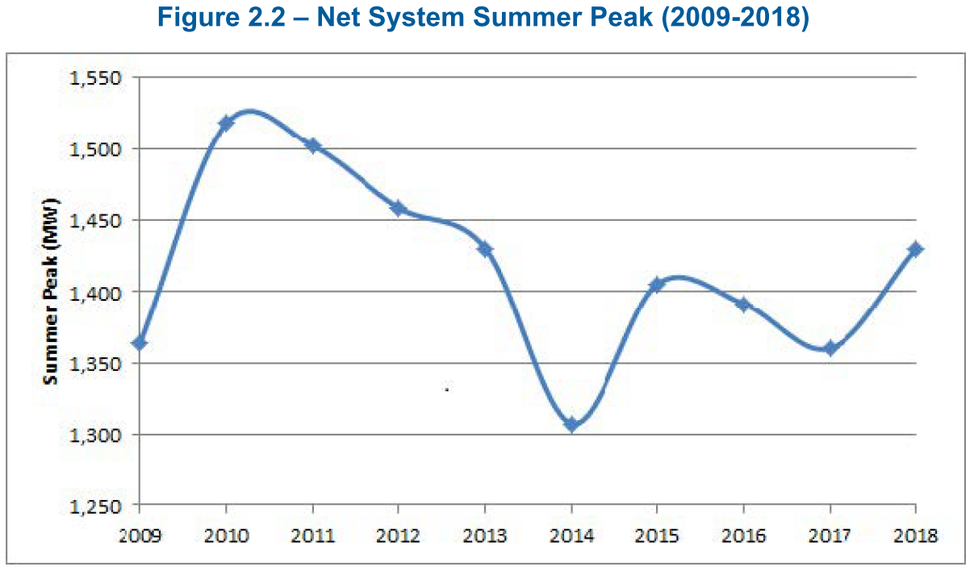
Question(s):
- Given the relatively flat or downward-trending net system summer peak load profile over the past decade, are the proposed capacity investments attributable solely to localized constraints driven by localized/suburb load additions?

- Are operating margins increasing elsewhere in the system where loads are not growing or are shrinking?

- What happened in 2014 to cause the abnormally low summer peak?

- What was the 2019 summer peak?

2-Staff-15
Ref: Exhibit 2 / Tab 4 / Schedule 3 / page 30 of 374
Preamble:
Regarding the age of its system, Hydro Ottawa stated (emphasis added):
Large segments of the system were constructed in the 1960s, 1970s, and 1980s, with a typical expected service life for these assets on the order of 50 years. Consequently, a considerable proportion of the system has exceeded or is approaching its anticipated end of life. These aging assets pose an increasing failure potential, and without corrective actions, will impact the utility’s ability to maintain system reliability and minimize unplanned renewal cost in the future.
Question(s):
- Does Hydro Ottawa historic data show evidence that assets assessed to be in Very Good, Good or Fair condition regularly fail unexpectedly or deteriorate precipitously?
  - If yes, what percentage for each category fails unexpectedly?
  - If no, given the Good and Very Good asset condition assessment results for the bulk of assets in most asset classes (with the possible exception of poles), is the emphasized statement above actually valid?

2-Staff-16
Ref: Exhibit 2 / Tab 4 / Schedule 3 / page 37 of 374
Preamble:
Regarding ice accumulation and snow loading, Hydro Ottawa stated:
Another impact of the harsh winters is an increased use of road salt which can lead to premature rusting of equipment located along the road right of way. The salt spray from roadways increases the need to repaint and repair rusted underground and overhead equipment. Salt contamination on porcelain insulators can lead to pole fires and flashovers. Insulator washing is necessary to mitigate the risk of these failure modes.
Question(s):
- Does Hydro Ottawa use or has Hydro Ottawa evaluated the use of silicone insulators near busy roadways to minimize the need for insulator washing?

- Does Hydro Ottawa still use porcelain insulators next to busy roads?
  - If not, in which year did Hydro Ottawa change its past practice?

2-Staff-17
Ref: Exhibit 2 / Tab 4 / Schedule 3 / page pp. 38-39 of 374
Preamble:
Regarding the effect of climate change on freeze-thaw cycles, Hydro Ottawa stated:
The annual number of freeze-thaw cycles is projected to decrease under climate change, from a baseline (1981-2010) mean of ~76 cycles per year to 59-60 cycles per year by the 2050’s. While the number of freeze-thaw cycles is projected to decrease in many months under climate change, increases are projected for the months of December, January, and February, during which freeze-thaw cycles can be particularly damaging.
Question(s):
- Why is a freeze-thaw cycle particularly damaging in December-January-February as compared to a freeze-thaw cycle in October, November, March, or April?

2-Staff-18
Ref: Exhibit 2 / Tab 4 / Schedule 3 / page 52 of 374
Preamble:
Regarding its Touch Logic customer survey, Hydro Ottawa provided the following table:
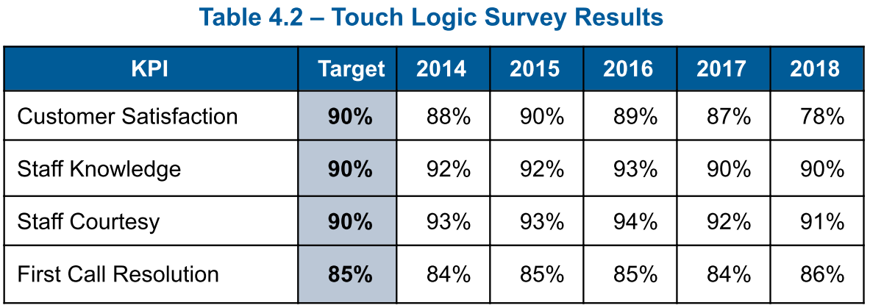
Question(s):
- What caused the drop in customer satisfaction in 2018?

- What are the 2019 results?

2-Staff-19
Ref: Exhibit 2 / Tab 4 / Schedule 3 / page 53 of 374
Preamble:
Regarding its SIMUL customer survey, Hydro Ottawa provided the following table:
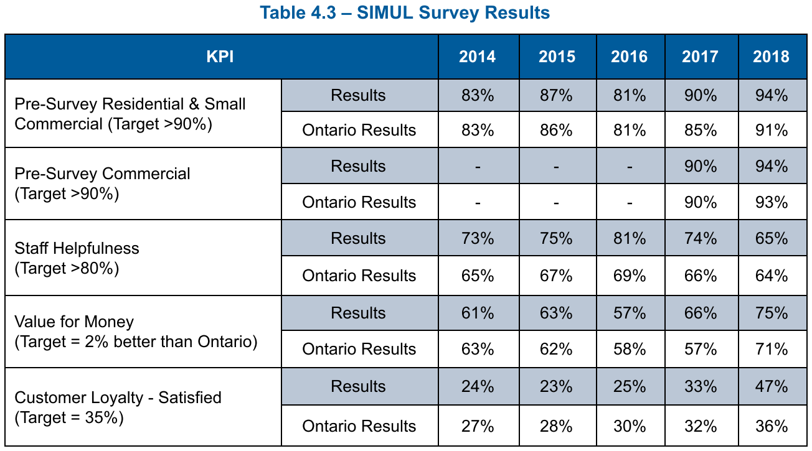
Question(s):
- Please provide descriptions for each KPI, including:
  - Definition of the KPI
  - How each KPI is measured
  - Source of Ontario data
  - Source of target level

- Please explain why the following measures consistently fail to achieve the target:
  - Staff Helpfulness
  - Customer Loyalty

2-Staff-20
Ref: Exhibit 2 / Tab 4 / Schedule 3 / page 55 of 374
Preamble:
Regarding its system average interruption frequency, Hydro Ottawa provided the following graph:
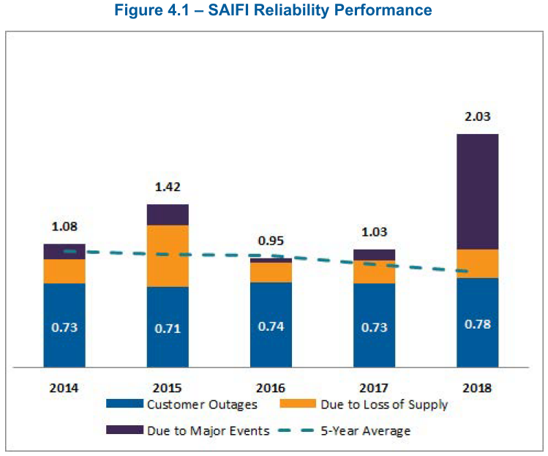
Question(s):
- Are 2019 results available?
  - If yes, please provide an updated figure that includes the 2019 results.

2-Staff-21
Ref: Exhibit 2 / Tab 4 / Schedule 3 / pp. 62-63 of 374
Preamble:
Regarding its System Average Root Mean Square (RMS) Variation Frequency Index results, Hydro Ottawa stated:
As indicated in Figure 4.7, there were 5,637 [variation] events recorded in 2018. Of these, 44 fell within the prohibited region. Of the 44 prohibited events, five were due to events on Hydro Ottawa’s system. There were no known customer impacts from these short duration RMS events. Hydro Ottawa continues to track and monitor SARFI events.
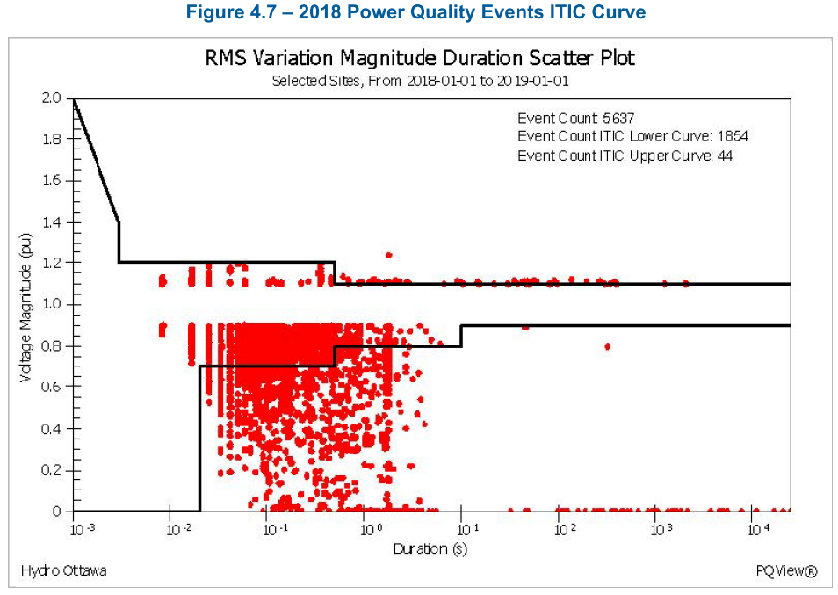
Question(s):
- Is Hydro Ottawa planning to take any steps to address the causes of the 5 prohibited events recorded in 2018 caused by factors in its system?

- Are there any steps Hydro Ottawa can take to mitigate events similar to those caused by factors outside of Hydro Ottawa’s system?

- Has Hydro Ottawa assigned an economic value to the power quality issues?
  - If yes, please provide details.

- In Figure 4.7, how many sites are measured and how were the selected sites chosen?

2-Staff-22
Ref: Exhibit 2 / Tab 4 / Schedule 3 / page 64 of 374
Preamble:
Regarding its cost efficiency indicator, Hydro Ottawa stated:
The target of the cost efficiency indicator is to achieve 100% completion of the annual planned work within the approved budget.
The yearly Cost Efficiency is shown in Table 4.8.
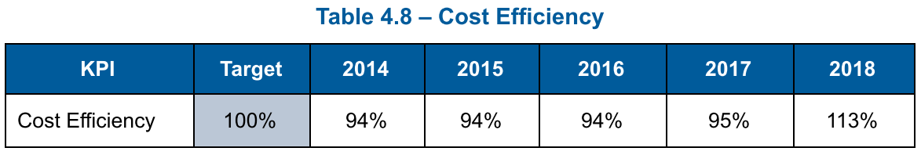
Question(s):
- Please explain when and how the "approved budget" input used in this calculation is established.

- Are there circumstances in which the approved budget is later changed? If yes, please explain.

- For the cost efficiency metric, please confirm if a figure below 100% indicates that total costs are less than all costs associated with completion of all projects identified in the “approved budget”.
  - If no, please describe how the Cost Efficiency metric is calculated.

- Please discuss whether Hydro Ottawa would consider including this Cost Efficiency metric in its proposed Custom Performance Scorecard.

2-Staff-23
Ref: Exhibit 2 / Tab 4 / Schedule 3 / page 66 of 374
Preamble:
Regarding its labour allocation, Hydro Ottawa provided the following table and comment:
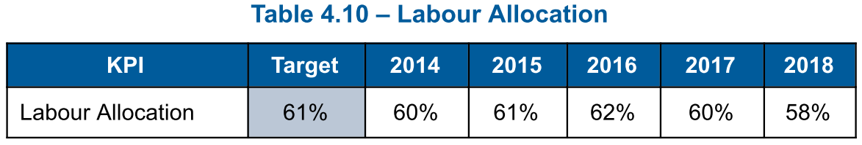
The reduction observed in 2018, over 2017, results primarily from an increase in mutual aid responses undertaken in that year.
Question(s):
- When was the target rate (of 61%) set?

- Why is 61% considered the optimal allocation of labour costs?

- Does Hydro Ottawa revisit the target rate periodically? Please explain.

2-Staff-24
Ref: Exhibit 2 / Tab 4 / Schedule 3 / page 67 of 374
Preamble:
Regarding its asset performance, Hydro Ottawa provided the following table:
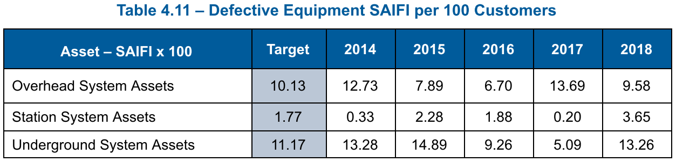
Question(s):
- What are the primary drivers of the inter-annual variability in these results, given that these outages are notionally caused by defective equipment?

- Do weather events or any other external factors contribute to increased impact of defective equipment in certain years?
  - If yes, please explain why these are classified as defective equipment events rather than storm/weather events.

- Do the SAIFI results incorporate interruption events driven by factors outside the control of Hydro Ottawa?
  - If yes, why does Hydro Ottawa measure itself using a metric that includes events that are outside of Hydro Ottawa's control?

2-Staff-25
Ref: Exhibit 2 / Tab 4 / Schedule 3 / page 68 of 374
Preamble:
Regarding public safety concerns, Hydro Ottawa provided the following table:
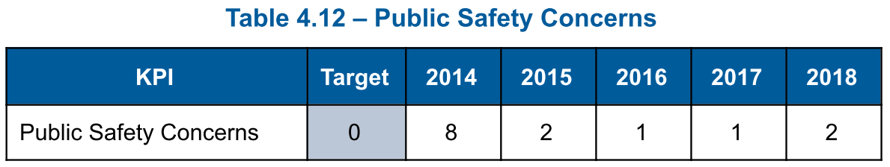
Question(s):
- What constitutes a "Public Safety Concern"?

- How are they reported and by whom?

- How are they assessed and validated by Hydro Ottawa?

2-Staff-26
Ref: Exhibit 2 / Tab 4 / Schedule 3 / page 69 of 374
Preamble:
Regarding oil spills, Hydro Ottawa provided the following table:
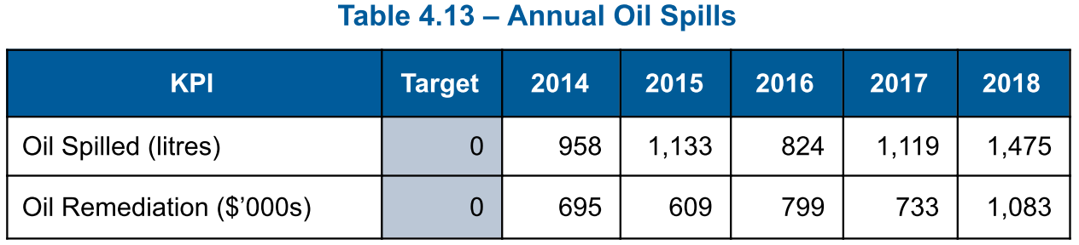
Question(s):
- What are the primary causes of Hydro Ottawa's oil spills?

- Are oil spills from transformers only counted if the spill escapes the oil containment structure?

- Do all Hydro Ottawa transformers have oil containment structures?

- How many events of oil spills occurred in each year between 2014 and 2018?

- Does Hydro Ottawa have data available to compare its annual oil spills, in terms of litres spilled and number of oil spill events, with its LDC peers?

2-Staff-27
Ref: Exhibit 2 / Tab 4 / Schedule 3 / page 70 of 374
Exhibit 2 / Tab 4 / Schedule 3 / page 72 of 374
Preamble:
Regarding stations capacity, Hydro Ottawa stated:
To improve System Accessibility, Stations Capacity KPIs are tracked to provide insight for larger medium- and long-term capacity needs, as well as smaller capacity deficits that may be solved through load transfers.
Regarding its stations exceeding their planned capacity, Hydro Ottawa provided the following table:
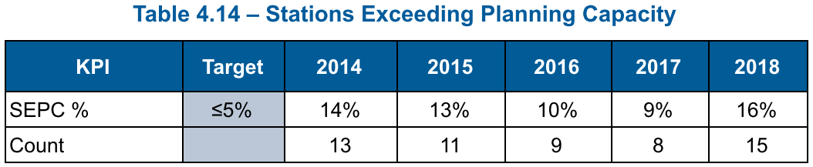
Question(s):
- Does Hydro Ottawa have a target station capacity factor (average load / rated capacity)?

- Does a low capacity factor indicate that assets are underutilized?

- In Table 4.14, what caused the spike in 2018?

- Is the 2019 SEPC% available for Table 4.14?

2-Staff-28
Ref: Exhibit 2 / Tab 4 / Schedule 3 / pp. 75-76 of 374
Preamble:
Regarding its feeder capacities, Hydro Ottawa provided the following Table:
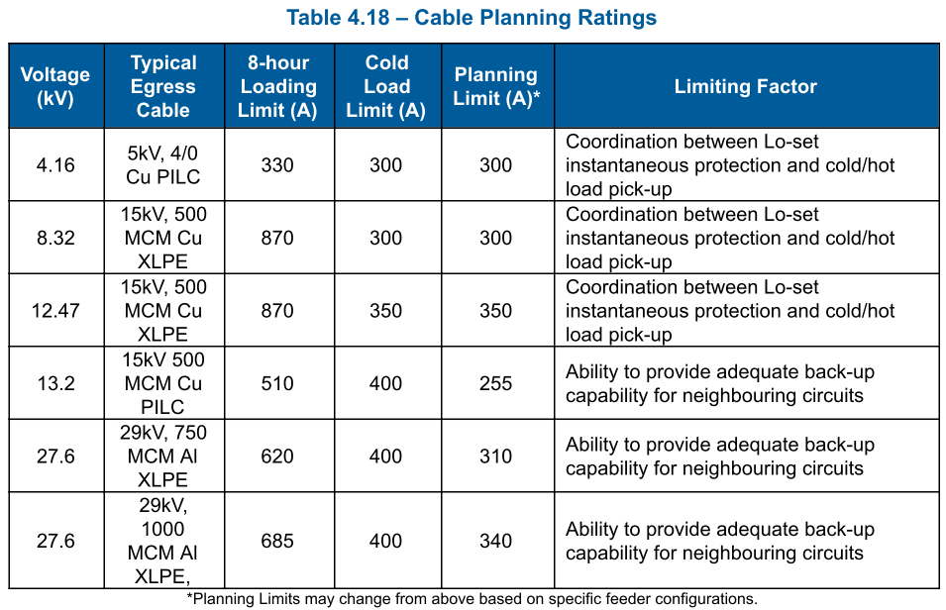
The rated capacity is defined as the egress cable 8-hour loading limit. If the circuits are loaded above this limit for longer than eight hours it will cause overheating and accelerated loss of life.
Question(s):
- Why is the planning limit set by the ability to provide adequate back-up capability for neighbouring circuits for 13.2 kV and 27.6 kV feeders and not feeders operating at other voltages?

- If egress cables are often the limiting factor for this KPI, does this indicate that Hydro Ottawa’s standard egress cable sizes are too small to adequately support the connected feeders?

- How is egress cable size selected?

2-Staff-29
Ref: Exhibit 2 / Tab 4 / Schedule 3 / page 77 of 374
Preamble:
Regarding unit cost metrics, Hydro Ottawa provided the following table:
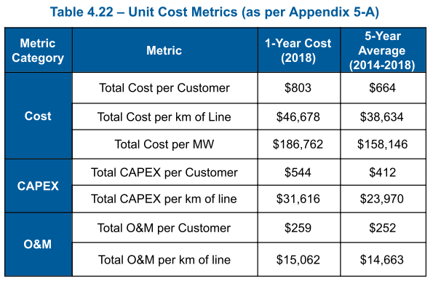
Question(s):
- What is causing the unfavourable unit cost trends?

- Does Hydro Ottawa anticipate these unfavourable trends to continue over the forecast period?

2-Staff-30
Ref: Exhibit 2 / Tab 4 / Schedule 3 / page 81 of 374
Preamble:
Regarding its historical reliability, Hydro Ottawa provided the following graph:
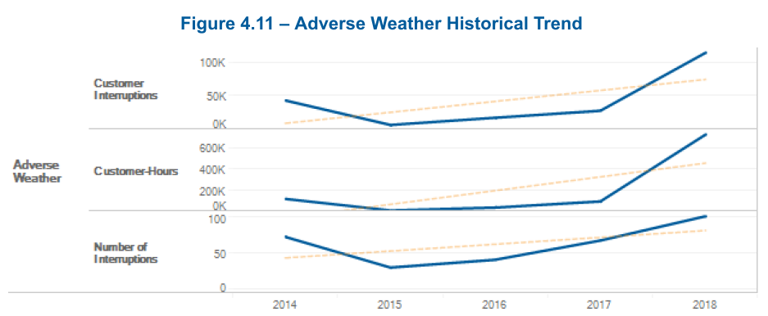
Question(s):
- Please provide updated graph which also includes 2019 results.

- Does a one-year outlier (i.e. 2018) create a statistically meaningful trend?

- Please confirm that the 2014 – 2017 trend is decreasing?

- Are any of the capital expenditures forecast in the present filing intended to improve Hydro Ottawa system performance in the face of increasing levels of extreme weather?
  - If yes, please identify, quantify the expenditures.
  - If yes, how will Hydro Ottawa measure if the expenditures are having the anticipated impact upon performance?

2-Staff-31
Ref: Exhibit 2 / Tab 4 / Schedule 3 / page 66 of 374
Exhibit 2 / Tab 4 / Schedule 3 / page 91 of 374
Preamble:
Regarding defective equipment contributing to SAIFI, Hydro Ottawa stated:
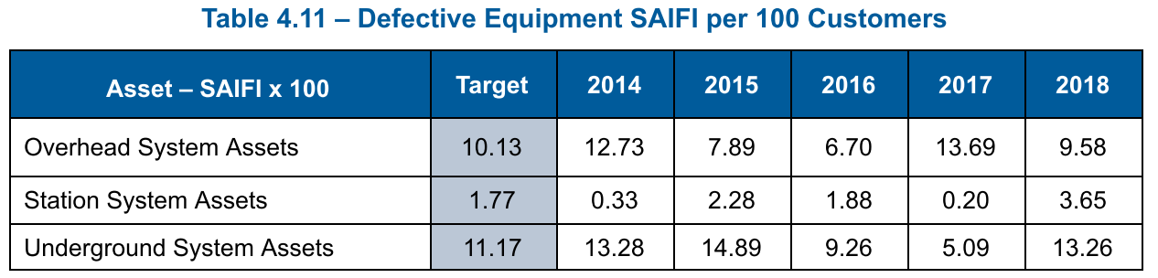
Regarding the impact of historical performance on the DSP, Hydro Ottawa stated:
Based on historical performance of Asset Performance, Hydro Ottawa has made the following changes:
- Increased frequency of customer interruption due to cable failure is driving increased investment in the cable renewal program.
- Recent Oil Spilled trends are showing more leaking residential underground transformers, which have increased the cost of remediation. This emphasizes the importance of active inspection and replacement of underground transformers to mitigate this environmental impact.
Question(s):
- Please reconcile this statement with the historically decreasing trend in the defective underground equipment contribution to SAIFI shown in Table 4.11.

- Regarding oil spilled from underground transformers, is this an equipment “type fault”?
  - If yes, are there any practical mitigations other than replacement?

2-Staff-32
Ref: Exhibit 2 / Tab 4 / Schedule 3 / page 93 of 374
Preamble:
Regarding its smart meters, Hydro Ottawa stated:
Due to an early adoption of the provincial smart meter initiative, Hydro Ottawa’s smart meters have very limited last gasp functionality. In 2006, the self-reporting technology offered limited functionality.
Question(s):
- What is the remaining service life of the existing smart meter fleet?

- Will Hydro Ottawa be faced with the need to replace a significant portion of its smart meters in the near future?
  - If yes, in which years will that occur and what is the forecast cost each year?

2-Staff-33
Ref: Exhibit 2 / Tab 4 / Schedule 3 / page 135 of 374
Preamble:
Regarding modernization of its distribution system, Hydro Ottawa stated:
When station transformers are identified for replacement, the new units will have reverse flow capabilities to eliminate potential restrictions to connecting ERFs.
Question(s):
- What is the cost differential between reverse flow and uni-direction transformers?

- Is Hydro Ottawa’s current standard practice to use reverse flow transformers for every new station installation?
  - If no, what circumstances result in decision to install reverse flow transformers.

- Can existing uni-directional transformers be modified or retrofitted to provided service in reverse-flow applications?
  - If yes, what is the typical project scope and cost of upgrading a representative transformer size and voltage class?

2-Staff-34
Ref: Exhibit 2 / Tab 4 / Schedule 3 / page 142 of 374
Preamble:
Regarding its station transformers, Hydro Ottawa stated:
The health index of a transformer is determined through various criteria such as visual inspections, power factor tests, load history, infrared scanning, oil analysis (dissolved gas analysis and degree of polymerization), as well as additional criteria for on-load tap changers if applicable. The resultant health index is a condition rating from Very Good to Very Poor.
Question(s):
- Does Hydro Ottawa’s station transformer health index use age as a calculation input?

- Does Hydro Ottawa determine station transformer replacement needs based upon the health index, asset age, or both?
  - If age is used in the decision, please provide an example of when age factors override health index factors in the determination to replace an asset?

- Has Hydro Ottawa assessed a probability of failure based upon asset health index?

2-Staff-35
Ref: Exhibit 2 / Tab 4 / Schedule 3 / page 146 of 374
Preamble:
Regarding its station switchgear and breaker, Hydro Ottawa stated:
The expected service life of oil breakers is 55 years, and the average age is 54. The expected service life of gas (SF6) breakers is 51 years, and the average age is 24. The expected service life of vacuum breakers is 46 years, and the average age is seven. There are 532 breakers that have reached their expected service life, and 49 that are within 10 years of their expected service life.
Question(s):
- Is the expected service life figure for this asset class derived using equipment supplier estimates?
  - If not, how is it determined?

- Is Hydro Ottawa’s own fleet empirical data incorporated to determine service life?

- Please confirm that the average age is based upon Hydro Ottawa's fleet numbers.

- Please explain why there is a significant difference between the expected service life (46 years) and the average age for vacuum breakers ( 7 years).

2-Staff-36
Ref: Exhibit 2 / Tab 4 / Schedule 3 / page 151 of 374
Preamble:
Regarding its station batteries, Hydro Ottawa stated:
There are no batteries that are past their expected service life and six batteries that are within 10 years of their expected service life.
Question(s):
- Are there any condition assessments being done for the batteries, or are they simply being replaced whenever they reach the end of their expected service lives?

2-Staff-37
Ref: Exhibit 2 / Tab 4 / Schedule 3 / page 154 of 374
Preamble:
Regarding its protection and control equipment, Hydro Ottawa provided the following figure:
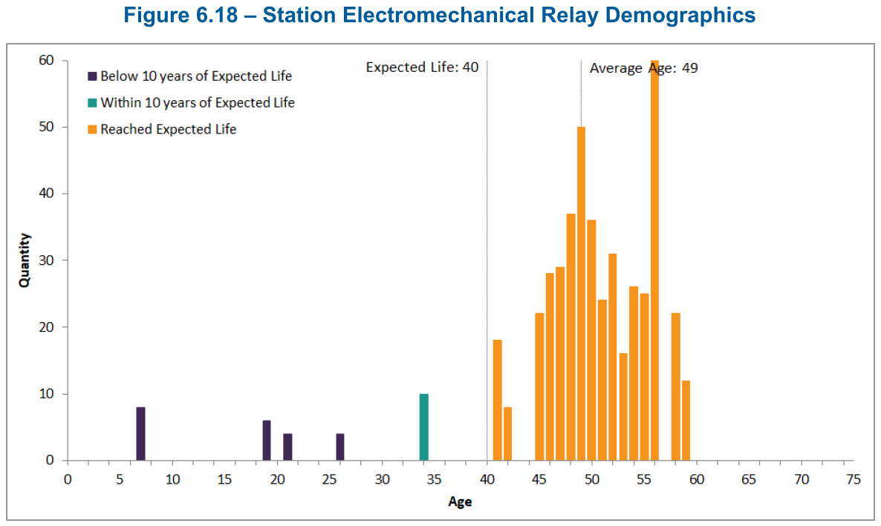
Question(s):
- Are health index measurements performed for electromechanical relays?

- Please explain why the majority of station electromechanical relays have remained in service well beyond their expected lives.

2-Staff-38
Ref: Exhibit 2 / Tab 4 / Schedule 3 / pp. 165-166 of 374
Preamble:
Regarding the condition of its overhead transformers, Hydro Ottawa provided the following figures:
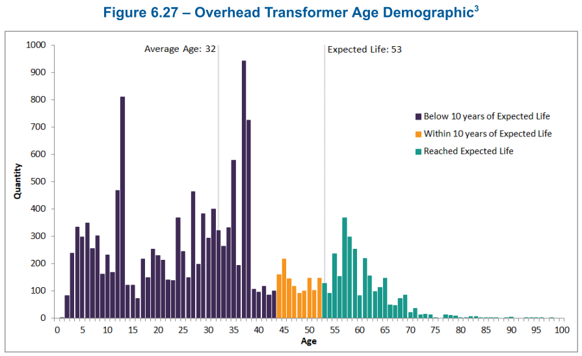
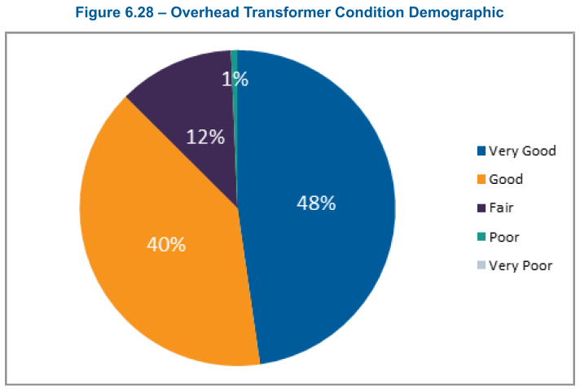
Question(s):
- Please explain why condition assessment for the overhead transformer fleet (Figure 6.28) is materially better than what appears to be implied by the age demographic chart (Figure 6.27)?

- What percentage of oil spills (referenced Table 4.13) relate to equipment represented in Figure 6.28?

2-Staff-39
Ref: Exhibit 2 / Tab 4 / Schedule 3 / page 169-170 of 374
Preamble:
Regarding the condition of its overhead switches, Hydro Ottawa provided the following figures:
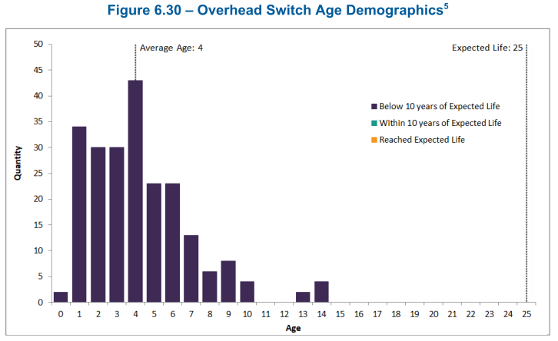
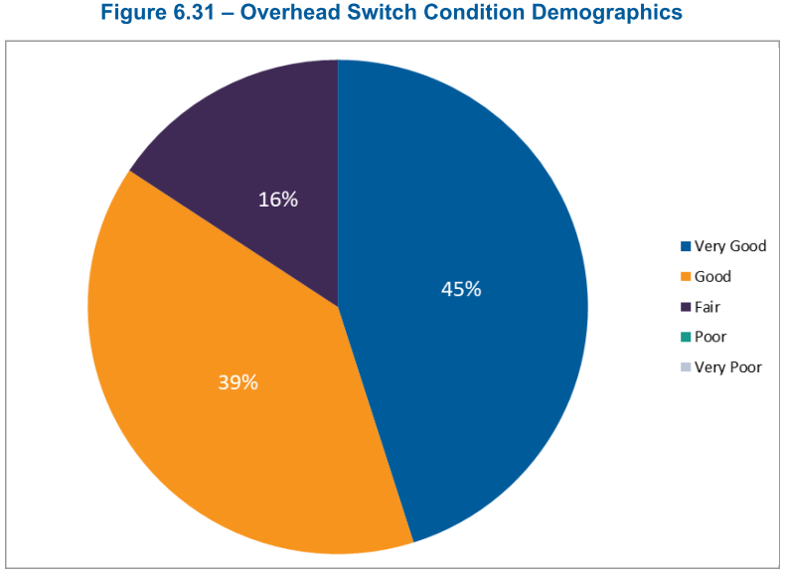

Question(s):
- Why are such a significant proportion of overhead switches in Good or Fair condition (rather than Very Good) despite the relatively young age demographic grouping of the assets? Is there a type fault or a maintenance issue preventing most of them from being classified as Very Good?

2-Staff-40
Ref: Exhibit 2 / Tab 4 / Schedule 3 / pp. 173-174 of 374
Preamble:
Regarding the condition of its PILC cables, Hydro Ottawa provided the following figures:
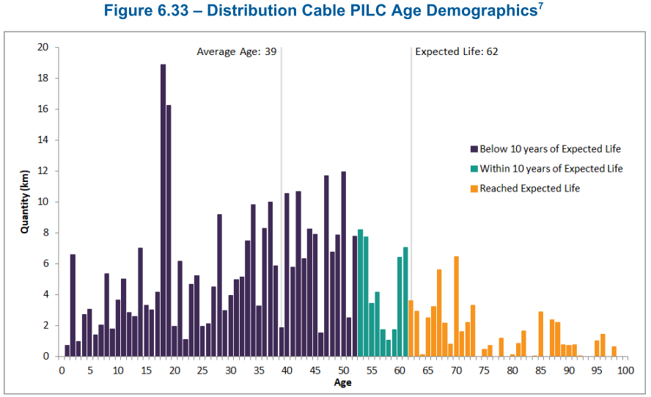
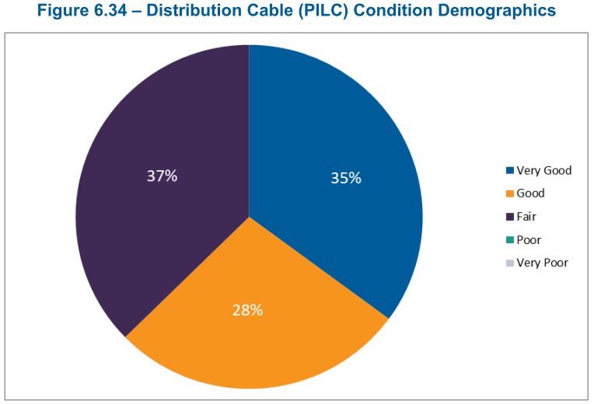
Question(s):
- If health index is based partly or largely upon age, why are no cables rated as poor or very poor?

2-Staff-41
Ref: Exhibit 2 / Tab 4 / Schedule 3 / page 177 of 374
Preamble:
Regarding its polymer distribution cables, Hydro Ottawa provided the following figure:
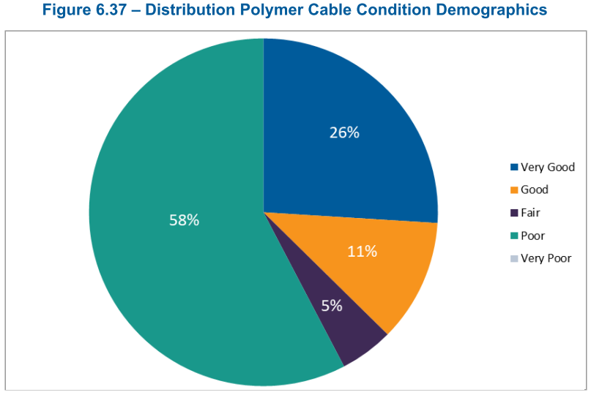
Question(s):
- Why does the polymer cable fleet demonstrate significantly worse health index demographics than the PILC cables shown in Figure 6.34?

2-Staff-42
Ref: Exhibit 2 / Tab 4 / Schedule 3 / page 194 of 374
Preamble:
Regarding its asset replacement and refurbishment policies, Hydro Ottawa stated:
Refurbishment is expected to renew the asset and extend the expected service life.

Question(s):
- Does Hydro Ottawa adjust the expected service lives of assets that are refurbished (i.e. as reflected in improved health index scores), to account for the anticipated extended period of useful service?

2-Staff-43
Ref: Exhibit 2 / Tab 4 / Schedule 3 / page 196 of 374
Preamble:
Regarding its station transformers, Hydro Ottawa stated:
Various monitoring technologies have been added to station transformers due the consequences associated with a failure. These include online dissolved gas analysis (“ODGA”), winding and oil temperature, tap changer status, cooling fan status, and loading information. Warnings and alarms from these monitoring units allow Hydro Ottawa to identify the need for corrective actions with real-time data.
Question(s):
- Please explain the calibration methodology for alarm settings.

- How frequently does Hydro Ottawa confirm the calibration settings?

- Has Hydro Ottawa noticed (or does Hydro Ottawa anticipate) operational efficiencies based on the new monitoring technologies? Please explain why or why not.

2-Staff-44
Ref: Exhibit 2 / Tab 4 / Schedule 3 / page 197 of 374
Preamble:
Regarding station switchgear and breakers, Hydro Ottawa stated:
Every 10 years, detailed preventative maintenance is performed on the entire switchgear assembly. Switchgear maintenance includes detailed internal visual inspections, insulation resistance tests, and ensuring that there are no structural deficiencies, such as cracks, leaks or warped metal in the switchgear.
Question(s):
- Have switchgear and breaker maintenance schedules been changed or refined as a result of Hydro Ottawa’s evolving asset management program? Please explain.

2-Staff-45
Ref: Exhibit 2 / Tab 4 / Schedule 3 / pp. 203-204 of 374
Preamble:
Regarding the capacity of its existing stations, Hydro Ottawa provided the following table and commentary:
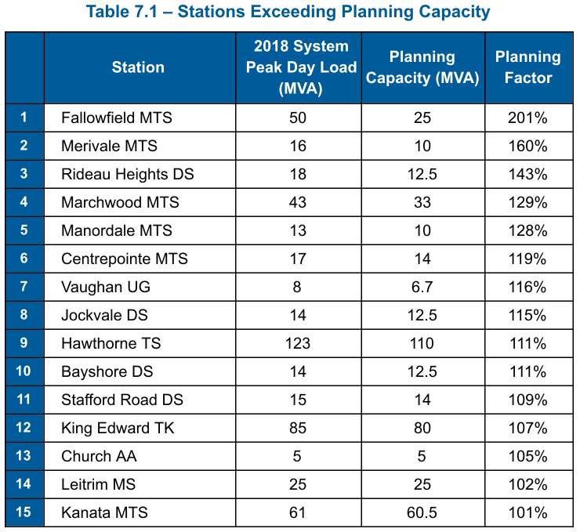
Merivale and Rideau Heights Stations in the Nepean Core 8kV area continue to be above their planning capacity limits. A project to increase capacity at Merivale station is currently in progress and expected to be energized by the end of 2019, enabling a decrease of load at Rideau Heights station.

Hawthorne Station was a new addition to the list in 2018. Hydro One Networks Inc. (“HONI”) is currently replacing the transformers and increasing capacity at this station. The project was set to be completed by Q4 2019.
Question(s):
- Please provide any differences between the information shown in this table and the same information as it existed at the time of Hydro Ottawa’s last rebasing application.

- Is the number of stations operating above planning capacity unusually high compared with Hydro Ottawa’s historical experience?
  - If yes, how long has Hydro Ottawa had a similar number of stations operating above planning capacity?

- What are the nameplate capacities for the stations shown in Table 7.1?

- Were the Merivale and Hawthorne projects completed?
  - If yes, please update the table correspondingly.

2-Staff-46
Ref: Exhibit 2 / Tab 4 / Schedule 3 / page 205 of 374
Preamble:
Regarding its existing feeder capacity, Hydro Ottawa provided the following table:
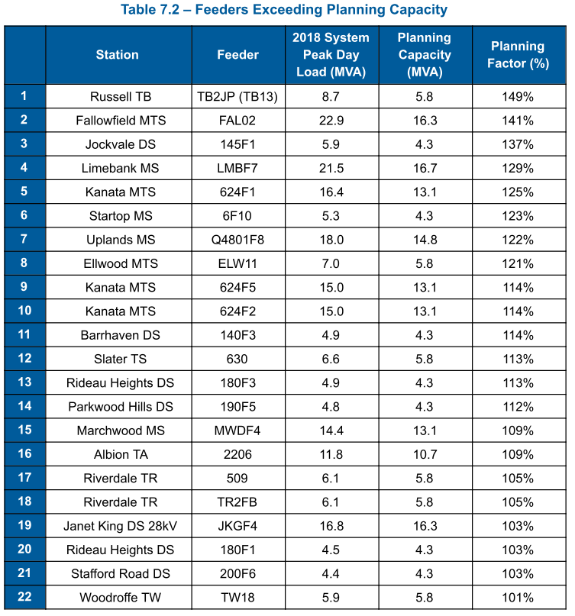
Question(s):
- Please provide any differences between the information shown in this table and the same information as it existed at the time of Hydro Ottawa’s last rebasing application.

- Does Hydro Ottawa consider this to be a high number of feeders operating above capacity?
  - If yes, how long has Hydro Ottawa had a similar number of feeders operating above capacity?

- What is the operational rated capacity of the feeders shown in Figure 7.2?

2-Staff-47
Ref: Exhibit 2 / Tab 4 / Schedule 3 / page 215 of 374
Preamble:
Regarding its system load forecast, Hydro Ottawa provided the following figure:
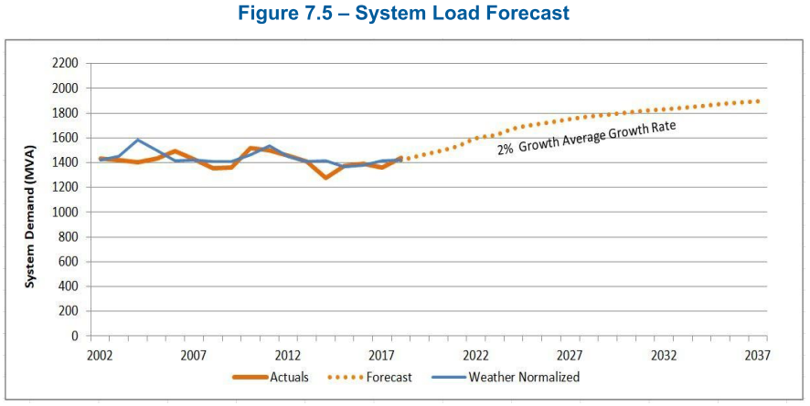
Question(s):
- Is the 2% average growth forecast primarily driven by the number of new customers or the expected usage per customer?
  - If primarily driven by the number of new customers, how does the forecast number of new customers over the test period compare to the number of actual new customers that were connected during the historic period (e.g. 2014 – 2018)?
  - What was the 2014 – 2018 new customer forecast at the time of Hydro Ottawa’s last rebasing application?
  - If primarily driven by the forecast usage per customer, how does the usage per customer forecast over the test period compare to the actual per customer usage over the historic period (e.g. 2014 – 2018)?
  - What was the forecast change in usage per customer over the 2014 – 2018 period at the time of Hydro Ottawa’s last rebasing application?

- How does the actual 2002 – 2018 load shown in Figure 7.5 support an expected 2% load growth trend? Please explain what has changed.

- Please explain the downward inflection of the growth projection (around 2025). What is expected to change at that time to cause the downward inflection?

2-Staff-48
Ref: Exhibit 2 / Tab 4 / Schedule 3 / pp. 255-257 of 374
Preamble:
Regarding energy resource facilities, Hydro Ottawa stated and provided the following:
Interest in generation projects within Hydro Ottawa’s service area has fluctuated over the historical years driven by external factors. Removing connections larger than 1 MW results in a historical increasing trend in connected capacity for 2016-2019, as shown in Figure 7.39 below. This increasing trend is expected to continue. Thus, an ERF annual growth rate of 11% has been applied to the forecast for the next five years.

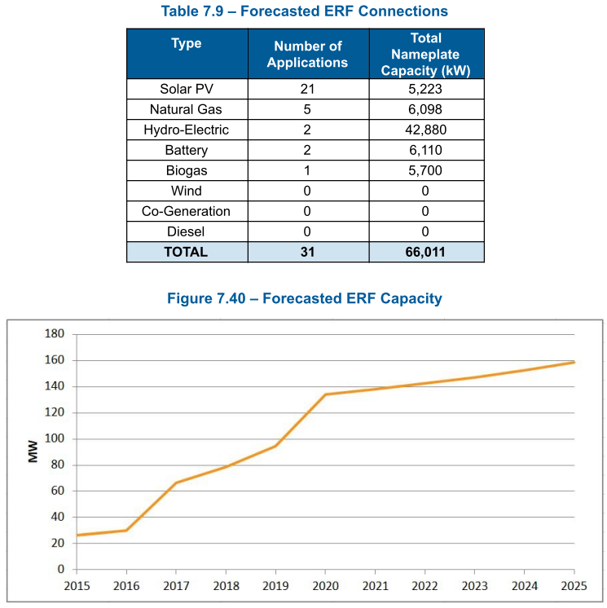
Question(s):
- Please identify all capital investments that are primarily or largely intended to accommodate the 11% Energy Resource Facility (ERF) growth forecast?

- What capital reduction would be possible if ERF growth is half that shown in Figure 7.40?

- To which years does Table 7.9 correspond?

- What is prompting the growth from 2020 to 2025 in Figure 7.40 of approximately 25 MW?

- Does the ERF growth forecast during the test period assume any government financial support or government off-taker arrangements?

- Do Table 7.9 and Figure 7.40 account for the impact of the recent cancellation of the Ontario FIT program? If not, please update.

2-Staff-49
Ref: Exhibit 2 / Tab 4 / Schedule 3 / page 272 of 374
Preamble:
Regarding its expenditure drivers, Hydro Ottawa provided the following table:
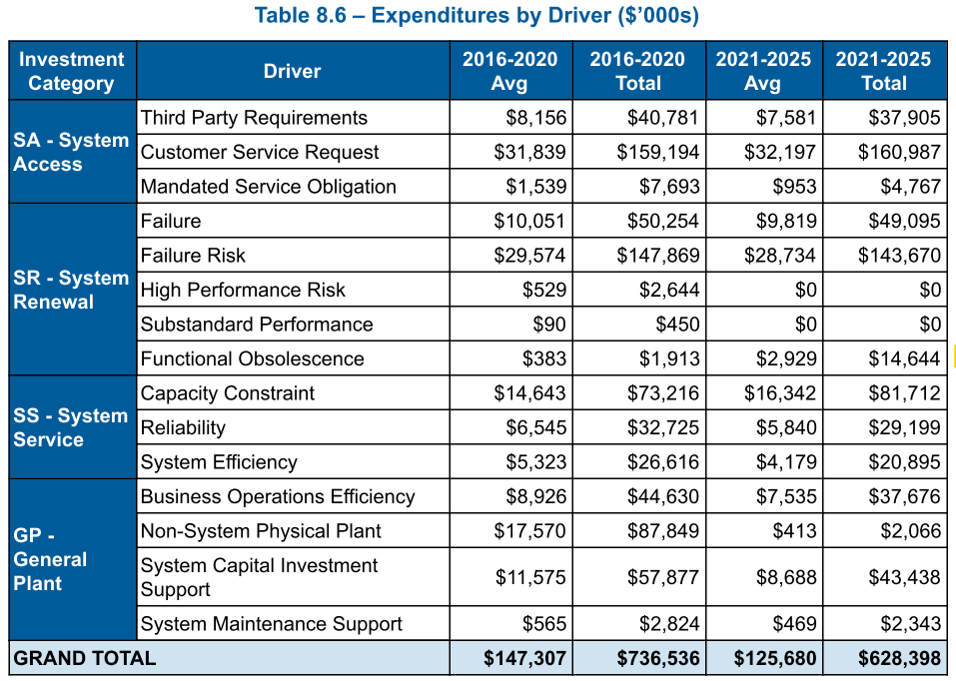
Question(s):
- What are the primary drivers of the significant increase in functional obsolescence spending in 2021-2025, and which assets are most impacted?

- Why is the System Renewal failure average lower in the forecast period than the historical period?

2-Staff-50
Ref: Exhibit 2 / Tab 4 / Schedule 3 / page 281 of 374
Preamble:
Regarding climate adaptation, Hydro Ottawa stated:
Renewal of aged, and decayed overhead infrastructure to withstand climatic forces from storm events is key to resilience over the long term for the system. Most notably, Pole Renewal programs support the development of this resilience. Hydro Ottawa will augment the impact of these renewal investments over the 2021-2025 period through the development of new anti-cascade standards and risk based application guides to further mitigate damage in high risk installations when damage does occur.
Question(s):
- Please describe the proposed new anti-cascade standards and the associated changes in line design practices.

- Do the proposed practices deviate from relevant industry standards typically utilized by Ontario distributors?
  - If yes, please describe the differences.

- Has Hydro Ottawa budgeted costs related to the implementation of new anti-cascade standards for 2021-2025?
- If so, please specify the budget.
- If so, what’s the incremental per-unit cost (i.e. cost per km of new line construction) associated with implementing the additional anti-cascade functionality as a ratio of the historical per-unit costs?

2-Staff-51
Ref: Exhibit 2 / Tab 4 / Schedule 3 / pp. 288-289 of 374
Preamble:
Regarding technology based opportunities, Hydro Ottawa stated:
Over the next five years, Hydro Ottawa will continue implementing grid technologies to improve the reliability and efficiency of the distribution system. Annual automation installations will continue to improve system reliability and operational performance. Continued investment in the communication infrastructure will be essential to support current automation plans while maintaining the flexibility to integrate the technologies of tomorrow.
…
Another follow up to the SCADA project is the integration of the existing Outage Management System (“OMS”)
…
In 2020, Hydro Ottawa will upgrade Copperleaf C55, an industry-leading and established Asset Investment Planning tool.
Question(s):
- How will benefits be assessed and quantified for:
  - Annual automation installations?
  - Communication infrastructure?
  - OMS?
  - Copperleaf C55?

2-Staff-52
Ref: Exhibit 2 / Tab 4 / Schedule 3 / Attachment E / pg. 27 of 534
Preamble:
Station Breaker Failure Rate
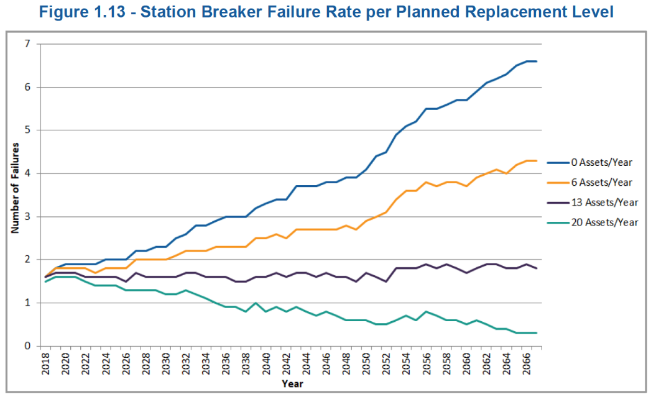
Question(s):
- Please provide the calculations and assumptions used to develop failure rate curves shown in Figure 1.13 and explain the relationship between the shown failure rate results, the Health Index values shown in Figure 1.10 and the SAIFI results shown in Fig 1.11.

2-Staff-53
Ref: Exhibit 2 / Tab 4 / Schedule 3 / Attachment E / pg. 75 of 534
Preamble:
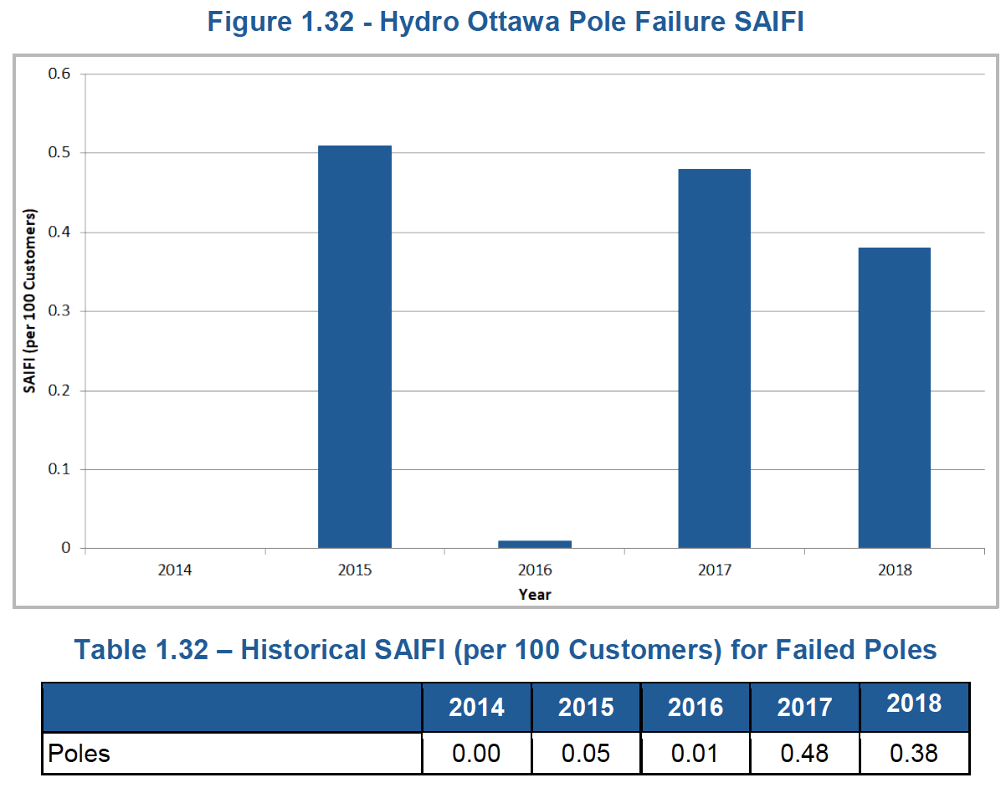
Discussing Failure / Reliability of Poles, Hydro Ottawa states:
The goal of the pole renewal program is to minimize the impact failed poles have on reliability, and by extension SAIFI and SAIDI (by replacing the pole before it fails), and to mitigate safety impacts associated with failed poles while undertaking renewal in a cost efficient planned manner. Further, given that many of Hydro Ottawa’s poles mechanically support assets containing oil, including overhead transformers, the proactive replacement of poles will also reduce the risk of oil released to the environment due to unforeseen pole failures.

Question(s):
- What are the reasons for the significant inter-annual variability of the SAIFI impacts of pole failures?

- Is the 2015 SAIFI value (0.05) shown in Table 1.32 correct?

- What is the typical trigger causing failure of poles assessed as being in poor and very poor condition? Do they typically fail in severe weather, due to some other external trigger (such as treefalls), or are spontaneous pole failures common? Please provide supporting data.

- Has Hydro Ottawa tracked the condition of poles that have failed in severe weather events to confirm that poles in poor and very poor condition poles have a higher failure probability than good and very good condition poles in such conditions?
  - If yes, please provide supporting data.
  - If no, why not?

- Hydro Ottawa indicates that poles supporting oil-filled devices have higher failure consequence than poles that do not support such devices. Has Hydro Ottawa prioritized its pole replacements to first replace all poles supporting oil-filled devices that are in very poor and poor condition?
  - If not, why not.

- If poles that don't support oil-filled devices have a lower failure consequence, is Hydro Ottawa able to defer replacement of such poles that are in very poor condition until all the very poor and poor condition poles supporting oil-filled devices have been replaced?
  - If not, why not?

2-Staff-54
Ref: Exhibit 2 / Tab 4 / Schedule 3 / Attachment E / pg. 94 of 534
Preamble:
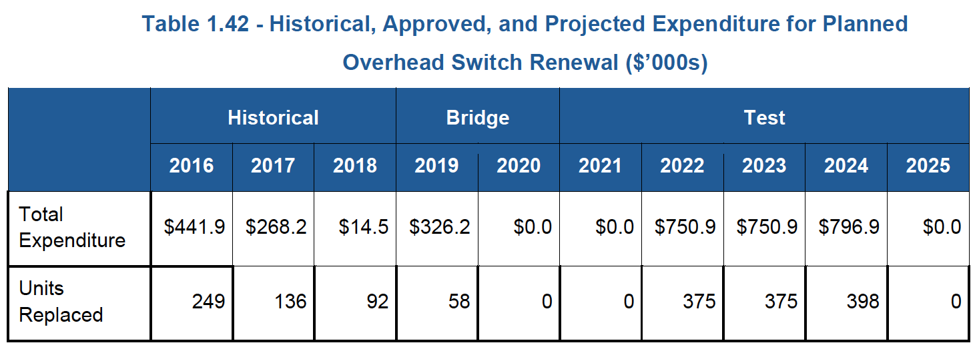
Question(s):
- Is the proposed significant increased spending on overhead switch replacements in 2022, 2023 and 2024 solely attributable to the porcelain-insulated switch replacement initiative?

- Please provide the expected change in system reliability performance that is expected to be achieved by implementing this replacement program, and provide the assumptions and calculations used to derive the change.

2-Staff-55
Ref: Exhibit 2 / Tab 4 / Schedule 3 / Attachment E / pp. 133 & 134 of 534
Preamble:
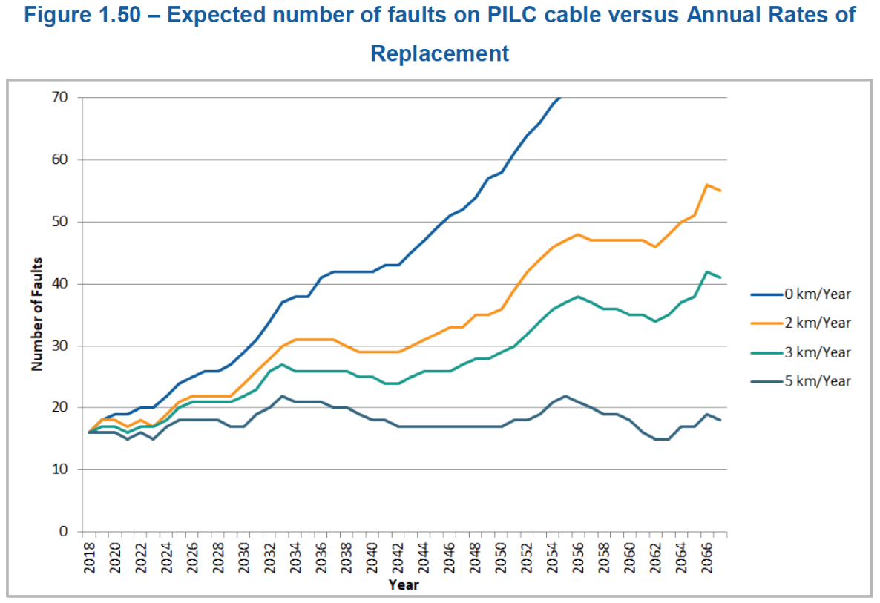
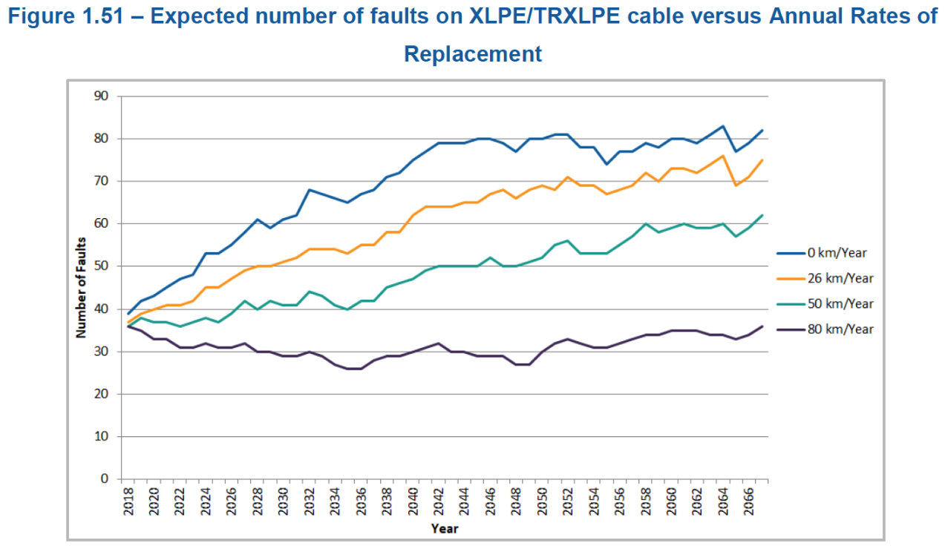
Question(s):
- Please provide the assumptions and calculations used to derive the curves shown in Figures 1.50 & 1.51.

- What is the reason for extending the failure forecast for 50 years?

- Please quantify the expected reliability impact for deferring the planned PILC replacements beyond the test period.

2-Staff-56
Ref: Exhibit 2 / Tab 4 / Schedule 3 / Attachment I / Stantec Hydro Ottawa Climate Adaptation Plan pg. 33 of 70
Preamble:
Table 12 on pg. 33 lists recommended climate change adaptation recommendations.
Question(s):
- Please identify which of the Stantec recommendations Hydro Ottawa intends to implement, which it will not be implementing and explain why in each case.

- Please identify any capital expenditures or incremental operating costs associated with the recommendations that will be implemented.

2-Staff-57
Ref: Exhibit 2 / Tab 4 / Schedule 3 / Attachment M / Metsco Review of Hydro Ottawa’s Asset Condition Assessment Framework pg. 6 of 13
Preamble:
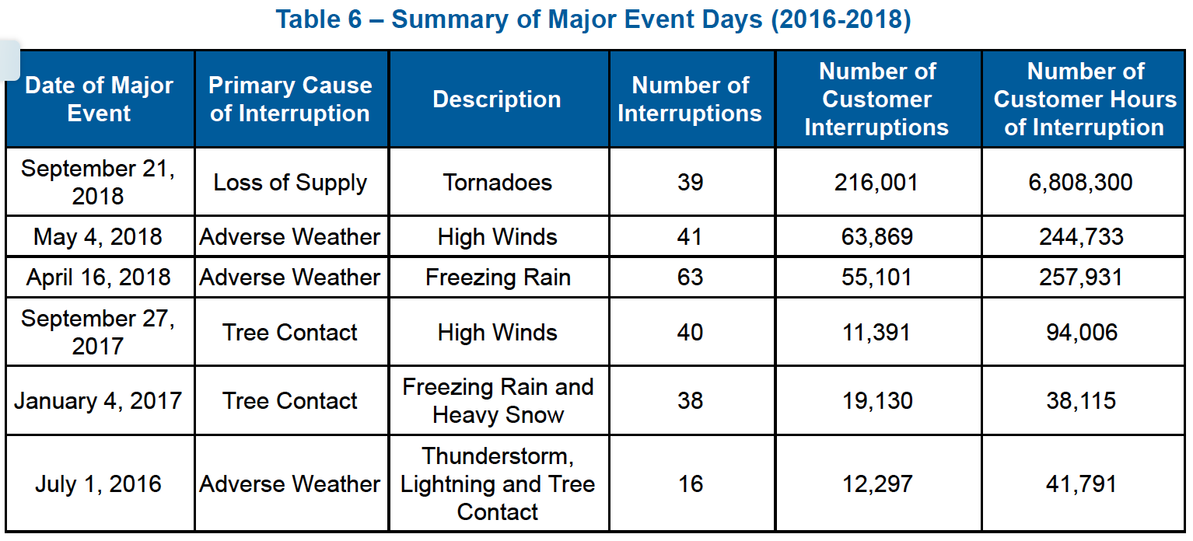
Table 6 shows that the MEDs on Sept 27, 2018, January 4 2017 and July 1, 2016 all featured Tree Contact as either the Primary Cause of Interruption or in the Description of the event, although high winds and freezing rain and heavy snow are given in the description in both 2017 events.
Question(s):
- Do these results indicate that Hydro Ottawa could improve its resilience to some major weather events by improving its brushing and tree management processes?
  - If no, please explain why not.

Capital Expenditure Plan

2-Staff-58
Ref: Exhibit 1/Tab 1/Schedule 9/Attachment A/pp.1-4 of 21
Exhibit 2/Tab 4/Schedule 3/page 269 of 374

Preamble:

An average forecast of capital expenditures of $95 million per year was developed in the initial budgeting process. The proposed capital expenditures average at $100.8 million per year for 2021-2025.
Question(s):
- Please explain how the initial average capital expenditures of $95 million was developed.

- Please explain key drivers for the change from the original average budget of $95 million to the proposed budget of $100.8 million per year.

- Please specify the inflation rates that were used for each year over the 2020-2025 period during the initial budgeting process.

Smart Grid Costs

2-Staff-59
Ref: Exhibit 2/Tab 4/Schedule 3/Attachment E/pp. 344-373 of 534
Exhibit 1/Tab 1/Schedule 5/page 8 of 19
Question(s):
- Please provide a copy of the Smart Energy Roadmap document that was prepared by the Smart Energy Steering Committee.

- Please clarify whether Table 5 (Updated Exhibit 1/Tab 1/Schedule 5/page 12 of 27) provides the complete list of projects/programs within the Smart Energy Roadmap for the 2021-2025 rate period. If no, please provide the complete list.

- Please provide the historical rate funded expenditures on each project/program listed in Table 5 (Updated Exhibit 1/Tab 1/Schedule 5/page 12 of 27) by year for the 2016-2020 period.

New Facilities

2-Staff-60
Ref: EB-2015-0004/Decision on Settlement and PO NO. 11/pp. 2-5
EB-2015-0004/Settlement Proposal (Refiled)/pp.18-19
Exhibit 2/Tab 1/Schedule 1/Attachment A

Preamble:
In the decision on Hydro Ottawa’s 2016-2020 Custom IR application, the OEB found that Hydro Ottawa has demonstrated the need for the new facilities. However, the OEB did not find sufficient evidence to determine the prudence of the $73 million cost estimate for the new buildings and the prudence of the $19 million cost for the 41 acres of land. Therefore, the OEB accepted a Y-factor treatment of up to $66 million for the new facilities and land. The $66 million was determined as the sum of the operations building budget of $22 million, 70% of the administration building budget of $41 million ($29 million) and land cost of $15 million. Any amounts above $66 million, $15 million for land and $51 million for facilities, are subject to a prudence review. The total project cost for the new facilities is $99,543,840.
Question(s):
- Please provide a breakdown (in the table below) of the construction and land cost for each facility compared to the cost projections proposed in the 2016-2020 Custom IR proceeding.

Table 2-Staff-60-1: Comparison of Actual Cost to Costs filed in the 2016-2020 Custom IR ($’000s)

 | Construction |  |  | Land
 | Actual | Per EB-2015-0004 | Variance ($) | Actual | Per EB-2015-0004 | Variance ($)
Ease Campus
EC-1 Administrative Office
EC-2 East Operations Centre
EC-3 PILC Storage
Sub-total
South Campus
SC-1 South Operations Centre and Warehouse
Total
- Please provide a breakdown of the total project cost of $99.5 million by year.

- Regarding land area requirement, the OEB found in the 2015 decision that “The total cost of $19 million includes 9 acres of excess land value at $4 million. The benefit to customers associated with the $4 million cost of excess land has also not been explained”. Please explain the benefit to customers associated with the $4 million cost of excess land compared to the original land estimate of 32 acres for $15 million.

- Please explain why the 9 acres of excess land is necessary compared to the original land estimate of 32 acres.

- Please explain whether the size of the EC-1 Administrative Office (127,132 square feet) provides any additional office space that can accommodate future staff growth. If so, please provide an estimate of the additional space available in the building. If not, why not.

- OEB staff notes that on a cost/sq. ft. basis, the actual cost for EC-1 Administrative Office increased from the projected $265/sq. ft. to $372/sq. ft. (40% increase), please discuss why the OEB should accept the actual spending on EC-1 as prudent considering the actual cost is 40% higher than the projected cost.

2-Staff-61
Ref: Exhibit 2/Tab 1/Schedule 1/Attachment A/pp. 43-44 of 73
EB-2015-0004/Settlement Proposal/Refiled December 7, 2015/page 15 of 60
Preamble:
The settlement agreement from the 2016-2020 Custom IR stated that value of the old facilities replaced by new facilities will be removed from rate base within the same calendar year of the new Administrative building going into service, or upon the sale of the old facilities, if that is earlier.

Hydro Ottawa noted that the Merivale Road, Albion Road Property A and Property C have been removed from rate base effective September 30, 2019. However, in order to help control project costs, it was decided by the Executive Management Team to retain the Bank Street facility for training centre and fleet management purposes instead of building new facilities for these functions. Albion Road B property is also being retained as there is a transformer station on that site.

Question(s):
- Please provide the net book value of the Bank Street facility as of December 31, 2019.

- Please provide the remaining service life of the Bank Street facility.

- Please explain how the decision of retaining the Bank Street facility provides benefits to ratepayers.

2-Staff-62
Ref: Exhibit 2/Tab 1/Schedule 1/Attachment A/pp. 17-18 of 73

Hydro Ottawa noted that the $92.3 million filed in the 2016-2020 Custom IR application was based on a Class D cost estimate (April 29, 2015). A more thorough Class C estimate of $124.7 million was developed on January 20, 2016. On May 18, 2016, the value engineering and revised design validation was completed and a detailed Class B estimate was prepared.

Question(s):
- Please provide a copy for the detailed Class D, Class C, and Class B cost estimates.

- Please clarify whether there was a Class A cost estimate prepared. If so, please provide a copy. If not, why not.

- Please provide the detailed building sizes breakdown that each cost estimate was based on in the table below.

Table 2-Staff-62-1: Building Sizes at Each Stage of the Cost Estimate (Square Feet)

 | Class A (if applicable) | Class B | Class C | Class D
Ease Campus
EC-1 Administrative Office
EC-2 East Operations Centre
EC-3 PILC Storage
Sub-total
South Campus
SC-1 South Operations Centre and Warehouse
Total

2-Staff-63
Ref: Exhibit 2/Tab 1/Schedule 1/Attachment A/page 40 of 73
Question(s):
- Please provide a copy of the Quantity Survey Report dated May 18, 2016.

Cambrian Municipal Transformer Station

2-Staff-64
Ref: EB-2019-0077/Exhibit B/Tab 9/Schedule 1/page 2 of 18
EB-2019-0077/Decision and Order/page 9
Exhibit 2/Tab 4/Schedule 3/Attachment E/page 234 of 534
Exhibit 2/Tab 1/Schedule 1/page 11 of 13
Exhibit 2/Tab 4/Schedule 1/page 8 of 13
Preamble:
With respect to the Cambrian municipal transformer station (MTS) project, it was noted in the leave to construct application that the cost of the transmission line will be borne by both Hydro Ottawa and Hydro One. Hydro One will be responsible for the avoided cost of the sustainment work. Hydro Ottawa will be responsible for the remainder of the line project cost which will be paid through load revenue and capital contribution.
In the decision and order on the leave to construct application, it was noted that “The incremental cost to Hydro Ottawa for the line work is $50.1 million. This cost will be met through a capital contribution of $48.2 million and load revenue. The station facilities’ costs of $27.0 million will be included in Hydro Ottawa’s rate base once in service.”
Question(s):
- Please explain the discrepancy between the $48.2 million cost estimate approved in the leave to construct application and the proposed Connection and Cost Recovery Agreements (CCRAs) payments of $50.2 million to Hydro One in this current application for the transmission line portion of the Cambrian MTS project.

- Please update Table 2.9, Expenditure for Cambrian MTS project (Ex 2-4-3, Attachment E, page 234), for 2019 actual and the latest forecast for 2020.

- Hydro Ottawa noted that the construction of Cambrian MTS started the week of November 25, 2019. Please clarify whether the current COVID-19 crisis has any impact on the expected in-service date of Q2 2022.

- Please confirm that the 2021 budgeted capital additions include $50 million CCRAs payments to Hydro One associated with the transmission line portion of the Cambrian MTS project.
- If yes, please explain why Hydro Ottawa proposes to include $50 million additions in 2021 given that the expected in-service date has changed to Q2 2022.
New East Station

2-Staff-65
Ref: Exhibit 2/Tab 4/Schedule 3/Attachment E/pp. 254-267 of 13
Preamble:
Hydro Ottawa forecasted $30.69 million (including CCRAs payments) over 2021 to 2025 for the New East Station project.
Question(s):
- Please confirm that the IESO confirmed the need and recommended Hydro Ottawa proceed with the plan to build the New East Station in the final 2019 Integrated Regional Resource Planning (IRRP) for the Greater Ottawa region.

- Please clarify whether there will be a Regional Infrastructure Planning (RIP) process following the IRRP.
- If yes, please explain when the RIP will be completed. Please also identify any risks associated with the ongoing RIP process on the scope, schedule and cost estimate for the New East Station.

- Please confirm that a leave to construct application is not required for the New East Station project.

- Hydro Ottawa noted that the primary driver for the New East Station is load growth, which depends on the residential housing market and the implementation of City of Ottawa’s Light Rail Transit (LRT) project. Please provide the City’s planned implementation schedule for the LRT project.

Pole Renewal

2-Staff-66
Ref: Exhibit 2/Tab 4/Schedule 3/Attachment E/pp. 80-84
Preamble:
On page 84, it has been stated that the pole renewal project “may also require replacement of adjacent assets in poor condition including overhead switches, insulators, and overhead transformers.” Also the program details on page 84 mention the specific areas in which the pole renewal projects are planned to be conducted. Table 1.35 on page 80 shows the number of poles to be replaced (i.e. 400 per year for years 2021 to 2025).
Question(s):
- Does Hydro Ottawa have a separate dedicated overhead transformer renewal program or are the overhead transformers always replaced as a part of the pole renewal and corrective renewal programs?

- For each year (2021 to 2025), please provide the total number of overhead transformers that are currently installed on the proposed 400 poles to be replaced. Out of those currently installed transformers, how many are proposed to be concurrently replaced along with the poles as a part of the pole renewal program?

- For each year (2021 to 2025), please provide the total number of overhead switches that are currently installed on the proposed 400 poles to be replaced. Out of those currently installed switches, how many are proposed to be concurrently replaced along with the poles as a part of the pole renewal program?
Underground Cable Replacement

2-Staff-67
Ref: Exhibit 2/Tab 4/Schedule 3/Attachment E/pp. 138-143
Preamble:
On page 143, it is stated that the underground cable renewal project “also includes the replacement of adjacent end of life assets including pad-mounted transformers and pad-mounted switchgear”. The program details on page 143 mentions the specific areas in which the underground cable renewal projects are planned to be conducted. Moreover, Table 1.65 on page 138 shows the length of the underground cable to be replaced (i.e. 26 km per year for years 2021 to 2025).
Question(s):
- For each year (2021 to 2025), please provide the total number of pad-mounted transformers that are currently installed along the 26 km of underground cable to be replaced. Out of those currently installed transformers, how many are proposed to be concurrently replaced along with the cable as part of the underground cable renewal program?

- For each year (2021 to 2025), please provide the total number of pad-mounted switchgear that are currently installed along the 26 km of underground cable to be replaced. Out of those currently installed switches, how many are proposed to be concurrently replaced along with the cable as part of the underground cable renewal program?
Underground Switchgear Renewal

2-Staff-68
Ref: Exhibit 2/Tab 4/Schedule 3/Attachment E/pp. 153-157
Preamble:
On page 157, it has been stated that underground switchgear renewal project “may also require the replacement of adjacent assets in poor condition, including underground cable.” Moreover, Table 1.72 on page 153 shows the number of switchgear to be replaced (i.e. 4 per year for years 2021 to 2025).
Question(s):
- For each year (2021-2025), please provide the total length of underground cable to be replaced as a part of the underground switchgear renewal program?

Fixed Asset Continuity Schedule

2-Staff-69
Ref: Exhibit 2/Tab 2/Schedule 1/Attachment C: Appendix 2-BA 2018 Fixed Asset Continuity Schedule
Exhibit 1/Tab 3/Schedule 2/Table 6 on page 7
Preamble:
Hydro Ottawa provided a reconciliation of capital assets from 2018 AFS to the regulated capital assets for 2018 in an amount of $1,062,410,000.
Hydro Ottawa presented the Fixed Asset Continuity Schedule for 2018 in Appendix 2-BA with the ending Net Book Value (NBV) of $918,374,276.
Question(s):
- Please reconcile the 2018 regulated capital assets balance of $1,062,410,000 to the NBV balance of $918,374,276 from 2018 Fixed Asset Continuity Schedule.

2-Staff-70
Ref: Updated Exhibit 2/Tab 2/Schedule 1/Attachment D: Appendix 2-BA 2019 Fixed Asset Continuity Schedule
Updated Exhibit 1/Tab 3/Schedule 1/Attachment C 2019 AFS
Preamble:
Hydro Ottawa provided the updated Fixed Asset Continuity Schedule for 2019 in Appendix 2-BA with the ending NBV of $1,067,031,846.
Question(s):
- Please provide the 2019 capital assets reconciliation between the amounts from the AFS and the regulated capital assets NBV of $1,067,031,846 from the Fixed Asset Continuity Schedule.

Shared Services and Corporate Cost Allocation

2-Staff-71
Ref: Exhibit 4/Tab 2/Schedule 1/pp. 4-5
Preamble:
Hydro Ottawa is wholly owned by Hydro Ottawa Holding Inc. (Holding Company). Hydro Ottawa has two other affiliated companies: Energy Ottawa Inc. (Energy Ottawa) and Envari Holding Inc. (Envari). Hydro Ottawa made the following changes to its shared service methodology since its last rebasing in 2016:
- The pricing methodology for Finance Services provided by Hydro Ottawa to its affiliates changed in 2018 from being based on the proportionate share of cost, factored by time spent, to being based on the number and/or value of transactions processed. Hydro Ottawa stated that this measure more accurately reflected the time and effort spent on the various finance services provided, such as procurement (now based on number of transactions), warehousing (now based on value of inventory) and accounts payable (now based on number of payments processed).
- The pricing methodology for Treasury Services provided by Hydro Ottawa to the Holding Company, and vice versa, changed in 2018 from being based on the proportionate share of cost, factored by time spent, to being based on the proportionate share of cost, based on the value of debt outstanding. Hydro Ottawa stated that this measure more accurately reflected the time and effort spent on the various treasury functions.
- Key account services provided by Hydro Ottawa to Envari were added to the allocations in 2019 to capture Hydro Ottawa’s time spent towards developing opportunities with its large commercial customers on behalf of Enveri.
Question(s):
- Please explain what gave rise to the changes in the shared service methodology in 1) and 2).

- Please demonstrate why the proposed changes captured the value of the shared services provided by Hydro Ottawa more accurately. Was there any study done?

- Please explain how the revenue earned from Key Account Services provided to Envari as identified in 3) was determined.
Exhibit 3 – Operating Revenue
Load Forecast

3-Staff-1
Ref: Updated Exhibit 3, Tab 1, Schedule 2, page 2
Updated Chapter 2 Appendix 2-IB
Preamble:
Hydro Ottawa states that:
Hydro Ottawa has provided Attachment 3-1-1(A): Appendix 2-IB - Load Forecast Analysis, which summarizes the data and develops year-over-year trends in historical and forecast customer counts, consumption, demand, and revenues. The utility completed Appendix 2-IB with the following inputs:
- 2016-2019 actual sales, demand, customer count and connections, and distribution revenue;
- 2016-2019 actual weather-normalized sales and demand;
- 2020 updated load forecast and approved distribution revenue; and
- 2021-2025 proposed load forecast and proposed distribution revenue.
Question(s):
- Please provide forecasts for 2013 to 2019 energy, demand and customer connections using the proposed forecast models with actual values used for explanatory variables.

3-Staff-2
Ref: Updated Chapter 2 Appendix 2-IB
Part 2 Load Forecast Data
Preamble:
The energy forecast Data workbook has identified with the prefixes, Res, GS 50, GS 1000, GS 1000NI, GS 5000, L, MU, SL, DCL.
Hydro Ottawa has the rate classes Residential, General Service < 50 kW, General Service 50 to 1,000 kW Non Interval, General Service 50 to 1,000 kW Interval, General Service 1,000 to 1,499 kW, General Service 1,500 to 4,999 kW, Large Use, Unmetered Scattered Load, Sentinel Lighting, Street Lighting.
Question(s):
- Please provide a mapping from regression models to rate classes.

- Please indicate which variable is the dependent variable in each model. If the dependent variable is not provided, please provide.

- Please reconcile any variances between the dependent variables and the historic energy use as indicated in Appendix 2-IB

- If a dependent variable is not energy, please explain how it relates to energy, and how the model is used to calculate energy use.

3-Staff-3
Ref: Part2Load Forecast Data
Preamble:
The energy forecast models include several binary variables. These are summarized in the table below:
 | Res | GS 50 | GS 1000 | GS 1000NI | GS 5000 | L | SL
January |  |  |  | X |  |  | X
February |  |  |  | X |  |  | X
March | X |  |  | X |  |  | X
April | X |  |  | X |  |  | X
May | X |  |  | X |  |  | X
June |  |  |  | X |  |  | X
July |  |  |  | X |  |  | X
August |  |  |  | X |  |  | X
September |  |  |  | X |  |  | X
October |  |  |  | X |  |  | X
November | X |  |  | X |  |  | X
December |  |  |  | X |  |  | X
2015 | X
2016 | X
2018 |  |  |  |  |  |  | X
January 2013 |  |  | X
September 2013 |  |  |  |  |  | X
December 2013 |  |  |  |  |  | X
February 2014 |  |  |  | X
March 2014 |  |  |  | X | X
June 2014 |  | X
May 2015 |  |  |  |  | X
June 2015 |  |  |  |  |  | X
July 2016 |  |  |  |  | X
October 2017 |  |  |  |  | X
July 2018 |  |  | X
April 2015 Plus |  |  |  |  |  | X
May 2016 Plus |  |  |  |  |  | X
2019 Plus |  |  |  |  |  |  | X

For the GS 1000NI model, dummy variables are used for every month, and no intercept (or constant) coefficient is calculated. The monthly binary variables have coefficients ranging from to 0.532 (June) 0.577 (January) and average 0.552. April is ranked sixth largest out of the 12 months, and is closest to the average with a coefficient of 0.555.
For the SL model, dummy variables are also used for every month, and no intercept (or constant) coefficient is calculated. The monthly binary variables have coefficients ranging from to 2662 (June) 4468 (January) and average 3527. September is ranked seventh largest out of the 12 months, and is closest to the average with a coefficient of 3389.
Single month dummy variables have been used 12 times in 11 distinct months.
Question(s):
- Please prepare a scenario for GS 1000NI where April is not included as an explanatory variable, and a Constant or Intercept value is included.

- Please prepare a scenario for SL where September is not included as an explanatory variable, and a Constant or Intercept value is included.

- Has Hydro Ottawa looked into seasonality of energy use underpinning the regression models Res, GS1000NI, and SL that has led to the use of monthly dummy variables? If so, please explain. If not please examine possible causes and how they might be impacting seasonal energy use.

- What steps have Hydro Ottawa and Itron taken to review the data entries for the 12 instances where a single month dummy variable was used?

- Dummy variables for 2018 and 2019 plus are used in the SL regression model. Please explain the underlying reasons which necessitated the dummy variables in 2018 and 2019, and why 2019 Plus was used instead of only 2019.

3-Staff-4
Ref: Exhibit 3, Tab 1, Schedule 1, Attachment C, pp. 23-25
Updated Chapter 2 Appendix 2-IB
Preamble:
Itron states that “Large User sales have been relatively constant since 2016. We assume that sales continue at this level over the next five years.” With respect to street lighting, it states that “the forecast is derived by holding current street lighting sales constant and then adjusting for expected savings from further CDM street lighting activity. Finally, it states that “MU and DCL classes are both small rate classes with little sales. Given there is little information to explain sales trends, models are estimated with simple exponential smoothing.”
Forecasted loads, kWh and kW where applicable, exhibit decreasing trend in the Large Use, Street Light, and Unmetered Scattered Load (USL) rate classes over the time period from 2019 to 2025. In USL, the annual load reductions vary from 2.1% to 2.7% over the 2015-2019 period. Over the 2020-2025 period, the forecasted annual reductions vary from 3.5% to 3.8%.
Question(s):
- Please confirm that the MU model is used to forecast the USL rate class.

- Please explain whether the forecast reductions in Large Use and Street Light are driven entirely by CDM. If something else is causing the reductions in use, please explain the cause.

- Please explain how exponential smoothing has resulted in larger decreases in the forecast period than in the historic period.

3-Staff-5
Ref: Exhibit 3, Tab 1, Schedule 1, Attachment C, page 26
Part3Load Forecast Data
Preamble:
Itron states that “Monthly billing demand regression models are estimated for each rate class.” However, the provided Part3Load Forecast Data only has one regression model. Only one model has been provided in the referenced Excel workbook. The provided model includes variables for GS1000I_kW, GS1000I_MWh, and dummy variables for 12 calendar months of the year, June 2013, and Yr18Plus (identifying all observations beginning in 2018).
Question(s):
- Please explain which rate classes are forecasted using this model.

- For any rate classes not forecasted by the provided model, please provide models underpinning the forecasts, or, if regression is not used, please describe the methodology used, and provide the supporting calculations.

- Does Hydro Ottawa know the underlying reason the billing demand was different in June 2013, and change from January 2018 onwards necessitating the June 2013 and Yr18Plus variables.

3-Staff-6
Ref: Updated Exhibit 3, Tab 1, Schedule 1, page 3
Updated Exhibit 3, Tab 1, Schedule 1, Attachment C, pp. 26, 31
Preamble:
The table at the first reference:

Is materially different from the table at the second reference:

Table 8: Class Demand Forecast

Class Billing Demand (MW)
Year | GS 1000 NI | Chg | GS 1000 I | Chg | GS 1500 | Chg | GS 5000 | Chg | Large  Users | Chg | St Light | Chg
2013 | 387,717 |  | 254,033 |  | 70,296 |  | 191,749 |  | 121,622 |  | 10,344
2014 | 357,675 | ‐7.7% | 232,563 | ‐8.5% | 65,093 | ‐7.4% | 174,815 | ‐8.8% | 102,709 | ‐15.6% | 10,344 | 0.0%
2015 | 357,091 | ‐0.2% | 245,936 | 5.8% | 79,880 | 22.7% | 169,512 | ‐3.0% | 104,951 | 2.2% | 10,810 | 4.5%
2016 | 355,176 | ‐0.5% | 264,544 | 7.6% | 85,387 | 6.9% | 165,417 | ‐2.4% | 104,754 | ‐0.2% | 10,665 | ‐1.3%
2017 | 324,676 | ‐8.6% | 263,462 | ‐0.4% | 90,763 | 6.3% | 179,137 | 8.3% | 102,642 | ‐2.0% | 9,793 | ‐8.2%
2018 | 342,355 | 5.4% | 278,914 | 5.9% | 88,992 | ‐2.0% | 173,017 | ‐3.4% | 104,001 | 1.3% | 7,818 | ‐20.2%
2019 | 288,388 | ‐15.8% | 289,047 | 3.6% | 81,320 | ‐8.6% | 155,831 | ‐9.9% | 103,877 | ‐0.1% | 6,606 | ‐15.5%
2020 | 274,479 | ‐4.8% | 285,282 | ‐1.3% | 77,147 | ‐5.1% | 142,531 | ‐8.5% | 100,489 | ‐3.3% | 5,873 | ‐11.1%
2021 | 264,819 | ‐3.5% | 291,205 | 2.1% | 77,120 | 0.0% | 139,884 | ‐1.9% | 98,814 | ‐1.7% | 5,313 | ‐9.5%
2022 | 257,330 | ‐2.8% | 299,008 | 2.7% | 77,407 | 0.4% | 140,051 | 0.1% | 98,706 | ‐0.1% | 4,991 | ‐6.1%
2023 | 249,962 | ‐2.9% | 306,779 | 2.6% | 77,676 | 0.3% | 140,198 | 0.1% | 98,597 | ‐0.1% | 4,804 | ‐3.7%
2024 | 242,511 | ‐3.0% | 314,611 | 2.6% | 77,984 | 0.4% | 140,364 | 0.1% | 98,489 | ‐0.1% | 4,617 | ‐3.9%
2025 | 235,832 | ‐2.8% | 322,574 | 2.5% | 78,355 | 0.5% | 140,597 | 0.2% | 98,385 | ‐0.1% | 4,430 | ‐4.1%
2013‐19 | ‐4.6% |  | 2.3% |  | 3.0% |  | ‐3.2% |  | ‐2.4% |  | ‐6.8%
2020‐25 | ‐3.0% |  | 2.5% |  | 0.3% |  | ‐0.3% |  | ‐0.4% |  | ‐5.5%

It is noted that the system peak demand at in Table 9 is less than 1,500 MW in every year.
Question(s):
- Please explain how the first table, reflecting Hydro Ottawa’s forecasted billing demand results from the table at the second reference reflecting Itron’s forecasted billing demand.

- Please reconcile billing demand in the hundreds of GW for multiple rate classes in Table 8 with the system peak demand less than 1.5 GW in Table 9.

- If any tables are in error, please re-state with a corrected table.

3-Staff-7
Ref: Updated Exhibit 3, Tab 1, Schedule 1, pp 3, 5
Updated Exhibit 3, Tab 1, Schedule 1, Attachment C, pp. 26-27
Part2LoadForecast Data kWh, sheet Res – Data
Preamble:
Itron states:
Estimated historical and forecasted CDM savings are directly incorporated into the estimated rate class sales forecast models; cumulative historical CDM are included as a separate model variable.
…
There are two reasons to include CDM as a model variable. First, adding CDM helps explain the declining customer usage and as a result improves on the model fit statistics. Second, it helps avoid double-counting savings.

In the Res – Data worksheet, the variable ResCDM_PC has a value of 47.94 in December, 2019. The value continues to increase each month until November 2021 when it has a value of 50.32. From November 2021 to December 2025, the value of 50.32 is maintained.

On Page 5, Hydro Ottawa has also identified CDM adjustments to the load forecast.
Question(s):
- Please explain the reason for the continued increase in the ResCDM_PC variable in 2020 and 2021. Please differentiate these savings in the regression model from the CDM Adjustments discussed on page 5 of the first reference, and explain how the potential for double-counting has been avoided.

- Please explain how historical CDM savings, and persisting savings from historical CDM delivery, are reflected in the energy models for rate classes other than Residential.

- Please differentiate between savings captured in the regression models in part b) from CDM Adjustments discussed on page 5 of the first reference, and explain how the potential for double-counting has been avoided.

Conservation and Demand Management Adjustments

3-Staff-8
Ref: Updated Exhibit 3/ Tab 1/ Schedule 1/ Tables 6 and 7
Exhibit 4/ Tab 1/ Schedule 6, p. 9
IESO CDM 2017 Final Verified Results Report, Tab “LDC Persistence”

Preamble:
Exhibit 3, Tab 1, Schedule 1 includes the following five-year Conservation and Demand Management (CDM) adjustments provided below:
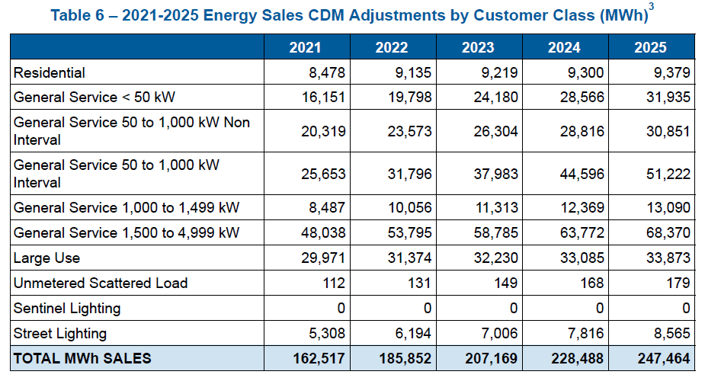
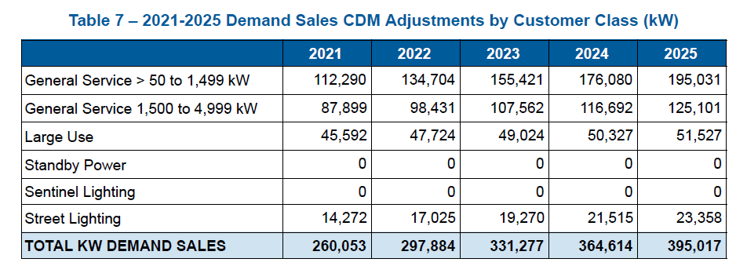
Source: Updated Exhibit 3, Tab 1, Schedule 1
The five-year CDM adjustments are based on three components:
- contractual agreements between Hydro Ottawa and customers made on/before April 30, 2019
- estimated rate-based savings of 2 GWh per year from commercial customers
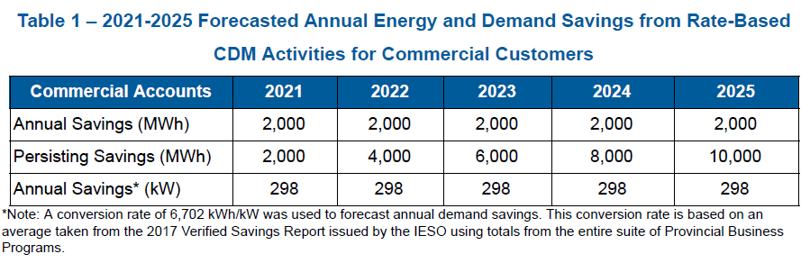
Source: Exhibit 4, Tab 1, Schedule 6, p. 9
- estimated impacts related to the continuation of CDM programs which are still being administered at the provincial level by the IESO

Based on the CDM forecasts in Tables 6 and 7, it shows a progressive increase in forecasted energy and demand savings from ongoing and potentially new programs. The forecasted demand savings in Table 7 are significantly higher than the persistence of demand savings of 2017 programs in the former Conservation First Framework (CFF) into the 2021-2025 years:
Year | Energy savings (kWh) | Demand savings (kW)
2021 | 273,675,778 | 36,977
2022 | 268,541,589 | 35,959
2023 | 267,015,594 | 35,625
2024 | 262,747,721 | 34,966
2025 | 248,446,183 | 33,009
Source: 2017 Final Verified Results Report

Question(s):

- In excel format, please re-file Tables 6 and 7 (Exhibit 3, Tab 1, Schedule 1) with the breakdown of each of the rate class savings into the following three categories:
- amount of persisting savings from remaining contracts executed under the CFF on/before April 30, 2019
- “rate-based” savings from new projects (showing the allocation of 2 GWh/year of projected savings across commercial classes)
- continuation of CDM programs which are still being administered at the provincial level by the IESO

- For the first category of savings related to i) persisting savings from remaining contracts executed on/before April 30, 2019:
  - Please discuss how Hydro Ottawa has revised its future estimated CDM savings from CFF programs following the cancellation of the CFF.
  - Please reconcile the CDM savings (in Tables 6 and 7) with the savings from the CDM-IS project reports that were part of the former CFF.
Please file the project lists from the CDM-IS savings report in excel format, inclusive of the following information:
            - What CFF program the project(s) are being completed under
            - The timing of approval for each project
            - Confirmation that Hydro Ottawa and its customer(s) have entered into a contractual agreement for the energy efficiency project(s) to be completed
            - The total estimated savings and project timeframe for each CFF-project(s) that Hydro Ottawa is contractually obligated to complete

- For the second category of savings related to ii) on “rate-based” savings from commercial customers, please clarify what “rate-based” savings mean. It appears that Hydro Ottawa is not seeking approval of a distributor-specific, ratepayer funded CDM program in this application.

  - Please confirm these savings will only be achieved from yet to be approved annual costs of $0.2-0.5 million related to compensation, marketing and miscellaneous costs in OM&A. If not, please clarify.

  - Please explain the appropriateness of including CDM staffing costs in OM&A, as they were formerly not included in the revenue requirement. Please explain the need for new CDM staff, if there are existing staff available for delivery of conservation activities related to the former CFF, and provide greater clarity on what planning tools, reports and information Hydro Ottawa is relying on to support the need for an increase to its OM&A.

  - Please discuss whether Hydro Ottawa has sought approval or engaged in discussions with the IESO related to the projected rate-based savings from commercial customers. In Hydro Ottawa’s response, please provide any correspondence with the IESO on this topic.

- If the OEB does not approve of the requested OM&A funding for these rate-based CDM activities, please discuss whether Hydro Ottawa will continue to pursue these opportunities.

  - In excel format, please file the following details by project to support the inclusion of rate-based savings in the CDM adjustment:
- What program (e.g., interim framework, post-CFF) the project(s) or CDM activities will be completed under
- What entity (e.g., IESO, Hydro Ottawa) will be delivering each project or CDM activity?
- The timing of approval for each project or CDM activity
- What kind of confirmation Hydro Ottawa will receive to indicate that the project will be completed
- The total estimated savings (including net-to-gross ratios) and project timeframe for each project or CDM activity. Please provide all relevant input assumptions including savings by measure and customer participation rates, if available.

  - Please discuss the appropriateness of including projected savings from rate-based activities in the CDM adjustment, as they have yet to be defined and appear to be beyond the scope of the former CFF.
  - What OEB policy guidance is Hydro Ottawa relying on in making this proposal?
  - How will Hydro Ottawa ensure these potential savings can be achieved and verified?
  - Please discuss the proposed process that would follow in the event the projected CDM savings do not materialize, including cost responsibility.

- For the third category of savings related to iii) continuation of CDM projects administered at the provincial level, please address the following:
  - Please clarify what “the continuation of CDM projects administered at the provincial level” specifically refers to.

    - Please explain how Hydro Ottawa has estimated lost revenue results at the distributor level.

    - Please discuss whether Hydro Ottawa has sought direction, approval or advice from the IESO in developing these savings estimates. In Hydro Ottawa’s response, please provide all correspondence between Hydro Ottawa and the IESO on this topic.
  - As the IESO will no longer be providing distributor-level savings reports to LDCs, please discuss the appropriateness of including an estimate of savings from the continuation of CDM projects administered at the provincial level in the CDM adjustment.

  - In excel format, please file the following details by project to support the estimated savings from the continuation of CDM projects administered at the provincial level:
- What program (e.g., interim framework, post-CFF) the project(s) will be completed under
- What entity (e.g., IESO, Hydro Ottawa) will be delivering each project or program?
- The timing of approval for each project
- What kind of confirmation Hydro Ottawa will receive to indicate that the project will be completed
- The total estimated savings (including net-to-gross ratios) and project timeframe for each project. Please provide all relevant input assumptions including savings by measure and customer participation rates, if available.

- For the savings forecast from street lighting customers in Tables 6 and 7, please discuss the source of funding for the street light retrofit upgrades, the planned number of upgrades (also as % of total street lights) over the 2021-2025 period, and what the street light bulbs will be upgraded to.

3-Staff-9
Ref: Exhibit 2/ Tab 4/ Schedule 3/ pp. 273-274
Exhibit 4/ Tab 1/ Schedule 6/ pp. 7-8

Preamble:

Based on its Local Achievable Potential Study, Hydro Ottawa notes that utility-scale energy storage is needed to reduce peak of 3.75-7.5 MW at a cost of $9.6-22.7 million.

To date, Hydro Ottawa has submitted an application for funding from the IESO (for $3.25 million) to relieve of capacity constrained areas in Kanata North (Thermostat and Retrofit Program) that could contribute 2.56 MW towards peak reduction.

Hydro Ottawa states that it could help with minimizing the rates for customers and provide short-term capacity relief in Kanata North, but did not include expenditures for non-distribution activities in the forecast expenditure plan.

Question(s):

- What is the status of the application for IESO funding ($3.25 million) for the two projects to relieve of capacity issues in Kanata North?

- Does Hydro Ottawa plan to request ratepayer funding for the remainder of the project in a future application?

3-Staff-10
Ref: Appendix 2-I
Updated Exhibit 3/ Tab 1/ Schedule 1/ Tables 6 and 7

Question(s):

Based on the responses to the above CDM adjustment interrogatories:
- Please confirm whether there were any change(s) made. If yes, please re-file revised forecasts of CDM savings and updates to all related models from 2021 to 2025.

- Please provide the LRAMVA thresholds (i.e., annualized equivalent of the CDM adjustments) for each year from 2021 to 2025, as the tables in Appendix 2-I did not include the test years’ CDM adjustments and LRAMVA threshold amounts.

3-Staff-11
Ref: Exhibit 3, Tab 1, Schedule 1, Attachment C, page 5
Chapter 2 filing requirements, issued July 12, 2018, page 23.
Preamble:
Itron has calculated normal monthly degree days “as an average of monthly degree-days over the past twenty years - 1999 through 2018.”
The filing requirements require “In addition to the proposed test year load forecast, the load forecasts based on a 10-year average and 20-year trends in HDD and CDD”.
Question(s):
- Please provide a forecast where a 10-year average has been used.

- Please provide a forecast where a 20-year trend has been used.

3-Staff-12
Ref: Exhibit 3, Tab 1, Schedule 1, Attachment C, page 6
Preamble:
Itron states that:
Normal peak-day HDD and TDD are derived as a twenty-year average using a rank and average approach. This approach entails first finding the highest HDD and TDD that occurred in each month over the last twenty years (1999 to 2018), and within each year ranking the degree-days from the highest to the lowest value so that there are 12 monthly ranked HDD and TDD in each year. The ranking across the years are then averaged effectively generating peak-weather TDD and HDD duration curves with 12 average values.
The ranked-average TDD and HDD are assigned to specific months based on that peak month TDD or HDD is most likely to occur. The highest weighted TDD is assigned to July, the next highest August, the third highest June, and so forth. The highest HDD value is assigned to January, the next highest to February, the third highest to December, and so forth.

Question(s):
- Please explain why the ranked-average TDD are HDD are assigned to specific months based on the month the peak is most likely to occur, instead of the month it actually occurred?

- Has Itron considered averaging 20 peak HDD and TDD from January, 20 from February and so on, assigning those to the respective months? Why was this approach discounted?

- What measures has Itron taken to validate the suitability of a 20-year average with respect to long-term trends in weather?
Other Revenue

3-Staff-13
Ref: Exhibit 3, Tab 2, Schedule 1, page 17 of 26
Question(s):
- Please provide supporting calculations for the forecasted revenue related to the Dry Core Transformer Distribution Charges for 2021-2025.

- Please specify what assumptions are used regarding the forecasted Regulated Price Plan, transmission rate, low voltage rate, and regulatory charge.

Exhibit 4 – Operating Expenses
Operations, Maintenance and Administration (OM&A)

4-Staff-1
Ref: Exhibit 4/Tab 1/Schedule 1/pp 4-5 of 6
Preamble:
Hydro Ottawa noted that the proposed 2021-2025 OM&A spending levels were reviewed by the Executive Management Team (EMT) and several adjustments/reductions were made to the proposals.

Question(s):
- Please provide the initial OM&A budget presented to the EMT for each year of the 2021-2025 period.

- Please specify and explain the nature of each adjustment/reduction made to the initial OM&A budget for the 2021-2025 period, please also quantify the impact of each adjustment/reduction by year.

- With the upgrade/acquisition of new IT and operational technology systems (e.g. Supervisory Control and Data Acquisition System and the Enterprise Resource Planning System), please discuss how much OM&A will be saved for the 2021-2025 period.

4-Staff-2
Ref: Exhibit 4/Tab 1/Schedule 3/page 9 of 10
Preamble:
Hydro Ottawa noted that an inflation rate of 2.01% was assumed for 2021 for all non-compensation related costs.
Question(s):
- Please specify the inflation rate used for 2020 for non-compensation related costs.

4-Staff-3
Ref: Exhibit 4/Tab 1/Schedule 4/page 3 of 43
Exhibit 4/Tab 1/Schedule 5/Attachment A
Appendix 2-K Employee Costs
Question(s):
- Please explain the difference between Table 2 (Updated Ex 4-1-4, page 5) and Table 7 (Updated Ex 4-1-5, Attachment A, page 16). For example, for the 2021 test year, there is a difference of approximately $2 million between these two tables.

- Please specify OM&A costs incurred in 2018 that is attributable to the three extreme weather events.

- With respect to the salary structure for executive and management:
- Hydro Ottawa notes that “Performance and contributions are directly tied to Hydro Ottawa’s corporate performance scorecard, ensuring that the focus of this workforce segment is aligned to the advancement of the utility’s Strategic Direction.” Please explain how performance and contributions are directly tied to Hydro Ottawa’s corporate performance scorecard.
- Please provide historical and the forecast range of merit increases (i.e. lowest and highest increases in percentage) for executives and management for historical (2016-2019), bridge (2020), and the test year (2021).

- For unionized employees, Hydro Ottawa noted that the current collective agreement is in effect from April 1, 2017 until March 31, 2021. Negotiated wage increases are 2.0% for 2017, 2.10% for 2018, 2.10% for 2019, and 2.2% for 2020. Please specify the assumption of wage increases used for 2021.

- Please provide a revised version of Appendix 2-K, Employee Costs, to reflect requests as follows:

A breakdown of management positions by executives and non-executive positions.
A breakdown of non-management employees by union and non-union.
To show the expensed and capitalized compensation costs for historical (2016-2019), bridge (2020), and the test year (2021).

4-Staff-4
Ref: Updated Exhibit 4/Tab 1/Schedule 4/pp.28-29 of 54
Preamble:
For the Collections, Accounts and Activities program, there is a 47% increase in budgeted costs for 2020 compared to the level of expenses for 2019. The year-over-year variances in this program are mainly due to fluctuations in bad debt expense. Hydro Ottawa noted that in 2018, the bad debt expense dropped, due to the implementation of a Disconnection Moratorium. The expectation is that these levels will be maintained over the 2020-2021 period.

Question(s):
- Please explain why a 47% increase in budgeted costs for 2020, and a further 3% increase for 2021 are necessary, given that the expectation is that the level of bad debt expense will be maintained over the 2020-2021 period.

4-Staff-5
Ref: Updated Exhibit 4/Tab 1/Schedule 4/pp.31-32 of 54
Preamble:
Hydro Ottawa explained that the increase of 22% in 2020 from 2019, for the Customer and Community Relations program, is driven by investments in increased automation. These solutions will enhance the customer experience and the efficiency of field operations. OEB staff notes that there is an incremental increase of 7% budgeted for 2021 for this program.
Question(s):
- Please explain the drivers for this incremental increase of 7% for 2021 considering the expected efficiencies gained from increased automation.

4-Staff-6
Ref: Updated Exhibit 4/Tab 1/Schedule 4/page 33 of 54

Question(s):
- Hydro Ottawa notes that the increase in customer billing program in 2020 is partially due to the timing of the Customer Care & Billing System upgrade project. Please specify the budgeted OM&A costs related to the Customer Care & Billing System upgrade project for 2020 and 2021 respectively.

4-Staff-7
Ref: Exhibit 4/Tab 1/Schedule 5/Attachment A/pp.9-11 of 13

Question(s):

- Please clarify whether Hydro Ottawa has a target percentage of temporary equivalents of the total number of FTEs for the 2021-2025 period.
- If so, please specify the target.
- If so, please also explain how the target is determined.

Payments in Lieu of Taxes Workform

4-Staff-8
Ref: Updated Exhibit 4/Tab 4/Schedule 1/Attachments D-H: PILS Workforms
Updated Exhibit 2/Tab 2/Schedule 1/Attachments F-J: Fixed Assets Continuity Schedules
Question(s):
- Please explain and reconcile the differences between the amortization added back in the PILS workforms to the Fixed Assets Continuity Schedules for the following test years.

- Please explain and reconcile the differences between the capital additions in Schedule 8 from the PILS workforms to the Fixed Assets Continuity Schedules for the following test years.

Exhibit 5 – Cost of Capital and Capital Structure

Short-term Debt

5-Staff-1
Ref: Exhibit 5/Tab 1/Schedule 1/p. 2
Preamble:
Hydro Ottawa proposes to use the deemed short-term debt rate of 2.75% established and issued by the OEB for 2020 as the deemed short-term debt for all years of the plan from 2021 to 2025.
Question(s):
- Please confirm OEB staff’s understanding that Hydro Ottawa is not proposing to update the deemed short-term debt rate at the time of the decision and draft rate order for 2021 rates, even in the even that the updated cost of capital parameters for 2021 have been issued by the OEB.

- Please explain how Hydro Ottawa’s proposal is consistent with the OEB’s policies and practices, particularly as documented in the Rate Handbook, and the Report of the Board on the Cost of Capital for Ontario’s Regulated Utilities, (EB-2009-0084), issued December 11, 2009 (the Cost of Capital Report).

- Please identify any precedents that Hydro Ottawa is relying on in support of its deemed short-term debt rate proposal.

Long-Term Debt

5-Staff-2
Ref: Exhibit 5/Tab 1/Schedule 1/pp. 3-8
Appendices 2-OB for years 2021-2025
Preamble:
Hydro Ottawa has calculated its actual and forecasted long-term debt for each year of the plan from 2021 to 2025. Hydro Ottawa forecasts new debt issuances of $60 million in 2021 and $80 million in 2023, as shown in Table 1 on page 6 of Exhibit 5/Tab 1/Schedule 1.
Hydro Ottawa has forecasted the long-term debt rate for each year of the plan, stating:
The long-term debt rate is calculated as the weighted average rate of existing embedded debt and forecast debt planned to be issued from 2021-2025. The calculation to determine the anticipated long-term debt rate is comprised of three components:
- The forecast Government of Canada 10-year bond yield;
- The 30-year to 10-year Government of Canada bond yield spread; and
- The Hydro Ottawa credit risk spread.
The use of these three components emulates the calculation of the OEB Cost of Capital Report.
Hydro Ottawa then describes the methodology that it used for forecasting the debt rates for forecasted debt of 10-year and 30-year maturities for each year:
The underlying forecast for the Government of Canada 10-year yield is that which is presented in the October 2019 Consensus Long-Term Forecast (which is issued twice per year, in October and April).
Hydro Ottawa 10-year bonds are forecast by adding the Hydro Ottawa historical credit spread of 112 basis points (“bps”) for 10-year bonds to the forecast Government of Canada 10-year yield.
The 30-year Government of Canada bond yield is calculated using the Consensus Long-Term Forecast 10-year bond yield plus 44 bps, which as of October 2019 is the historical five-year average spread of the 30-year over 10-year Government of Canada bond yield, as calculated per the OEB Cost of Capital Report.
Hydro Ottawa 30-year bonds are then forecast by adding the Hydro Ottawa historical credit spread of 148 bps for 30-year bonds to the forecast 30-year Government of Canada yields.
The Hydro Ottawa historical credit spreads used for 10-year and 30-year bonds are as of October 2019 and are based on the average Bank of Montreal (“BMO”) Capital Markets indicative spreads over the past two-and-a-half years for the Holding Company.
For the deemed long-term debt rate and the Return on Equity (ROE), the OEB uses spreads over between actual data (i.e., actual 10-year and 30-year Government of Bond yields, and 30-year Canadian utility A-rated corporate bond yields) for the same month of the Consensus Forecasts. For the annual cost of capital forecasts for the following rate year (January 1-December 31), this uses actual data for all business days in the month of September, and the September Consensus Forecasts. Consensus Economics conducts the survey around mid-month, and the date on the publication is the date the survey is conducted (publication is a few days later). This temporal alignment is used to get forecasts for the 30-year Government of Canada bond yields and Canadian A-rated Utility bond yields based on the most current information and which should most closely correspond with the 3-month ahead and 12-month ahead forecasts of the 10-year Government of Canada bond yields published in Consensus Forecasts (i.e. current information that the surveyed economic forecasters would have also had for making their 10-year Government of Canada bond yield forecast).
This approach has been continued from when the OEB first adopted a formulaic ROE approach in 1997 for natural gas distributors, with the Ontario Energy Board Draft Guidelines on a Formula-Based Return on Common Equity for Regulated Utilities (Draft Guidelines), issued March 1997. Developed for Ontario natural gas distributors, it was the starting point for the OEB’s policies for electricity utility rate regulation in the 2000s following electricity sector restructuring, until reviewed and updated in late 2009 by the current Cost of Capital Report.
The Draft Guidelines were also based on ROE adjustment formulae adopted by the National Energy Board (NEB) (now the Canadian Energy Regulator), the British Columbia Utilities Commission and the Public Utilities Board of Manitoba; these formulae were generally referenced as the RH-2-94 formula, referring to the NEB’s 1994 order adopting this formulaic approach.
Question(s):
- OEB staff observes that forecasts are subject to uncertainty – they are not actuals, but predictions of what is likely to occur, based on past and current circumstances, and what is currently identified as the trend into the future. Further, the degree of uncertainty increases the further out the forecast, and in an increasing and non-linear pace. While we have a point estimate forecast for any point in time, the confidence interval increases, typically in what can be described as a horn shape.
Does Consensus Economics provide any information on the confidence interval or other caveats regarding its long-range forecasts? If so, please provide.
- In its Application, as noted above, Hydro Ottawa has adopted: i) a five-year average historical variance between actual 10-year and 30-year Government of Canada bonds; and ii) a 2.5 year average historical variance between Government of Canada and corporate bond spreads (“credit spreads”) for similar maturities (10 years or 30 years).
Please explain the basis and rationale for:
- Using longer-term historical periods than used by the OEB and previously by other Canadian regulators for estimating the variances between Government and corporate/utility bond yields;
- Using, on the one hand, a 5-year period for estimating the average spread between 10-year and 30-year Government of Canada bond yields, and, on the other, 2.5 years for estimating the spreads between Government of Canada and corporate/utility bond yields of similar maturities.

Return on Equity

5-Staff-3
Ref: Exhibit 5/Tab 1/Schedule 1/pp. 8-10
Exhibit 1/Tab 1/Schedule x
Preamble:
Hydro Ottawa has forecasted the ROE for each year of the plan for 2021 (the rebasing year) and the subsequent years for 2022-2025. Hydro Ottawa states:
Hydro Ottawa has used a forecast ROE for the full five-year period covered by this Application. This is in line with the guidance set forth in the Handbook for Utility Rate Applications, which states that “the OEB expects there to be no further rate applications for annual updates within the five-year term” and “the OEB does not expect to address annual rate applications for updates for cost of capital.”⁴ Hydro Ottawa has followed this guidance and has proposed an ROE that balances Hydro Ottawa’s expectation of a reasonable return with customers’ needs for investment in the system, while providing regulatory efficiency. Hydro Ottawa has utilized the OEB’s formulaic calculation in determining the forward-looking ROE.
- Ontario Energy Board, Handbook for Utility Rate Applications (October 13, 2016), page 26.
Hydro Ottawa then states the changes that it has made to the application of the OEB’s ROE formula, since Hydro Ottawa is forecasting longer than 1 year ahead:
The ROE calculation utilizes three components:
● The Consensus Forecast Government of Canada 10-year bond yield;
● The 30-year to 10-year Government of Canada bond yield spread; and
● Change in A-rated Utility Bond Yield Spread from September 2009.
The ROE calculation in the model utilizes Consensus Forecast forward-looking rates for 10-year bonds on a three-month and 12-month basis. To forecast the ROE over the five-year period of 2021-2025, the October 2019 Consensus Long-Term Forecast was utilized using the average annual yield for 10-year bonds.
Similar to long-term debt, the 30-year Government of Canada bond yield is then calculated using the forecast 10-year bond yield plus 44 bps, which is the five-year historical average spread of the 30-year over 10-year Government of Canada bond yield as calculated per the OEB Cost of Capital Report.
To determine the change in A-rated 30-year Utility Bond Yield spreads, the five-year historical average spread as utilized in the Cost of Capital calculations up to October 2019 was used. This five-year historical average equals 154 bps.
Table 4 on page 10 of this exhibit documents the forecasted ROE for each year. OEB staff has compiled the following table summarizing the forecasted ROEs along with the OEB-issued ROE for 2020, per the OEB’s letter on the Cost of Capital Parameters as issued on October 31, 2019.
Table 5-Staff-3-1:
OEB-issued ROE for 2020 and
Hydro Ottawa forecasted ROEs for 2021-2025
 | OEB-issued | Hydro Ottawa forecasts
Year | 2020 | 2021 | 2022 | 2023 | 2024 | 2025
ROE | 8.52% | 8.88% | 9.13% | 9.31% | 9.41% | 9.46%
Question(s):
- Please confirm the entries in the above table.

- Please explain what Hydro Ottawa means in stating that it “has proposed an ROE that balances Hydro Ottawa’s expectation of a reasonable return with customers’ needs for investment in the system”. What is the evidence that Hydro Ottawa is relying on in support of this statement?

- In the methodology to calculate the long-term debt rate and the ROE, the spreads between: i) 10-year and 30-year Government of Canada bond yields; and ii) 30-year Canadian A-rated Utility Bond and 30-year Government of Canada bond yields are done for the business days in the same month that the Consensus Forecasts survey was done in. This ensures that there is a temporal alignment between the forecasts, and the current economic data that the surveyed forecasters would be aware of in making their predictions. Please explain the rationale for Hydro Ottawa using 5-year historical averages to estimate these spreads for the purposes of forecasting the ROE for all years of its Custom IR plan term.

5-Staff-4
Re: Exhibit 5/Tab 1/Schedule 1
Preamble:
Hydro Ottawa’s forecasts were prepared based on data from October 2019. This was long before the current COVID-19 crisis emerged, and which has caused significant socioeconomic shock world-wide, affecting financial markets, economic activity and our daily way of living.
Hydro Ottawa notes, on page 6 of this exhibit, that the Long-Term Consensus Forecasts publication that it used is published semi-annually, in April and November of each year.
Question(s):
- Please provide an updated forecast of the cost of capital parameters using Hydro Ottawa’s proposed methodology and the April 2020 Long-Term Consensus Forecasts. Please provide the data used, and identify or provide the sources. Please document all assumptions, and identify any changes in assumptions from what is documented in this exhibit as initially filed. If possible, please provide the data and calculations in a working Microsoft Excel spreadsheet.

Exhibit 6 – Calculation of Revenue Deficiency or Sufficiency
Revenue Deficiency Amounts & Cost Drivers

6-Staff-1
Ref: Exhibit 6/Tab 1/Schedule 1/page 5 of 7
Preamble:
Hydro Ottawa notes an increase of $11.9 million in return on rate base budgeted for 2021 compared to the 2020 OEB-approved level, which is driven by a $171.9 million increase in net fixed assets.
Question(s):
- Please provide a breakdown of the $171.9 million increase in net fixed assets by key capital projects/programs.

Exhibit 7 – Cost Allocation

7-Staff-1
Ref: Exhibit 7, Tab 1, Schedule 1, Attachment B, pp 2-3
Preamble:
Elenchus stated that “Hydro Ottawa filed a separate cost allocation model for each year of the rate period in Proceeding EB-2015-0004.” OEB staff notes that Hydro Ottawa filed updated cost allocation models in each year of its Custom IR term.
Elenchus states that it advised Hydro Ottawa that “a single cost allocation model based on the test year would be suitable for the purposes of cost allocation and rate design for this CIR application.” Accordingly, Hydro Ottawa has filed a single cost allocation model for 2021.

Question(s):
- Please confirm that Hydro Ottawa does not intend to perform updates to its cost allocation model through its Custom IR term in 2022-2025.
- If confirmed, please explain how does Hydro Ottawa plan to determine revenue requirements by rate classes for 2022-2025?

7-Staff-2
Ref: Updated Cost Allocation Model, sheet I4 BO Assets
Preamble:
In completing sheet I4 BO Assets, Hydro Ottawa has broken out the assets as operating at primary and secondary voltage as follows:
- Account 1830 – Poles, Towers and Fixtures – 70% Primary, 30% Secondary
- Account 1835 – Overhead Conductors and Devices – 100% Primary
- Account 1840 – Underground Conduit – 71.9% Primary, 28.1% Secondary
- Account 1845 – Underground Conductors and Devices – 100% Primary
Question(s):
- Please explain how Hydro Ottawa determines the primary and secondary proportions.

- Please explain the apparent inconsistency of requiring secondary poles and underground conduit when there are no secondary conductors.

7-Staff-3
Ref: Exhibit 7, Tab 1, Schedule 1, page 1
Updated Cost Allocation Model, sheet I5.2 Weighting Factors
EB-2015-0004, 2016 Cost Allocation Model, sheet I5.2 Weighting Factors
Preamble:
In the section detailing Weighting Factors, Hydro Ottawa states: “For a detailed description of the methodology for development of allocation and load factors, please refer to Attachment 7-1-1(B): Hydro Ottawa Cost Allocation Report.” However, the referenced report does not provide details on weighting factors.
In this application, the weighting factors for Billing and Collecting have been updated since the cost allocation model filed with its 2016 Custom IR application. The weighting factors for services are proposed to be the same in 2021 as 2016. These are summarized in the following table:
 | Services – 2016 and 2021 models | Billing and Collecting – 2016 model | Billing and Collecting 2021 model
Residential | 1.0 | 1.0 | 1.0
General Service < 50 kW | 2.0 | 1.0 | 1.1
General Service 50 to 1,499 kW | 10.0 | 6.4 | 3.0
General Service 1,500 to 4,999 kW | 10.0 | 25.3 | 4.0
Large Use | 30.0 | 25.2 | 3.9
Street Light | 1.0 | 25.2 | 4.1
Sentinel | 1.0 | 0.7 | 0.7
Unmetered Scattered Load | 1.0 | 1.0 | 1.1
Standby (all volumes) | 10.0 | 24.9 | 3.9
Question(s):
- Please provide a derivation of the weighting factors used for Service and Billing and Collecting.

- Has Hydro Ottawa reviewed its costs for Services in the context of this application, and if not, when was the last time these costs were reviewed?

7-Staff-4
Ref: Updated Cost Allocation Model, sheet I6.1 Revenue; sheet I8 Demand Data
EB-2015-0004, 2016 Cost Allocation Model, sheet I6.1 Revenue; sheet I8 Demand Data
Preamble:
The Standby rate class billing demand and demand allocators from the previous proceeding and proposed in this proceeding are summarized below:
 | 2016 Cost Allocation Model (kW) | 2021 Cost Allocation Model (kW)
Billing Demand | 4,800 | 7,440
Classification 1NCP | 1,152 | 1,152
Primary 1NCP | 1,152 | 1,152
Line Transformer 1NCP | 680 | 680
Classification 4NCP | 3,836 | 412
Primary 4NCP | 3,836 | 412
Line Transformer 4NCP | 2,263 | 243
Classification 12NCP | 7,657 | 642
Primary 12NCP | 7,657 | 642
Line Transformer 12NCP | 4,517 | 379
Question(s):
- Please describe the methodology use to arrive at the demand allocators in 2021 and contrast that with 2016. In particular, please detail any assumptions around actual or deemed demand used.

- Please explain how the 1NCP values are higher than the 4NCP values. Logically, the total peak demand from each of the four months demand during the highest month of the year would include the peak from the 1NCP, and the next three highest monthly peaks would be included in the 4NCP.

7-Staff-5
Ref: Updated Cost Allocation Model, sheet I6.2 Customer Data; sheet I8 Demand Data
Preamble:
Hydro Ottawa indicates that out of 316,346 residential customers, 286,894 rely on secondary distribution, and out of 25,391 General Service < 50 customers, 18,091 rely on secondary distribution. However, on sheet I8 Demand Data, the 1NCP, 4NCP and 12NCP indicate the Secondary NCP, Line Transformer NCP, Primary NCP, and Classification NCP are all the same for these rate classes, implying that all of the load receives secondary distribution.
Question(s):
- Please reconcile the apparent inconsistency.

- Does Hydro Ottawa have any residential condominiums or other buildings which are served using customer owned transformers or secondary distribution? If so, please provide customer count and aggregate consumption information for customer owned transformation and secondary distribution.

- Does Hydro Ottawa have any General Service < 50 kW customers in analogous buildings where customers are served using customer owned transformers or secondary distribution?

7-Staff-6
Ref: Cost Allocation Model
Question(s):
- Please provide an updated cost allocation model to reflect any updates to the application resulting from the interrogatories. If available, please use the 2021 Cost Allocation model.

7-Staff-7
Ref: Chapter 2 filing requirements, issued July 12, 2018, page 46.
Preamble:
The filing requirements state that:
The OEB expects distributors to document their communications with unmetered load customers, including street lighting customers, and how the distributor assisted them in understanding the regulatory context in which distributors operate and how it affects unmetered load customers.
Question(s):
- Please provide details on the communication that has taken place with the unmetered load customers, including street lighting customers.

7-Staff-8
Ref: Exhibit 7, Tab 1, Schedule 1, pp. 2, 4
Updated Revenue Requirement Work Form, sheet 11. Cost_Allocation
Preamble:
The revenue-to-cost ratio for the Sentinel Rate class has increased from 21.03% in 2016 to 156.34% proposed in this application.
Question(s):
- Has Hydro Ottawa examined the cause of the change in the Standby rate class revenue-to-cost ratio?

Exhibit 8 – Rate Design

8-Staff-1
Ref: Updated Exhibit 8, Tab 1, Schedule 1, pp. 3-8
Updated Exhibit 8, Tab 10, Schedule 1, Attachment A, pp. 48-50
Preamble:
In the Street Lighting rate class, Hydro Ottawa is proposing to increase the proportion of rate revenue to be collected by the fixed charge from 44% of the total in 2020 to 64% in 2021, increasing each year to 68% in 2025. Similarly for Sentinel Lighting, the proportion of total revenue collected from the fixed charge is proposed to increase from 32% in 2020 to 52% in 2021. A smaller increase in the fixed charge percentage is proposed for the Unmetered Scattered Load (USL) rate class.
The changes to the both fixed and variable charges are approximately 9-10% for USL, 23-24% for Sentinel Light, and 4-5% for Street Light.
Hydro Ottawa states that “for customer classes where the 2020 fixed charge is higher than the calculated upper bound, Hydro Ottawa proposes to maintain the current fixed charge for 2021.” But “Starting in 2022, Hydro Ottawa proposes to maintain the fixed/variable split in recovering the revenue requirement.” The filing requirements state:
If a distributor’s current fixed charge for any non-residential class is higher than the calculated ceiling, there is no requirement to lower the fixed charge to the ceiling, nor are distributors expected to raise the fixed charge further above the ceiling for any non-residential class.
Hydro Ottawa proposes to increase the fixed charge for the General Service > 50 to 1,499 kW rate class from $200 in 2020 and 2021 to $212.51 in 2022 and every year to 2025 despite the calculated ceiling being $78.85. Similarly, in the General Service > 1,500 to 4,999 kW rate class, Hydro Ottawa is proposing increases every year starting in 2022 to 2024, and in the Large Use rate class in 2022 and 2023 despite the fixed charges for these rate classes already being above the calculated ceiling.
In the General Service < 50 kW rate class, Hydro Ottawa is proposing to increase the fixed charge to $20.61 in 2021, which remains below the ceiling of $21.04, but then to $22.03 in 2022, and every year to 2025.
Question(s):
- Please confirm that Hydro Ottawa is proposing to change fixed and variable charges by the same percentages, with differences due to rate rounding.

- Please confirm that the changes in fixed/variable splits arise from changes in forecasted volumes, and absent changes in projected volumes, the fixed/variable splits would not change.

- Please explain why Hydro Ottawa is proposing to increase the fixed charges for these rate classes to rates that are either above or further above the ceiling.

8-Staff-2
Ref: UpdatedExhibit 8, Tab 1, Schedule 1, page 9
Preamble:
Hydro Ottawa states that Effective April 1, 2015, customers with customer-owned transformers installed after November 1, 2000 were no longer eligible to receive the Transformer Ownership Credit (TOC). As of November 1, 2025, the TOC is proposed to be eliminated entirely.
Question(s):
- Please provide the reason for the November 1, 2000 cut-off date.

- Please provide copies of communication on April 1, 2015 to customers indicating the change to the TOC.

- Please explain the reason for the November 1, 2025 end date for the TOC, two months prior to the end of the period covered by this Custom IR application.

8-Staff-3
Ref: Exhibit 8, Tab 3, Schedule 1, page 1
RTSR Workform, Sheet 3. RRR Data; Sheet 4. UTRs and Sub-Transmission
Preamble:
Hydro Ottawa has filed a 2020 RTSR model, which was current as of the date of filing. The RTSR model has been filed with 2019 UTRs and Hydro One Sub-Transmission rates. Hydro Ottawa states that its “rates are derived from 2018 billing determinants, as those are the determinants that have been most recently reported through the utility’s RRR filings.”
Question(s):
- Please update using 2019 RRR data, 2020 UTRs and 2020 Hydro One Sub-Transmission rates. Please use the 2021 RTSR model, if available.

8-Staff-4
Ref: Updated Exhibit 1, Tab 1, Schedule 10, page 25
Exhibit 8, Tab 4, Schedule 1, page 1
Updated Exhibit 8, Tab 7, Schedule 1, pp 1, 6-9
Preamble:
In reference to retail service charges, Hydro Ottawa states that it “will not be seeking distributor-specific RSCs.” It states that “as a placeholder for the generic RSCs, 2021 has been inflated by the OEB’s 2020 inflationary rate of 2.0%, while 2022-2025 charge have been escalated annually by 2.51%”
OEB staff note that, in the event the escalation factor used by Hydro Ottawa to escalate its retail service charges differs from the rate used by the OEB, Hydro Ottawa will in effect have distributor-specific retail service charges.
Similar proposals are made to escalate charges for Specific Service Charges, Wireline Attachments, Generator Fixed Service Charges and the Standard Supply Service Charge.
Hydro Ottawa’s Custom Price Escalation Factor of 2.51% is calculated including a customer Growth Factor of 0.40% to reflect growth in costs due to an increasing number of customers.
Question(s):
- Please confirm whether or not Hydro Ottawa plans to adopt the OEB’s 2021 inflation for 2021 when that is known.

- Does Hydro Ottawa propose to apply its escalation factor of 2.51% for the years 2022-2025, or does it plan to apply the OEB’s generic escalation factor as this is known?

- Please explain why it is appropriate to inflate per-incident and per-customer charges on the basis of an escalation factor which includes growth in customer counts as one of the causes of growth in costs.

8-Staff-5
Ref: Updated Exhibit 8, Tab 7, Schedule 1, page 1
Exhibit 8, Tab 7, Schedule 1, Attachment A, pp. 1-9
Preamble:
Hydro Ottawa states that it has “undertook a review of many routine service charges to ensure they reflected the associated costs of providing services”. Hydro Ottawa is proposing to update several specific service charges, while some are decreasing, others are increasing. In addition, in some cases, the proposed charge does not reconcile to the calculated costs at the second reference. In particular the following are increases or have costs that a materially different from the proposed change:

Description | 2020 Charge | 2021 Charge | Proposed Increase | Charge per Costing
Arrears Certificate (Account Certificate in 2020) | $15 | $16 |  | $51
Easement Certificate (Account Certificate in 2020) | $15 | $25 | 67% | $99
Special Billing Service, per hour | $104 | $122 | 17% | $122
Unprocessed Payment Charge (+ bank charges) | $15 | $25 | 67% | $28
Reconnect at Pole – Regular Hours | $185 | $250 | 35% | $270

Question(s):
- Please provide details of consultation Hydro Ottawa has performed with customers regarding the increased charges.

- Please provide any feedback received from customers on the proposed service charge changes.

- Please provide an explanation of material differences between the costs to provide services, and the proposed charges in the context of this update to ensure service charges reflect costs of providing services.

8-Staff-6
Ref: Updated Exhibit 8, Tab 7, Schedule 1, page 8
Preamble:
Hydro Ottawa is proposing to revise its generator fixed service charges including microFIT, Net-Metering ERF, FIT ERF, HCI, RESOP, and other ERF. Several customers have filed comments expressing concern over the microFIT fixed charges. The HCI, RESOP, and Other ERF charge is proposed to increase 12% from $281 to $314.
Question(s):
- Please provide details of any consultation Hydro Ottawa has performed with its customers regarding the generator fixed service charges.

8-Staff-7
Ref: Updated Exhibit 8, Tab 7, Schedule 1, pp. 8-9
Preamble:
Hydro Ottawa is to increase its standard supply service from $0.25 in 2020 to $0.62 in 2021. This is “to align with the 2021-2025 Retail Services Distributor-consolidated billing monthly charge”.
Question(s):
- Does Hydro Ottawa incur the same costs in providing this for retail customers as it does for its own customers?

- Has Hydro Ottawa estimated the costs incurred in providing this service? If so, please provide.

- Please provide details of any consultation Hydro Ottawa has performed with its customers regarding the increased charge.

Exhibit 9 – Deferral and Variance Accounts

Lost Revenue Adjustment Mechanism Variance Account (LRAMVA)

9-Staff-1
Ref: Updated Exhibit 4/Tab 5/Schedule 2/pp. 1-6
LRAMVA Workforms A, B, C, D and E

Preamble:

At the time of filing, Hydro Ottawa applied for lost revenues up to the 2014 CDM year, amounting to debit $491,812. Hydro Ottawa indicated it may provide LRAMVA claims for years after 2014 as part of subsequent updates to this application.

At the time of filing for 2019 actuals, Hydro Ottawa filed for the additional recovery of lost revenues related to 2015 and 2016 activity. A total debit amount of $2,733,351 is claimed up to the end of 2016 (as part of its 2021-2025 CIR application) inclusive of carrying charges up to Jan. 1, 2021, with the components of the claim summarized below:

Workform A ($424,027): 2014 new CDM, and 2013 persistence into 2014
Workform B ($67,785): 2013 adjustments (in 2013)
Workform C ($334,574): 2011-2014 persistence into 2015
Workform D ($1,071,818): 2015 new CDM
Workform E ($835,147): 2016 new CDM, and 2015 persistence into 2016

Question(s):

- Please clarify why Hydro Ottawa has not claimed lost revenues up to the end of the Conservation First Framework

- There are a few inconsistencies in the LRAMVA workforms with respect to the LRAMVA thresholds used in each. For example, Workforms B and D do not include LRAMVA thresholds in Tab 2, but the corresponding Workforms A and C include one. Please clarify whether that was excluded in error. If not, please discuss how the LRAMVA balances in Workforms B and D are accurate when there is no forecast savings being compared to actual savings for each of Workform B (2013 adjustments) and Workform D (2015 incremental savings).

- Please explain why Hydro Ottawa did not combine all filings in one LRAMVA workform.

- Please confirm that the total LRAMVA debit balance of $2,733,351 is to be disposed of over a 1-year period. (Note: Workforms A and B indicate 1-year disposition, while Workforms C, D and E indicate 2-year disposition)

9-Staff-2
Ref: EB-2015-0004/Exhibit D/Tab 5/Schedule 2
Updated Exhibit 4/Tab 5/Schedule 2/p. 3
LRAMVA Workform A (“2014LRAMVA_452A”)
LRAMVA Workform B (“2014Adjustments_LRAMVA_452B”)

Preamble:

In the 2016-2020 CIR proceeding (EB-2015-0004), Hydro Ottawa was approved to dispose of lost revenues related to 2011 to 2013 CDM activity.

In the current proceeding, Hydro Ottawa is requesting to dispose of a total debit balance of $491,812 for 2014 activity based on:
- new 2014 CDM amounts (debit of $424,027) per Workform A (“2014LRAMVA_452A”)
- 2013 adjustments (debit of $67,785) that were not included in its previous claim per Workform B (“2014Adjustments_LRAMVA_452B”)

As noted above, these two components were filed in two separate workforms:

- In Workform A (“2014LRAMVA_452A”), the 2014 LRAMVA balance of $424,027 is inclusive of persistence from 2011-2013 program savings in 2014, and persistence of 2013 savings adjustments in 2014.
- In Workform B (“2014Adjustments_LRAMVA_452B”), the LRAMVA balance of $67,785 is inclusive of 2013 adjustments and the persistence of 2012 program savings in 2013.

Hydro Ottawa stated that it has complied with the OEB’s direction to dispose of the LRAMVA balance as part of their COS application. Hydro Ottawa notes that it would have waited to clear the 2013 year (as IESO reports could include significant adjustments) had it received further clarity from the OEB that the LRAMVA balance was related to calendar year savings rather than the IESO report.

Question(s):

- As 2013 CDM amounts were disposed of in its 2016-2020 CIR proceeding, please explain how claiming 2013 savings adjustments in this proceeding would not constitute rate retroactivity, and how it falls within prospective treatment of changes.

- Please clarify which appropriate guideline, filing requirement or workform was referenced by Hydro Ottawa where it learned the “LRAMVA balance was related to calendar year savings rather than the IESO report”.

- In light of the OEB’s guidance (Chapter 2 Filing Requirements for 2018 COS Filers) and prior decisions where the OEB did not allow for retroactivity, please explain why Hydro Ottawa is seeking to recover 2013 adjustments (as per “2014Adjustments_LRAMVA_452B”) and the appropriateness of doing so. In response to this interrogatory, please indicate if Hydro Ottawa seeks to maintain its retroactive request to recover 2013 adjustments filed in Workform B.

9-Staff-3
Ref: LRAMVA Workforms A, B, C and D
EB-2011-0054/2012 Settlement Agreement/Section 3.3 (p. 13 of 33)
EB-2011-0054/IRRs – Part I/Exhibit K3/Issue 3.3/IR #2 (Energy Probe #28b) / PDF p. 407 of 729

Preamble:

In this proceeding, Workforms A and C included a LRAMVA threshold of 29,390,965 kWh, which are the forecast savings applied against actual savings in 2014 and 2015. An extract of the LRAMVA threshold (and its rate class breakdown) is provided below:

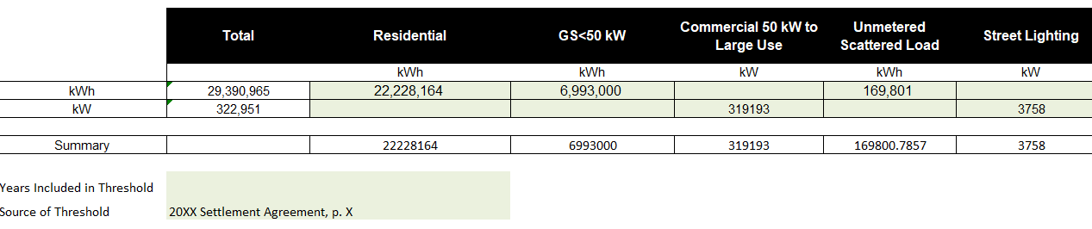
Source: LRAMVA Workforms A and C, Tab 2

The 2012 Settlement Agreement noted that the CDM adjustment to the load forecast was 75 million kWh (p. 13) but this amount is not reflected in its entirety in the workform.

Notwithstanding the above, Table 6 from Part 1 of its 2012 COS proceeding IRRs showed different 2011 and 2012 CDM adjustment figures than the amounts included in the LRAMVA workform:

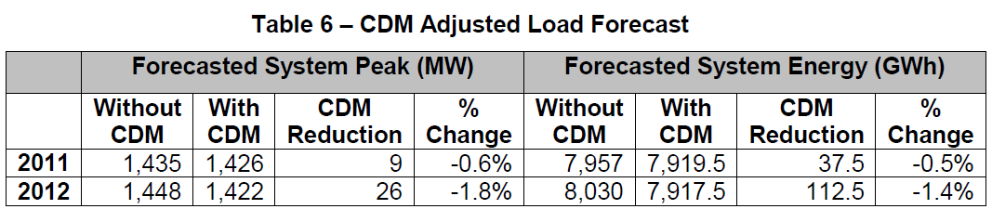
Source: EB-2011-0054, Part 1 IRRs, K3-3-2 (Energy Probe #28b)

Question(s):

- Please clarify whether the 29,390,965 kWh used as LRAMVA threshold in Workforms A and C is a component of the 75 GWh CDM adjustment associated with energy billed customers.

- Please confirm the figures in Table 6 (preamble):

  - 75 GWh reflects the incremental CDM adjustment to the 2012 load forecast based on the difference between 112.5 GWh (2012 figure) and 37.5 GWh (2011 figure)
  - 112.5 GWh reflects the cumulative CDM impact included in the 2012 load forecast

- In light of the OEB’s partial decision in Alectra’s 2020 IRM application where a cumulative LRAMVA threshold was used in the Horizon Rate Zone, please explain why Hydro Ottawa is using an ‘incremental’ LRAMVA threshold of 29,390,965 kWh (LRAMVA Workforms A and C) rather than ‘cumulative’ forecast savings of 112.5 million kWh (per Table 6 in K3-3-2 (#28) to EP).

- Please update Tab 2 of Workforms A, B (if applicable), C and D with a LRAMVA threshold value of 112.5 million kWh along with the appropriate rate class breakdown. Please ensure that the total kWh LRAMVA threshold by rate class (as entered in LRAMVA workform) matches the LRAMVA threshold amounts on the EB-2011-0054 record.

9-Staff-4
Ref: LRAMVA Workform A (“2014LRAMVA_452A”)/ Tab 4
LRAMVA Workform B (“2014Adjustments_LRAMVA_452B”)/ Tab 4

Preamble:

It appears there are two 2013 adjustments entered into Workform B (“2014Adjustments_LRAMVA_452B”) that were not included in Workform A (“2014LRAMVA_452A”).
- Energy Manager (846,892 kWh in 2013; 1,141,184 kWh in 2014)
- High Performance New Construction (-949,590 kWh in 2013 and 2014)

Question(s):

- Please re-file Workform A (“2014LRAMVA_452A”) with the two above-noted adjustments included.

- If Hydro Ottawa believes that the adjustments should not be included, please explain why.

9-Staff-5
Ref: LRAMVA Workforms A, B, C, D and E / Tabs 4 and 5
Updated Exhibit 4/Tab 5/Schedule 2/pp. 4-5

Preamble:

For 2014, Hydro Ottawa noted that it does not have customer-level data to allocate savings to the GS> 50 kW customer classes. The utility has continued to use the same methodology for disposing of LRAM claims for the 2014 Report as was used for the 2011-2013 reports. Hydro Ottawa has confirmed that, for years after 2014, customer-level data will be used to allocate savings to customer classes.

In its re-filing of 2019 actuals, Hydro Ottawa updated the allocation of GS 50-1,499 kW, GS 1,500-4,999 kW, and Large Use classes based on 2019 actual non-RPP consumption.

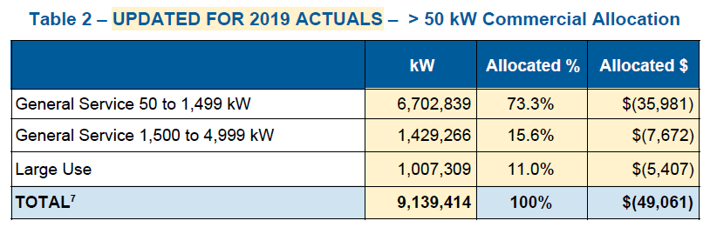
Source: Updated Exhibit 4, Tab 5, Schedule 2, p. 5

Question(s):

- As Hydro Ottawa did not have customer-level data to allocate savings to GS>50 kW classes for 2014 and prior, please clarify the basis of the customer class allocations by residential, commercial and industrial CDM programs from 2014 and prior years. As the utility has continued to use the same methodology for disposing of LRAMVA claims for the 2014 Report as was used for the 2011-2013 reports, please discuss the methodology applied.

- For the GS>50 kW class allocations, please explain how these class allocations in Table 2 (included in preamble) reconcile with the allocations used in Tab 4 (of the LRAMVA Workforms D and E) which show class specific allocations broken down by program in 2015 and 2016.

- Please explain whether the basis of GS>50 kW class allocations derived from non-RPP consumption is reflective of the consumption from participating customers for the purposes of allocating lost revenues.

9-Staff-6
Ref: LRAMVA Workform E/Tab 2
EB-2015-0004/Settlement Proposal/Attachment 4 (pp. 57-58)
EB-2015-0004/IRRs to VECC/Question #27/ PDF p. 59 of 159

Preamble:
In this proceeding, Workform E included a LRAMVA threshold of 27,452,000 kWh, which are the forecast savings applied against actual savings in 2016. An extract of the LRAMVA threshold (and its rate class breakdown) is provided below:

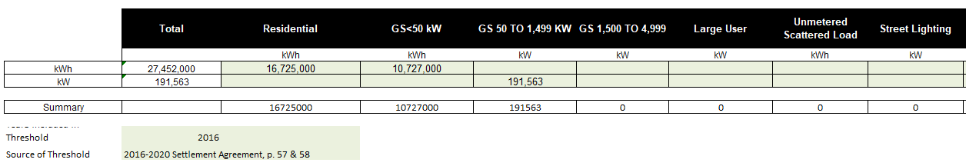
Source: LRAMVA Workform E, Tab 2

In the 2016-2020 Custom IR Settlement Proposal, the following approved CDM adjustments were included in Attachment 4:

9-Staff-6-1:
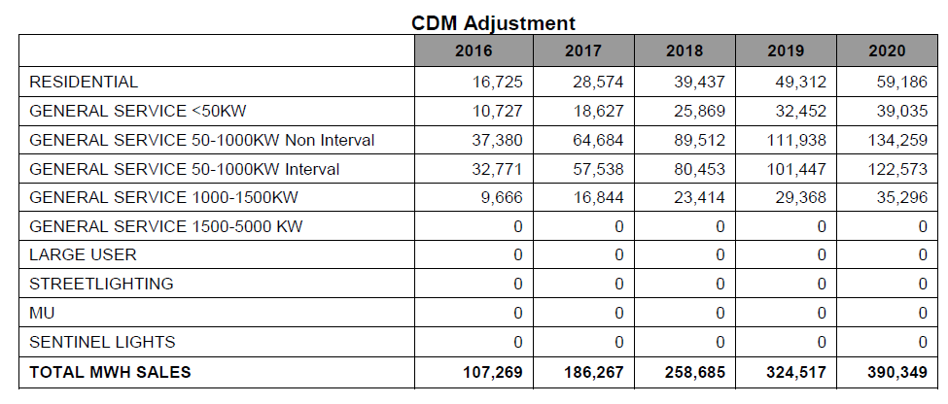
9-Staff-6-2: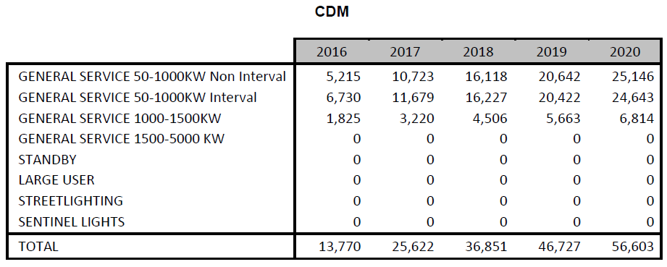
Source: EB-2015-0004, Settlement Proposal, refiled December 7, 2015, Attachment 4

The LRAMVA threshold (kWh) in the Settlement Proposal is consistent with the cumulative savings embedded in the 2016 to 2020 load forecasts.

9-Staff-6-3:
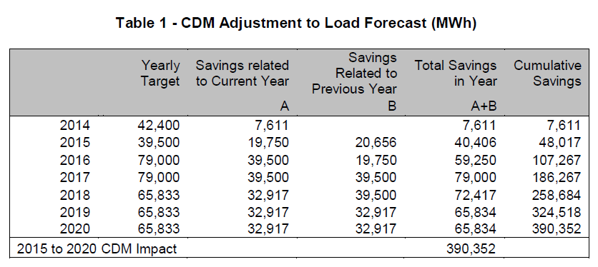
Source: EB-2015-0004, IRR 3-VECC#27

Question(s):

- Please reconcile the LRAMVA threshold (199,563 kW) in Tab 2 of the LRAMVA workform with Table 2 in the preamble, and explain whether the LRAMVA threshold (kW) used in the lost revenue calculation is correct.

- Please provide the inputs and assumptions used to arrive at the class breakdown of CDM adjustments of 199,543 kW for the GS>kW class.

- For consistency, please revise Tab 2 of LRAMVA Workform E to show the LRAMVA threshold (kWh) for all classes, in order to match the approved LRAMVA threshold of 107,267,000 kWh in 2016.

9-Staff-7
Ref: LRAMVA Workform E/Tab 8

Preamble:

As part of the filing of 2019 actuals, Hydro Ottawa included street light demand savings amounting to a debit of $12,301 (principal) as part of its 2016 lost revenue claim. The savings were achieved through the streetlight upgrades on a monthly basis, and detailed tables were provided to show the change in demand by type of bulb for several months of 2016.
Question(s):

- Please confirm whether street light demand savings were funded through the IESO saveOnEnergy retrofit program in 2016.

- Please confirm whether there were any street lighting upgrades completed outside of the IESO’s saveOnEnergy Retrofit program that are counted in total billed demand. If yes, please quantify and remove the impact of these savings in the LRAMVA.

- If yes to a) above, please confirm whether the energy savings from street light projects have been deducted from the respective 2016 saveOnEnergy retrofit program. If not, please revise Tab 5 of LRAMVA Workform E to show that the 2016 retrofit program’s energy savings (claimed in the LRAMVA) are exclusive of street light retrofits.

- Please discuss whether Hydro Ottawa received reports from the City of Ottawa to confirm the number of bulbs, types of bulbs and timing of the bulbs replaced. If not, please discuss whether the number or wattage of bulb retrofits were validated.

- Please confirm that the change in demand savings were tracked on a monthly basis; and thus, it is appropriate to multiple the monthly savings by the number of months the new bulbs were in-service for the remainder of the year.

- Without a net-to-gross ratio (NTG) applied, savings from street light upgrades are gross values. Please explain why it is appropriate not to apply a free ridership assumption to municipal streetlighting projects. Alternatively, please discuss whether it is reasonable to apply a 85% NTG ratio based on similar retrofit projects in Hydro Ottawa’s service territory. Please make the necessary revision(s) to Tab 8, as applicable.

9-Staff-8
Ref: LRAMVA Workforms A, B, C, D and E
Updated Exhibit 4/Tab 5/Schedule 2/p. 6/Table 3

Question(s):

- Please file the 2011-2015 Persistence Savings Report.

- Please file updated LRAMVA workform(s) as requested in the above LRAMVA interrogatories or as one consolidated LRAMVA workform with all years inclusive, if this can done. Please confirm the LRAMVA balance requested for disposition, the disposition period and the revised rate riders.

- Please confirm any changes to the LRAMVA workform in response to these LRAMVA interrogatories in “Table A-2. Updates to LRAMVA Disposition (Tab 1-a)”.

Other Deferral and Variance Accounts

9-Staff-9
Ref: Updated Exhibit 9/Tab 1/Schedule 3/pp. 14-15
Preamble:
The accounting order from the 2016 -2020 Custom IR established the following for Account 1508 Other Regulatory – Sub-account Gains/Losses from the Sale of Existing Facilities Deferral Account
Hydro Ottawa shall establish a new deferral account 1508 Other Regulatory Assets – Subaccount Gains/Losses from Sale of Existing Facilities, effective January 1, 2016, to record the after tax gains/losses from the sale of existing buildings and land. (Emphasis added)
This account shall capture 100% of the after tax net gains/losses on the sale of land and existing facilities buildings at Albion Road, Merivale Road and Bank Street. (Emphasis added)
In the current application, Hydro Ottawa seeks disposition of a total gain of $2,151,861 in Sub-account 1508. Hydro Ottawa proposes no tax adjustment to the gain being returned to customers. Hydro Ottawa proposes to use the Replacement Property rules under the Income Tax Act to defer the capital gain on the sale of the land and buildings of the Existing Facilities and reduce the additions to the New Facilities by the gain for tax purposes of $7.9 million in 2019.
Question(s):
- Please explain if and how this proposal is consistent with the accounting order from the 2016 -2020 Custom IR.

- Please explain how the $7.9 million gain for tax purposes was determined.

- Please quantify the impact to the relevant account(s) in reference to the Accounting Order from the 2016-2020 Custom IR without the application of the Replacement Property rules.

9-Staff-10
Ref: Exhibit 9/Tab 1/Schedule 3/page 2
Updated Exhibit 9/Tab 3/Schedule 1/page 7
Preamble:
In the current application, Hydro Ottawa proposes to dispose 1508 Sub-account Energy East TransCanada Pipeline balance of $55,424 on a final basis and to discontinue use of this Account.
In Question 4 of the APH issued on March 2015, OEB stated the following:
This is a Group 2 account and disposition will normally occur when the utility files a cost of service or custom IR application. Materiality thresholds apply to the amounts recorded. Carrying charges will apply and these should be recorded in a separate sub-account. (Emphasis added)
Question(s):
- Please explain why Hydro Ottawa requested disposition when the balance is below materiality.

9-Staff-11
Ref: Exhibit 9/Tab 1/Schedule 3/page 2
Updated Exhibit 9/Tab 1/Schedule 1/Attachment A: DVA Workform

Preamble:
Sub-Account 1508 Other Post-Employment Benefits (OPEB) was originally approved in Hydro Ottawa’s 2012 rate application to record cumulative actuarial gains or losses in Hydro Ottawa’s post-retirement benefits. The Accounting Order from the 2012 Rate Order stated:
Hydro Ottawa shall capture the one-time adjustment of approximately $2.8 million to the post-retirement liability on the date of transition to IFRS. This amount shall result from an election applied under IFRS 1 that would otherwise result in a charge to Hydro Ottawa’s retained earnings. The amount of the one-time adjustment that will be recorded in this account shall be supported by an actuarial valuation when disposition of the deferral account is sought by Hydro Ottawa.

In the current application, Hydro Ottawa is seeking disposition of a credit balance of $4,431,595 in Sub-account 1508 OPEB.
The Report of the Ontario Energy Board: Regulatory Treatment of Pension and Other Post-employment Benefits (OPEBs) Costs stated “Utilities may propose disposition of the account in future cost based rate proceedings if the gains and losses that are tracked in this account do not substantially offset over time.”
Question(s):
- Please confirm if Hydro Ottawa has recorded the $2.8 million one-time adjustment according to the 2012 Accounting Order.

  - If Hydro Ottawa has recorded a different amount or has not recorded the one-time adjustment, please explain why and clarify what balance has been recorded.

- Please provide the support for the balance requested for disposition.

- What is the projected gain/loss for this account in 2020 and the current Custom IR period of 2021 to 2025, if available?

- Please provide the balances for the gain/loss in this account since the approval of this account in 2012 rate application and explain if the OPEB gains and losses tracked in this account have substantially offset over time.

9-Staff-12
Ref: Exhibit 9/Tab 1/Schedule 3/Table 7 on page 13
Updated Exhibit 9/Tab 1/Schedule 3/Table 6 on page 17
Preamble:
Sub-account 1508 Gains and Losses on Disposal of Fixed Assets was established in the accounting order from the 2016 -2020 Custom IR to record the difference between the forecast and actual loss on the disposal of fixed assets, related to the retirement of assets or damage to plant. The forecasted amount was an annual gain of $198,349 for the period of 2016 to 2020.
Question(s):
- Please explain why the 2019 actual loss of $1,984k was at least 5 times higher as compared to the rest of the years from 2016 to 2020.

- Please explain how the estimated losses for 2021 to 2025 were determined and confirm if Hydro Ottawa intends to use the estimated losses as the forecast amounts to determine the account balances for the period of 2021 to 2025.

- Please explain why the estimated loss in 2022 is doubled as compared to the rest of the test years from 2021 to 2025?

9-Staff-13
Ref: Updated Exhibit 9/Tab 1/Schedule 3/Table 8 on page 20
Updated Exhibit 9/Tab 1/Schedule 1/Attachment A: DVA Workform
Preamble:
As stated in Hydro Ottawa’s 2019 Decision, Hydro Ottawa recorded $1,384,801 in the Sub-account 1508 Earning Sharing Mechanism (ESM) in 2017 related to 2016 earnings.
As stated in Hydro Ottawa’s 2020 Decision, Hydro Ottawa recorded $2,149,000 in the Sub-account 1508 Earning Sharing Mechanism (ESM) in 2018 related to 2017 earnings.
In the current application, Hydro Ottawa presented the calculations for the 2016 ESM as a credit balance of $1,309,000 and 2017 ESM as a credit balance of $2,364,000.
Hydro Ottawa stated that no ESM was recorded related to 2018 earnings as it didn’t over earn in 2018.
In the updated DVA Workform in the current application, Hydro Ottawa recorded a credit balance of $1,384,801 (column AJ) and a credit balance of $1,976,394 (column AT) in the transaction columns for 2017 and 2018 related to 2016 and 2017 ESM for a total credit principal amount of $3,361,195. Hydro Ottawa also recorded a credit balance of $311,490 (column BD) in the transaction column for 2019.
Question(s):
- Please explain the differences and confirm the balances recorded in the Sub-account 1508 ESM related to 2016 and 2017 earnings
- Please explain what the credit balance of $311,490 relates to.
- Please update the DVA Workform if necessary.

9-Staff-14
Ref:
Exhibit 9/Tab 1/Schedule 3/page 19
Updated Exhibit 9/Tab 3/Schedule 1/Table 1 on page 7
Updated Exhibit 4/Tab 2/Schedule 4/Attachment A: Appendix 2-M
Preamble:
Sub-account 1508 OEB Cost Assessment is to record any material difference between OEB cost assessment that were built into rates, and cost assessments that would result from the application of the new Cost Assessment Model effective April 1, 2016. $916k projection was included in Hydro Ottawa’s 2016 rebasing year.
Hydro Ottawa is seeking disposition of principal balance of $1,879,684 along with interest in Sub-account 1508 OEB Cost Assessment.
Question(s):
- Please provide a schedule for the relevant years to support the principal balance of $1,879,684. Please ensure the amounts from the schedule are reconciled to the amounts presented in the updated Appendix 2-M Regulatory Cost Schedule, if applicable.

9-Staff-15
Ref: Exhibit 9/Tab 1/Schedule 4/Table 3 on page 3
Updated Exhibit 9/Tab 1/Schedule 3/Table 9 on page 23
Preamble:
Hydro Ottawa stated that there were no qualifying CCRA payments made in 2018 when calculating the impact of the accelerated CCA in 1592 Sub-account PILs in Table 3.
Hydro Ottawa recorded the revenue requirement for an additional $2,163,940 CCRA payments in 2018 in Table 9 for 1508 Sub-account CCRA.
Question(s):
- Please confirm the nature and the period CCRA payments related to. (i.e. before or after November 20, 2018)

9-Staff-16
Ref: Exhibit 9/Tab 1/Schedule 4/Attachments A
Updated Exhibit 9/Tab 1/Schedule 4/Attachments B, C, F, G
Updated Exhibit 9/Tab 1/Schedule 4/Table 1 on page 2
Updated Exhibit 9/Tab 1/Schedule 4/Table 2 on page 4
Updated Exhibit 9/Tab 1/Schedule 4/pp. 2-3
Preamble:
The OEB issued a guidance on July 25, 2019 to establish a separate sub-account of Account 1592 to track the impact of the Bill C-97 CCA rules changes for the period of November 21, 2018 until the effective date of the Utility’s next cost-based rate order. Utilities will record the full revenue requirement impact of any changes in CCA rules that are not reflected in base rates.
Hydro Ottawa has recorded the impact of the Bill C-97 in Sub-account 1592 – PILs and Tax Variances - CCA changes for capital additions for the period of 2018 to 2020, cost of the New Facilities up to $66 million and the New Facilities above $66 million. The impact of Bill C-97 was not included in the sub-account 1508 Y-Factor and sub-account 1508 New Facilities.
In the updated evidence on capital additions, Hydro Ottawa stated that “originally, it was estimated that 100% of additions in 2019 and 2020 would qualify for accelerated CCA. Table 1 has been updated to reflect remeasurements of 2019 and 2020 additions that would qualify for accelerated CCA.”
In the updated evidence on New Facilities, Hydro Ottawa stated that “originally, it was estimated that 28% of new additions for the New Facilities in 2019 would qualify for accelerated CCA. This estimate has been updated, with approximately 40% of new additions for the New Facilities in 2019 set to qualify for accelerated CCA.”
Question(s):
Capital Additions
- Please confirm if the amounts in column (3) titled “cost of acquisition during the year” for 2018 to 2020 in Attachment A and the updated Attachments B and C were the approved capital additions as part of the 2016 Settlement Agreement, or actual capital additions for 2018, 2019 and 2020.
a.1) Please explain why Hydro Ottawa has chosen to use approved or actual additions.

- Please confirm if the amounts in column (4) titled “cost of acquisitions from column 3 that are accelerated investment incentive property (AIIP)” in Attachment A represent the capital additions available for use and acquired after November 20, 2018. Please also confirm if the amounts in column (4) were based on estimates or actuals.
b.1) Please explain why Hydro Ottawa has chosen to use estimates or actuals.

- Please explain how the amounts in column (4) titled “cost of acquisitions from column 3 that are AIIP” in the updated Attachments B and C were determined. What criteria were used to determine if the additions would qualify for accelerated CCA in 2019 and 2020.

- Please provide supporting calculations for the amounts in column “Prior CCA/ECE” as shown in Table 1 for capital additions.

- Please confirm if the accelerated CCA calculated agreed with the amounts from Hydro Ottawa’s Tax Returns for 2018 and 2019, if actuals were used.

- Please explain why Hydro Ottawa is seeking disposition for 2020 balances in the current application.
New Facilities up to $66 million
- Please confirm the New Facilities additions in column (3) titled “cost of acquisition during the year” and column (4) titled “cost of acquisitions from column 3 that are AIIP” in updated Attachments F are based on actuals or estimates for 2019. Please explain why Hydro Ottawa has chosen to use actual or estimates.

- The New Facilities up to $66 million includes $51 million of facilities and $15 million of land. The New Facilities addition in column (3) titled “cost of acquisition during the year” shows a balance of $43 million in updated Attachment F for 2019. Please explain what the difference between $51 million and $43 million relates to.

- Please explain what criteria were used to determine 40% of new additions in 2019 would qualify for accelerated CCA.

- Please confirm if the accelerated CCA calculated agreed with the amounts from Hydro Ottawa’s Tax Return for 2019, if actuals were used.
New Facilities above $66 million
- Please explain why $72 million was recorded in column (3) titled “cost of acquisition during the year” where new addition in 2019 would be no more than $33.5 million.

- Please confirm the New Facilities additions in column (3) titled “cost of acquisition during the year” and column (4) titled “cost of acquisitions from column 3 that are AIIP” in the updated Attachment G were based on actual or estimates for 2019.
J.1) Please explain why Hydro Ottawa has chosen to use actuals or estimates

- Please explain what criteria were used to determine 40% of new additions in 2019 would qualify for accelerated CCA.

- Please confirm if the accelerated CCA calculated agreed with Hydro Ottawa’s Tax Return for 2019, if actuals were used.

- Please explain why Hydro Ottawa is seeking disposition for 2020 balances in the current application.

9-Staff-17
Ref: Exhibit 9/Tab 2/Schedule 1/pp.1-2
Preamble:
As part of Hydro Ottawa’s 2016-2020 application, $5 million of CCRA payments to HONI were estimated per year. During the adjudication process of Hydro Ottawa’s 2016-2020 application, it was agreed to move the CCRA payments out of the proposed revenue requirement. As a result, Sub-account 1508 CCRA was established in the Accounting Order from 2016 -2020 Custom IR to record the revenue requirement impact of CCRA payment made to Hydro One commencing in the year in which the facilities to which each CCRA payment relates provide services to Hydro Ottawa customers.
In the current application, Hydro Ottawa requests a modification to the account that, as of January 1, 2021, the CCRA account include both new and true-up payments and functions as a symmetrical account to collect or refund the differences for CCRA payments between what Hydro Ottawa has forecasted and what is actually paid for both new and true-up CCRA payments.
Question(s):
- Please explain the impacts of the requested modification on Hydro Ottawa and Hydro Ottawa’s ratepayers.

- Please explain if the differences between forecast and actual new and true-up CCRA payments will substantially offset during the period of 2021 to 2025.

9-Staff-18
Ref: Exhibit 9/Tab 2/Schedule 1/pp. 3-5
Preamble:
Sub-account 1508 Capital Additions was established in the Accounting Order from 2016-2020 Custom IR to track revenue requirement resulting from underspending in Hydro Ottawa’s three capital spending categories: System renewal/System service, System access and General plant.
For the period of 2016 to 2018, no amount was recorded as a result of overspending than forecast. Hydro Ottawa will update 2019 actual later in the proceeding.
In the current application, Hydro Ottawa is requesting to split System Access capital additions into a separate sub-account. The sub-account 1508 System Access Capital Additions will be a symmetrical account to record the revenue requirement related to overspending or underspending in the System Access category for 2021-2025.
Hydro Ottawa drew a similar comparison of the proposed System Access capital additions sub-account to the Externally Driven Capital variance account approved in Toronto Hydro’s 2015-2019 and 2020-2024 rate applications.
In Toronto Hydro’s application, Toronto Hydro proposes to only include spend for relocation and expansion work that is currently committed in its Distribution System Plan (DSP) for the 2020-2024 period (e.g. Metrolinx Eglinton Crosstown 18 LRT and Metrolinx Finch LRT) in its Externally Driven Capital variance account.
The methodology for sub-account 1508 Capital Addition (excluding System Access) is consistent with what was approved in 2016 Custom IR and will continue to be an asymmetrical account where overspending or earlier spending will not result in recovery from customers during the 2021- 2025 period.
Question(s):
- Please explain the impacts of the requested modifications on Hydro Ottawa and Hydro Ottawa’s ratepayers.

- Please explain how the modifications of the account meets the materiality and prudence criteria.

- Given that Toronto Hydro only captured investments on the externally initiated plant relocation and expansion program in the approved Externally Driven Capital Variance account, please explain why it is appropriate for Hydro Ottawa to capture all investments under System Access in the proposed sub-account, including customer requests for new connections.

EB-2015-0019
https://www.oeb.ca/industry/rules-codes-and-requirements/performance-assessment
FORTISBC Inc. Multi-Year Performance Based Ratemaking Plan For 2014 Through 2018, Decision, September 15, 2014, p. 32
FORTISBC Energy Inc. Multi-Year Performance Based Ratemaking Plan For 2014 Through 2018, Decision, September 15, 2014 pp. 32-33
Report of the Board on Rate Setting Parameters and Benchmarking under the Renewed Regulatory Framework for Ontario’s Electricity Distributors (EB-2020-0379), issued November 23, 2013, corrected December 4, 2013.
Decision and Order EB-2017-0049, March 7, 2019.
Decision and Order EB-2017-0049, March 7, 2019
Decision and Order EB-2018-0165, December 19, 2019
FORTISBC Inc. Multi-Year Performance Based Ratemaking Plan For 2014 Through 2018, Decision, September 15, 2014, p. 116-119, and FORTISBC Energy Inc. Multi-Year Performance Based Ratemaking Plan For 2014 Through 2018, Decision, September 15, 2014 pp. 119-123
EB-2018-0165, Decision and Order, December 19, 2019, p. 193
EB-2018-0165
EB-2017-0049, Decision and Order, March 7, 2019, p. 28
Ibid., p. 29
Exhibit 1/Tab 1/Schedule 12/Attachment A, p. 17
Millo, G. (2017). Robust Standard Error Estimators for Panel Models: A Unifying Approach. Journal of Statistical Software, 82(3): 1-26. doi:10.18637/jss.v082.i03
See, for example, the OEB’s recent Custom IR plan decisions for Hydro One Transmission (EB-2019-0082) and Toronto Hydro (EB-2018-0165). A table similar to this one was filed as part of OEB Staff’s Revised S Factor Working Papers in EB-2019-0082 on October 25, 2019.
Lowry, M.N., PBR Plan Design for National Grid in Massachusetts, March 22, 2019, filed as Exhibit AG-MNL-2 in Massachusetts Department of Public Utilities D.P.U. 18-150, p. 40.
EB-2018-0165, Exhibit 1B-2-1, Appendix B. UMS Unit Cost Benchmarking Study.
EB-2018-0165, Exhibit 1B-2-1, Appendix B. UMS Unit Cost Benchmarking Study. Page 17, Table IV-1.
EB-2010-0379
EB-2018-0044
EB-2019-0046
Including interest and overhead.
EB-2015-0004, Decision on Settlement and Procedural Order No.11, November 23, 2015, page 3.
Calculated as ($41 million/155,000 sq. ft.). Data from EB-2015-0004, Exh B Rate Base Part 2 Distribution System Plan page 341, and response to SEC IR#11 Attachment B page 5.
Section 2.4.6 of Chapter 2 Filing Requirements (2018 Edition for 2019 Rate Applications), July 12, 2018
Exhibit 5/Tab 1/Schedule 1/page 8.
EB-2016-0075 (Guelph Hydro 2017 IRM); EB-2016-0080 (Hydro One Brampton 2017 IRM); EB-2016-0214 (North Bay Hydro 2017 IRM)
EB-2019-0018, Partial Decision and Interim Rate Order, December 12, 2019, p. 20-21
2017 verified program results, Tab “LDC Progress”, Col. FQ, NTG for the 2016 retrofit program
Schedule C, Accounting Orders, EB-2015-0004
Appendix B, Rate Order EB-2011-0054
Page 13 of the Report of the Ontario Energy Board: Regulatory Treatment of Pension and Other Post-employment Benefits (OPEBs) Costs EB-2015-0040
Schedule C, Accounting Orders, EB-2015-0004
EB-2018-0044, section 4 Base Rate Adjustment pp. 6-7
EB-2019-0046, section 4 Base Rate Adjustment pp. 5-6
Accounting Direction Regarding Bill C-97 and Other Changes in Regulatory or legislated Tax Rules for Capital Cost Allowance dated July 25, 2019.
Schedule C, Accounting Orders, EB-2015-0004
Decision and Order EB-2014-0116 (March 1, 2016), Appendix E, pp. 1-2
Decision and Order EB-2018-0165 (December 19, 2019), pp. 42-43
EB-2018-0165 Ex9/Tab 1/Sch 1/pp. 14-17

