Updated Application
U-Staff-1
Ref: Updated Exhibit 2/Tab 4/Schedule 1/page 1 of 21
Updated Exhibit 2/Tab 4/Schedule 3/Attachment E/page 11 of 43

Preamble:

Hydro Ottawa provided updates to capital expenditures in 2021 and 2022 as the result of the updated MiGen project.

The original and updated capital expenditures on MiGen are summarized in the tables below.

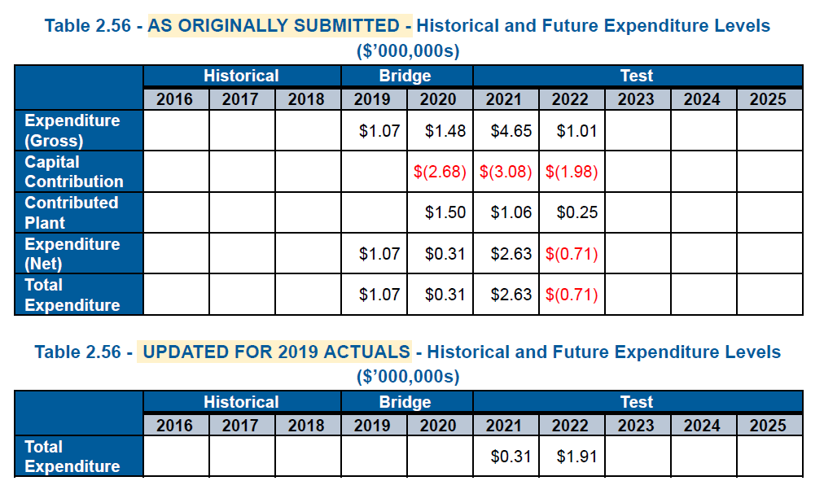
Question(s):
- In the summary of 2021-2025 capital expenditures, Hydro Ottawa highlighted updates to System Service and Capital Contributions (Updated Ex 2/Tab 4/Sch 1/page 1/Table 1). Please clarify whether the updates to System Service and Capital Contributions are solely attributable to updates to the MiGen project. If not, please identify updates to other programs/projects within the Distribution Enhancements program.

- Please provide the historical and future expenditures in the format of Table 2.56 as originally submitted (including gross expenditure, capital contribution, and net expenditure) for each of the following programs: Smart Grid Fund Initiatives, MiGen, and Other Distribution Enhancements Projects.

- Hydro Ottawa stated that it is engaged in detailed discussions with Natural Resources Canada regarding the lessons learned from the initial phase of the MiGen project (i.e. the GREAT-DR) and how these lessons can be incorporated into the next phase. Please specify the actual/planned start and completion dates for the initial and second phases of the MiGen project.

- Please confirm Table 5 (Updated Ex 1/Tab 1/Sch 5/page 12), Updated for 2019 Actuals – Planned Smart Grid Investments, shows net capital expenditures (i.e. excluding capital contributions) for all budget program and project summarized in the table.

- Descriptions on project scope filed in the original application were removed in the updated filing (Updated Ex 2/Tab 4/Sch 3/Attachment E-s.2.3.3/pp. 16-17). Please explain the current scope of the MiGen project.

- Descriptions on project performance targets and objectives filed in the original application were removed in the updated filing (Updated Ex 2/Tab 4/Sch 3/Attachment E-s.2.3.3/page 21). Please explain the current performance targets and objectives of the MiGen project.

- Descriptions on consequences of deferral filed in the original application were removed in the updated filing (Updated Ex 2/Tab 4/Sch 3/Attachment E-s.2.3.3/page 28). Does this mean there is no negative consequences to Hydro Ottawa’s distribution system and customers if this MiGen project is deferred beyond 2021-2025?

- Descriptions on project execution path/implementation plan filed in the original application were removed in the updated filing (Updated Ex 2/Tab 4/Sch 3/Attachment E-s.2.3.3/page 29). Please explain the current execution path/implementation plan of the MiGen project.

- With respect to project benefits, 6 benefits to customers identified in the original application were removed in the updated filing (Updated Ex 2/Tab 4/Sch 3/Attachment E-s.2.3.3/page 26). Please explain why these 6 benefits cannot be achieved under the current scope of the MiGen project.

U-Staff-2
Ref: Updated Exhibit 2/Tab 4/Schedule 1/page 11 of 21
Updated Appendix 2-BA/Fixed Asset Continuity Schedule

Preamble:

Revisions have been made to the forecasted 2021-2025 capital additions. Hydro Ottawa noted that the updated capital additions reflect 2019 actuals and updates to the MiGen project, as well as revisions to correspond with the originally submitted versions of 2021-2025 Appendix 2-BA: Fixed Asset Continuity Schedule.

Hydro Ottawa summarized the originally submitted, revised, and updated 2021-2025 capital additions in the tables below.

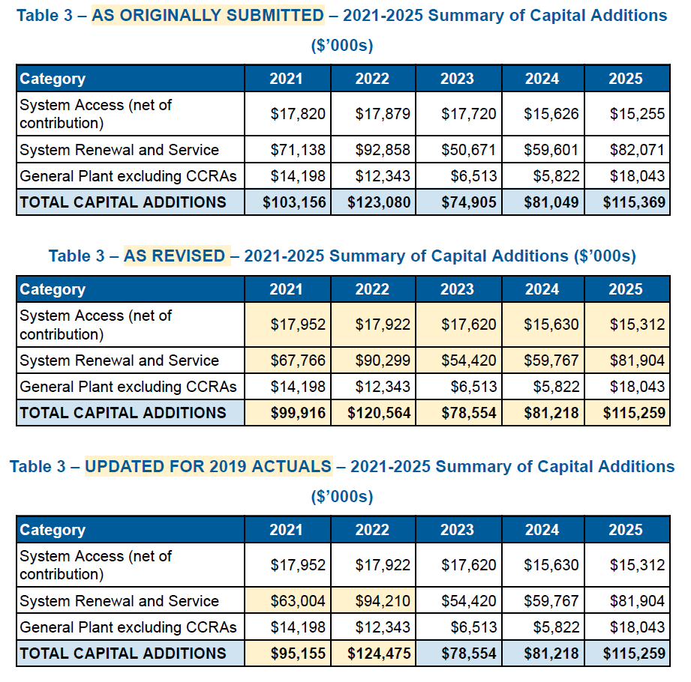
Question(s):
- With respect to the updated Appendix 2-BA, please confirm additions in column E do not include construction work in progress.
- Please explain how Hydro Ottawa forecast the capital expenditures to in-service additions conversion ratios.

- Please provide the total proposed capital additions for 2021-2025 including CCRAs.

- When comparing Table 3 (As Revised) and Table 3 (Updated for 2019 Actuals), changes only exist in the System Renewal and Service category. Please clarify whether updates to 2019 actual capital expenditures have any impact on those identified changes for 2021-2022 capital additions in System Renewal and Service.

U-Staff-3
Ref: Updated Exhibit 4/Tab 1/Schedule 3/pp. 7-8 of 12

Preamble:

The actual OM&A expenditures in 2019 were $4.4 million lower than the forecasted amount. Hydro Ottawa provided explanations for the variance as follows:
- Compensation was below forecast by $2.5 million
- Shared services fell $0.8 million below the forecast
- A $1.1 million reduction was achieved by cost control and cost deferral
Question(s):
- OEB staff notes that Hydro Ottawa forecasted 5 more permanent FTEs for 2021 compared to the 2019 actual FTEs. Please explain what new permanent positions have been budgeted for 2021.

- Please discuss whether the identified efficiencies related to the $1.1 million savings (e.g. cost control in spills cleanup activities) are expected to continue in 2021-2025.

U-Staff-4
Ref: Updated Exhibit 3/Tab 2/Schedule 1/page 28 of 34

Preamble:

Hydro Ottawa provided updates to the forecasted other revenues for 2021-2022. The updates are identified in the services to third parties category under Other Income and Deductions. The originally submitted and updated other revenues for this category is summarized in the table below.

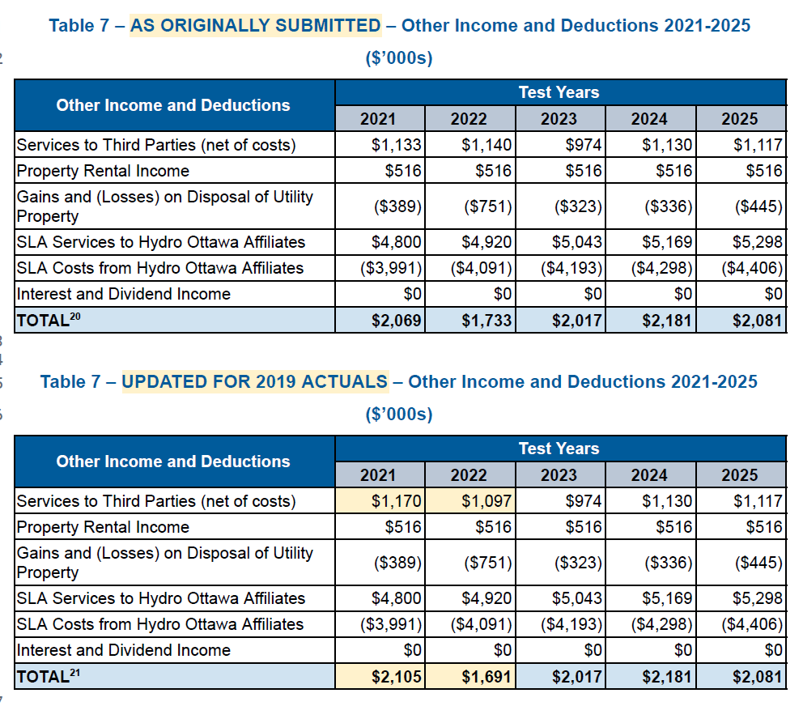

Hydro Ottawa noted that the update in 2020-2022 was made as a result of the updated MiGen project.
Question(s):
- Please explain why the update to the MiGen project has an impact on the forecasted other revenues.

