May 21, 2020

Shelly-Anne Connell
Ontario Energy Board Secretary
2300 Yonge St., 27th Floor
Toronto, ON
M4P 1E4

Re: April 30 2020 Decision of Ontario Energy Board EB-2018-0270

I Frank Kehoe, an Intervenor on EB-2018-0270, would like to say that with the current pandemic I am in a lock down position with no access to secretarial help or legal representation as they are also in lock down. My comments of the legality of the Orillia City Council selling the Orillia Power Distribution is contained, for the most part, in the attached letter. With my wife and I both in our eighties working from an iPad, we are unable to devout the time required to show that the Orillia City Council lacked the authority to sell the city owned Hydro Distribution without the approval of its voting electorate. When I have access to a scanner I will forward a copy of the first Public Utilities Act that followed the peoples referendum that removed the Orillia owned utility from Town Council control.

I am forwarding the same letter that was sent to the Attorney General Ministry dated June 10, 2019.

June 10, 2019

The Hon. Caroline Mulroney
Minister of Attorney General
11th Floor, 720 Bay Street
Toronto, ON
M7A 2S9

Dear Minister:

This letter is meant to bring to your attention what I consider serious breaches of our Canadian democracy as implemented by one or more senior cabinet ministers in the years 1996 through 2001. Many of the breaches of the latter years are impacting on the situation as it exists today.

I want it made emphatically clear that the current government is not responsible in any way for matters of the past. Please recognize that I am in advanced years and my writing skills are not what they used to be hence I apologize for the length of this communication.

Canadians at large, especially our Provincial Lieutenant Governor and myself, strongly believe that no issue in government that adds to the destruction of the integrity of our Canadian democracy should be left unchecked which is why I am writing this letter.

Our Lieutenant Governor The Hon. Elizabeth Dowdeswell must take a great deal of credit for devoting three rooms of her suite at Queen’s Park for the postings of “Speaking of Democracy”. Close to twenty-four heads of democratic nations, former Canadian Governor Generals, Head Justices and Justices of the Supreme Court of Canada and a number of people of note stated their comments on the topic of democracy in the postings. I had the distinct pleasure of attending the presentation on May 9, 2019. I am attaching a copy of her hand out Speaking of Democracy that you may care to distribute to your staff. The exhibition can be viewed at http://arts.lgontario.ca/democracy-democratie.

Before addressing the main topics of what I and others consider a serious provincial breach of our Canadian democracy I must first give some background history: The year is 1897 nine years before the Legislature created the Hydro Electric Power Commission of Ontario (HEPC). Two industrial men of vision convinced the then Orillia town council that Orillia could become a magnet to attract industry and give their citizens access to the electricity convenience in their homes and businesses. The Council of the day were then convinced to now seek the approval of the Legislature for authority to borrow the monies required to build such a project. The legislature gave credit for this early vision but also expressed that the borrowed money as requested for a project of this nature would likely be twice the money so requested hence placed some conditions. The main condition was that the town call a plebiscite / referendum for their approval of their citizens to build a dam and power generation plant at Ragid Rapids on the Severn River and transport the electrical energy 18 miles to Orillia.

No municipal owned utility on the continent had ever transported electrical energy over that vast distance and it was not sure if it was possible. The peoples referendum took place in 1898 and past by a large majority. The construction started in 1899. Key industrialists agreed to back any over-run from the figures approved conditional on two things – that rates set to the electrical consumers were the only pay back against the debt incurred and that the council would leave the utility in tack and not use the utility to off-set the tax base of the town. Both of which were agreed to.

The first electrical energy flowed to Orillia in January of 1902 – 117 years ago. During the construction stage the people of Orillia banded together from all areas of the town to give much needed volunteer labour related to the clearing and grubbing on the transmission line right away as well as digging of the post holes for the transmission line and as well as supplying approximately thirty horses together with their feed. The wives of the volunteers supplied sandwiches and pies and other food to the workers. The names of the volunteers were posted in areas of the Main Street and some merchants gave price reductions on their merchandise to those community minded volunteers.

Orillia was given the distinct honour as being the first municipally owned utility to then pioneer long distance transmission of electrical energy and after that happening a dozen of the municipal entities in the province said why not us. Niagara Falls was the biggest single source of hydro electricity potential but these rights to electricity were then held in private hands.

The year is now 1911 and it was discovered that the council had been dipping into the new utility revenue by depleting some contingency and reserve funding so as to supplement the general revenue account to show that the council were doing a great job to hold the line on tax increases.

The industrialist and most of the electrical consumers were livid with this breach of promise. Key industrialists which included two members of parliament, Orillia’s J.B. Tudhope and London’s Adam Beck who attended at the Premiers Office at the legislature with a deputation from Orillia. The sitting Premier Sir James Whitney then gave his assurance that if the question was to go back to the Orillia electorate in a formal referendum the Province would back the outcome.

The 1912 Council election was what people referred to as the Electricity Council. The new 1912 Council composed the appropriate by-law (557) to be voted on in 1913 to now create a separate Municipal Corporation independent of Town Council to administer and manage the utility free of all council interference. The vote for this separation was carried by 62% of the eligible electors supporting it.

Months after the Orillia vote the legislature brought into law the first Public Utilities Act. The Act totally supported the rights of the electorate who decided the referendum issue. The Public Utilities Act was ascended to on the 6th of May 1913 and stayed in place with amendments for the next 87 years. Two years after the Orillia referendum the new HEPC made a large financial offer to the town council to purchase the Orillia utility so a mandatory third referendum was called and the sale was defeated by a large majority.

The year is 1915 and the Provincial Legislator passed into law the Town of Orillia Act which reads in part:

“The legislature of the Province of Ontario passed the 1915 Town of Orillia Act and section 11(1) of the Act merely confirms the aforementioned.

“11(1) – subject to subsection 2, all the powers, rights and privileges with regard to the government of the Orillia Power Transmission plant or the generation, distribution and sale of electrical power and light heretofore or hereafter granted by any special Acts to the council or Corporation of the Town of Orillia shall, WHILE THE BYLAW APPOINTING SUCH COMMISSION REMAINS IN FORCE, BE EXERCISED BY THE ORILLIA WATER, LIGHT AND POWER COMMISSION, AND NOT BY THE COUNCIL OF THE CORPORATION.”

(2) Nothing contained in this section shall divest the council of its authority with reference to providing the money required for such works, and the treasurer of the municipality shall, upon the certificate of the Commission, pay out any money so provided.”

The year is now 1996 and now comes a sad day for the integrity of democracy with an absolute betrayal of the citizens of Orillia and other like municipalities when one or more provincial elected cabinet ministers secretly inserts a clause on a brand new 225 page document of legislation described as an act to achieve fiscal savings and promote economic prosperity through public sector restructuring, streamlining end efficiencies and to implement other aspects of the government’s economic agenda (the short title of this act is the Savings and Restructuring Act 1996).

Our provincial leadership elite may still want to believe in abiding by democratic principles – they certainly profess that they do. In the case of electricity legislation, a small minority have shown themselves all too willing to violate their principles to gain or retain a certain power. So, in this new conspicuous act, certain draconian elected people secretly inserted a single clause to try to reverse the electoral power of the people of Orillia and possibly other like municipalities who democratically cast their vote in a dually called legal referendum to keep the people’s municipal controlled ownership by their elected representatives free of council involvement.

This oligarchy insertion into the new Savings and Restructuring Act Schedule M, Chapter 1, Item 33, page 172 introduces the following:

33. The Public Utilities Act is amended by adding the following section:

By-law waiving 67. (1) A municipal corporation may pass a by-law to eliminate the requirement to
the assent of obtain the assent of the electors before the corporation exercises a power
the electors under this Act.

Exception (2) Subsection (1) does not apply to a municipal corporation exercising its power
with respect to natural gas.

The insertion of this clause if legal would be a certain slap in the face of our Canadian Constitution and betrayal of our Canadian Democracy and of the rights and freedoms of its citizens and represents a serious breach of other legislation in place. This single clause is a betrayal of the absolute commitment and promise given Orillians and the legislation that was put in place to protect their municipal utility as voted on by the Orillia electorate.

I am not a lawyer but strongly believe in Canadian democracy and the rule of law and the work of our leaders in the definition of the importance of citizen involvement and transparency in the making and enforcement of this principal of our Democracy. I am extremely proud of our Ontario Lieutenant Governor The Hon. Elizabeth Dowdeswell for posting the democracy material for display in three rooms of her legislative suite open for public viewing.

One of the displays that I think appropriate is The Honourable Rosalie Abella Justice of the Supreme Court of Canada. Her quote from the Lieutenant Governor’s handbook reads as follows: (The biography of Rosalie Abella is attached for your viewing.)

“For me, the components of democracy are most starkly revealed in comparison to its antonym, totalitarianism. What democratic societies promote – and repressive ones do not – are the rights of its citizens and their participation in decision-making about the rules they will be governed by. Democracy promotes choice, voice and access to rights. Totalitarianism promotes none of those.”

As previously mentioned where a draconian senior elected member of the legislature manages to insert Section 67(1) that is completely opposite to Section 45(1).

45.-(1) The council may, by by-law passed with the assent of the municipal electors, repeal any by-law passed under sections 38, 39 and 40.

Section 45(1) of the Public Utilities Act remained intact until December of 2001. Certainly there was a conflict in this legislation that may or may not have been intentional. For my belief Section 67(1) did not over-rule the promises made by Sir James Whitney and the supported role of Orillia’s electorate on the two previous referendums nor did it over-ride the 1915 Town of Orillia Act and is certainly in conflict with our Canadian democracy.

The City of Orillia senior staff jumped on the situation that 67(1) took away the legal requirement to go back to its electorate for any changes or amendments to By-law 557. This process, if it were legal, would be the biggest slap in the face to Canadian democracy ever enacted in Ontario which took away the rights of the Orillia electorate and totally breached Canadian democracy principles. City By-law 2000-145 is attached using Section 67(1).

The next breach of democracy in my opinion comes in what is called the Electricity Act 1998 under Section 142 and is included on the next page.

The Orillia Electricity Corporation (Commission) came into existence prior to the Public Utilities Act and operated as an independent entity for fifty years selling a portion of its power to HECP. The Orillia Power Corporation (Commission) by legislation had the legislative authority to operate in multiple townships together with the authority to operate within a 25 mile radius of Orillia. This utility had the respect of all townships it operated in. The citizens of Orillia shared the pride in its municipal ownership separate and apart from the town or city. The Electricity Act gave no recognition of this and was stacked for a separate provincial purpose.

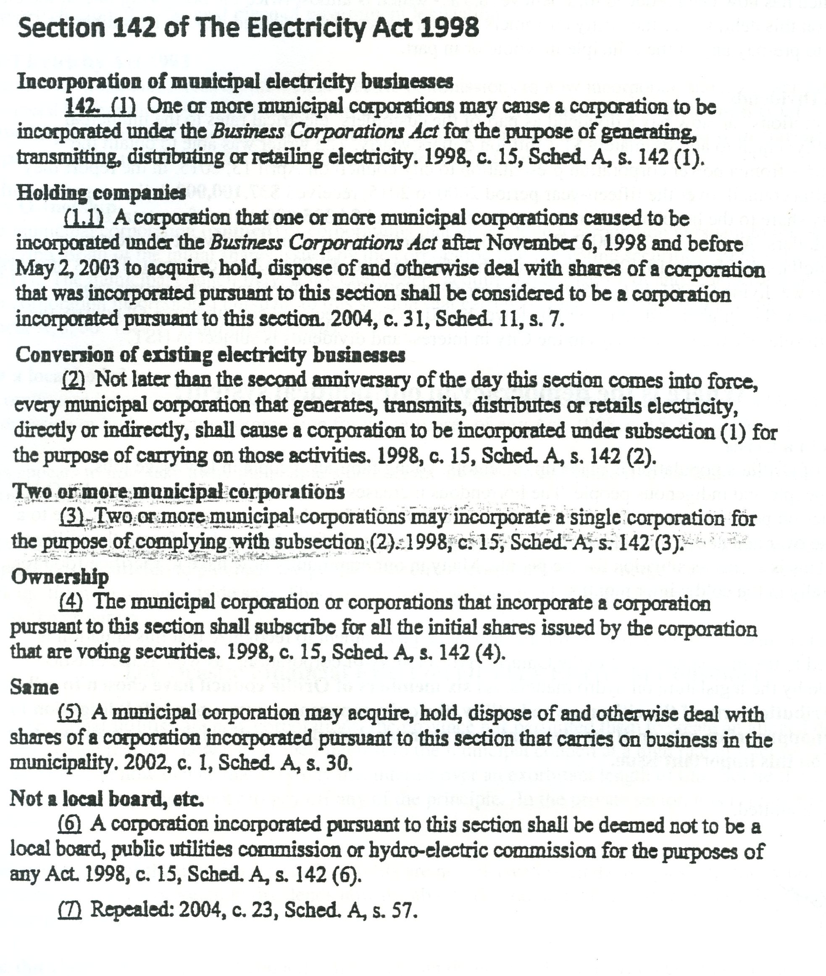

As a 19 year member of the elected Board of Directors a portion of which I Chaired I was aware that certain clauses existed in this legislation particularly the clauses that pertained to creating new corporations acting under the Corporations Act from the existing Corporation Orillia Water Light and Power Corporation (Commission). The elected Board of Directors had at this point never seen the written legislation or were ever told that the legislation would give the council alleged rights to sell Orillia’s cherished electricity asset that had served Orillians for 98 years and had over periods of time the cheapest electricity rates in North America, cheapest in all of Canada and for most of its existence the cheapest rates in Ontario which of course included HEPC.

It was fourteen years later when there was a rumour coming from an Orillia Council member that the Council was considering selling the Orillia Water Light and Power Corporation. The writer then started to investigate the behind the scenes tactics and copies of legislation, by-laws, meeting minutes of council and other relevant documents that represents in my opinion municipal treason of its citizens and the betrayal of all the Orillia electrical consumers. This situation is a complete breach of our Canadian Democracy. We as the elected Board members were told that the transfer to a new corporation would require at minimum a transfer document or bill of sale signed and approved by resolution under the corporate seal of the Orillia Water Light & Power Corporation (Commission). None of these transfer documents were ever placed before the Board of Directors (attached is a Sworn Signed Affidavit of the Commission Board of Directors).

The legislature in this situation appears to not care about Canadian democracy and the removal of all transparency as shown in S.253(2) of the Ontario Municipal Act, Part VI attached. The move to new corporations may satisfy the lobby groups, unions and others but it now allows hydro corporations as well as municipal hydro corporations to operate in complete secrecy with no more newspaper articles against the workings of the provincial owned former Ontario Hydro or other utilities. Freedom of information is no longer legally available and all transparency is a thing of the past. The new corporations can or must now pay dividends, however no longer to the consumers but now to the alleged new owners controlled by City Council. The corporations can now create debt on the books where there was no debt (in Orillia’s case there was a large surplus). The new corporations can now pay massive interest on this alleged new debt to the city coffers without the knowledge of probably 99% or greater of all the electrical consumers.

Orillia that has a disproportion number of poor and people on low or fixed income particularly seniors that need help to meet rent and food. Orillia has approximately 13,400 electrical metered customers. High electricity billing that includes interest on the new corporations debt together with the exceptionally high dividends paid to the city eats heavily on the income for many particularly in the winter months where they must substitute food costs for heat.

With the new corporations the City Council now is permitted to extract massive amounts of money from electrical consumers (in the private sector this could be easily called extortion or loan sharking).

In the non-electrical charges the new corporations reporting to City Council extract between 1.3 million dollars to 1.6 million dollars in what is called dividends and close to or slightly more than 1 million dollars in interest payments yearly from its electrical consumers. The electrical consumers are barred and not permitted to pay anything against the principle of this alleged artificial debt until year 2030 at which time they will still owe the same alleged debt as they did in year 2000. The corporations pay other expenditures when requested by city officials such as paying for new roofs on city buildings and rental fees for solar panels on other city buildings and other sundry items. The new corporations do not show any of the aforementioned fees on the consumer’s monthly electricity bill. So for the roughly 2.5 million dollars that flows yearly to the city there is no figure relating to this expenditure. However on the consumer’s electricity bill the new corporations charge the electrical consumers HST.


