BY EMAIL AND RESS

June 17, 2020

Ms. Christine E. Long
Board Secretary
Ontario Energy Board
Suite 2700, 2300 Yonge Street
P.O. Box 2319
Toronto, ON M4P 1E4

Dear Ms. Long:

Re: EB-2018-0117 – Hydro One Networks Inc.'s Section 92 – Barrie Area Transmission Upgrade – Update on Project Construction Commencement

In accordance with the Ontario Energy Board’s (“OEB”) Decision and Order, regarding Hydro One’s leave to construct application for the Barrie Area Transmission Upgrade (“BATU”) Project dated April 23, 2020, Hydro One is providing the OEB with an update to the BATU Project’s construction commencement.

To date, Hydro One has not commenced construction of the BATU Project. There are two main drivers for this delay.

Firstly, the full internal funding release process has not yet occurred because that process is dependent of the execution of the Capital Cost Recovery Agreement (“CCRA”) with InnPower (the customer) who is driving the Project’s need. This agreement is still pending, however, Hydro One expects to have the CCRA signed not later than the end of August 2020. This will allow Hydro One to execute the full release of project funding so it can mobilize and commence construction prior to the end of Q3 2020. In order to mitigate any lost time and to ensure it can mobilize shortly after the CCRA is signed, Hydro One has executed a partial internal funding release to order long lead time material items, such as the transformers. This will enable Hydro One to recover some of the time lost due to the delay in construction commencement.

Secondly, there have been delays introduced due to COVID-19. As many industries have experienced, the development of COVID-19 resulted in a temporary pause or slowdown of some projects and activities, not only at Hydro One but also with our customers, resulting in some unintended delays. Since March 2020, Hydro One have prioritized its investments aimed at recovering from any delay due to COVID-19, for this project and others. At this time Hydro One is still assessing the impact of COVID-19 on the BATU Project and the impact to the Project’s full construction schedule. At this stage Hydro One is confident the Project will still be placed in-service according to the timelines as filed.

Hydro One will continue to assess the Project throughout construction and will notify the board in writing should there be any further material changes or impacts to the Project, compared to the S.92 OEB-approval.

Sincerely,

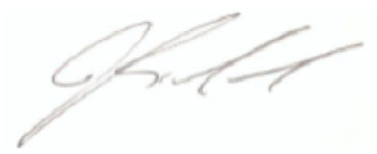

Joanne Richardson

cc.
Nancy Marconi – Ontario Energy Board - Manager of Transmission
David Martinello – Ontario Energy Board - Case Manager

