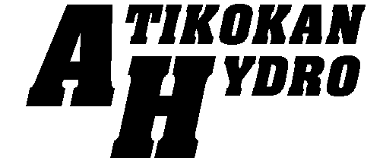
117 Gorrie Street, Box 1480

Atikokan, Ontario P0T 1C0

Telephone

(807)597
-
6600

Fax

(807)597
-
6988

e
-
mail
jen.wiens@athydro.com

Website: www.athydro.com

INC.

October 8, 2020

Christine E. Long
Registrar and Board Secretary
Ontario Energy Board
2300 Yonge St.
Suite 2700, P.O. Box 2319
Toronto, Ontario
M4P 1E4

Dear Ms. Long

RE: Atikokan Hydro Inc. Price Cap IRM Application OEB File NO. EB-2020-0004

Atikokan Hydro has selected the Price Cap IR method for rate-setting for its 2021 distribution rates effective May 1, 2021. Atikokan Hydro has been assigned the filing deadline of October 13, 2020 as per the Tranche Assignment letter.

Atikokan Hydro has made best efforts to provide the OEB with a filing by this deadline, however, due to COVID-19 and other utility mandates Atikokan Hydro is unable to file by the assigned deadline.

Atikokan will continue to work diligently on its Applicable and anticipates submission on or before October 30th, 2020.

We apologize for any inconvenience this delay may cause. Please feel free to contact if you have any questions.

Yours truly,

Jennifer Wiens
CEO/Secretary/Treasurer
Atikokan Hydro Inc.
(807)597-6600
jen.wiens@athydro.com

