Cooperative Hydro Embrun Inc. (Cooperative Hydro Embrun)
EB-2020-0011

Staff Question-1
Ref: A portion of Sheet 3 “Continuity Schedule” is reproduced below
The table from Cooperative Hydro Embrun’s 2019 IRM Decision which identified the principal and interest amounts approved for disposition, is reproduced below.

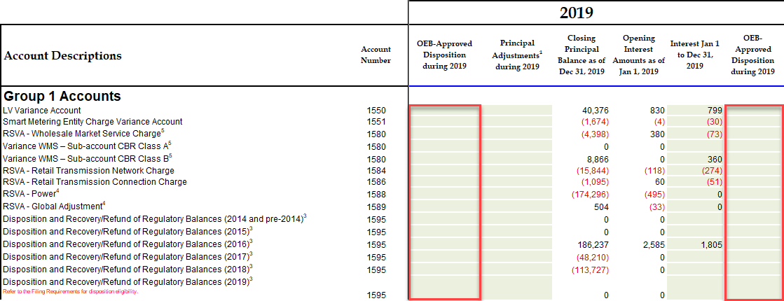

OEB staff notes that the “OEB-Approved Disposition during 2019” and interest Disposition during 2019 do not reconcile with the approved amounts in the 2019 IRM Decision (columns BE and BJ).
Please reconcile differences. If the input into the Rate Generator Model is an error please provide corrections and OEB staff will make the necessary changes to the model.
CHEI Response: CHEI confirms that this was an inadvertent omission on its part in that disposition based on Decision and Rate Order EB-2018-0026 were not transferred from the different accounts to account 1595. The model filed along with these responses reflects the correction.
CHEI notes that in correcting the entry creates a variance from the RRR balances. Details are shown at the next page. CHEI commits to updating its RRR once Board Staff has confirmed the response. Revising the RRR will eliminate the variances shown in the model.

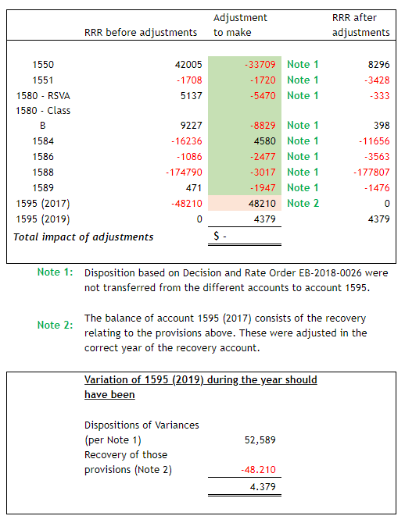

Staff Question-2
Ref: A portion of Sheet 3 “Continuity Schedule” is reproduced below
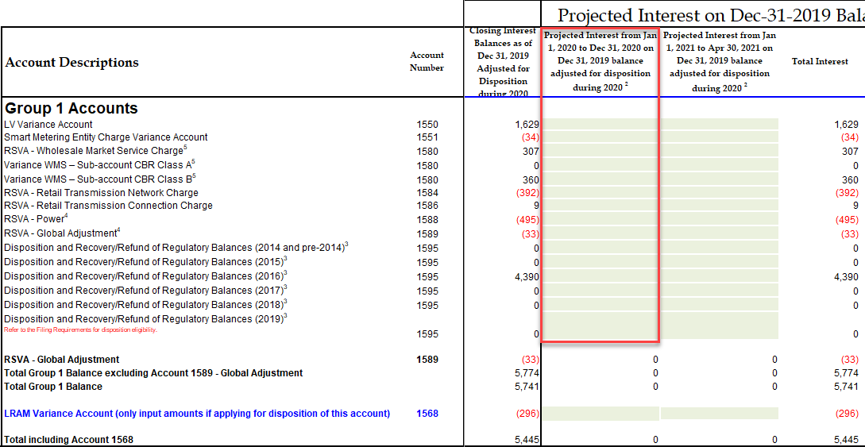
Board staff notes that the column BQ pertaining to the “Projected Interest from
January 1, 2020 to December 31, 2020 balance adjusted for disposition during 2020” is unpopulated.

If the omission of this interest is an error, Board staff will make the relevant correction.

CHEI Response: CHEI confirms that this was an inadvertent omission on its part. Please make the relevant corrections.

Staff Question-3 Ben
Ref: 2020 IRM Model, Tab 20 – Bill Impacts

OEB staff notes that the % change in the impact of RTSRs for the “Network” on every rate class exceeds 4.5% (from -5.33% to -5.82%) and “Connection and/or line and Transformation Connection” on every rate class exceeds 4.5% (from -6.15% to -7.14%).
- Please explain the reasoning for the change in RTSRs.

CHEI Response: All inputs from RTSRs (Network and Connection) come from the Hydro One Power bill. The UTRs are set and approved by the OEB. As a pass-through charge, CHEI had little to no control over the resulting RTSR rates and charges and bill impacts.

Staff Question-4
Ref: 2020 IRM Model, Tab 3. Continuity Schedule

OEB staff notes that the DVA continuity schedule starts from the “principal adjustments” cells for all Group 1 DVAs including Accounts 1588 and 1589.

In addition, OEB staff notes that there are no figures inputted for the interests from Jan 1 to Dec 31, 2019 (Cells BI28 and BI29) for Accounts 1588 and 1589.

- Given that Group 1 DVAs were final disposed in the 2018 cost of service application for the 2016 balances, please provide a complete continuity schedule for 2017 for Accounts 1588 and 1589 respectively as below:
1588
 | 2017 Opening Balance | Transaction Debits/(Credits) | Principal Adjustments | 2017 Ending Balance
Principal | (40,081) | 3,338 |  | (36,743)
Interest | 58 | (578) |  | (521)

1589
 | 2017 Opening Balance | Transaction Debits/(Credits) | Principal Adjustments | 2017 Ending Balance
Principal | (14,333) | 2,018 |  | (12,315)
Interest | 1,034 | (172) |  | 862

- Please tie the 2017 transaction debits/(credits) to the Net transactions in the 2017 GA Analysis workform. Please explain any variance.

CHEI/BDO Response: Refer to point A. Ending balance of the breakdown provided at point A agrees with the balance of “Principal Adjustments” for accounts 1588/1589.

- Please include the 2019 interests on the DVA continuity schedule for Accounts 1588 and 1589.

CHEI/BDO Response: Error during the year for which Interests on the accounts 1588 / 1589 were not calculated. This issue stems from the “November 2019” instructions and the problems CHEI had with the OEB Model (refer to Question 5). Interests were not calculated as there was, at that time, differences between the OEB Model and internal reconciliation. Since CHEI did not received any clarification that they could tailor the OEB model to suite the utility process, the internal reconciliation was used to balance the principal of 1588/1589 and was waiting on further instructions.

With the new clarifications received in August 2020, CHEI will factor in the interests of 2019 in their 2020 numbers (to prevent differences between DVA continuity schedule, RRR and audited financial statements.

Staff Question-5
Ref: IRE-2020-0698

OEB staff notes that Co-operative Hydro Embrun sent an IRE in its preparation of the 2021 IRM application regarding the 1588/1589 process. In the IRE, it states that:

We are looking for approval to 1) either modify the OEB's worksheet to match our actual process or 2) use our own models for reconciliation purposes, which may differ in its results from the OEB's worksheet.
OEB staff provided its response to the utility in August 2020. The response states that:
It is expected that regardless of whether a utility uses the OEB's Model or their own, the end result would be the same. You mentioned that the OEB Model results differ from the internal reconciliation as produced by BDO. You may want to confirm that you have made the appropriate modifications to the OEB Model to reflect your particular circumstances as a fully embedded utility. Any further differences with your internal reconciliation would warrant further investigation. It may be helpful discuss the results of this comparison in your rate next rate application to support the disposition of account balances.
- Please confirm whether Co-operative Hydro Embrun has performed such comparison as directed in the OEB staff’s response to the IRE. If so, please provide the results of the comparison including the differences of the reconciliation process, any differences in the results and the reasons for the different results.
- If the comparison has not been prepared, please explain why.

CHEI/BDO Response: Response given by OEB staff as of August 2020 differs from the response received in November 2019. CHEI was originally told they had no choice but convert to the new OEB model.

Since CHEI process differs greatly from the process determined within the OEB model, it would take too much time to modify the model in order to have it agree with CHEI process. Both CHEI and BDO Canada (auditors) are confident that the internal reconciliation results are accurate and represents the correct transactions in the year.

Staff Question-6
Ref: Application, pages 18 and 19; 1588 Variation Breakdown Excel File

Co-operative Hydro Embrun provides the following correspondence from its auditor BDO:

The internal review results for 2018 dispositions were submitted to the accounting department during the follow-up questions of the 2020 IRM in November 2019. The results, which were provided as a quick reference to the OEB’s question on why the 1588 account included a variance of $66,423 showed that the variation between the rates of 1st estimate and actual, CHEI was able to show an explanation of $61,156 from the $66,423. The difference consisting of other factors, which were excluded from the results in order to simplify the analysis.

Details are illustrated in the excel file 1588 variation breakdown.xls

Since it’s been shown that the variance of 1589 is accurate (refer to GA Analysis
submitted in the past and also in the 2021 IRM) and that, per the process, the electricity billed to the customers (excludes the distribution fees) must corresponds to the amount invoiced by Hydro One, CHEI concluded that the variation of 1588 was also accurate. Based on the results above and the process, there were no adjustments made to prior historical balances.

OEB staff notes that Co-operative Hydro Embrun did not specify the year of the 12 months’ variances in the excel file of 1588 variance breakdown. In addition, it is not clear how the excel file ties to the balances of Accounts 1588 and 1589 in the DVA continuity schedule.

- Please provide the date of the BDO’s correspondence in pages 18 and 19 of the evidence.

CHEI/BDO Response:

Relates to the year 2018.

This was in part to answer the directives given by OEB staff from November 2019 as they wanted proof that the amount to be disposed in 1588 were plausible. BDO prepared a quick reconciliation to help support at that time as it would of taken too much time to redo the year with the OEB Model (per the OEB guidance of November 2019).

In no part is this quick breakdown a complete summary of the variations incurred in account 1588 of $66,423, as shown in the “Principal adjustments during 2018” column of the DVA Continuity Schedule. The amount is included in the $66,423 but other factors are not shown in the breakdown as it was only for a quick reference.

- Please explain how BDO arrives the accuracy of the balance in Account 1588 by the two reasons provided: i.e. the variance in Account 1589 is accurate and the electricity billed to customers must corresponds to the amount invoiced by Hydro One.

CHEI/BDO Response: CHEI is not a market participant.

***Please note that the following is all based on discussions with OEB for the directives given in November 2019. A summary of what was discussed and that answers the question of point B is provided below.***

Please refer to the procedures of CHEI provided in multiple IRMs to understand how the process works.
- CHEI will invoice all customers based on 1st estimate * kWh billed to customers
- Hydro One will then invoice CHEI for the electricity they have purchased from Hydro One. The invoice from Hydro One shows both the kWh with and without line loss.
  - The amount billed by Hydro One represents the Actual revenue volumes (as it is determined based on kWh * Actual Rate).
- Variances of 1588 / 1589 majorly comes from the difference between the amount invoiced to customers and the amount that was billed to CHEI by Hydro One. Since Hydro One amount represents the Actual volume while CHEI’s invoicing represents the 1st estimate (and there is no 2nd estimate).
  - In simple terms, CHEI must ensure that what is billed to customers agrees with the invoice received of Hydro One. As such, we can summarize with the following equation:
    - Revenues of Electricity = Amount billed by CHEI to customers + Variances of 1588 / 1589
    - Revenues of Electricity must equal Expenses of electricity (bills from Hydro One)
  - If we are able to concur that all components of the equations are accurate (Ammounts billed to customers, Variance of 1589, expenses of electricity) than by default, if the equation agrees, this means that variance of 1588 is accurate also.

- Please explain how the excel file 1588 variance breakdown ties to the balances in the DVA continuity schedule.

Refer to point A

- Please confirm whether Co-operative Hydro Embrun has recorded the total Variation between Billed and invoiced by Hydro One - RPP cell N24 of $61,155.87 in Account 1588. If so, what cell in the DVA continuity schedule is the corresponding figure?

CHEI/BDO Response: Refer to point A

Staff Question-7
Ref: 1588 Variation Breakdown Excel File

Please provide the answers to the following questions regarding the excel file:

CHEI/BDO Response: Please refer to Question 6. Based on the new guidance provided in August 2020, the Variation breakdown becomes a moot point.

- Line 17 “Total kWh's invoiced by Hydro One (Global adjustment at Actual rate)”: where is the total kWh coming from? Why it is the same kWhs billed to the customers (i.e. line 8)? In other words, why there is no line losses experienced by the utility?

CHEI/BDO Response: For the analysis in the Excel Breakdown, we did not factor in line loss as it was made as a quick calculation to help support the adjustments of the year (and not to reconcile 100% the amount). The Excel was only prepared to answer a question from the OEB in November 2019.

Line losses are experienced and factored in the reconciliation of 1588/1589.

- Line 11 “Amount billed to RPP Customers” is calculated as Line 6 “kWh's billed to RPP customers” multiplied by Line 10 “GA 1st estimate Rate”. Please explain whether Co-operative Hydro Embrun uses GA 1st estimate rate to settle the RPP variances with Hydro One. If so, is the rate trued up to the actual rate?

CHEI/BDO Response: CHEI is not a market participant.

There is no settlements with Hydro One as the variation between the amount billed to customers (at 1st estimate) and amount invoiced by Hydro One (at Actual Rates) needs to be settled by the customers, hence why they are included in the variations of 1588 / 1589.

Please refer to the procedures of CHEI provided in multiple IRMs to understand how the process works.
- CHEI will invoice all customers based on 1st estimates * kWh billed to customers
- Hydro One will then invoice CHEI for the electricity they have purchased from Hydro One. The invoice from Hydro One shows both the kWh with and without line loss.

For the analysis in the Excel Breakdown, we did not factor in line loss as it was made as a quick calculation to help support the adjustments of the year (and not to reconcile 100% the amount). The Excel was only prepared to answer a question from the OEB in November 2019.

- Line 24 “Variation between Billed and invoiced by Hydro One – RPP” is calculated as Line 11“Amount billed to RPP Customers” less Line 20 “GA invoiced re: RPP customers”. Please explain whether this variance is settled with Hydro One on a monthly basis.

CHEI/BDO Response: CHEI is not a market participant.

There is no settlements with Hydro One as the variation between the amount billed to customers (at 1st estimate) and amount invoiced by Hydro One (at Actual Rates) needs to be settled by the customers, hence why they are included in the variations of 1588 / 1589.

Staff Question-8
Ref: A portion of GA Analysis Workform is reproduced below for 2017
Ref: A portion of GA Analysis Workform is reproduced below for 2018

2017
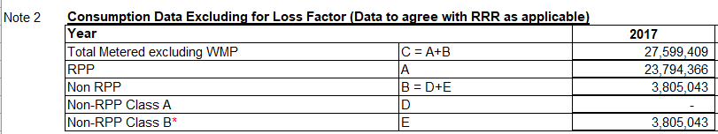

2018
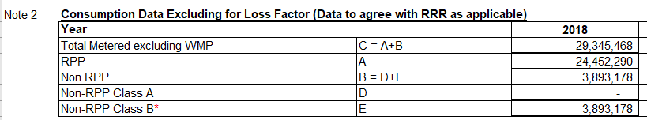

OEB staff notes that Cooperative Hydro Embrun’s “Total Metered excluding WMP” for 2017 is 27,030,036 according to the most recent 2018 RRR filings. The GA Analysis Workform filed in this application currently says 27,599,409.

For 2018, the “Total Metered excluding WMP” is 28,453,922 according to the most recent 2019 RRR filings. The GA Analysis Workform filed in this application currently says 29,345,468.

- Please explain why there is a variance between Cooperative Hydro Embrun’s RRR filing and the GA Analysis Workform for 2017 & 2018. Please confirm the correct number and check whether the volumes submitted in RRR require updating.

CHEI/BDO Response: CHEI’s RRR were revised for both 2017/2018. Details of the request are shown below.

2017: Date of the request August 14, 2020 -Approved and completed
2018: Date of request September 25, 2019 - Approved and completed

EB-2018-0026 issued December 13, 2018, page 11 of 24

