Festival Hydro Inc. (Festival Hydro)
OEB Staff Questions
2021 IRM Application
EB-2020-0022
October 22th, 2020
*Responses to OEB Staff questions, including supporting documentation, must not include personal information unless filed in accordance with rule 9A of the OEB’s Rules of Practice and Procedure.
OEB Staff- 1
Reference: (i) IRM Rate Generator Model, Tab 3: Continuity Schedule
(ii) EB-2019-0035 Decision and Rate Order 20191212, Page 9
Festival Hydro has reported in Tab 3 of the IRM Model that the “Principal Disposition during 2020- instructed by OEB” and the “Interest Disposition during 2020- instructed by OEB” in Account 1580 RSVA- Wholesale Market Service Charge in 2020 was a credit of $93,033 and debit of $3,238, respectively. OEB staff notes that as per the 2019 IRM Decision and Rate Order, the principal and interest disposition in Account 1580 was a credit of $101,170 and debit of $2,659, respectively.
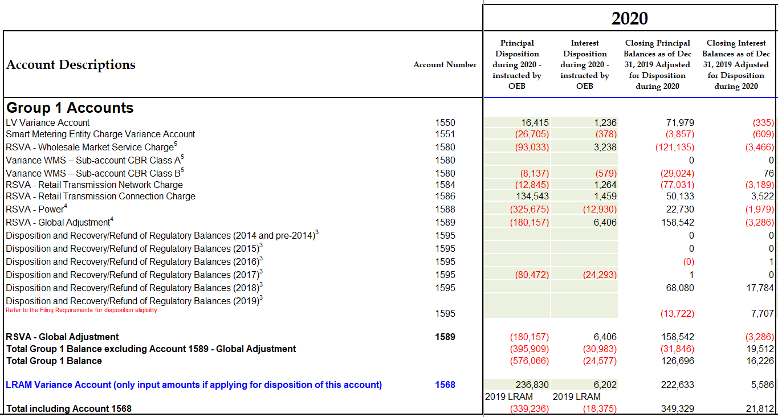
- Please review the Account 1580 RSVA- Wholesale Market Service Charge disposition amounts in 2020 and provide an explanation for the noted discrepancies. OEB staff is of the understanding that the balances in Account 1580 are being subtracted with sub-account CBR Class B.

The RSVA – Wholesale Market Service Change 1580 is the total credit of $101,170 and debit of $2,659 subtracting the Variance WMS – Sub-account CBR Class B amount. When adding the two lines on tab-3 continuity schedule the balance equals the total approved disposal from the 2019 IRM Decision and Rate Order.

- If required, please make any necessary adjustments to the Continuity Schedule in the 2021 IRM Rate Generator Model.

No changes required.

OEB Staff- 2
Reference: (i) IRM Rate Generator Model, Tab 3: Continuity Schedule
On Tab 3 the “Projected Interest from Jan 1, 2020 to Dec 31, 2020 on Dec 31, 2019 balance adjusted for disposition during 2020” (column BQ) for Accounts 1550, 1551, 1580, 1584, 1586, 1588, and 1589, amounts were calculated using the formula:
BQ## = BM##*((0.0218*(6/12))+(0.0057*(6/12)))
Typically, the projected interest (column BQ) is calculated using the “Closing Principal Balances as of Dec 31, 2019 Adjusted for Disposition during 2020” (column BO) instead of the “Principal Disposition during 2020- instructed by OEB” (column BM).
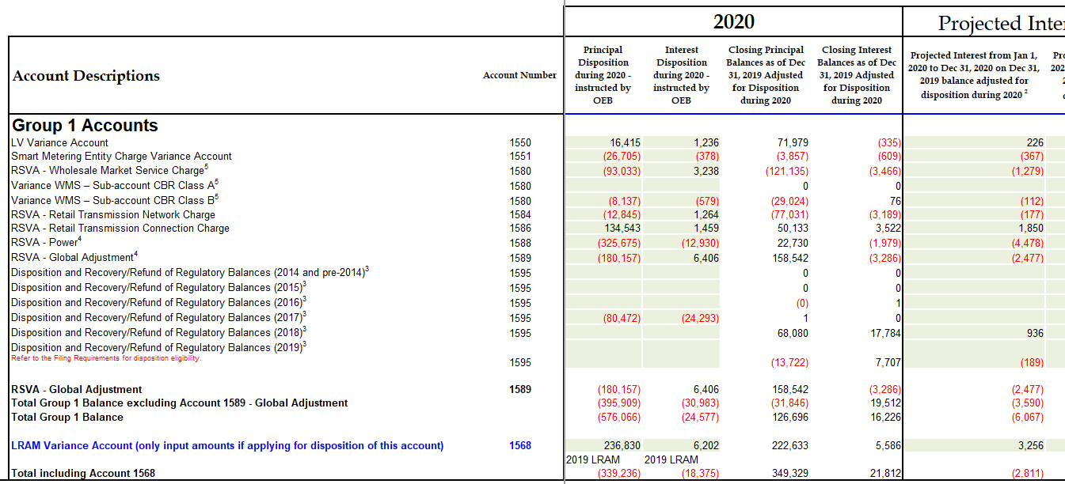
- Please explain why the projected interest (column BQ) was calculated using column BM as noted in the above formula instead of column BO.

Festival used column BM in the formula to calculate the projected interest (column BQ) in error and should have used column BO.

- If required, please make necessary adjustments to the Continuity Schedule in the 2021 IRM Rate Generator Model.

Festival has corrected the formula used to calculate the projected interest (column BQ) to use column BO instead of BM in the Continuity Schedule of the 2021 IRM Rate Generator Model.

OEB Staff- 3
Reference: (i) GA Analysis Workform
OEB staff notes in the GA Analysis Workform that there is no principal adjustment in the current year for Account 1588 and 1589 for the following 3 adjustments:
- CT 148 true-up of GA Charges based on actual RPP volumes
- CT 1142 true-up based on actuals
- Unbilled to actual revenue differences

- Please confirm that Festival Hydro has recorded these true-ups in the general ledger in 2019, and therefore, no principal adjustments are needed in the DVA continuity schedule/ GA Analysis Workform.

Festival keeps the year-end general ledger open to record the true-ups and actual revenue for the year and therefore requires no principle adjustments.

OEB Staff- 4
Reference: (i) GA Analysis Workform
Festival Hydro’s approved loss factor is 1.0291 and the calculated loss factor from the GA Analysis Workform is 1.1025, a difference of 7.13%. Please explain the difference and revise the GA Analysis Workform as needed.
After further review, Festival has determined that the non-RPP 2019 kWh needs to be revised. Festival has submitted a RRR Revision Request to update the GA>50 and Large Use non-RPP kwh. This revision will result in the following:
Year |  | 2019
Total Metered excluding WMP | C = A+B | 614,306,359 | kWh
RPP | A | 203,073,047 | kWh
Non RPP | B = D+E | 411,233,312 | kWh
Non-RPP Class A | D | 277,827,791 | kWh
Non-RPP Class B* | E | 133,405,521 | kWh
Non-RPP Class B incl LF |  | 139,007,773 | kWh
Calculated Loss Factor |  | 1.0420
Approved Loss Factor |  | 1.0291
Difference |  | 0.01289

Festival has not attached an updated GA Workform as we are unable to update the amounts within the workform. In addition, these changes impact tab 4 in the 2021 IRM Rate Generator Model. Festival is also unable to update these numbers within the model.
OEB Staff- 5
Reference: EB-2020-0022, Page 7
Festival Hydro notes that it continues to carry a balance of $5,683 from the 2016 LRAMVA disposal and requests this balance be rolled into the approved 2021 1595 sub-account rate rider.
- Please confirm that Festival Hydro continues to carry a residual balance of $5,683 from the 2016 disposal that is solely related to the LRAMVA balance.

Festival continues to carry a residual balance of $5,683 from the 2016 disposal that is solely related to LRAMVA balance.

- Please discuss why Festival Hydro believes it is appropriate to transfer a residual balance from the 1595 (2016) sub-account to the 1595 (2021) sub-account, considering the residual balance is related to the 2016 vintage year and should only be cleared once on a final basis.

The 1586 2016 LRAMVA disposal (2018 rate year disposition) completed billing in February 2019 and as the balance remaining in the account was not recovered through the 2018 approved LRAMVA rate, and the 2019 GL balances have been audited, Festival is now requesting the residual balance be transferred into 1595 (2021) sub-account to be disposed of in the 2022 rate year rate rider.

OEB Staff- 6
Reference: (i) LRAMVA Workform, Tab 5
An LRAMVA balance adjustment to the 2017 savings for the Retrofit program and LRAMVA balance adjustments to the 2018 savings from the Save on Energy Small Business, and Business Refrigeration Local programs are being sought.
- Please identify the source documentation for these LRAMVA balance adjustments. If this documentation was not submitted as part of the initial application submission, please provide a copy.

- 2017 adjustment to Retrofit program
The OEB had questions about the allocation of streetlight savings in Festival’s 2020 IRM submission (EB-2019-0035). Based on the OEB’s direction last year this adjustment was added in the revised LRAMVA workform submitted and approved. Please refer to Festival responses to Staff Question 9 in the 2020 IRM submission.
- 2018 adjustment to Small Business Lighting program
Festival has reviewed the 2018 SBL and BRI true-ups and discovered that some of these applications were sorted incorrectly. There were some projects completed in 2019 and were incorrectly included as 2018 true-ups. A revised 2021 LRAMVA Workform is attached. The 2018 true-ups have been removed and the 2019 savings have been updated.
OEB Staff- 7
Reference: (i) LRAMVA Workform, Tab 5
Festival Hydro is claiming a 2018 LRAMVA balance for the Save on Energy Coupon program, including the Instant Discount program. The electricity savings for this program could not be reconciled to the submitted IESO LDC CDM Program Results, IESO Participation and Cost, or project-level savings reports.
- Please explain the calculations used to arrive at the 2018 LRAMVA balances for the Save on Energy Coupon program, including the Instant Discount program. In the response, please identify the source documentation of all input values.

The electricity savings were obtained from the April 2019 Participation & Cost report attached. Please note that these values were the same in the workform submitted and approved last year.

OEB Staff- 8
Reference: (i) LRAMVA Workform, Tab 5
(ii) IESO Savings Persistence Report
The electricity savings persisting from 2015 claimed on Tab 5 of the LRAMVA Workform could not be reconciled to the submitted IESO Savings Persistence Report.
- Please provide the details and calculations used to arrive at the 2015 persisting electricity savings. In the response, please confirm the source documentation of the claimed electricity savings persisting from 2015.

These values were first introduced in Festivals 2018 IRM filing. The format of the workform changed at that time and introduced this approach to calculating the effect of persisting energy savings in future years. The persisting savings tab has values by program by year starting from persistence of 2015 projects in 2016. Festival believes that this information was provided in a stand-alone Persistence report from the IESO but are unable to locate that as a separate document in any of our records. Festival has provided the 2018 IRM submission for reference.
OEB Staff- 9
Please provide an updated IRM Model Rate Generator model and LRAMVA Workform, reflecting any changes required in response to OEB Staff questions. Please record all changes in Tab 1-a of the LRAMVA Workform.
Festival has provided updated LRAMVA workform, additional LRAM supporting documentation, and Rate Generator model which also includes the change to Festivals stretch factor group from 4 to 3 based on the 2019 Benchmarking Report.

