**Oakville Hydro Electricity Distribution Inc. (Oakville Hydro)**

**EB-2020-0045**

**Round#3 Follow up Questions**

**November 3, 2020**

*Responses to interrogatories, including supporting documentation, must not include personal information unless filed in accordance with rule 9A of the OEB’s *Rules of Practice and Procedure*.

**Follow-up Question #1**

**Ref: Follow-up Question #4**

In the November 2nd response, Oakville Hydro stated in Follow-up Question #4 that another GA Workform and DVA continuity schedule will be filed separately. Please submit the two attachments.

**Response:**

Oakville Hydro will submit the updated GA workform and DVA continuity schedule along with this response.

**Follow-up Question #2**

**Ref: Follow-up Question #4**

In response to follow-up question #4, it states that “The variance between the general ledger balances and the balances in the DVA Continuity Schedule is now equal to the 2019 principal adjustments made for the 2019 year-end only (i.e. no reversals pertaining to 2018) and the amount pertaining to Class A in the 2018 Account 1589 balances.” Please confirm that this means the Class A GA balance for 2018 is still included in the 2019 balance in the general ledger. If not, please explain further. Please also explain how the 2018 Class A GA balance is treated in the general ledger in 2019 and whether it is included or excluded in the 2019 transactions in the DVA Continuity Schedule.

**Response:**

Oakville Hydro confirms that Class A GA balance for 2018 is included in the 2019 balance in the general ledger. The Class A GA balances for 2018 and 2019 have been included in 2018 and 2019 transactions in the DVA Continuity Schedule and the Class A GA balance for 2018 and 2019 have been removed from Account 1589 balance as permanent adjustments and they are not reversed.

**Follow-up Question #3**

**Ref: Manager’s Summary, Table 4, Rate Rider 1 to Dispose of a Portion of Account 1588, page 6 of 14**

**Ref: Tab 4 – Continuity Schedule**

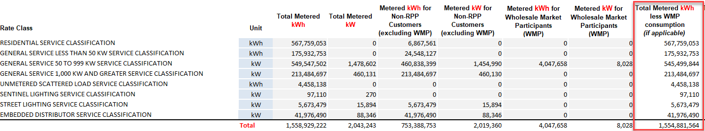

OEB Staff notes that Oakville Hydro provided the rate rider calculations to dispose portion of account 1588 using the billing determinants from Tab 4, “Total Metered kWh” (Column C) rather than “Total Metered kWh less WMP [if applicable]” (Column I).

1. Please re-calculate the rate riders using Column I data.

**Response:**

Oakville Hydro updated the rate rider calculations to dispose portion of account 1588 by using the billing determinants from Tab4 Column I “Total Metered kWh less WMP (if applicable)”.

