Festival Hydro Inc. (Festival Hydro)
OEB Staff Questions- Round 2
2021 IRM Application
EB-2020-0022
November 11th, 2020
Please note, Festival Hydro is responsible for ensuring that all documents it files with the OEB, including responses to OEB staff questions and any other supporting documentation, do not include personal information (as that phrase is defined in the Freedom of Information and Protection of Privacy Act), unless filed in accordance with rule 9A of the OEB’s Rules of Practice and Procedure.

OEB Staff- 10
Reference: (i) IRM Rate Generator Model, Tab 4: Billing Det. for Def-Var
(ii) IRM Rate Generator Model, Tab 6: Class A Consumption Data
(iii) Staff Question Response to OEB Staff-4

In response to OEB-Staff 4, Festival stated that it has submitted a RRR Revision Request to update the GS>50 and Large Use non-RPP kwh. Festival further states that those changes impact tab 4 of the 2021 IRM Rate Generator Model but it was unable to make those updates to the model.
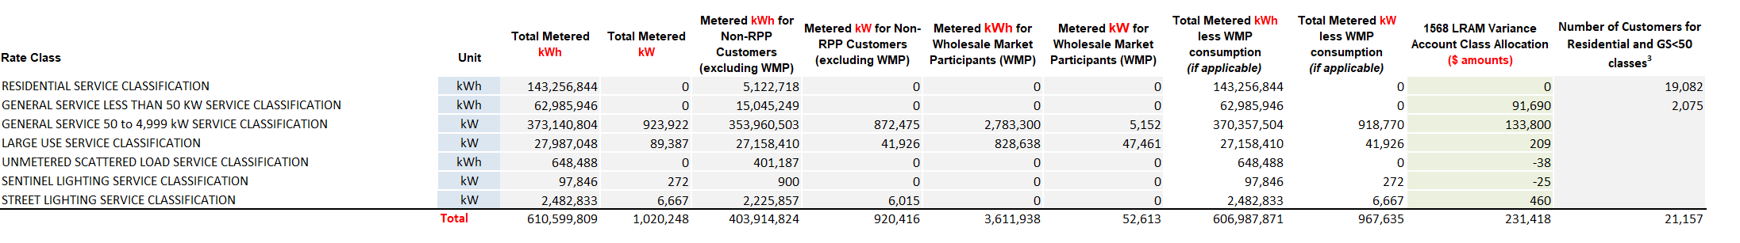
a) Please summarize the changes to be made in the table above, including the consumption data by rate class, that are affected by the RRR Revision Request for OEB staff to update in the model.
On tab 4 of the rate generator model the following amounts need to be updated with revised RRR submitted by Festival.

Total Metered kWh
 | Original RRR Reported | Revised RRR Reported
General Service 50 to 4,999 kW Service Classification | 373,140,804 | 379,872,624
Large Use Service Classification | 27,987,048 | 28,573,717
Metered kWh for Non-RPP Customers (excluding WMP)
 | Original RRR Reported | Revised RRR Reported
General Service 50 to 4,999 kW Service Classification | 353,960,503 | 360,692,322
Large Use Service Classification | 27,158,410 | 27,745,078

Festival has attached an updated version of the rate generator model with updates on tab 4 for the revised 1568 LRAM Variance Account Class Allocation ($ amounts) based on the revised LRAM workform submitted with the OEB initial question responses on Nov 3rd 2020.
b) Please confirm that no changes need to be made to tab 6 of the model (class A consumption) as a result of the RRR revision.
Festival confirms there are no changes to tab 6 of the model for Class A consumption.

