Hydro Hawkesbury Inc.

OEB Staff Questions

EB-2020-0029

**Hydro Hawkesbury Inc.**

**EB-2020-0029**

Applicants are responsible for ensuring that all documents filed with the OEB, including responses to OEB staff questions and other supporting documentation, do not include personal information (as that phrase is defined in the *Freedom of Information and Protection of Privacy Act*), unless filed in accordance with rule 9A of the OEB’s *Rules of Practice and Procedure*.

## Staff Question-1

Ref: Tab 1 of the Rate Generator Model (Nov 18, 2020) – attached

EB-2019-0042, Decision and Rate Order, page 9

In the 2020 rate proceeding, the OEB approved the interim disposition of the remaining 2018 Group 1 account balances, exclusive of Accounts 1588 and 1589. Furthermore, the OEB accepted Hydro Hawkesbury’s request to keep the disposition of its 2017 Group 1 balances interim and not to dispose of the 2018 balances in Accounts 1588 and 1589 at this time.

1. For the remaining 2017 and 2018 Group 1 DVA balances (exclusive of Accounts 1588 and 1589) that were approved on an interim basis, please confirm there were no changes in those balances. If confirmed, please revise the selection in Question 3 b. i) from “2016” to “2017”.
2. Please confirm whether the earliest vintage year in which there is a balance in Account 1595 is “2017”. If confirmed, please revise the selection in Question 4 from “2018” to “2017”.

## Staff Question-2

Ref: Application, pages 17-18

At the above reference, Hydro Hawkesbury confirms that it is in compliance with the OEB’s February 21, 2019 accounting guidance related to Accounts 1588 and 1589. OEB staff noticed significant adjustments were booked in 2018 and 2019.

1. Please explain the nature of the changes that led to these substantial adjustments made to Accounts 1588 and 1589.
2. As a result of confirming that it has implemented the OEB’s February 21, 2019

accounting guidance, please confirm whether Hydro Hawkesbury is seeking final

disposition of its 2017 and 2018 Group 1 DVA account balances as part of the current proceeding.

1. Please confirm whether Hydro Hawkesbury is requesting final disposition of its 2019 Group 1 DVA account balances in the current proceeding.

## Staff Question-3

Ref: HHI Response to OEB incomplete letter

Excel attachment, “Impact of new methodology”

At page 4 of the incomplete letter, the OEB noted that Hawkesbury Hydro did not provide an explanation of variances between RRR and the Group 1 account balances for Accounts 1588 and 1589 in its Application. At page 6 of the incomplete letter, Hydro Hawkesbury was to report back on the findings of its analysis as part of its next IRM application, including the details of this internal review related to the significant balance in Account 1588.

In response, Hydro Hawkesbury stated that it recalculated its variances for 2017, 2018 and 2019 with the new OEB methodology based on the February 21, 2019 accounting guidance. Based on this new methodology, there was a reduction in the principal balance of $507,638 and in carrying charges of $6,107 in Account 1588. Furthermore, Hydro Hawkesbury noted:

* A reclassification of $202,427 between Accounts 1588 and 1589 has also been eliminated.
* For Account 1589, there was an increase of $652,878 in the principal balance and $23,533 in carrying charges.
* Those amounts correspond to the differences in column BW of Tab 3 of the Continuity Schedule in the IRM Rate Generator for Accounts 1588 and 1589.

Hydro Hawkesbury filed an excel attachment, “Impact of new methodology” to show how the reclassification of $202,427 between Accounts 1588 and 1589 was quantified.

An extract of the “Impact of new methodology” excel spreadsheet are provided for reference. OEB staff understands that the values under the “Differences” row refer to the principal adjustments for 2017, 2018 and 2019.

Principal adjustments:

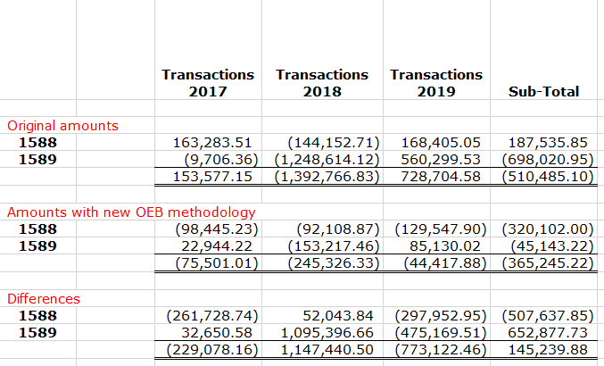

The total 2017-2019 principal adjustment amount (inclusive of interest) is a credit balance of $513,744, and the reclassification of $202,427 is shown to be calculated based on the difference between ($716,171) and ($513,744).

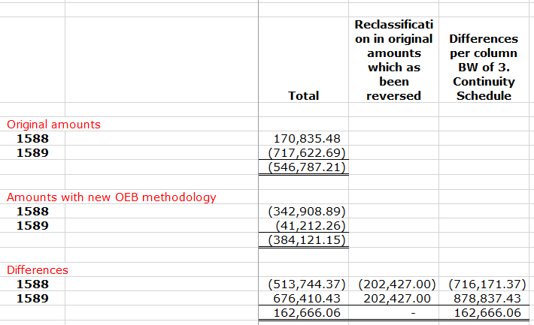

1. Please clarify what is meant when a reclassification of $202,427 is eliminated.
2. What are the key reasons for the change in 2017, 2018 and 2019 transactions as a result of the implementation of the OEB accounting guidance?
3. Please confirm whether an amendment to RRR 2.1.7 for Accounts 1588 and 1589 in the DVA Continuity Schedule is required in order to reflect the elimination of the $202,427 reclassification amount. If yes, please confirm what change is required and OEB staff can assist in correcting the RRR 2.1.7 balances.

## Staff Question-4

Ref: Application, page 18

Typically, large balances are not expected for Account 1588 as it should only hold the variance between commodity costs based on actual line losses and commodity revenues calculated using values for line losses approved by the OEB in the utility’s last rebasing application.

Based on RRR data filed for Hawkesbury Hydro for Account 4705 Cost of Power, OEB staff calculated, in the table below, the annual net activity (i.e. transactions plus principal adjustments) from the DVA Continuity Schedule as a percentage of annual Account 4705 to be as follows:



1. Please confirm this calculation or, if necessary, provide a revised calculation.
2. For year(s) where the percentage is greater than +/-1%, please provide an explanation as to why the sum of the transactions in Account 1588 is relatively large.

## Staff Question-5

Ref: Application, pages 17-18

GA Analysis Workform

The following explanation was provided at Note 4 of the GA Analysis Workform:

“With the new method, recalculations have made remade [sic] for 2017, 2018 and 2019. Because the previous method was different, there is a shift between RPP and non-RPP. The numbers at the top of this spreadsheet are the numbers originally submitted. Because there was a change between RPP and non-RPP, this has an impact on the loss factor. The numbers at the top of this spreadsheet are protected. We are unable to change them.”

1. Based on Note 4 above, please describe the impact on the loss factor due to the reallocations between RPP and non-RPP. If the impacts are not demonstrated in the responses to Staff Question-6 b) and c), please discuss what has changed and why.
2. The Application states: “With the previous methodology, HHI was using its revenues and dividing them with the applicable RPP/TOU rates to obtain the number of kWh.” Please explain what is used now to obtain the number of kWh.
3. Please explain whether Hydro Hawkesbury’s systems can determine calendarized consumption.
4. The Application further states: “Class A and embedded generators clients were not considered with the previous methodology. IESO did a review of HHI’s process and methodology a few years ago. They agreed with the way HHI was making its calculations.”
5. Please confirm if the statement above means that Hawkesbury Hydro did not previously report Class A and embedded consumption to the IESO accurately.
6. If the answer to question c) is yes, please explain what the impact of this issue was and confirm whether it has been resolved with the IESO.
7. If the answer to question c) is no, please explain what the issue is with the previous methodology.
8. Hawkesbury Hydro indicates that “energy purchases were also treated differently under the previous methodology.” Please explain how it was different.

## Staff Question-6

Ref: GA Analysis Workform, Tabs 2017, 2018 and 2019

GA Analysis Workforms – filed in 2019 and 2020 IRM proceedings

EB-2019-0042, Response to OEB Staff Questions (Oct 25, 2019), Question 9

In the GA Analysis Workform submitted in this proceeding, the approved loss factors for 2017, 2018 and 2019 were not provided. There also appears to be changes in billed kWh for non-RPP (class B) in the GA Analysis Workforms filed between the current and prior proceedings.

1. Please provide the approved loss factors for secondary metered customers <5,000 kW in all tabs of the GA Analysis Workform.
2. OEB staff compiled the following table to show 2017 billed consumption for non-RPP class B customers and the calculated loss factor:

|  |  |  |  |
| --- | --- | --- | --- |
| **Tab 2017 GA** |  | **2017** | |
|  | Line | “Previous” GA Workform filed in 2019 IRM proceeding (kWh)  Col. 1 | “Updated” GA Workform filed in 2021 IRM proceeding (kWh)  Col. 2 |
| Billed kWh for non-RPP class B, including loss adjustment | A | 76,122,606 | 77,369,799 |
| Actual kWh for non-RPP class B | B | 72,037,036 | 72,037,036 |
| Calculated loss factor – A / B |  | 1.0567 | 1.074 |

1. At Line A, Columns 1 and 2, please explain why billed consumption for non-RPP class B customers increased from 76,122,606 kWh to 77,369,799 kWh in 2017.
2. If the updated figures in Column 2 are correct, please provide the supporting analysis to explain how the calculated loss factor of 1.074 is reasonable compared to the approved loss factor of 1.0541.
3. OEB staff compiled the following table to show 2018 billed consumption for non-RPP class B customers and the calculated loss factor:

|  |  |  |  |
| --- | --- | --- | --- |
| **Tab 2018 GA** |  | **2018** | |
|  | Line | “Previous” GA Workform filed in 2020 IRM proceeding (kWh)  Col. 1 | “Updated” GA Workform filed in 2021 IRM proceeding (kWh)  Col. 2 |
| Billed kWh for non-RPP class B, including loss adjustment | A | 69,699,047 | 69,416,007 |
| Actual kWh for non-RPP class B | B | 66,297,565 | 64,652,489 |
| Class A volumes | C | 13,396,041 * | 15,041,117 |
| Calculated loss factor – A / B |  | 1.051 | 1.074 |

* revised in Response to OEB Staff Question #9 in 2020 IRM staff questions

1. At Line A, Columns 1 and 2, please explain why the billed consumption for non-RPP class B customers decreased from 69,699,047 kWh to 69,416,007 kWh in 2018.
2. At Line C, Column 2, please confirm accuracy of the Class A volumes of 15,041,117 kWh in the GA Analysis Workform submitted in this proceeding.
3. In the 2019 GA Tab, it appears that the difference between the calculated and approved loss factor is greater than 1% (i.e. 1.0632 – 1.0509). Please provide the supporting analysis to explain how the calculated loss factor of 1.0632 is reasonable compared to the approved loss factor of 1.0509.
4. If any of the response(s) above require an amendment to the GA Workform or the Rate Generator Model, please indicate the change(s) required. Please confirm the changes needed, as OEB staff can assist with any required revisions to ensure the records are accurate.

## Staff Question-7

Ref: Application, page 24, and LRAMVA Workform

Tabs 3 and 4 of the Rate Generator Model (Nov 18, 2020) – attached

EB-2017-0048, 2018 DVA Continuity Schedule, Tab 6

In the LRAMVA Workform, Hydro Hawkesbury calculated a credit balance of $749 comprised of incremental 2017 and 2018 lost revenues. However, Hydro Hawkesbury is requesting disposition of a total LRAMVA credit balance of $6,288 based on the December 31, 2020 balance for Account 1568 in the DVA Continuity Schedule.

1. Please confirm that the LRAMVA debit balance of $7,860 was disposed of in the 2018 COS proceeding or clarify if this is not the case.
2. Please confirm that Hydro Hawkesbury relied on the 2019 Participation & Cost (P&C) Report. If yes, please confirm that the net savings for 2018 are consistent with the reported results on the 2019 P&C Report.
3. Please confirm whether Hydro Hawkesbury agrees to update Tab 4 of the Rate Generator Model to reflect the disposition of a credit balance of $749 based on the rate class allocations calculated in the LRAMVA Workform. If yes, please revise the correct rate class amounts in Tab 4 based on Tab 1 (Table 1-a) of the LRAMVA Workform. If not, please discuss.

## Staff Question-8

Ref: Tabs 6, 6.1a and 6.2a of Rate Generator Model (Nov 18, 2020) – attached

GA Analysis Workform, Tab 2019

OEB staff enabled the macros in Tab 6 of the Rate Generator Model to generate a table with columns for 2017 and 2018. As a complete version of this table was not generated in the Rate Generator Model filed by the utility, 2017 and 2018 data was not provided.

1. In Tab 6 of the Rate Generator Model, please provide the 2017 and 2018 data in Tables 3a and 3b.
2. Based on the response to Staff Question 6-c ii), please reconcile the difference between the 2019 Class A volumes of 11,544,609 kWh (in Tab 6 of Rate Generator Model) and 13,264,976 kWh (in Tab “2019 GA” of the GA Analysis Workform).
3. Please provide the 2017 and 2018 volumes in Tab 6.1a (pertaining to total non-RPP consumption, less WMP) and in Tab 6.2a (pertaining to total metered consumption, less WMP).

## Staff Question-9

Ref: Tabs 8 and 9 of Rate Generator Model (Nov 18, 2020) – attached

EB-2017-0048, PILS Workform, Tab “T0 PILs, Tax Provision”

Hydro Hawkesbury calculated a tax sharing credit amount of $117 based on the decrease in the combined effective tax rate from 12.5% in 2018 to 12.2% in 2021.

1. Please explain the rationale for using an effective tax rate of 12.5% in 2018, when the approved effective tax rate was 15% in the 2018 PILs Workform.
2. Please confirm whether Hydro Hawkesbury agrees to update the 2018 effective tax rate to 15% in Tab 8 of the Rate Generator Model. If yes, please confirm the revised tax sharing amount.
3. Please provide the requested data in columns C through H in Tab 9 of the Rate Generator Model.

## Staff Question-10

Ref: Tab 3 of the Rate Generator Model (Nov 18, 2020) – attached

In Tab 3 of the Rate Generator Model, there are principal adjustments to Account 1595 (pre-2014 and 2015) balances in the 2018 rate year.

1. Please explain why Hydro Hawkesbury reflected the draw-down of Account 1595 balances in the principal adjustment column in the 2018 rate year.
2. Please reflect the draw-down of Account 1595 (pre-2014 and 2015) balances in the transactions column of the applicable rate year(s) in the DVA Continuity Schedule, as appropriate.

## Staff Question-11

Ref: Tab 20 of Rate Generator Model (Nov 18, 2020) – attached

RTSR – network charges have increased by more than 4% for certain customer classes, specifically for Residential, GS<50 kW, Unmetered Scattered Load. As noted in Tab 20 of the Rate Generator Model, an explanation is required in the Manager’s Summary if the change in RTSR charges is more than 4%.

1. Please discuss whether the increase from RTSR – network charges for the above-noted customer classes are mainly attributable to the update in 2020 UTRs effective December 17, 2019 (EB-2019-0043). If there are other factors, please discuss.

## Staff Question-12

Ref: All models filed with 2021 IRM application

1. Based on Hydro Hawkesbury’s responses to the above questions, please re-file all applicable models (for example, Rate Generator Model, GA Workform and LRAMVA Workform as applicable) to reflect the updates. In the re-filed version of the Rate Generator Model in particular, please run through all tabs (tabs 1 to 20) to ensure that the rate riders are generated properly.
2. Please file the 2017 Final Verified Results Report and 2019 P&C Report as provided by the IESO to support Hydro Hawkesbury’s LRAMVA application.