Grimsby Power Incorporated

OEB Staff Questions

EB-2020-0025

**Grimsby Power Incorporated (Grimsby Power)**

**EB-2020-0025**

**Staff Question-1**

**Ref: Manager’s Summary, p. 14**

Grimsby Power states that to dispose of the ($17,652) balance in account 1598, it is proposing a volumetric rate rider of ($0.0003) for all Non RPP Class B customers with the exception of the Embedded Distributor. Please confirm the reference to a ($17,652) balance in account 1598 belongs to account 1589.

**Staff Question-2**

**Ref: Rate Generator Model, Tab 3**

The closing 2019 principal balance for Account 1588, adjusted for dispositions during 2020, is $189,136. Typically, large balances are not expected for Account 1588, as it should only hold the difference between actual and approved line losses associated with RPP-related commodity costs. Please explain the large closing 2019 principal balance for Account 1588 in consideration of line losses.

**Staff Question-3**

**Ref: GA Workform, Principal Adjustments Tab**

Grimsby Power noted an adjustment to Account 1589 for $116,738 related to the reversal of 2018 CT 148 true up of GA charges posted in 2019.



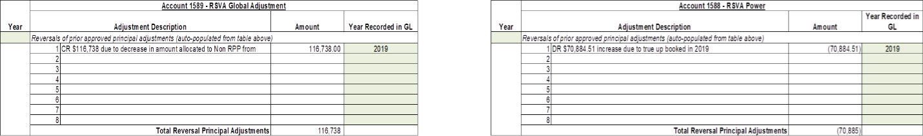

1. Please explain why there is not a correspondent reversal entry for $116,738 for Account 1588.
2. Please explain why there are no similar adjustments for CT 148 true-ups made in 2019.
3. Please enter the year in Note 8 (cells A43 and M43)

**Staff Question-4**

**Ref: Rate Generator Model, Tab 16**

Grimsby Power chose Group 2 for the applicable stretch factor. Please updated Tab 16 of the Rate Generator Model to reflect that Grimsby Power is in the first grouping as per the latest PEG report.