Centre Wellington Hydro Ltd.
OEB Staff Questions
EB-2020-0009

Centre Wellington Hydro Ltd.
EB-2020-0009

Please note, CWH is responsible for ensuring that all documents it files with the OEB, including responses to OEB staff questions and any other supporting documentation, do not include personal information (as that phrase is defined in the Freedom of Information and Protection of Privacy Act), unless filed in accordance with rule 9A of the OEB’s Rules of Practice and Procedure.

Staff Question-1
Ref: IRM Model, Tab 3
The entries for the “OEB-Approved Disposition during 2019” do not match the “Principal Disposition during 2019” value from CWH’s final 2020 IRM Rate Generator from the previous year’s IRM proceeding. For reference, see below the values from 2021 filed IRM Rate Generator (left) and 2020 final IRM Rate Generator (right).
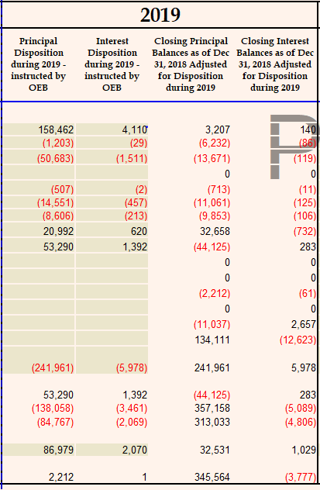
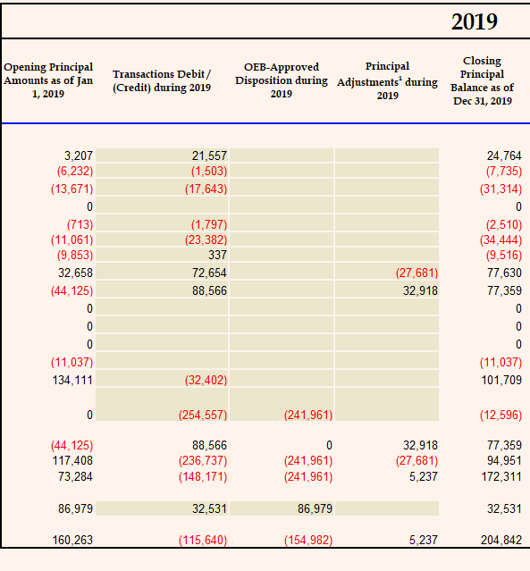

Please confirm whether the OEB-Approved Disposition values during 2019 are correct and revise the rate generator model as necessary.
Response:
CWH has corrected tab 3 of the Rate Generator. There was a misunderstanding of how disposed of amounts were included in the continuity schedule. You will see that the values in column AL have also changed to reflect the appropriate disposals in the correct column.

Staff Question-2
Ref: IRM Model, Tab 3
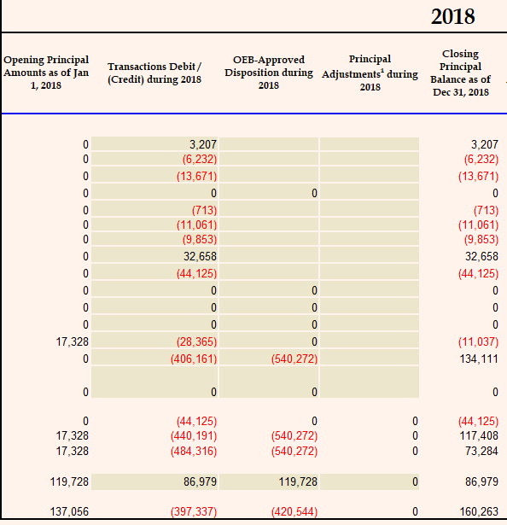
The entries for the “OEB-Approved Disposition during 2018” in 2021 IRM Rate Generator Model do not match the values from CWH’s final 2020 IRM Rate Generator Model from the previous year’s IRM proceeding. For reference, see below the values from filed 2021 IRM Rate Generator Model (top) and final 2020 IRM Rate Generator Model (bottom).

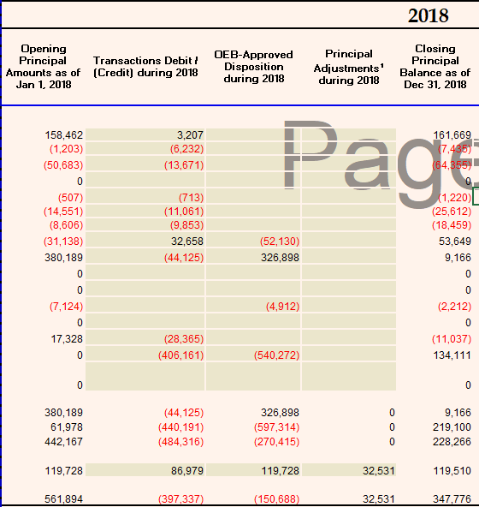

Please confirm whether the OEB-Approved Disposition values during 2018 are correct and revise the rate generator model as necessary.

Response:
CWH has corrected tab 3 of the Rate Generator. There was a misunderstanding of how disposed of amounts were included in the continuity schedule. You will see that the values in column AL have also changed to reflect the appropriate disposals in the correct column.

