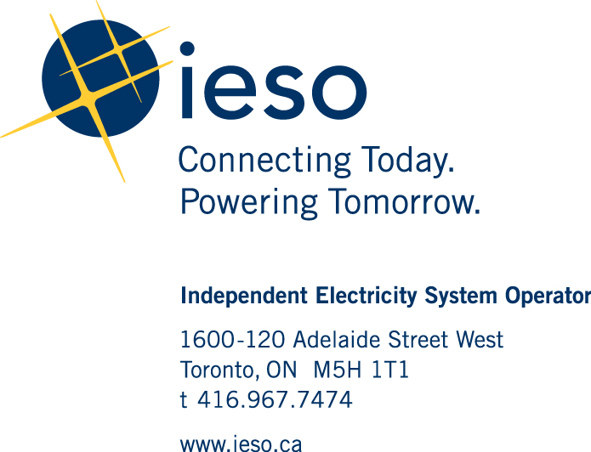

December 10, 2020

Ms. Christine Long, Registrar

Ontario Energy Board

2300 Yonge Street, 27th floor,P.O. Box 2319,

Toronto, ON,

M4P 1E4

Re: EB-2020-0297 – OPG Stakeholder Conference Attendance

Dear: Ms. Long

Adrian Pye will attend the stakeholder conference on behalf of the IESO. The IESO is not seeking cost eligibility.

Yours truly,

Devon Huber,

Senior Manager, Regulatory Affairs