**Welland Hydro-Electric System Corp. (Welland Hydro)**

**EB-2020-0060**

Please note, Welland Hdyro is responsible for ensuring that all documents it files with the OEB, including responses to OEB staff questions and any other supporting documentation, do not include personal information (as that phrase is defined in the Freedom of Information and Protection of Privacy Act), unless filed in accordance with rule 9A of the OEB’s Rules of Practice and Procedure.

## Staff-1

Ref: (1) 2021 IRM Rate Generator, Tab 3 (balances for 2019 rate year)

(2) 2020 IRM Rate Generator, Tab 3 (balances for 2019 rate year)

(3) EB-2019-0072, Decision and Rate Order, Table 6.4 (2020 approvals)

Preamble:

2019 Approved Balances

The 2021 IRM Rate Generator shows, for the 2019 rate year, a balance in Account 1595 (2019) principal and carrying charges (cells BE36 and BJ36) which do not match Table 6.2 of Welland Hydro’s 2019 Decision and Rate Order or the 2020 Rate Generator.

Extract of 2019 balances in the 2021 IRM Rate Generator:

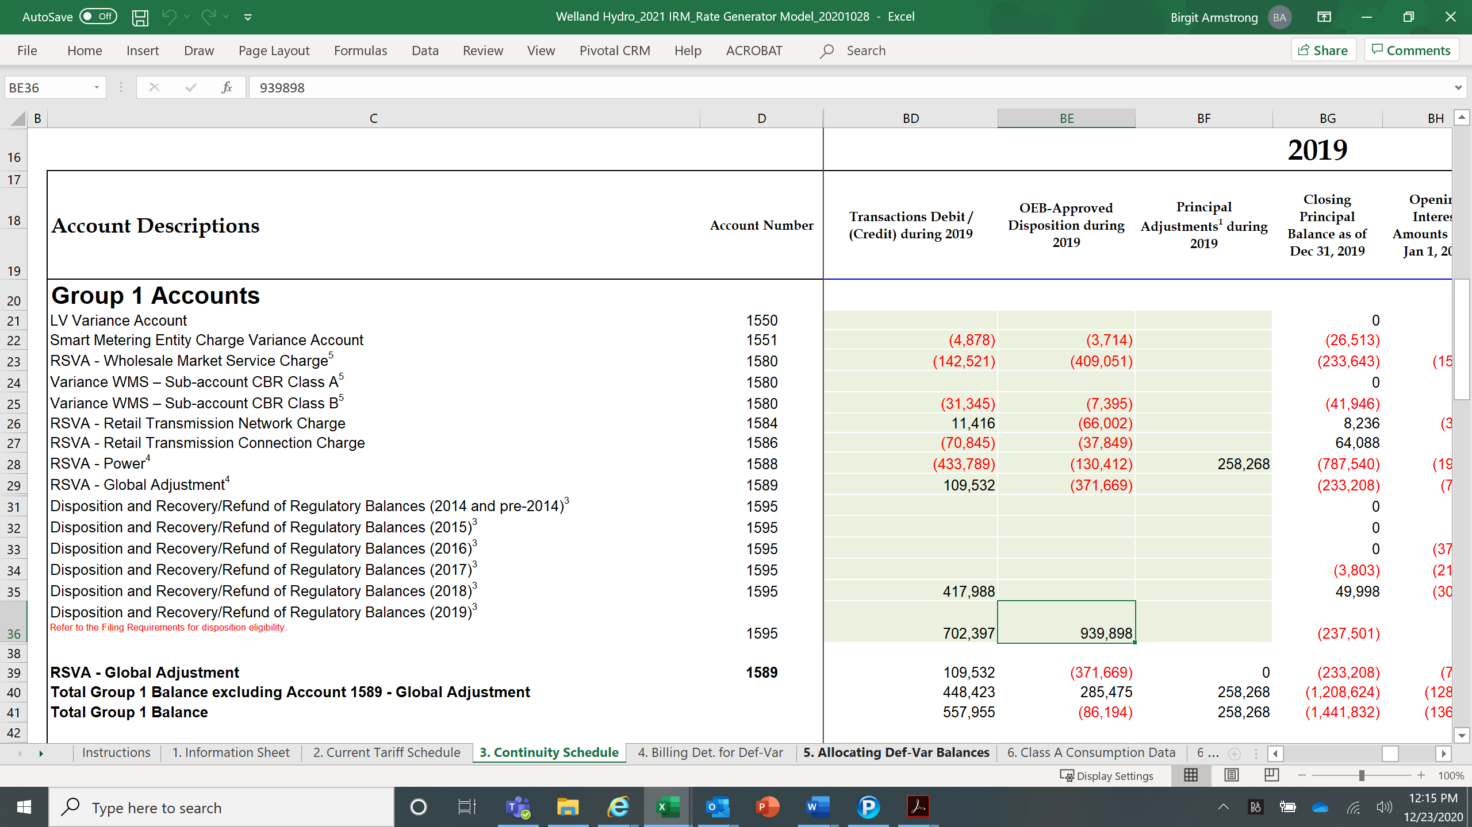

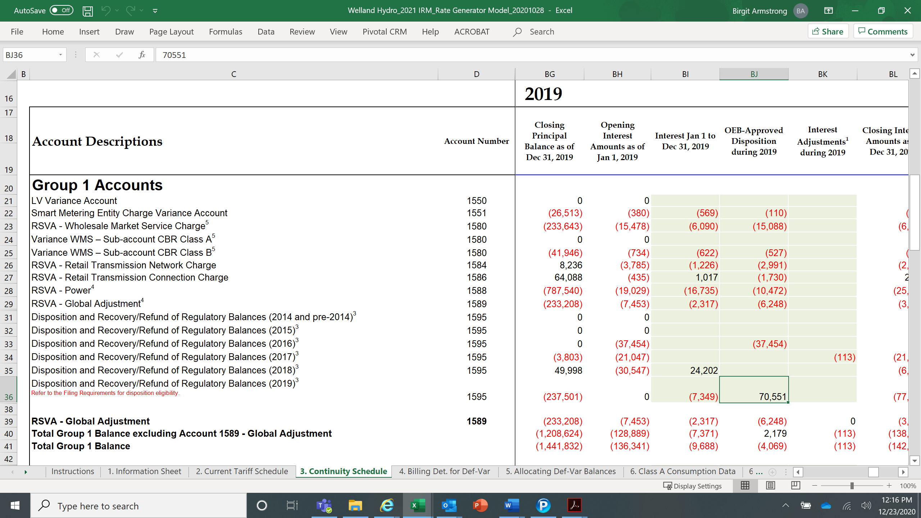

Extract of Table 6.2 of Welland Hydro’s 2019 Decision and Rate Order:

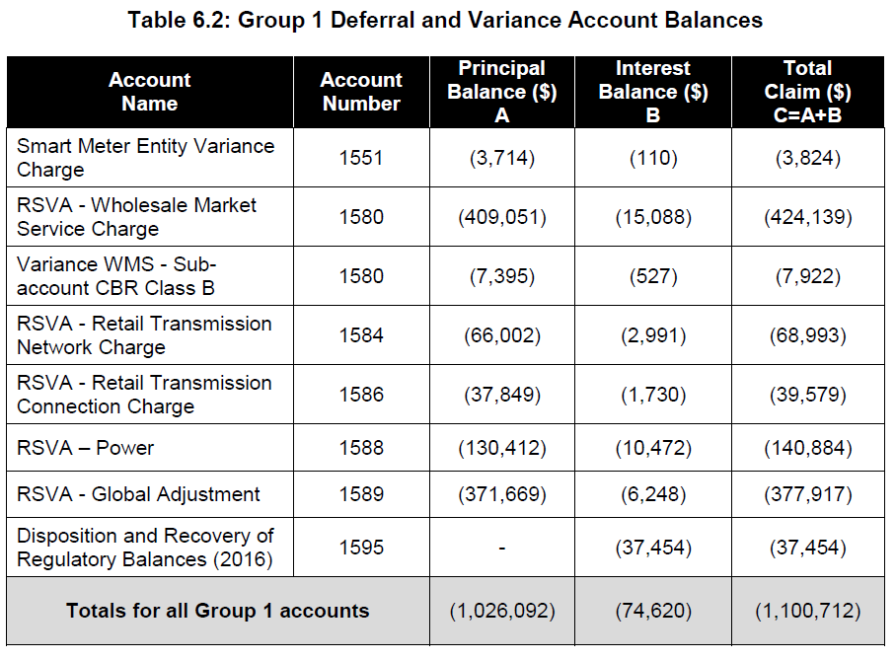

Questions:

1. OEB staff notes that the LRAM debit balance of $90,263 has not been itemized on tab 3 of the rate generator for disposition in 2019. Please confirm that this amount has been transferred into Account 1595 (2019).

**Response:**

**Welland Hydro confirms that the LRAM debit balance of $90,263 has been transferred into Account 1595 (2019).**

**The description in Cell C43 on Tab 3 of the Rate Generator states to “only input amounts if applying for disposition of this account.” Welland Hydro is not applying for disposition of an LRAMVA balance in this rate application and therefore did not populate this row on the Continuity Schedule.**

**In order to reconcile Welland Hydro’s 2019 Decision and Rate Order to the 2021 Rate Generator, the LRAMVA balance approved in the 2019 Rate application must be considered.**

**Below is an extract of Table 7.1 of Welland Hydro’s 2019 Decision and Rate Order:**

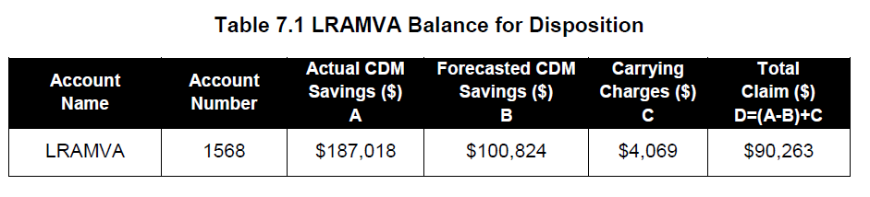

**In the reconciliation below, it can be seen that when the Group 1 approved balances and LRAMVA approved balances are added together, the amount is equal to what was reported in cells BE36 and BJ36 on Tab 3 of the 2021 Rate Generator as approved Account 1595 (2019) dispositions during 2019.**



1. Please explain any remaining difference in Account 1595 (2019).

**Response:**

**There are no remaining differences in Account 1595 (2019).**

## Staff-2

Ref: 2021 Rate Generator, Tab 4 (verification of billing determinants)

OEB staff notes that cell J4 on Tab 4 of the Rate Generator has not been checked.

1. Please verify the accuracy of the billing determinants.

**Response:**

**Welland Hydro has verified that the billing determinants on Tab 4 of the Rate Generator are accurate and that the box on Cell J4, Tab 4 was omitted in error.**

1. If any of the billing determinants are not accurate, please provide an explanation as to the variances.

**Response:**

**All billing determinants are accurate.**

**Staff-3**

Ref: (1) 2021 Rate Generator, Tab 16

(2) OEB’s letter, 2021 Inflation Parameters, issued November 9, 2020,

OEB staff has updated the Rate Generator in the following areas:

* Tab 16 cell B12 the Price Escalator has been updated with a placeholder value of 2.20%

In light of the continued uncertainty regarding the COVID-19 pandemic, the OEB allowed utilities to elect the calculated IPI level per the OEB-approved methodology (offset by the applicable stretch factor and other adjustments for some plans) or a lower value. For the 2021 rate year, utilities also have the discretion to forego the inflationary increase entirely. The letter noted that utilities filing rate application for May 1, 2021 shall make an election by February 5, 2021.[1]

1. Please confirm when Welland Hydro if intending to file their election for the IPI level used to determine Wellend Hydro’s Price Cap Adjustment for the 2021 rate year.

**Response:**

**Welland Hydro has elected to apply the unadjusted inflation factor of 2.2% to 2021 rates. Welland Hydro filed its election on January 8, 2021 and has attached a copy of its letter with the responses to these Staff questions.**

1. Please confirm the accuracy of the Rate Generator following OEB staff’s updates.

**Response:**

**Welland Hydro has reviewed the Rate Generator following OEB staff’s updates and confirms that it is accurate.**

**Staff-4**

Ref: (1) 2021 Rate Generator, Tab 17

OEB staff has made the following updates to Welland Hydro’s Rate Generator:

* Tab 17 cell F39 Specific charge for access to the power poles - per pole/year (with the exception of wireless attachments) - Approved on an Interim Basis has been kept to $44.50[2]
* Tab 17 cell D23 RPP Prices – Off-Peak $/kWh 0.0850
* Tab 17 cell D24 RPP Prices – Mid-Peak $/kWh 0.1190
* Tab 17 cell D15 RPP Prices – On-Peak $/kWh 0.1760[3]
* Tab 20 Ontario Electricity Rebate of 21.2%

(Please note there may further updates before final issuance of the Decision)

1. Please confirm the accuracy of the Rate Generator following OEB staff’s updates.

**Response:**

**Welland Hydro has reviewed the updates made by OEB staff and confirms the accuracy of the Rate Generator following those updates**.

1. OEB Letter, 2021 Inflation Factor, issued November 9, 2020
2. EB-2020-0288, Order, issued December 10, 2020, p. 3
3. EB-2020-0251, Decision and Order, issued December 17, 2020, p. 2 and Schedule B