ThisChapleau Public Utilities Corporation
OEB Staff Questions
EB-2020-0011

Chapleau Public Utilities Corporation (Chapleau PUC)
EB-2020-0011

Please note, Chapleau PUC is responsible for ensuring that all documents it files with the OEB, including responses to OEB staff questions and any other supporting documentation, do not include personal information (as that phrase is defined in the Freedom of Information and Protection of Privacy Act), unless filed in accordance with rule 9A of the OEB’s Rules of Practice and Procedure.

Staff Question-1
Ref: A portion of Revenue to Cost Ratio Workform, Tab 6 is reproduced below.

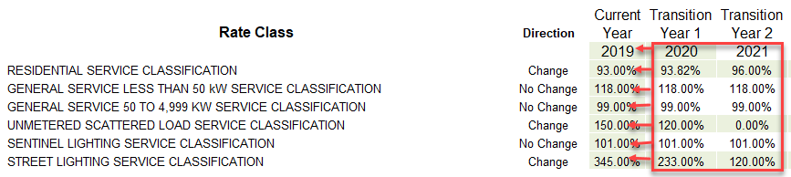

Staff notes that in Tab 6, Chapleau PUC inputted the following:

- Cell E21 “Current Year 2019” which should be “Current Year 2020”
- Cell F21 “Transition Year 1 2020” which should be “Transition 2 2021”

Please update Tab 6 to reflect the correct data for each rate class by transferring the numbers from cells F22 to F27 to columns E22 and F27 and from cells G22 to G27 to F22 to F27.

CPUC Response: The cells are protected and as such cannot be changed.

Staff Question-2
Ref: A portion of the Revenue to Cost Ratio Adjustment Model, Tab 6 is reproduced below.
Ref: A portion of Chapleau PUC’s 2017 CoS proceeding Decision & Rate Order, is reproduced below.
Revenue to Cost Ratio, Tab 6. Decision Cost Revenue Adj
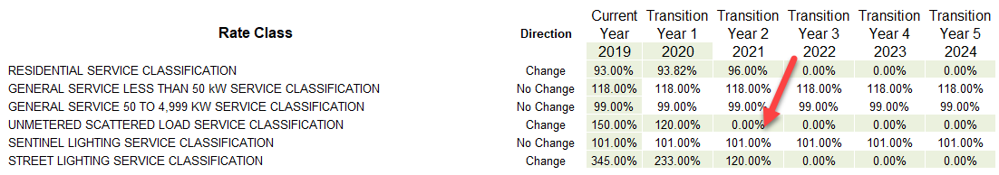

2017 CoS proceeding Decision & Rate Order
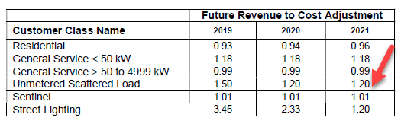
In tab 6 of the Revenue to Cost Ratio Adjustment model, the revenue to cost ratio entered for the Unmetered Scattered Load Service Class for 2021 is 0.00%. On page 37 of the Decision and Rate Order filed in Chapleau PUCs’ 2017 CoS proceeding, it is noted that the revenue to cost ratio for the Unmetered Scattered Load Class for year 2021 is 120.0%.
- Please provide an explanation for the discrepancy in this ratio (as shown with red arrows). If this revenue to cost ratio needs to be revised, please file an updated Revenue to Cost Ratio Adjustment model, and an updated 2021 IRM Rate Generator model.

CPUC Response: CPUC notes that its Cost of Service was approved in 2019 – not 2017.
In the OEB model, once the desired ratio has been reached, subsequent ratios are shown as 0% and as such, 2021 should show 0%.
If this interpretation is incorrect, the Residential, USL and Street Lighting should then all be modified to show the final adjustment. Pease advise on how to proceed.

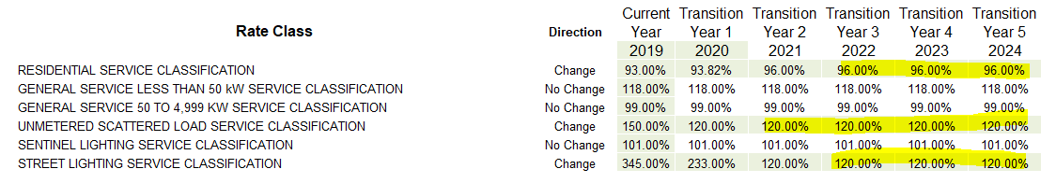

Staff Question-3
Ref: A portion of Revenue to Cost Ratio Adjustment Model - Tab 14 – Adjust to Proposed Rates is reproduced below.
Ref: A portion of IRM Model - Tab 16 – Rev2Cost_GDPIPI is reproduced below.
Revenue to Cost Ratio Adjustments Model Tab 14
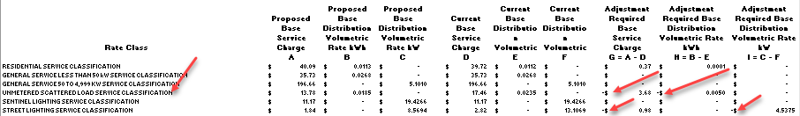

IRM Model Tab 16
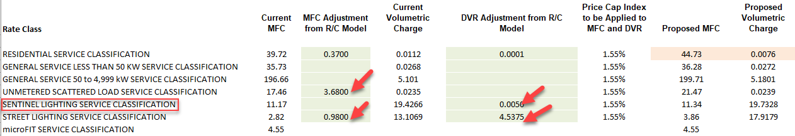

OEB staff is unable to reconcile the adjustments in columns M, N and O of the Revenue-to-Cost Ratio Adjustments Model with the adjustments to the distribution volumetric rate adjustments in Tab 16 of the IRM Model. The adjustments are shown in the table below:

 | Revenue to Cost Adjustment Model – Tab 14 | IRM Model – Tab 16
Unmetered Scattered Load | Cell M25 shows negative 3.68 | Change positive sign in Cell C20 to negative.
Unmetered Scattered Load | Cell N25 shows negative 0.0050 | This should be Unmetered Scattered Load class not Sentinel Lighting class, should be in Cell E20. Also change positive sign to negative.
Street Lighting | Cell M27 shows negative 0.98 and Cell O27 shows negative 4.5375 | Change positive sign in Cells C22 and E22 to negative.

- Please confirm that the adjustments in the IRM Model are accurate, and file an updated 2021 IRM Rate Generator model. If not, please explain.

CPUC Response: Staff is correct in that the numbers transcribed from the Revenue to Cost model should have reflected a “negative”.

(It should be noted that the formatting of those particular cells in the R/C models make this an easy mistake to make. The model’s formatting should be modified to make it easier to see whether the amount is a credit or debit)

Staff Question-4
Ref: Managers Summary, page 13
Chapleau PUC is seeking final disposition of the 2019 Group 1 deferral and variance account balances and 2020 rate riders. Please confirm no adjustments were made to the 2019 Group 1 deferral and variance accounts approved on an interim basis.
CPUC Response: CPUC confirms that no adjustments were made to Group 1 balances.

EB-2017-0087 issued June 6, 2019, page 37

