Northern Ontario Wires Inc.

OEB Staff Questions

EB-2020-0044

**Northern Ontario Wires Inc. (Northern Ontario Wires)**

**EB-2020-0044**

Please note, Northern Ontario Wires is responsible for ensuring that all documents it files with the OEB, including responses to OEB staff questions and any other supporting documentation, do not include personal information (as that phrase is defined in the *Freedom of Information and Protection of Privacy Act*), unless filed in accordance with rule 9A of the OEB’s *Rules of Practice and Procedure*.

**Staff Question-1**

**Ref: IRM Model, Tab 1 – Information Sheet**

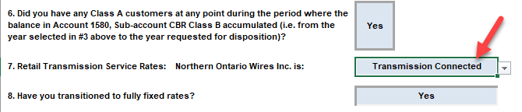

In Tab 1 of the IRM Model (cell F53), Northern Ontario Wires indicated that it is “Transmission Connected”. Please confirm whether this is correct or if Northern Ontario Wires is only “partially embedded” within Hydro One Networks’ distribution system, as was indicated in Northern Ontario Wires’ 2020 rate application, and make any necessary correction to the model.

***Northern Ontario Wires confirms that it is Transmission Connected. This is the same as was filed in the 2020 rate application as seen in the image below.***

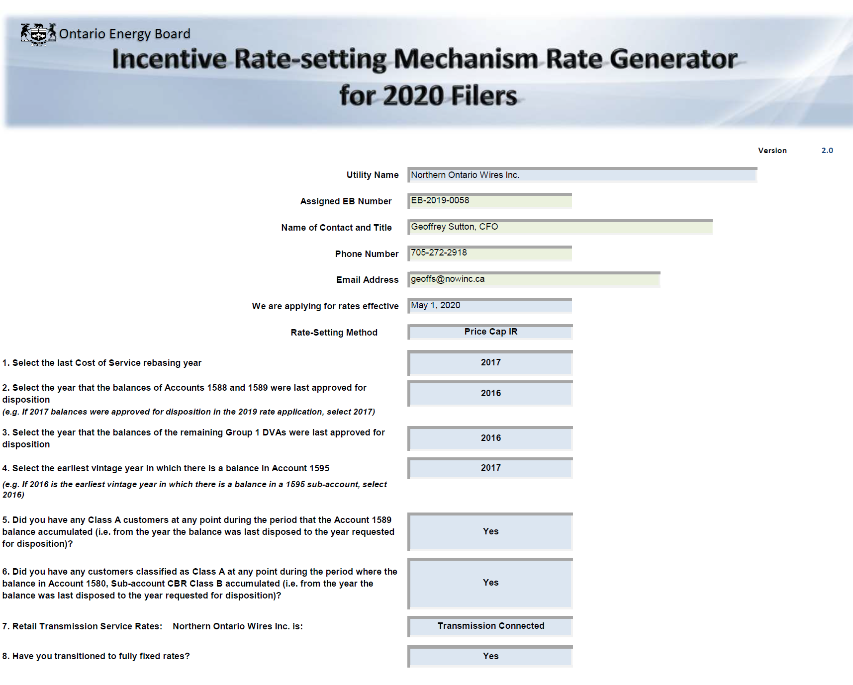

**Staff Question-2**

**Ref: 1595 Analysis Workform**

Please confirm Northern Ontario Wires has not submitted the 1595 Analysis Workform because it has no vintage 1595 Account balances eligible for disposition in this proceeding. If Northern Ontario Wires does have 1595 residual balances eligible for disposition, please submit the 1595 Analysis Workform.

***NOW Inc. confirms that the 1595 Analysis Workform was not submitted was because there are no vintage 1595 Account balances eligible for disposition as per the note on the IRM Checklist.***

**Staff Question-3**

**Ref: Managers Summary, Section 7 Deferral and Variance Accounts, pg 15 of 110**

Typically, large balances are not expected for Account 1588 as it should only hold the variance between commodity costs based on actual line losses and commodity revenues calculated using values for line losses approved by the OEB in the utility’s last rebasing application. Based on RRR data filed for Northern Ontario Wires for Account 4705 Cost of Power, OEB staff calculates the annual net activity (i.e. transactions plus principal adjustments) from the DVA Continuity Schedule as a percentage of annual Account 4705 to be as follows:



1. Please confirm the accuracy of the above calculation or provide a revised calculation, as appropriate.

***NOW Inc. confirms the accuracy of the above calculation.***

b) Please provide an explanation for why the Account 1588 activity is relatively large (i.e. in excess of 1% of total cost of power purchased), in consideration of line losses.

***This is due to change in methodologies of recording 1588 and 1589 in accordance with new procedures which was completed in 2019. The cumulative impacts were brought forward from 2018 in to 2019. The General Ledger was adjusted in 2019 to align with the OEB accounting guidance methodology. Had this cumulative adjustment not taken place, then the Calculation in part a) would have been below the 1% threshold. As 2019 was the transition year for implementation and General Ledger alignment, this larger than expected variance is not expected in the upcoming year.***