Atikokan Hydro Inc.

OEB Staff Questions

EB-2020-0004

**Atikokan Hydro Inc.**

**Staff Questions**

**EB-2020-0004**

Applicants are responsible for ensuring that all documents filed with the OEB, including responses to OEB staff questions and other supporting documentation, do not include personal information (as that phrase is defined in the *Freedom of Information and Protection of Privacy Act*), unless filed in accordance with rule 9A of the OEB’s *Rules of Practice and Procedure*.

**Staff Question-1**

**Ref: 2020 IRM Model, Tab 20 – Bill Impacts**

OEB staff notes that the % change in the impact of RTSRs for the Network “Connection and/or line and Transformation Connection” on every rate class exceeds 4% (from 5.32% to 6.90%).

1. Please explain the reasoning for the change in RTSRs.

**Atikokan Response -1:**

The change is to re-align and recover the current wholesale network costs.

**Staff Question-2**

**Ref: A portion of Sheet 6 - Class A Consumption Data is reproduced below**

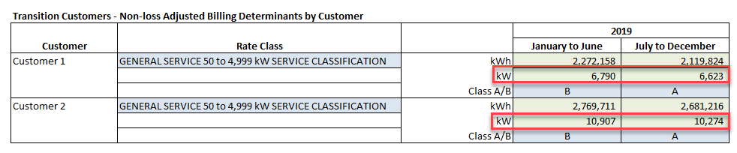

Please confirm that the kW is correct for the Class A customers.

**Atikokan Response-2:**

Atikokan confirms the kW is correct for the Class A customer.

**Staff Question #3**

**Ref: Review and Disposition of Group 1 Deferral and Variance Accounts, pages 11,15, and 16 of 25.**

**Questions:**

Typically, large balances are not expected for Account 1588 as it should only hold the variance between commodity costs based on actual line losses and commodity revenues calculated using values for line losses approved by the OEB in the utility’s last rebasing application. Based on RRR data filed for Atikokan Hydro for Account 4705 Cost of Power, OEB staff calculates the annual net activity (i.e. transactions plus principal adjustments) from the DVA Continuity Schedule as a percentage of annual Account 4705 to be as follows:



1. Please confirm this calculation or provide a revised calculation.
2. For year(s) where the percentage is greater than +/-1%, please provide an explanation as to why the Account 1588 activity would be high in consideration of line losses.

**Atikokan Response -3:**

In consideration of line loss, Atikokan notes the calculated actual annual line loss has been less than the line loss charged to customers as per the Board Approved line loss factor of 1.0945%. Therefore, this supports that the 1588 variance account contributes to a credit refund Deferral and Variance credit to the customer. In consideration of both 2018 and 2019 Atikokan calculates the actual Loss factors for the years to be 1.0783 and 1.0774 respectively.