Greater Sudbury Hydro Inc.

OEB Staff Questions

EB-2020-0024

**Greater Sudbury Hydro Inc. (Greater Sudbury Hydro)**

**EB-2020-0024**

Please note, Greater Sudbury Hydro is responsible for ensuring that all documents it files with the OEB, including responses to OEB staff questions and any other supporting documentation, do not include personal information (as that phrase is defined in the *Freedom of Information and Protection of Privacy Act*), unless filed in accordance with rule 9A of the OEB’s *Rules of Practice and Procedure*.

**Staff Question-1**

**Ref: Rate Generator Model, Tab 2**

In Tab 2 of the Rate Generator Model, Greater Sudbury Hydro indicated that it has not confirmed the accuracy of its current tariff sheet. Please explain and provide details on any discrepancies.

**Staff Question-2**

**Ref: Manager’s Summary, p. 9**

**Rate Generator Model, Tab 3**

Greater Sudbury Hydro provided the following reason for the variance of $(164,447) for account 1580 – RSVA Wholesale Market Service Charge:

“The balance of this variance was subtracted from the consolidated balance of account 1580 to report separately as Sub-accounts CBR Class A and Class B. The continuity is correctly reflecting these balances. To correct this variance in the Rate Generator Model, the column “2.1.7 RRR As of Dec 31, 2019” should have the account 1580 – RSVA Wholesale Market Service Charge balance adjusted to $(429,947) which is the appropriate balance net of the CBR Class B sub-account.”

1. Please confirm if any changes have been made or requested to be made to the amounts reported through the RRR for any of the 1580 account or sub-account balances.
2. If not, please explain why not.

**Staff Question-3**

**Ref: Rate Generator Model, Tab 6**

In section 3b, Greater Sudbury Hydro indicated that there was one rate class in which there were customers who were Class A for the full year during the period the account 1589 or account 1580 CBR B account balance accumulated. Please enter the rate class and total Class A consumption for full year Class A customers in the table in 3b.

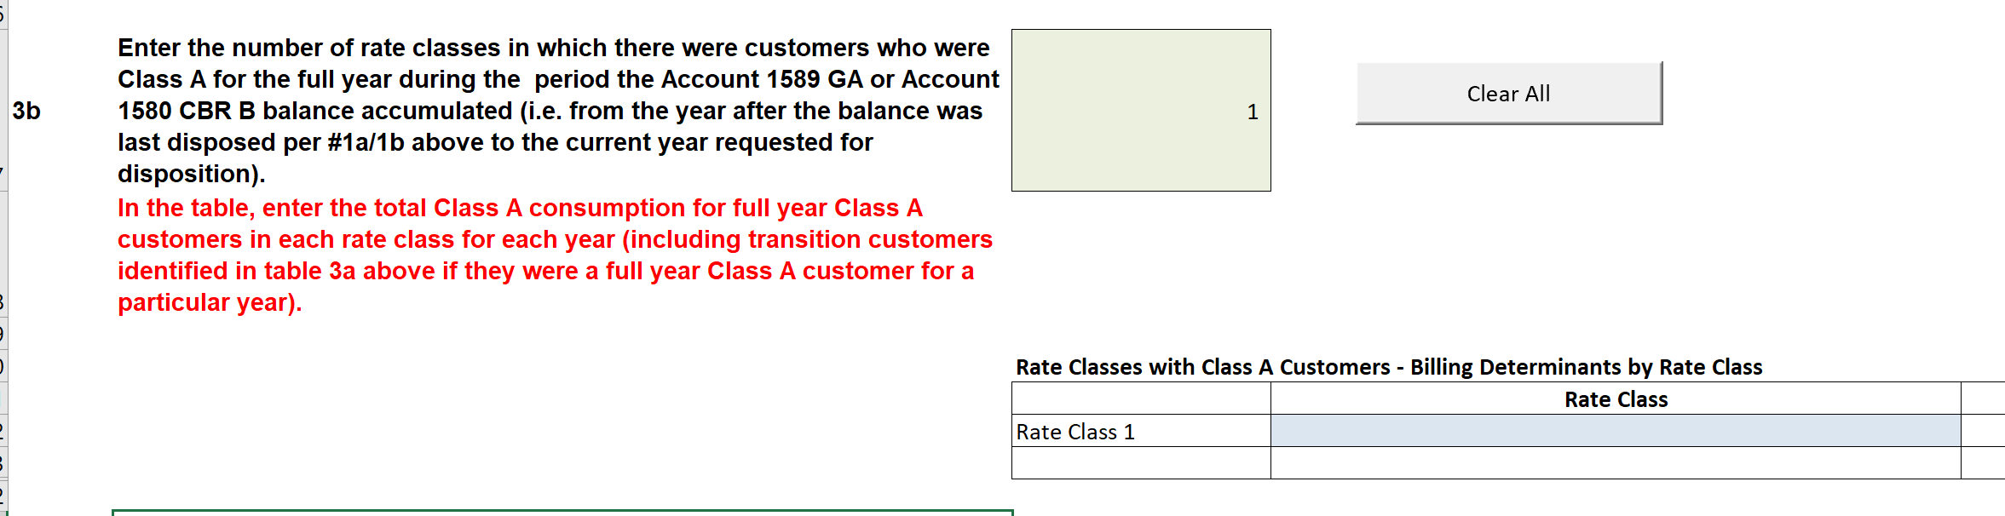

**Staff Question-4**

**Ref: Manager’s Summary, pp. 10-12**

**COVID-19 Foregone Revenue Rate Rider Model**

In accordance with the Decision and Rate Order in Greater Sudbury’s 2020 Cost-of-Service application, Greater Sudbury Hydro filed the COVID-19 Foregone Revenue Rate Rider Model in order to collect foregone revenue for the period of May 1, 2020 to October 1, 2020. Greater Sudbury Hydro noted that within the COVID-19 Forgone Revenue Rate Rider Model titles and dates within the model do not reflect Greater Sudbury Hydro’ situation. OEB staff will work with Greater Sudbury Hydro to make any potential adjustments to the COVID-19 Forgone Revenue Rate Rider Model that may be required.

1. Please outline what changes Greater Sudbury Hydro requires in order to make the COVID-19 Forgone Revenue Rate Rider Model reflect Greater Sudbury Hydro’s request.
2. Please confirm that the title below, for the foregone revenue rate rider(s), is appropriate for Greater Sudbury Hydro’s circumstances. If so, OEB staff will update the Rate Generator Model accordingly. If not, please provide proposed alternate wording and rationale.

“Rate Rider for Recovery of COVID-19 Forgone Revenue from Postponing Rate Implementation - effective from May 1, 2021 and effective until April 30, 2022”

**Staff Question-5**

**Ref: Manager’s Summary, pp. 16-18**

**Capital Module – Applicable to ACM and ICM**

Greater Sudbury Hydro provided updated cost estimates in the ACM Model and stated that the costs included in the ACM Model have increased by 3.6%. Greater Sudbury Hydro further noted that this is well within the 30% threshold indicated in the IRM Filing Guidelines that would require a distributor to treat the project as a new ICM project if the applied for costs exceeded the projections or approval of the ACM in the Cost of Service by 30%. Please provide details on why costs have increased by 3.6%.

**Staff Question-6**

**Ref: GA Analysis Workform**

**Greater Sudbury Hydro’s 2020 Cost-of-Service Decision and Order (EB-2019-0037)**

On the GA analysis Workform, Greater Sudbury Hydro entered 1.054 for the cell “Most Recent Approved Loss Factor for Secondary Metered Customer < 5,000kW”.

OEB staff notes from the approved tariff and rates in Greater Sudbury Hydro’s 2020 CoS decision and order EB-2019-0037 that the approved loss factor is 1.0047.

Greater Sudbury Hydro has one reconciling item (#4) for “Differences in actual system losses and billed TLFs” of $327,087.

1. Please confirm that the cell “Most Recent Approved Loss Factor for Secondary Metered Customer < 5,000kW” should have the number of 1.0047. If confirmed, please update the GA analysis Workform.
2. Please provide the calculation for the differences in actual system losses and billed TLFs of $327,087.

**Staff Question-7**

**Ref: Manager’s Summary, p. 13**

Greater Sudbury Hydro states that:

One component of the February 21st guidance pertains to monthly accrual entries being made in distributor’s general ledgers with respect to energy sales and cost of energy. GSHI has not fully implemented this component of the guidance due to difficulty in establishing a consistent process in terms of posting of accruals versus actual invoices. While theoretically simple, in practice GSHI has had difficulty implementing this component due to inconsistent invoicing

from wholesale electricity providers. This component of the guidance has no impact on the true ups calculated on a monthly basis and has no impact on the balances of 1588 and 1589. GSHI continues to work towards implementing this component of the guidance.

1. Please elaborate the difficulty in implementing the accruals in accordance with the accounting guidance.
2. Please confirm that the invoices and the embedded RPP variances in the invoices are accrued for the calendar year from all wholesale electricity providers.
3. Please explain when Greater Sudbury Hydro expects to complete implementing this component of the accounting guidance.

**Staff Question-8**

**Ref: LRAMVA Workform, Tab 5**

**List of Post Termination Projects (Excel spreadsheet)**

In 2019, Greater Sudbury Hydro claimed additional project savings from a separate excel spreadsheet, entitled “List of Post Termination Projects”, which was filed with this LRAMVA application. Please confirm that the project savings of 905,527.58 kWh contained in this excel spreadsheet, “List of Post Termination Projects”, are the same list of CDM projects that were included in Greater Sudbury’s 2020 load forecast.

**Staff Question-9**

**Ref: LRAMVA Workform, Tabs 3 and 5**

Greater Sudbury completed the transition to a fixed residential charge as of May 1, 2019, but it has claimed lost revenues from the residential class in 2019. As a result of the transition to the fixed residential charge, distributors will no longer experience lost revenues due to reduced consumption.

As the May 1, 2019 fixed residential charge is no longer a volumetric rate, the LRAMVA Workform calculates residential lost revenues in 2019 by multiplying the annualized savings in 2019, and the full year value of persisting savings from prior years into 2019, by 1/3 of the 2018 volumetric rate (i.e. Jan 1 to April 30, 2019) to calculate lost revenues for 2019, as this period was before the fixed residential charge was in place.

Please provide rationale for claiming lost revenues for the residential class for all of 2019 when the utility has transitioned to a fixed residential charge as of May 1, 2019.

**Staff Question-10**

**Ref: Chapter 3 Filing Requirements, p. 22**

In support of the LRAMVA application, the IESO verified reports are to be filed in excel format with the LRAMVA Workform, as noted in the Chapter 3 Filing Requirement. Please file the following additional reports:

* Participation and Cost Report to substantiate CDM savings in 2018 and 2019
* 2017 Final Verified Results Report, which includes the tab “LDC Savings Persistence” to show the persistence of savings from 2015-2017 CDM programs into 2018 and 2019
* 2014 Persistence Savings Report to show the persisting savings from 2011-2014 CDM programs into 2018 and 2019