London Hydro Inc.

OEB Staff Questions

EB-2020-0038

**London Hydro Inc.**

**EB-2020-0038**

Please note, London Hydro is responsible for ensuring that all documents it files with the OEB, including responses to OEB staff questions and any other supporting documentation, do not include personal information (as that phrase is defined in the *Freedom of Information and Protection of Privacy Act*), unless filed in accordance with rule 9A of the OEB’s *Rules of Practice and Procedure*.

## Staff Question-1

Ref: (1) Application, page 41 of 51

(2) Chapter 3 Filing Requirements, Appendix A, May 14, 2020

(3) Rate Generator Model, dated Jan 25 2021 – Tabs 3 and 4

(4) EB-2019-0052, Decision and Rate Order, April 16, 2020, pages 6 and 7

Preamble:

As noted in the first reference, London Hydro requested to dispose of the Account 1595 (2017) residual balance, a credit amount of $189,610, in this proceeding.

At the second reference, the Chapter 3 Filing Requirements note that the residual balance in sub-accounts of 1595 are eligible for disposition two years after the expiry of the rate rider. As London Hydro’s 2017 rate riders ended on April 30, 2018, the sub-account balance in Account 1595 (2017) would be eligible for disposition in the 2022 rate application, when audited December 31, 2020 balances would be available.

At the third reference, the Rate Generator Model shows that the Group 1 account balance inclusive of Account 1595 (2017) is a debit balance of $2,717,953. Although it does not meet the materiality threshold, London Hydro proposes to dispose of its Group 1 balances.

At the forth reference, the OEB notes in its 2020 IRM decision that it expects London Hydro will apply for disposition of all Group 1 account balances in its 2021 rate application, even if the disposition threshold is not met, given the passage of time since the last disposition. However, as noted, the OEB will make its final determination on this issue in the current proceeding.

Question(s):

1. Please clarify whether London Hydro maintains its request to dispose of the Account 1595 (2017) residual balance in this proceeding. If so, please provide rationale.
2. If London Hydro decides to withdraw the request to dispose of the Account 1595 (2017) residual balance in this proceeding, please confirm whether London Hydro maintains its position to dispose of all Group 1 accounts as it is still below the materiality threshold.
3. Please confirm that London Hydro seeks to dispose of its Group 1 account balances on a final basis in this proceeding.

## Staff Question-2

Ref: (1) Chapter 3 Filing Requirements, Appendix A, May 14, 2020

(2) Application, pages 38 and 39 of 51

(3) Rate Generator Model, dated Jan 25 2021 – Tab 3 (2018 principal adjustment to Account 1580 CBR class B)

Preamble:

At the first reference, the Chapter 3 Filing Requirements state that if 2018 rate riders end on April 30, 2019, the sub-account balance in 1595 (2018) would be eligible for disposition in the 2023 rate application, when audited 2021 balances would be available.

At the second reference, London Hydro proposes to dispose of the 2016 CBR B variance in Account 1595 (2018) with the 2017-2019 Account 1580 sub-account CBR class B in this proceeding. Since the 2016 CBR B balance was approved for disposition in the 2018 decision,[1] London Hydro transferred the 2016 CBR B balance to Account 1595 (2018) for disposition at a later time, but has not disposed of this balance.

London Hydro notes that it would not be appropriate to hold the 2016 CBR B variance, while disposing of the variances accumulating during subsequent years in 2017-2019 in this application. Table 11 of the Application shows that the 2016 CBR B variance (credit of $138,800) when combined with the 2017-2019 CBR balance (credit of $305,992) amounts to a total credit balance of $444,792 for disposition.

At the third reference, London Hydro implemented this change in Tab 3 of the Rate Generator Model, by reversing the 2016 CBR B variance out from Account 1595 (2018) as a principal adjustment in the 2018 continuity schedule, and recorded the reverse balance to dispose of it into Account 1580 CBR Class B.

Tab 6.2a of the Rate Generator Model determined that 6.15% of the total CBR balance (credit of $444,792) would be allocated to 53 transition customers who contributed towards the 2017-2019 CBR balance, while the remaining 93.85% of the total CBR B balance would be allocated to full year class B customers.

Question(s):

1. Please explain why it is not appropriate to hold the 2016 CBR B variance in Account 1595 (2018) until this account is eligible to be disposed of in the 2023 rate application.
2. Please confirm that the 2016 CBR B variance (credit of $138,800) should be allocated to full year class B customers in 2016. Please also clarify whether any of the 53 transition customers (in Tab 6.2a of the Rate Generator Model) contributed to the 2016 CBR B variance.
3. If London Hydro maintains its position to dispose of the 2016 CBR B variance with the 2017-2019 CBR balance in this application, please discuss the utility’s views of disposing the entire 2016 CBR variance to class B customers separately through the DVA riders in Tab 6.2b.
4. Please review Tabs 6.2a/b of the Rate Generator Model and confirm whether the utility determines that it is appropriate to adjust the total credit balance of $444,792 in Tab 6.1a to exclude the 2016 CBR B variance amount. If so, please provide the calculations and applicable adjustment(s) to ensure that the 53 transition customers are allocated CBR payment amounts that reflect their contribution towards the 2017-2019 CBR B balances.

## Staff Question-3

Ref: (1) EB-2018-0051, Decision and Rate Order, page 9

(2) Rate Generator Model, dated Jan 25 2021 – Tab 3 (2019 principal adjustment to Account 1584 and Account 1586 balances)

Preamble:

At the first reference, London Hydro was approved to recover the retail transmission revenue shortfall of $7,484,188 by way of 18-month rate riders that ended on October 31, 2020. In the 2019 IRM decision, the OEB directed London Hydro to record the following entries in its general ledger and the corresponding Account 1595 (2019):

* A credit of $3,799,265 to Account 1584 Retail Transmission Network Charge
* A credit of $3,684,923 to Account 1586 Retail Transmission Connection Charge
* A debit of $7,484,188 to Account 1595 (2019) principal effective April 30, 2019

The variance between the amounts approved for recovery and the amounts recovered was to be captured in the Account 1595 (2019) principal balance.

At the second reference, the 2019 continuity schedule included debit balance principal adjustments to Accounts 1584 and 1586, and a credit balance of $8,302,809 recorded in Account 1595 (2019).

Question(s):

1. Please confirm that the 2019 principal adjustments to Accounts 1584 and 1586 reflect a one-time reversal of the credit adjustments recorded in the 2018 general ledger, as noted in the 2019 decision.
2. Please explain what the credit balance of $8,302,809 recorded in the Account 1595 (2019) principal account includes. Please reconcile this amount with the debit balance of $7,484,188, which should have been recorded in Account 1595 (2019) as per the 2019 decision.

## Staff Question-4

Ref: (1) EB-2018-0051, 2019 IRM proceeding, excel file: “London

Hydro_Workbook_2018 RTSR_Corr_20181107” (Revised RTSR spreadsheet), Tab “2018 Full Corrected”

(2) Rate Generator Model, dated Jan 25 2021 – Tab 10 (non-loss adjusted kW for GS 50-4999 kW class)

(3) Rate Generator Model, dated Jan 25 2021 – Tab 20 (RTSR bill impact changes)

Preamble:

OEB staff compared the 2018 and 2019 volumes in the GS 50-4999 kW class and noted the following observations:

* At the first reference, the corrected 2018 non-loss adjusted billing determinants was a total of 3,763,315 kW comprised of:

1. 965,337 kW from the GS 50-4999 kW class
2. 2,802,978 kW from the GS 50-4999 kW (interval metered) class

* At the second reference, the 2019 non-loss adjusted billing determinants was a total of 3,668,057 kW comprised of:

1. 128,689 kW from the GS 50-4999 kW class
2. 3,539,368 kW from the GS 50-4999 kW (interval metered) class

At the third reference, Tab 20 of the Rate Generator Model indicates that an explanation is required in the Manager’s Summary, if the change in RTSR charges is greater than 4%.

Question(s):

1. At Tab 10 of the Rate Generator Model, please explain the reason for the large decline in load in the GS 50-4999 kW class from 965,337 kW (in 2018) to 128,689 kW (in 2019).
2. At Tab 20 of the Rate Generator Model, please explain the key driver(s) for the 4% change in RTSR – Network, and Connection and/or Line and Transformation Connection for the majority of the customer classes.

## Staff Question-5

Ref: (1) GA Analysis Workform, Tabs GA 2017, 2018 and 2019

(2) Rate Generator Model, dated Jan 25 2021 – Tabs 6 and 6.1a

Preamble:

OEB staff identified some discrepancies in the non-RPP class A and B consumption data noted in the GA Analysis Workform and Rate Generator Model:

|  |  |  |  |  |
| --- | --- | --- | --- | --- |
| **Non-RPP Class A consumption** |  | **2019** | **2018** | **2017** |
| Non-RPP Class A (GA workform) | a | 544,777,057 | 560,302,675 | 380,970,588 |
| Full year Class A customers, Tab 6 | b | 514,220,759 | 498,497,086 | 217,329,856 |
| Partial year Class A customers, Tab 6.1a | c | 32,891,622 | 51,210,806 | 158,964,812 |
| Class A consumption (RGM) | d = b+c | 547,112,381 | 549,707,892 | 376,294,668 |
| Difference (kWh) **– Line 1** | a - d | (2,335,325) | 10,594,783 | 4,675,920 |
|  |  |  |  |  |
| **Non-RPP Class B consumption** |  | **2019** | **2018** | **2017** |
| Non-RPP Class B (GA workform) | e | 1,005,812,115 | 1,047,215,826 | 1,228,789,380 |
| Non-RPP Class B, Tab 6.1a | f | 1,003,476,790 | 1,057,810,609 | 1,233,465,301 |
| Difference (kWh) **– Line 2** | e-f | 2,335,325 | (10,594,783) | (4,675,921) |

Question(s):

1. Please explain why there is a difference in the 2017, 2018 and 2019 kWh consumption for non-RPP class A customers (at line 1) and non-RPP class B customers (at line 2) as shown above.
2. Please clarify whether any revisions to either the GA Analysis Workform and Rate Generator Model are needed (specifically in Table 3a and 3b in Tab 6). If so, please indicate the change(s). If not, please explain.

## Staff Question-6

Ref: (1) LRAMVA Workform, Tab 5

(2) EB-2016-0091, 2017 Decision and Rate Order, s 3.1.2 of settlement proposal, page 32 of 50

Preamble:

At the first reference, London Hydro included the persistence of 2011 to 2015 programs in 2017 in its LRAMVA balance.

At the second reference, the approved settlement proposal indicates that the LRAMVA threshold of 70,113,851 kWh was established based on forecast conservation savings from 2016 and 2017.

Question(s):

1. Please provide rationale for claiming persistence of 2011-2015 savings in 2017, if the 2011 to 2015 actual program savings were already embedded in the 2017 load forecast.
2. Please explain whether London Hydro agrees that it is appropriate to remove the persistence of 2011-2015 savings in 2017. If so, please remove the persisting lost revenue amounts in the applicable rows in Tab 5 (i.e. cells Y581 to AB585) and file a revised version of the LRAMVA Workform. If not, please explain.

## Staff Question-7

Ref: (1) Application, page 33 of 51

Preamble:

At the first reference, London Hydro indicated:

During Phase 1 of the implementation process London Hydro found that it required to make adjustments for the change in GA methodology. CT 148 transactions were reviewed, the RPP percentage was applied and the RPP related costs were calculated. CT 142 GA credit transactions for RPP consumption were also reviewed and compared against the RPP portion of CT 148 GA cost. The net difference was deemed material and allocated out from GA costs to power costs effectively landing in 1588. London Hydro also reviewed its historical balances in 2017 and 2018, for which it carries principal variances, and made the required adjustments, as well.

Based on the above, London Hydro stated that “material differences” were identified for both 2017 and 2018 between Accounts 1588 and 1589.”

Question(s):

1. Please provide more detail, including a summary breakdown of the actual dollar amounts impacting Account 1588 and Account 1589 by year, as well as the nature of the adjustments.

## Staff Question-8

Ref: (1) Application, Table 10, page 35 of 51 (Account 1588)

(2) Rate Generator Model, dated Jan 25 2021, Tab 3 – Account 1588

Preamble:

London Hydro provided a summary of commodity balances for disposition after principal adjustments.

OEB staff notes some differences between Table 10 of the Application and the information contained in Tab 3 – Continuity Schedule of the Rate Generator Model. For example, the 2017-2019 opening balances in the Continuity Schedule have not been included in Table 10, and the “Principal Accumulated” column in Table 10 refer to the “Transactions” column of the Continuity Schedule.

Table 10 – Application



The opening principal balance as of January 1, 2017 in the Continuity Schedule shows ($79,854) but they are not shown in Table 10. The subsequent opening balances (2018 and 2019) noted in the screenshots below were also not included in Table 10 above.

Tab 3 - 2017 continuity schedule

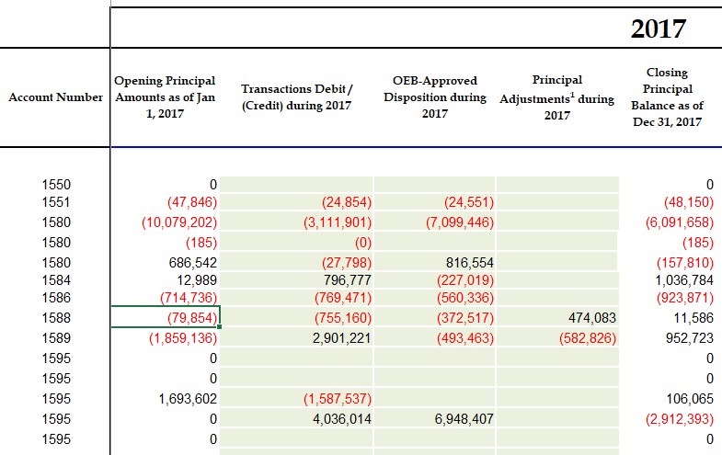

Tab 3_- 2018 continuity schedule

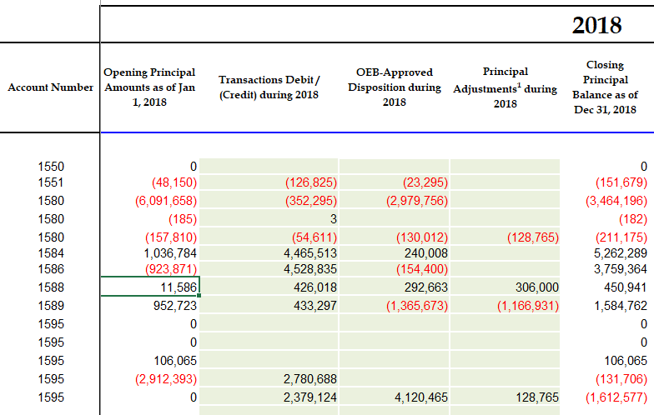

Tab 3 - 2019 continuity schedule

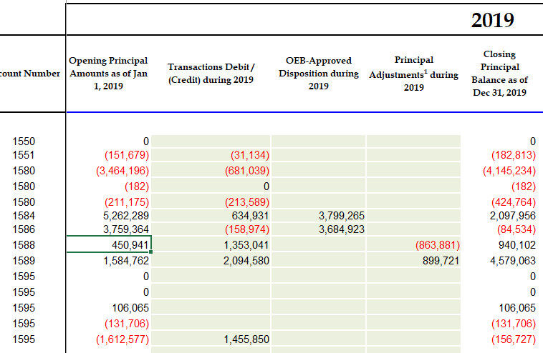

Question(s):

1. Please explain how the 2017-2019 opening balances are accounted for in Table 10 and reconcile the adjustments in Table 10 to the information in the DVA Continuity Schedule of the Rate Generator Model.

## Staff Question-9

Ref: (1) Application, page 35 of 51

Preamble:

At the first reference, London Hydro stated:

“[…] London Hydro now applies the actual invoiced (paid) GA price in the settlement true-up calculation. Two months later the proportion of GA costs are also trued-up based on the RPP/Non-RPP percentages calculated using the actual meter reads. London Hydro is working on separating the true-up of GA price from the volume true-up and submit this portion in the month following the initial submission. **London Hydro is committed to complete this final step of Phase 2 implementation by the end of the year**”. [emphasis added]

Question(s):

1. Please confirm that the Phase 2 implementation of “The Accounting Guidance Related to Commodity Pass-Through Accounts 1588 & 1589, issued on February 21, 2019”, was completed by year-end of 2020, as stated above.
2. If not, please explain when the accounting guidance will be completed, and confirm whether there could be any subsequent adjustments to any prior year balances as a result.

## Staff Question-10

Ref: (1) 2021 GA Analysis Workform, Tabs 2017, 2018 and 2019

Preamble:

In the GA Analysis Workform, the description at line 6 labelled as “Differences in GA IESO Significant Prior Period Billing Adjustments Recorded in Current Year” includes the following adjustments:

* the 2017 GA Analysis Workform shows a credit balance of $1,040,547
* the 2018 GA Analysis Workform shows a credit balance of $139,914

Question(s):

1. Please provide a more detailed explanation regarding these amounts on line 6 of both the 2017 GA Analysis Workform and the 2018 GA Analysis Workform.
2. Please describe whether these amounts of a credit balance of $1,040,547 for 2017 and a credit balance of $139,914 for 2018 also impact Account 1588 and quantify these impacts.
3. Please confirm in what years the above noted Account 1589 amounts were

recorded in London Hydro’s general ledger, including any amounts also recorded

in Account 1588.

## Staff Question-11

Ref: (1) 2021 GA Analysis Workform, Tabs 2017, 2018 and 2019

Preamble:

In the GA Analysis Workform, the description at line 9 labelled as “New Comm Acctg Guidance - switch from Method B” includes the following adjustments:

* the 2017 GA Analysis Workform shows a credit balance of $664,343
* the 2018 GA Analysis Workform shows a credit balance of $355,619

At line 9 in the “Explanation” column, London Hydro included the same explanation in both the 2017 GA Analysis Workform and the 2018 GA Analysis Workform:

“CT 148 GA cost and CT 142 GA credit related to RPP portion, to be moved to 1588 per New Commodity Accounting Guidance - booked in 2019.”

Question(s):

1. Please provide a more detailed explanation regarding these amounts on line 9 of both the 2017 and the 2018 GA Analysis Workforms.
2. Please describe whether these amounts of a credit balance of $664,343 for 2017 and a credit balance of $355,619 for 2018 also impact Account 1588 and quantify these impacts.
3. Please explain in what years the above noted Account 1589 amounts were recorded in London Hydro’s general ledger, including any amounts also recorded in Account 1588.

## Staff Question-12

Ref: (1) Rate Generator Model, dated Jan 25 2021 (attachment)

(2) EB-2020-0251, Decision and Rate Order, December 17, 2020 ([link](https://www.rds.oeb.ca/CMWebDrawer/Record/697719/File/document))

(3) EB-2020-0030, Decision and Rate Order, December 17, 2020 ([link](https://www.rds.oeb.ca/CMWebDrawer/Record/697747/File/document))

(4) EB-2020-0288, Order, issued December 10, 2020, p. 3 ([link](https://www.oeb.ca/sites/default/files/Order-Pole-Attachment-Charge-20201210.pdf))

(5) EB-2020-0285, Decision and Rate Order, December 3, 2020 ([link](https://www.oeb.ca/sites/default/files/dec-rate-order-RSC-2021-inflation-adjustment-20201203.pdf))

(6) Letter, 2021 Inflation Factor, November 9, 2020 ([link](https://www.oeb.ca/sites/default/files/OEB-ltr-2021-inflation-updates-20201109.pdf))

(7) Letter, New Regulated Price Plan Prices Effective January 1, 2021, December 15, 2020 ([link](https://www.oeb.ca/sites/default/files/letter-new-rpp-prices-20201215.pdf))

Preamble:

Attached with OEB staff’s questions is a revised Rate Generator Model (see first reference) with the following changes:

* Tab 11 – UTRs and 2021 Hydro One sub-tx rates were updated

Uniform Transmission Rates (see second reference):

* + Network Service Rate $/kW 4.67
  + Line Connection Service Rate $/kW 0.77
  + Transformation Connection Service Rate $/kW 2.53

Hydro One Sub-Transmission Rates (see third reference):

* + Network Service Rate $/kW 3.4778
  + Line Connection Service Rate $/kW 0.8128
  + Transformation Connection Service Rate $/kW 2.0458
* Tab 16 – Price escalator was updated with a placeholder value to 2.2% [2]
* Tab 17 – Regulatory charges and TOU pricing have been updated for Jan 1, 2021 rates
  + Specific service charge for access to the power poles – per pole/year (with the exception of wireless attachments) – approved on an Interim Basis, has been maintained at $44.50 (see forth reference)
  + Retailer service charges have been updated by the approved inflation factor of 2.2% (see fifth reference)
* Time of Use (TOU) RPP prices have been updated per Table 3 of the OEB letter (see seventh reference)
* Tab 20 – Ontario Electricity Rebate has been updated to 21.2% (see seventh reference)

Please note there may be further updates before final issuance of the decision.

Question(s):

1. Please confirm when London Hydro is intending to file their election for the IPI level used to determine the price cap IR adjustment for the 2021 rate year.
2. Please confirm that London Hydro is in agreement with OEB staff updates to Rate Generator Model.
3. Based on London Hydro’s responses to these staff questions, please re-file all applicable model(s), workform(s) and/or appendices to reflect any revisions required.
4. Please summarize all updates to the application, model(s) and/or appendices submitted in this proceeding.

1. EB-2017-0052, Decision and Rate Order, March 22, 2018
2. In light of the continued uncertainty regarding the COVID-19 pandemic, the OEB allowed utilities to elect the calculated IPI level per the OEB-approved methodology (offset by the applicable stretch factor and other adjustments for some plans) or a lower value. For the 2021 rate year, utilities also have the discretion to forego the inflationary increase entirely. The letter noted that utilities filing rate applications for May 1, 2021 shall make an election by February 5, 2021 (see sixth reference).