Lakeland Power Distribution Ltd.

Responses to OEB Staff Questions

EB-2020-0037

**Lakeland Power Distribution Ltd. (Lakeland Power)**

**EB-2020-0037**

Please note, Lakeland Power is responsible for ensuring that all documents it files with the OEB, including responses to OEB staff questions and any other supporting documentation, do not include personal information (as that phrase is defined in the *Freedom of Information and Protection of Privacy Act*) unless filed in accordance with rule 9A of the OEB’s *Rules of Practice and Procedure*.

**Staff Question – 1**

Ref: (1) Rate Generator, Tab 3, cells BJ25 and BJ36

2019 Approved Interest Balances

The 2021 IRM Rate Generator shows a credit balance of $390,991 in Account 1595 (2019) carrying charges (cell BJ36) for the 2019 rate year. OEB staff is unable to reconcile this amount with the approved amounts for disposition as shown in the continuity schedules for the Lakeland and Parry Sound rate zones as per the 2019 CoS proceeding EB-2019-0050.







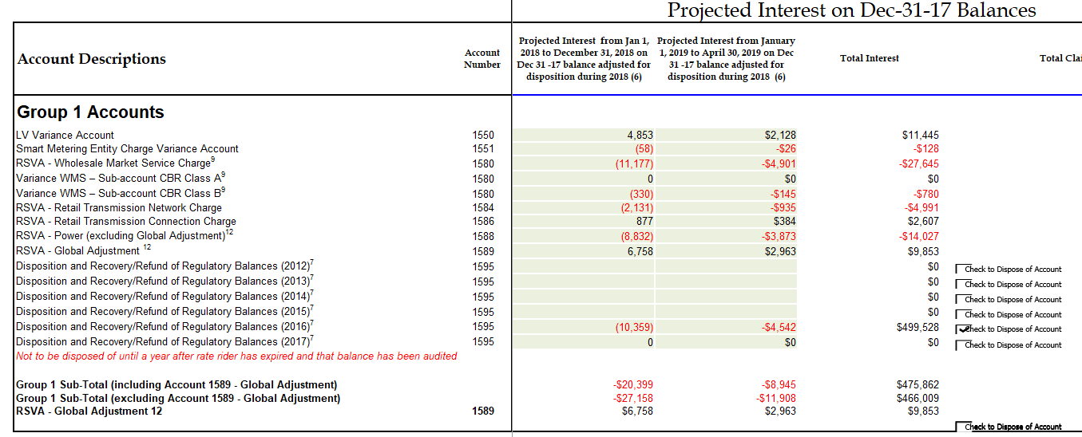



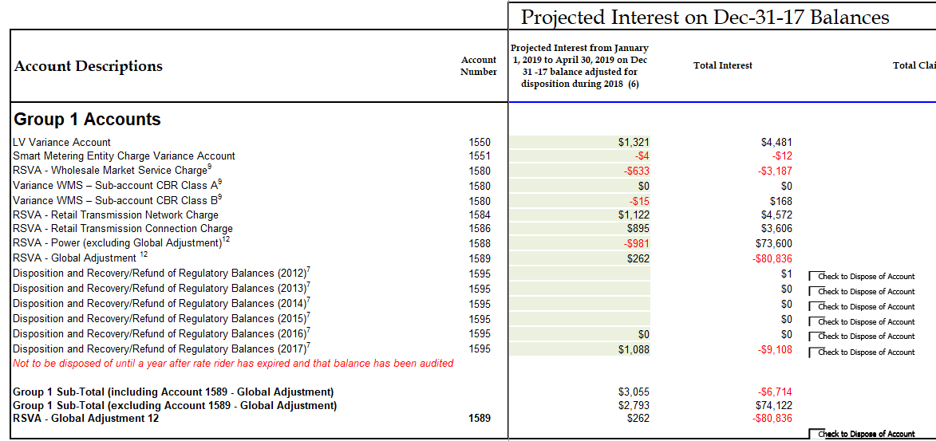



OEB staff further notes that for Account 1580 Variance WMS Sub-account CBR Class A, a combined balance of $4,199 has been transferred to cell BJ25 in the 2021 Rate Generator. The 2019 continuity schedules show an interest balance of $168 for Parry Sound and ($780) for Lakeland for this Account.

1. Please confirm that in the 2021 IRM Rate Generator, a combined interest amount of ($612) should have been itemized in cells BJ25 for Account 1580 Variance WMS – Sub-account CBR Class B.

**Lakeland Response:** *We confirm that the combined interest amount should be ($612). This has been corrected in the revised Harmonized Rate Generator.*

1. If so, OEB staff will make the necessary updates. If not, please explain why.

**Lakeland Response:** *This has been corrected in the revised Harmonized Rate Generator submitted in RESS.*

1. OEB staff is unable to reconcile the amount of ($390,991) transferred into Account 1595 (2019). Please explain this difference and any further variances to the amounts approved for disposition.

**Lakeland Response:** *The amount should be ($494,469). It is the combination of the following amounts from the decision in COS EB-2019-0050. This has been corrected in the revised Harmonized Rate Generator.*

|  |  |  |  |
| --- | --- | --- | --- |
|  | *LPDL* | *PSP* | *TOTAL* |
| *Group 1 Principal* | *(1,095,271)* | *240,861* | *(854,410)* |
| *Group 2 Principal* | *40,534* | *272,006* | *312,540* |
| *Total Principal* | *(1,054,737)* | *512,867* | *(541,870)* |
|  |  |  |  |
| *Group 1 Interest* | *475,862* | *2,394* | *478,256* |
| *Group 2 Interest* | *1,079* | *15,134* | *16,213* |
| *Total Interest* | *476,941* | *17,528* | *494,469* |

Revised Rate Generator Model looks as below:



**Staff Question – 2**

Ref: (1) Rate Generator, Tab 3, cells BM36 and BN36

(2) Manager’s Summary, p. 9

Account 1595 (2019)

The total remaining balance for 2018 Group 2 DVA in the former Parry Sound service area is a credit balance of $3,955 (including interest to April 30, 2021) and for the Lakeland Power service area, a debit balance of $7,849. As part of this application, Lakeland Power proposed to transfer the net debit balance of $3,894 for these Group 2 Accounts balances to Account 1595 for disposal at a future time.

The 2021 Rate Generator shows a Principal credit balance of $132,989 in cell BM36 and an Interest debit balance of $5,147 in Account 1595 (2019) as approved for disposition in 2020.

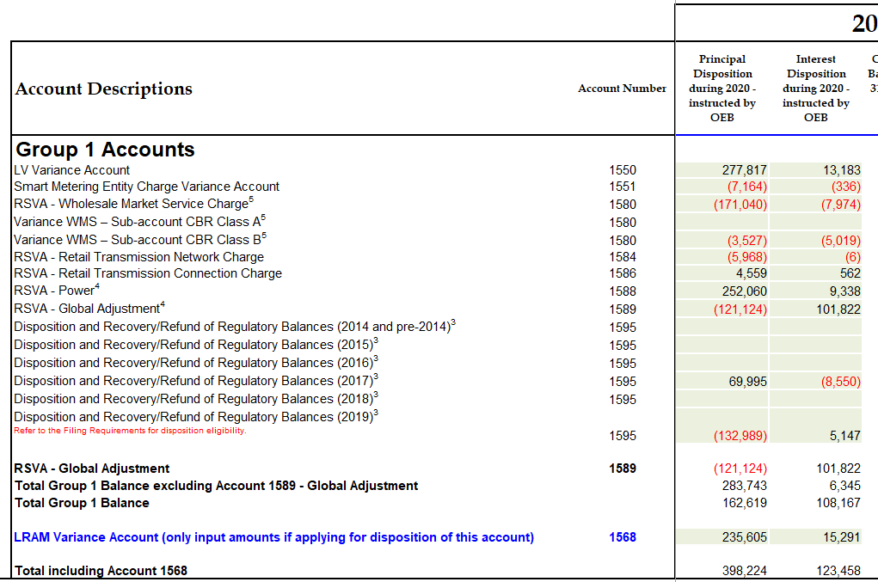



1. Please explain the origin of this balance and any variances to the above-noted transfer of a debit balance of $3,894.

**Lakeland Response:** *The chart referenced above is for Group 1 accounts and the amounts of ($132,989) and $5,147 are not 1595 Disposition and Recovery (2019) but rather part of 1595 Disposition and Recovery (2020). Line 37 of the Continuity Schedule will not expand to allow the input of the 1595 Disposition and Recovery (2020). In the revised Harmonized Rate Generator model, the amount has been left out but should look as below (if Staff could correct, that would be appreciated).*



*The amount of $3,894 is part of this application and the transfer has not yet been made. The transfer will be made in 2021 to a 1595 (2021) account, depending on the decision of this application. It primarily consists of 2018 transactions in Account 1518 – Retail Cost Variance of $(2,661) in Parray Sound and $7,517 in Lakeland Power plus associated interest.*



**Staff Question – 3**

Ref: (1) Manager’s Summary – pp. 25

(2) Lakeland Power_2021 IRM_Updated Harmonized_Rate Generator Model_20201211

Commodity Accounts 1588 and 1589

Typically, large balances are not expected for Account 1588 as it should only hold the variance between commodity costs based on actual line losses and commodity revenues calculated using values for line losses approved by the OEB in the utility’s last rebasing application. Based on RRR data filed for Lakeland Power Distribution for Account 4705 Cost of Power, OEB staff calculates the annual net activity (i.e. transactions plus principal adjustments) from the DVA Continuity Schedule as a percentage of annual Account 4705 to be as follows:



1. Please confirm this calculation or provide a revised calculation.
2. For 2019, the percentage is greater than +/-1%. Please explain why the Account 1588 activity would be high in consideration of line losses.
3. Please confirm whether Lakeland Power is requesting interim or final disposition of Group 1 Deferral and Variance accounts.

**Lakeland Response:**

1. *Lakeland Power confirms this calculation.*
2. *Account 1588 activity for 2019 is higher than expected due to a 2 year billing adjustment that occurred in April 2019. This 2019 adjustment was for a non-RPP customer that was underbilled in 2017 and 2018 by 1,720,000 kWh. The GA and Commodity revenue collected in this billing adjustment was approx $192 K which is reflected in the above net payable to customers in 2019. In Jan/19 the reconciliation of Dec/18 was booked for $159 K payable.*
3. *Lakeland Power confirms the request of interim disposition of Group 1 Deferral and Variance accounts.*

**Staff Question** **– 4**

Ref: Manager’s Summary, p. 26

Remaining LRAMVA Balances

Lakeland Power has requested to recover lost revenues up to and including the 2018 CDM program year.

1. Please discuss if Lakeland Power plans to seek further recovery of lost revenues from the 2019 CDM program year.
2. If so, please update the LRAMVA work forms for both rate zones to include 2019 CDM savings and the associated lost revenues. Please confirm that 2019 LRAMVA amounts have only been calculated up to the time when Lakeland Power fully transitioned to a fixed residential charge.
3. If not, please confirm that the 2018 LRAMVA balance will be the final amount sought for recovery from Account 1568 – LRAMVA.

**Lakeland Response:**

1. *Lakeland Power does not plan to seek further recovery of lost revenues from the 2019 CDM program year.*
2. *N/A*
3. *Lakeland Power confirms that the 2018 LRAMVA balance will be the final amount sought for recovery from Account 1568 - LRAMVA*

**Staff Question - 5**

Ref: (1) 2021 Rate Generator, Tab 16

(2) OEB’s letter, 2021 Inflation Parameters, issued November 9, 2020,

OEB staff has updated the 2021 Rate Generator the Price Escalator on Tab 16 (cell B12) with a placeholder value of 2.20%, representing the inflation factor calculated by the OEB-approved methodology for 2021.

In light of the continued uncertainty regarding the COVID-19 pandemic, the OEB allowed utilities to elect the calculated IPI level per the OEB-approved methodology (offset by the applicable stretch factor and other adjustments for some plans) or a lower value for the 2021 rate year. Utilities also have the discretion to forego the inflationary increase entirely. The letter noted that utilities filing rate application for May 1, 2021, shall make an election by February 5, 2021.

1. Please confirm that Lakeland Power intends to file a letter on the record of this proceeding, indicating its election for the 2021 inflation factor to be applied to its 2021 rates, by the February 5, 2021, deadline.

**Lakeland Response:** *Lakeland Power confirms that it has filed a letter on the record of this proceeding indicating its election for the 2021 inflation factor to be applies to its 2021 rates.*

**Staff Question – 6**

Updates – Rate Generator

Ref: (1) 2021 Rate Generator Tab 11 and Tab 17

OEB staff has made the following updates to Lakeland Power’s Rate Generator Model:

Tab 11

* UTR
  + Network Service Rate $/kW 4.67
  + Line Connection Service Rate $/kW 0.77
  + Transformation Connection Service Rate $kW 2.53[1]
* Hydro One Networks Inc. Sub-transmission Rates
  + Network Service Rate $/kW 3.4778
  + Line Connection Service Rate $/kW 0.8128
  + Transformation Connection Service Rate $kW 2.0458

Tab 17

* Wireline Pole Attachment Charge
  + Tab 17 cell F39 Specific charge for access to the power poles - per pole/year - Approved on an Interim Basis at $44.50[2]
* RPP Prices
  + Tab 17 cell D23 RPP Prices – Off-Peak $/kWh 0.0850
  + Tab 17 cell D24 RPP Prices – Mid-Peak $/kWh 0.1190
  + Tab 17 cell D15 RPP Prices – On-Peak $/kWh 0.1760[3]
* Updated the inflation factor applicable to Retail Service Charges – 2.20%

Tab 20

* Ontario Electricity Rebate of 21.2%

(Please note there may further updates before final issuance of the Decision)

Please confirm the accuracy of the Rate Generator Model following OEB staff’s updates.

**Lakeland Response:** *Lakeland Power confirms the accuracy of the Rate Generator Model following the OEB updates.*

1. EB-2020-0251, Decision and Rate Order, Schedule B, issued December 17, 2020
2. EB-2020-0288, Order, issued December 10, 2020, p. 3
3. EB-2020-0251, Decision and Order, issued December 17, 2020, p. 2 and Schedule B