Rideau St. Lawrence Distribution Inc.
OEB Staff Questions
EB-2020-0053

Rideau St. Lawrence Distribution Inc.
EB-2020-0053

Please note, Rideau St. Lawrence Distribution Inc. (Rideau St. Lawrence Distribution) is responsible for ensuring that all documents it files with the OEB, including responses to OEB staff questions and any other supporting documentation, do not include personal information (as that phrase is defined in the Freedom of Information and Protection of Privacy Act), unless filed in accordance with rule 9A of the OEB’s Rules of Practice and Procedure.

Staff Question - 1
Ref: Rate Generator Model – Tab 6. Class A Consumption Data
The consumption data of 21,562 kW for the General Service 50 to 4,999 kW Service Classification entered in cell F/G 493 does not match Rideau St. Lawrence Distribution’s RRR filing of 25,616 kW.
Please explain the difference or update the Rate Generator Model.
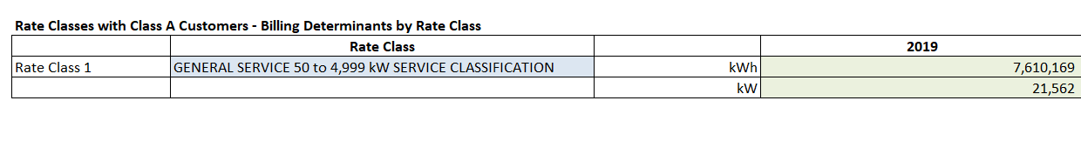
Staff Question - 2
Ref: Rate Generator Model

OEB staff has updated the IRM Rate Generator Model in the following areas:

- Tab 11 the 2021 UTR’s charges have been updated, as per EB-2020-0251
- Tab 17 cell E39 Specific charge for access to the power poles - per pole/year (with the exception of wireless attachments) - Approved on an Interim Basis has been updated to $44.50 (inflation factor removed)
- Tab 20 the Ontario Electricity Rebate has been updated to 18.9% and RPP rates have been updated
Please confirm that the IRM Rate Generator Model has been updated by OEB staff correctly.

