August 03, 2021
Marketing d’Énergie HQ Inc. /
HQ Energy Marketing Inc.
75, boul. René-Lévesque Ouest, 18e étage
Montréal, Québec
H2Z 1A4

VIA Email

Attention: Ms. Christine Long
Registrar and Board Secretary
Ontario Energy Board
P.O. Box 2319
2300 Yonge Street
27th Floor
Toronto ON
M4P 1E4

Dear Ms. Long:
Subject: EB-2021-0110 – Hydro One Stakeholder Conference Attendance
HQ Energy Marketing Inc. Attendance

On behalf of HQ Energy Marketing Inc., the following participants would like to attend the aforementioned conference on August 12, 2021:

Organization: HQ Energy Marketing Inc.
Authorized representative: Hélène Cossette
Title: Legal Counsel
Mailing address: 4e étage
75, René-Lévesque Boulevard Ouest
Montréal (Québec) Canada H2Z 1A4
E-mail address: cossette.helene@hydroquebec.com
Telephone number: 514 289-3146

Organization: HQ Energy Marketing Inc.
Authorized representative: Èveline Pelletier
Title: Manager - Regulatory Affairs
Mailing address: 18e étage
75, René-Lévesque Boulevard Ouest
Montréal (Québec) Canada H2Z 1A4
E-mail address: pelletier.eveline@hydroquebec.com
Telephone number: 514 289-6775

We are not requesting cost eligibility.

Sincerely,

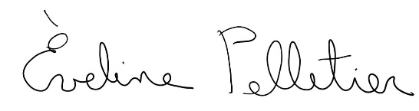
Èveline Pelletier
Manager, Regulatory Affairs, HQEM

c. Me. Hélène Cossette, Legal Counsel, Hydro-Québec

