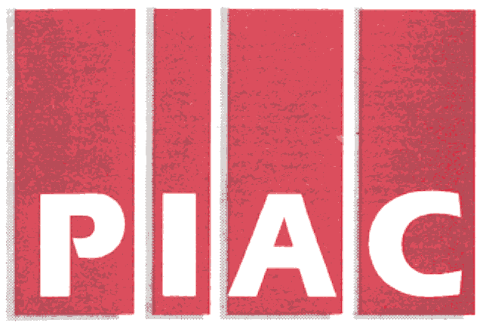June 11, 2007
PUBLIC INTEREST ADVOCACY CENTRE
LE CENTRE POUR LA DEFENSE DE L’INTERET PUBLIC

ONE Nicholas Street, Suite 1204, Ottawa, Ontario, Canada K1N 7B7
Tel: (613) 562-4002. Fax: (613) 562-0007. e-mail: piac@piac.ca. http://www.piac.ca

Fax and email only
Kirsten Walli
Board Secretary
Ontario Energy Board
Suite 2701
2300 Yonge Street
Toronto ON
M4P 1E4

Dear Ms Walli:

Re: Applications of Union Gas Limited (“Union”) and
Enbridge Gas Distribution Inc. (“EGD”) for approval of Rates for 2008 and Beyond/Your Files EB-2007-0615/EB-2007-0606

As counsel to the Vulnerable Energy Consumers Coalition, we are in receipt of correspondence dated May 30, 2007 from Mr. Robert Warren, counsel for the Consumers Council of Canada (CCC), concerning the request for reimbursement of expert expenses as they occur. We concur with the policy suggestion made by Mr. Warren associated with the treatment of expert disbursements. Such a policy would enable the continued retainer of qualified experts by intervenors by eliminating the prospect that, either the witness, or the intervening organization, will have to bear the burden of any disbursements until the payment of the cost award.

Thank you.

Yours truly,
Original signed
Micahel Janigan
Counsel for VECC

Cc: All parties

