Niagara Peninsula Energy Inc.
OEB Staff Questions
EB-2021-0043

Niagara Peninsula Energy Inc.
EB-2021-0043

Please note, Niagara Peninsula Energy Inc. (Niagara Peninsula Energy) is responsible for ensuring that all documents it files with the OEB, including responses to OEB staff questions and any other supporting documentation, do not include personal information (as that phrase is defined in the Freedom of Information and Protection of Privacy Act), unless filed in accordance with rule 9A of the OEB’s Rules of Practice and Procedure.

Staff Question-1
Ref: Rate Generator Model – Tab 4. Billing Det. For Def-Var is reproduced below

OEB staff is unable to reconcile the consumption data for the “General Service 50 to 4,999 kW Service Classification” with the reported amounts in Niagara Peninsula Energy’s 2.1.5 RRR.
- If Niagara Peninsula Energy believes the figures entered are correct, please provide an explanation for these discrepancies.

- If Niagara Peninsula Energy believes these figures needs adjustments, please confirm and OEB staff will update the model with the figures as found in the RRR.
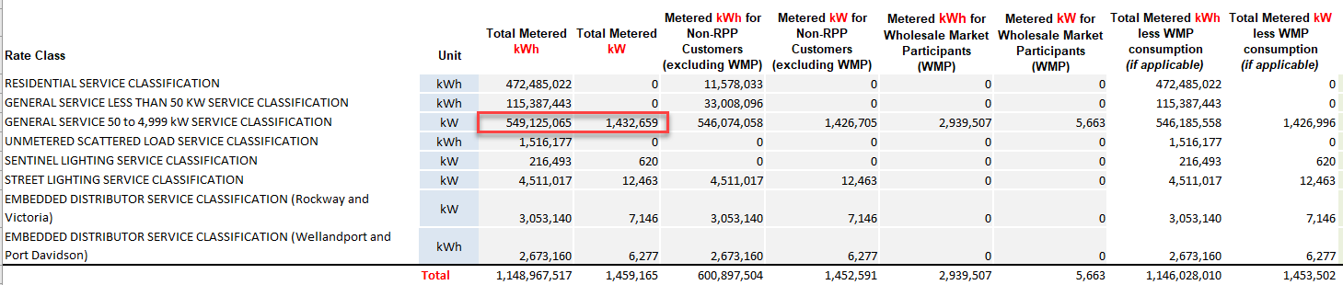

Staff Question-2
Ref: Tab 3. Continuity Schedule & Tab 4. Billing Det. For Def-Var

OEB staff notes that the amount in Tab 3, cell BV41 “Total Group 1 Balance for disposition” shows $730,424 whereas Tab 4, cell C29 – Billing Det. For Def-Var, the Total Claim for Threshold Test (All Group 1 accounts) shows $726,480.

Tab 3 – Continuity Schedule
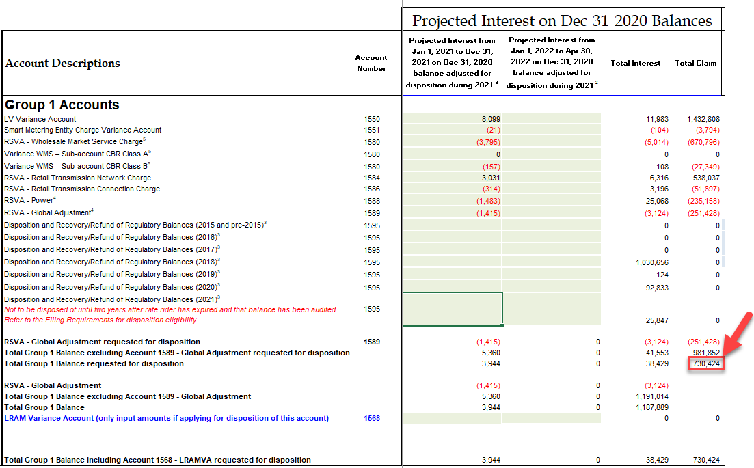

Tab 4 - Billing Det. For Def-Var
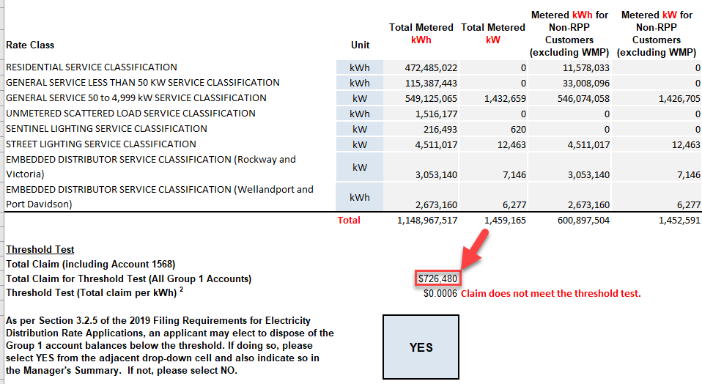

- OEB staff has updated Tab 4, cell C29 to reflect this change in Niagara Peninsula Energy’s IRM model. Please review and confirm the change.
Updates to the Rate Generator Model:

- In its Manager’s summary, NPEI stated that it has revised its 2022 Rate Generator Model, Tab 20. Bill Impacts to utilize an average non-RPP cost of power of $0.1060/kWh, rather than the default $0.2689/kWh.

Please note that staff has updated the Rate Generator Model to reflect the non-RPP cost of power of $0.1060/kWh, if you click on the “update” button on Tab 20, the macro will generate the correct bill impact.

Please review the updated Rate Generator Model and advise as to whether or not NPEI has any concerns with it and, if so, what they are.

- Update made in Staff Question-2 (Tabs 3 and 4)

