Niagara Peninsula Energy Inc.

Response to OEB Staff Questions

EB-2021-0043

**Niagara Peninsula Energy Inc.**

**EB-2021-0043**

Please note, Niagara Peninsula Energy Inc. (Niagara Peninsula Energy) is responsible for ensuring that all documents it files with the OEB, including responses to OEB staff questions and any other supporting documentation, do not include personal information (as that phrase is defined in the *Freedom of Information and Protection of Privacy Act*), unless filed in accordance with rule 9A of the OEB’s *Rules of Practice and Procedure*.

**Staff Question-1**

**Ref: Rate Generator Model – Tab 4. Billing Det. For Def-Var is reproduced below**

OEB staff is unable to reconcile the consumption data for the “General Service 50 to 4,999 kW Service Classification” with the reported amounts in Niagara Peninsula Energy’s 2.1.5 RRR.

1. If Niagara Peninsula Energy believes the figures entered are correct, please provide an explanation for these discrepancies.
2. If Niagara Peninsula Energy believes these figures needs adjustments, please confirm and OEB staff will update the model with the figures as found in the RRR.

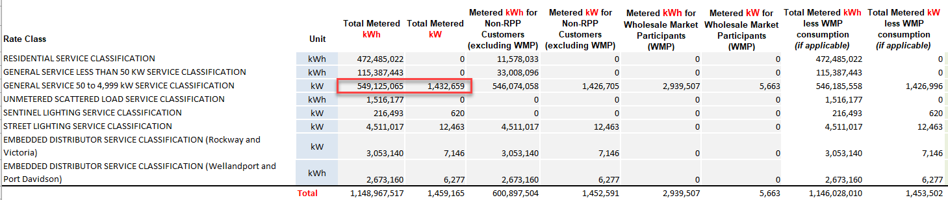

Response

1. Niagara Peninsula Energy Inc. (“NPEI”) confirms that the consumption and demand data for the “General Service 50 to 4,999 kW Service Classification” in the Rate Generator Model Tab 4. Billing Det. For Def-Var is correct.

As indicated in Section 3.1.3 Applications and Electronic Models of the application, the OEB approved a new Embedded Distributor rate class in NPEI’s 2021 Cost-of-Service rate application (EB-2020-0040), effective January 1, 2021. The Embedded Distributor rate class includes four Hydro One accounts, all of which are Primary Metering Elements (“PMEs”).Prior to 2021, these four accounts were classed as General Service 50 to 4,999 kW customers. Therefore, the consumption and demand for these four accounts was reported under the General Service 50 to 4,999 kW rate class in NPEI’s 2020 2.1.5 RRR.

NPEI worked with Board Staff to modify its 2022 IRM Rate Generator Model so that the 2020 consumption and demand data for these four accounts is presented separately from the rest of the 2020 General Service 50 to 4,999 kW rate class data in the Rate Generator Model Tab 4. Billing Det. For Def-Var.

The tables below provide reconciliations between the 2020 consumption and demand data in the Rate Generator Model Tab 4. Billing Det. For Def-Var, and NPEI’s 2020 2.1.5 RRR.

Table 1 – 2020 Consumption and Demand data - General Service 50 to 4,999 kW and Embedded Distributor Rate Classes only



Table 2 – 2020 Consumption and Demand - All Rate Classes



1. Not applicable.

**Staff Question-2**

**Ref: Tab 3. Continuity Schedule & Tab 4. Billing Det. For Def-Var**

OEB staff notes that the amount in Tab 3, cell BV41 “Total Group 1 Balance for disposition” shows $730,424 whereas Tab 4, cell C29 – Billing Det. For Def-Var, the Total Claim for Threshold Test (All Group 1 accounts) shows $726,480.

Tab 3 – Continuity Schedule

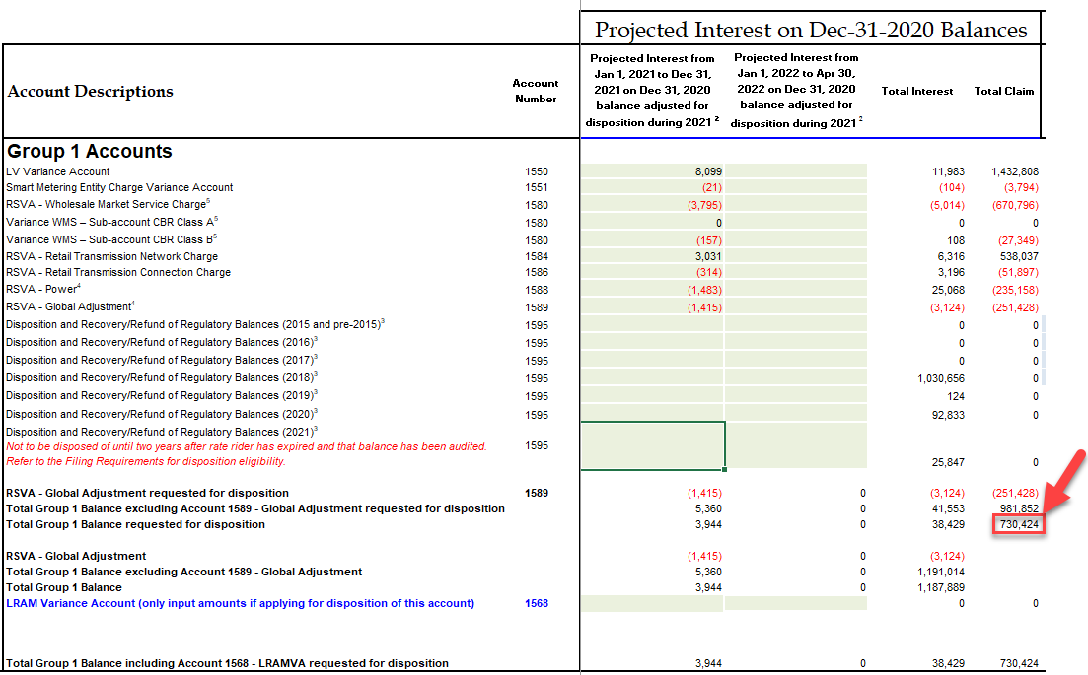

Tab 4 - Billing Det. For Def-Var

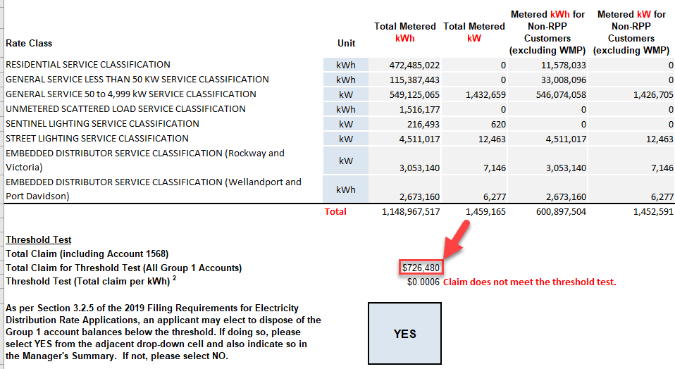

1. OEB staff has updated Tab 4, cell C29 to reflect this change in Niagara Peninsula Energy’s IRM model. Please review and confirm the change.
2. Response

NPEI confirms that the updated value in Tab 4, cell C29 is correct.

**Updates to the Rate Generator Model:**

1. In its Manager’s summary, NPEI stated that it has revised its 2022 Rate Generator Model, Tab 20. Bill Impacts to utilize an average non-RPP cost of power of $0.1060/kWh, rather than the default $0.2689/kWh.

Please note that staff has updated the Rate Generator Model to reflect the non-RPP cost of power of $0.1060/kWh, if you click on the “update” button on Tab 20, the macro will generate the correct bill impact.

Please review the updated Rate Generator Model and advise as to whether or not NPEI has any concerns with it and, if so, what they are.

1. Update made in Staff Question-2 (Tabs 3 and 4)