Cooperative Hydro Embrun Inc.
OEB Staff Questions
EB-2021-0014

Cooperative Hydro Embrun Inc.
EB-2021-0014

Please note, Cooperative Hydro Embrun Inc. (Cooperative Hydro Embrun) is responsible for ensuring that all documents it files with the OEB, including responses to OEB staff questions and any other supporting documentation, do not include personal information (as that phrase is defined in the Freedom of Information and Protection of Privacy Act), unless filed in accordance with rule 9A of the OEB’s Rules of Practice and Procedure.

Please also note, OEB staff has identified that the Non-RPP Retailer Average Price and Average IESO Wholesale Market Price used at the above reference were incorrectly entered as $0.2689. OEB staff has updated the attached model the pricing to reflect the correct amount of $0.1060.

Staff Question-1
Ref: Manager’s Summary

The date in the header section in Cooperative Hydro Embrun’s Manager Summary states “August 18, 2020” instead of “August 18, 2021”.

- Please confirm that the date is August 18, 2021.

CHEI Response: Confirmed

Staff Question-2
Ref: Manager’s Summary, page 6 of 71
In its Manager Summary, Cooperative Hydro Embrun states it is not seeking the Price Cap Incentive Rate-Setting option to adjust its 2022 rates.

- Please provide the reason why Cooperative Hydro Embrun chose not to seek a Price Cap Index adjustment in its 2022 rates.

CHEI Response: CHEI’s board of directors set a goal to keep its rate as low as possible. This internal objective will persist into the 2023 Cost of Service application which will be filed shortly therefore, keeping rates low will minimize the bill impact in the Cost of Service application.

Staff Question-3
Ref: A portion of Tab 1. Information Sheet from the Rate Generator Model is reproduced below

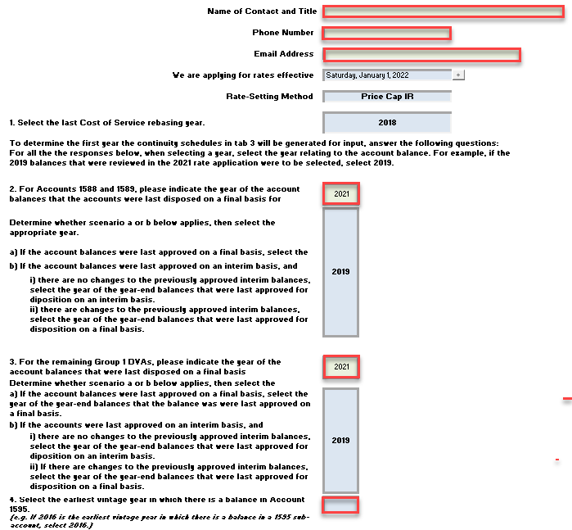

Cooperative Hydro Embrun provided the following responses in Tab 1. OEB staff has boxed in red the responses that require clarification:
Questions:
- The Name and Contact and Title; Phone Number and Email Address information is missing. Please complete the first three boxes.

- The following questions relate to Questions 2 and 3 (Cells F32 and F39):
Please explain why Cooperative Hydro Embrun selected “2021” as the last year in which Accounts 1588/1589 and remaining Group 1 balances were disposed.
In the 2021 IRM proceeding (EB-2020-0011), the OEB approved the disposition of Group 1 DVA balances as of December 31, 2019 on a final basis.
If “2021” was provided in error, please confirm whether the selection should be “2019” in both cells F32 and F39. If not, please explain.

CHEI Response: CHEI agrees with Staff. However, the input tab does not specify whether the year is the “rate year” or the “disposition year”. CHEI encourages Staff to update the model to be more specific about the desired input.

- The following question relates to Question 4.

Cell F47 is empty for Question 4 in the Information Sheet. OEB staff believes that the earliest vintage year in which Cooperative Hydro Embrun reported a balance in Account 1595 is 2018. Please review and confirm the earliest vintage year for Account 1595 and make the necessary updates to the model.

Staff Question-4
Ref: A portion of Sheet “3. Continuity Schedule” from the Rate Generator Model
is reproduced below.
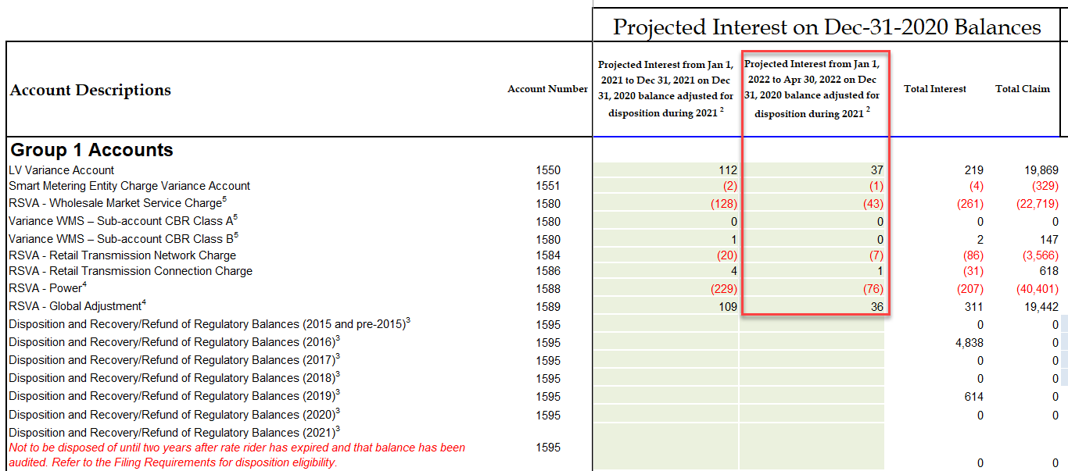
OEB staff notes that Cooperative Hydro Embrun completed the column BR pertaining to the cell titled “Projected Interest from January 1, 2022 to April 30, 2022 on Dec 31, 2020 balance adjusted for disposition during 2021”. The column BR applies for applicants applying for rates effective May 1, 2022.

- Please confirm that column BR should be removed.

CHEI Response: Yes, we confirm that column BR should be removed.

Staff Question-5
Ref: Rate Generator Model, Tab 8. STS - Tax Change
Ref: 2018 Cost of Service Application, EB-2017-0035, RRWF
OEB staff is unable to reconcile the Total Rate Base amount of $5,206,518. OEB staff notes that the Total Rate Base approved in Cooperative Hydro Embrun’s previous cost of service application was $4,680,408.
OEB staff is also unable to reconcile the Taxable Income amount of $17,548. OEB staff notes that the Taxable Income amount approved in Cooperative Hydro Embrun’s previous cost of service application was $27,218.
OEB staff is also unable to reconcile the Corporate Effective Tax Rate entered on tab 8 to Cooperative Hydro Embrun’s previous OEB-approved RRWF.

- Please provide references for the above noted inputs.
- Please confirm that the entire 50/50 sharing amount will be transferred to Account 1595 for disposition at a future date.

CHEI Response: CHEI amount of 17,548 is incorrect. However, CHEI cannot reconcile Board Staff’s amount of 27,218. The PILs model filed as part of the settlement agreement (RESS) shows a Regulatory Taxable income of $23,099 (tab T0 PILs, Tax Provision).

CHEI also confirms that the entire 50/50 sharing amount will be transferred to Account 1595 for disposition at a future date.

Staff Question-6
Ref: Manager’s Summary, page 15 of 71

In its Manager’s Summary, Cooperative Embrun provided a table showing the “Disposition Status of Account 1595”. OEB staff notes that in section 3.2.5.5 of the Filing Guidelines, “Distributors are expected to request disposition of residual balances in Account 1595 Sub-accounts for each vintage year only once, on a final basis. Distributors only become eligible to seek disposition of these residual balances two years after the expiry of the rate rider. During the two years after the expiry of the rate rider, distributors may still make billing corrections as per the Retail Settlement Code and record the related transactions in the associated Account 1595 sub-account.”

a) Please confirm that the table should read “Plus 2 years” instead of “Plus 1 year”.

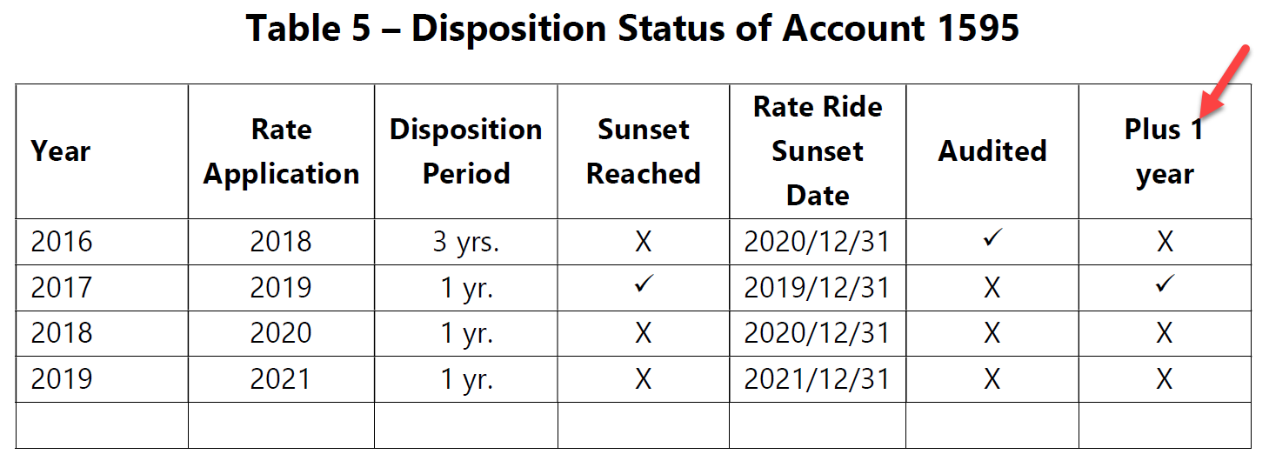

CHEI Response: In reviewing Chapter 3 filing requirement, specifically the OEB example:

“January 1 rate year – If 2019 rate riders end on December 31, 2019, the balance of sub-account 1595 (2019) could be disposed of once the December 31, 2021 account balance has been audited. Therefore, subaccount 1595 (2019) would be eligible for disposition in the 2023 rate Year…”

it would seem that residual balances will only be eligible in the 2023 application.
Therefore, CHEI will seek disposal of any residual balances in its 2023 Cost of Service.

Staff Question-7
Ref: D21-11840 EB-2021-0014 Cooperative Hydro Embrun 2022 IRM-Model_20210817, Tab #3. Continuity Schedule

At reference 1, Cooperative Hydro Embrun under account 1595 (2016) recorded transactions in the amount of $66,615 and principal adjustments for $113,727.

- Please explain the nature of the transactions and the principal adjustment mentioned above

CHEI Response:

The principal adjustment of $113,727 was moved from the 1595 (2018) to 1595 (2016) in order to properly reflect balances in the correct year. There was an error in the prior year continuity schedule as amounts had been presented on a separate line when they should have been together. Rather than request an adjustment to Prior year IRM, the amounts were reclassified this year.

The $66,615 consists of the recoveries billed to customers during the year 2020 as per the approved dispositions allowed of prior years.

