Hydro Hawkesbury

OEB Staff Questions

EB-2021-0031

**Hydro Hawkesbury Inc.**

**EB-2021-0031**

Please note, Hydro Hawkesbury Inc. (Hydro Hawkesbury) is responsible for ensuring that all documents it files with the OEB, including responses to OEB staff questions and any other supporting documentation, do not include personal information (as that phrase is defined in the *Freedom of Information and Protection of Privacy Act*), unless filed in accordance with rule 9A of the OEB’s *Rules of Practice and Procedure*.

Please also note, OEB staff has identified that the Non-RPP Retailer Average Price and Average IESO Wholesale Market Price used at the above reference were incorrectly entered as $0.2689. OEB staff has updated the attached model the pricing to reflect the correct amount of $0.1060.

**Staff Question-1**

**Ref: Rate Generator Model – A portion of Tab 1. Information Sheet is reproduced below.**

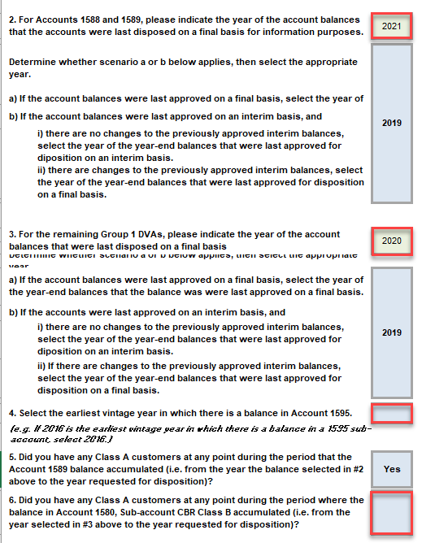

Hydro Hawkesbury provided the following responses in Tab 1. OEB staff has outlined in red the responses that require clarification:

Questions:

The following questions relate to Questions 2 and 3 (Cells F32 and F39):

1. Please explain why Hydro Hawkesbury selected “2021” as the last year in which Accounts 1588/1589 and remaining Group 1 balances were disposed.

In the 2021 IRM proceeding (EB-2020-0029), the OEB approved the disposition of Group 1 DVA balances as of December 31, 2019 on a final basis.

If “2021” was provided in error, please confirm whether the selection should be “2019” in both cells F32 and F39. If not, please explain. If any changes are required, please make them to the Rate Generator Model provided by OEB staff and attached to these questions.

HHI Response: With the lack of explanation in the model with respect to selecting “rate effective year” vs “disposition/balance year”, HHI used the “rate effective year”.

If the “disposition year” was the expectation (as implied), then HHI agrees with Board Staff’s suggested inputs.

HHI encourages the OEB to update the model to be more specific about the desired input.

1. The following question relates to Question 4.

Cell F47 is empty. OEB staff believes that the earliest vintage year in which Hydro Hawkesbury reported a balance in Account 1595 is 2018. Please review and confirm the earliest vintage year for Account 1595 and make the necessary updates to the Rate Generator Model.

HHI Response: It is unclear as to whether the OEB is looking for “rate effective year” or “disposition/balance year”.

If the “rate effective year” was the expectation (as implied and which contradicts the expectation in a) above), HHI agrees with Board Staff.

HHI encourages the OEB to update the model to be more specific about the desired input.

1. The following question relates to Question 6.

Cell F51 is empty. OEB staff believes that it should be marked as “Yes”. Please confirm and make the necessary updates to the Rate Generator Model.

HHI Response: Confirmed

**Staff Question-2**

**Ref: Rate Generator Model, Tab 8. STS - Tax Change**

**Ref: 2018 Cost of Service Application, EB-2017-0048, RRWF**

OEB staff is also unable to reconcile the Taxable Income amount of $57,713. OEB staff notes that the Taxable Income amount approved in Hydro Hawkesbury’s previous cost of service application was $59,713.

OEB staff is also unable to reconcile the Corporate Effective Tax Rate entered on tab 8 to Hydro Hawkesbury’s previous OEB-approved RRWF.

1. Please provide references for the above noted inputs. If any changes are required, please make them to the Rate Generator Model as provided.
2. Please confirm that the entire 50/50 sharing amount will be transferred to Account 1595 for disposition at a future date.

HHI Response: HHI confirms that the correct amount for Taxable Income is $59,713. The model filed with these responses reflects the correct amount.

**OEB Staff Question-3**

**Ref: Manager’s Summary, page 13 of 71**

**Ref: A Portion of Tab 3. Continuity Schedule is reproduced below**

**Adjustments to 2.1.7 RRR**

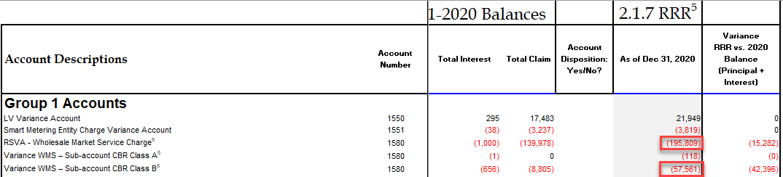

Hydro Hawkesbury stated that the amount of ($57,561) presented for CBR Class B in the 2.1.7 RRR is incorrect. Amounts should have been ($180,526) for RSVA 1580 - Wholesale Market Service Charge and ($15,165) for RSVA-1580 Wholesale Market Service Charge sub-account CBR Class B.

1. Did Hydro Hawkesbury submit a revision request to the OEB’s Performance Analytics & Reporting Group? If so, when? If not, please submit and notify the case manager when the RRR amendment is complete.

HHI Response: HHI confirms that it applied for a revision request as of the date of October 19, 2021.

**OEB Staff Question-5 –**

**Ref: A portion of Tab 3: Continuity Schedule is reproduced below**

**Ref: Manager’s Summary, page 14 of 71**

In its Manager’s summary, Hydro Hawkesbury states that there is a variance between amounts reported and the RRR values in account 1568 LRAMVA because the 2.1.7 RRR balance does not appear in column BV. These columns are prepopulated amounts.

OEB staff has updated the 2.1.7 RRR Account 1568 in the Rate Generator Model, cell BV 46. Please confirm accuracy.

OEB staff notes that Hydro Hawkesbury did not complete the disposition amounts in cells BM46 and BN46. Please complete cells BM46 and BN46.

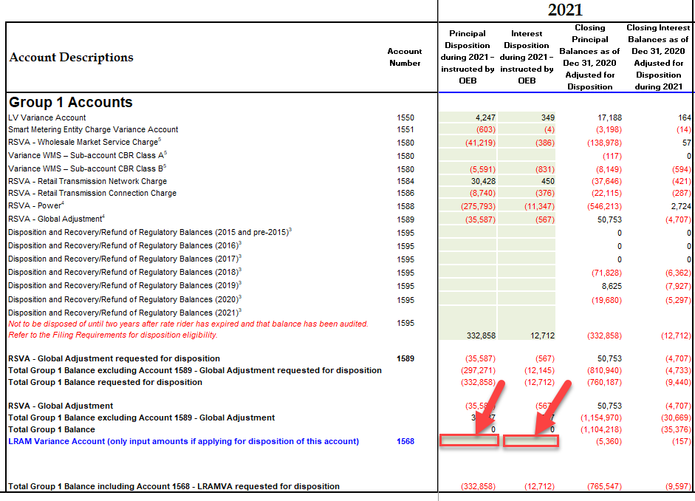

HHI Response: BM46 = (784) and BN46 = 35.

**OEB Staff Question-6**

**Ref: A portion of Tab 4. Billing Det. for Def-Var is reproduced below**

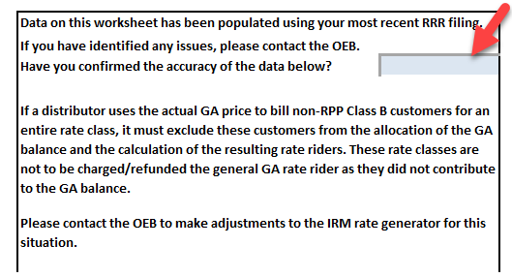

OEB staff notes that Cell J4 in Tab 4. Billing Det.for Def-Var is empty.

1. Please complete to confirm the accuracy of the RRR data used to populate the tab.

HHI Response: The model filed with these responses has been updated to reflect the update.

**OEB Staff Question-7**

**Ref: Manager’s Summary, page 15 of 71**

In its Manager’s Summary, Hydro Hawkesbury provided a table showing the “Disposition Status of Account 1595”. OEB staff notes that in section 3.2.5.5 of the Filing Guidelines, “Distributors are expected to request disposition of residual balances in Account 1595 Sub-accounts for each vintage year only once, on a final basis. Distributors only become eligible to seek disposition of these residual balances two years after the expiry of the rate rider. During the two years after the expiry of the rate rider, distributors may still make billing corrections as per the Retail Settlement Code and record the related transactions in the associated Account 1595 sub-account.”

1. Please confirm that the table should read “Plus 2 years” instead of “Plus 1 year”.

OEB staff notes that Hydro Hawkesbury states that Account 1595-2016, which was disposed in 2018 rate application, has a sunset date of 2019-02-28. If that’s true, then two years after that would be 2021-02-28. That February 2021 balance will be audited as part of December 31, 2021 year end, and eligible in the 2023 rate application (next year). If this is the case, does Hydro Hawkesbury agree with this and confirm whether they should be deferring the 1595-2016 residual balance disposition to next year?

HHI Response: In reviewing Chapter 3 filing requirement, specifically the OEB example:

“*January 1 rate year – If 2019 rate riders end on December 31, 2019, the balance of sub-account 1595 (2019) could be disposed of once the December 31, 2021, account balance has been audited. Therefore, subaccount 1595 (2019) would be eligible for disposition in the 2023 rate Year…”*

it would seem that residual balances will only be eligible in the 2023 application. Therefore, HHI will seek disposal of any residual balances in its 2023 Cost of Service.

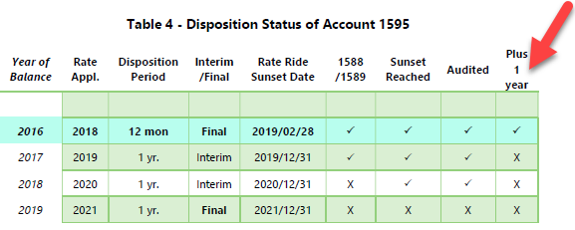

**OEB Staff Question-8**

**Ref: 2022 IRM_GA_Analysis_Workform_20210818, Tab “Account 1588”**

Large balances are not expected for Account 1588 as it should only hold the variance between commodity costs based on actual line losses and commodity revenues calculated using values for line losses approved by the OEB in the utility’s last rebasing application. Based on RRR data filed for Hawkesbury Hydro for Account 4705 Cost of Power, OEB staff calculates the annual net activity (i.e. transactions plus principal adjustments) from the DVA Continuity Schedule as a percentage of annual Account 4705 to be as follows:



a) Please confirm this calculation or provide a revised calculation. See attached file.

b) Given that the 2020 variance is greater than 1% of the total power purchased, please provide an explanation as to why the Account 1588 transactional balance is so large for 2020, with due consideration to the expected impact of line losses.

HHI Response: The accounting for 1588/1589 is done by an external accounting firm.

In reaching out to them for assistance, MNP (formerly Deloitte) is not able to fully explain the variances without considerable time, effort and additional costs, as some of the adjustments done throughout the year was done using the previous accounting method while the year end entries were done using the current method. Researching the variances will take several weeks. As such, the utility is seeking an exemption form disposing of account 1588/1589 until it has had a chance to work with MNP to provide accurate explanations for the variances.