Hydro Hawkesbury Inc.
OEB Staff Questions
EB-2021-0031

Hydro Hawkesbury Inc.
EB-2021-0031
November 9, 2021

Please note, Hydro Hawkesbury Inc. is responsible for ensuring that all documents it files with the OEB, including responses to OEB staff questions and any other supporting documentation, do not include personal information (as that phrase is defined in the Freedom of Information and Protection of Privacy Act), unless filed in accordance with rule 9A of the OEB’s Rules of Practice and Procedure.

Staff Follow up Question-1
Ref: Rate Generator Model – Tab 20 – Bill Impacts

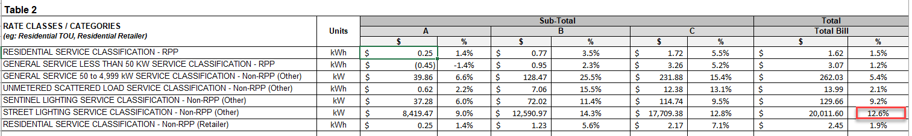
In response to Staff Question-8, Hydro Hawkesbury Inc. stated that it is seeking an exemption form disposing of account 1588/1589 until it has had a chance to work with MNP (formerly Deloitte) to provide accurate explanations for the variances. OEB staff has updated IRM Model and notes that Street Lighting rate class has a bill of impact of greater than 10%.

- Please explain if Hydro Hawkesbury Inc. has considered any rate mitigation measures. If not, please explain why.

HHI Response: HHI notes that the consumption in the bill impact tab was not populated correctly. The Demand on which the class is being billed on was left blank. HHI has updated the demand for the Sentinel Class and Street Lighting class. HHI also updated the kWh consumption for the Street Lighting class to reflect a monthly average bill. The billing determinant was also updated to reflect the number of devices approved it its 2018 Cost of Service.
The resulting bill impact for all classes are below the 10% threshold.

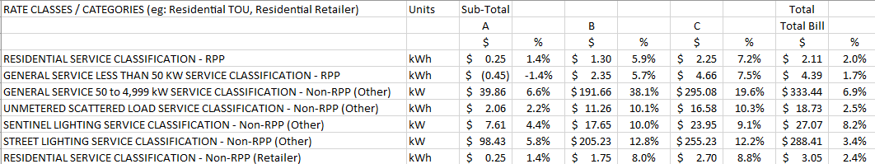

Updates to Rate Generator Model:
- Staff Question-1 c), Tab 1 – Information Sheet, Cell F51 updated to “Yes”
- Staff Question-5, Tab 3 – Continuity Schedule, updated cells BM46 = (784) and BN46 35
Please confirm accuracy of the updates.
HHI Response: HHI confirms the updates.

