Cooperative Hydro Embrun Inc.
OEB Staff Questions
EB-2021-0014

Cooperative Hydro Embrun Inc.
EB-2021-0014

Please note, Cooperative Hydro Embrun Inc. is responsible for ensuring that all documents it files with the OEB, including responses to OEB staff questions and any other supporting documentation, do not include personal information (as that phrase is defined in the Freedom of Information and Protection of Privacy Act), unless filed in accordance with rule 9A of the OEB’s Rules of Practice and Procedure.

Staff follow-up Question-1
Ref: Staff Question #3 a)

Please note that the earliest vintage year is the “rate application year”.
- Please confirm the earliest vintage year for Account 1595 in cell F47 and make the necessary updates to the model. If the earliest vintage year is 2018, please note that in Tab 3 - Continuity Schedule, the earliest vintage year in which Cooperative Hydro Embrun reported a balance in Account 1595 is 2019. Please revise the IRM model as necessary.
CHEI believes that the earliest vintage year for account 1595 is for 2018 rate application year for 2016 balances. The model has been modified to show 2018 in the highlighted cell above.

Staff follow-up Question-2
Ref: Staff Question #5 a)
Ref: Rate Generator Model, Tab 8. STS - Tax Change
A portion of 2018 Cost of Service Application, EB-2017-0035, RRWF is reproduced below:
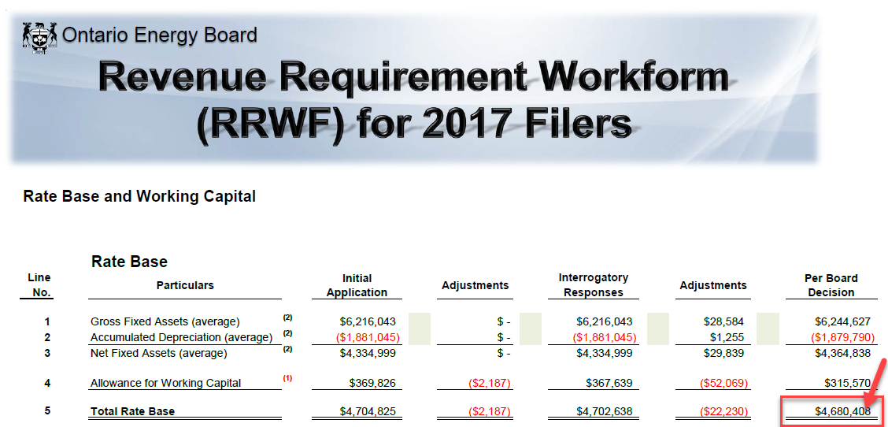
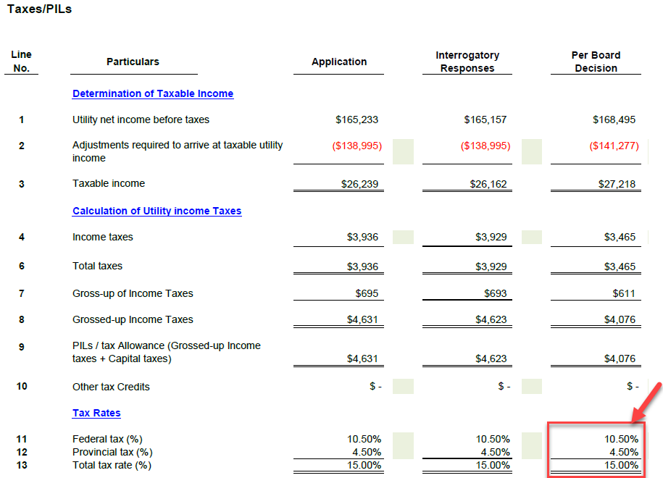
OEB staff is unable to reconcile the Total Rate Base amount of $5,206,518. OEB staff notes that the Total Rate Base approved in Cooperative Hydro Embrun’s previous cost of service application, which is also shown in the Manager’s summary, page 62 of 76, was $4,680,408.
CHEI has updated the model to reflect the rate base approved in its last Cost of Service therefore $4,680,408
OEB staff is also unable to reconcile the Taxable Income amount of $17,548. OEB staff notes that the Taxable Income amount approved in Cooperative Hydro Embrun’s previous cost of service application was $27,218. (CHEI Response: CHEI amount of 17,548 is incorrect. However, CHEI cannot reconcile Board Staff’s amount of 27,218. The PILs model filed as part of the settlement agreement (RESS) shows a Regulatory Taxable income of $23,099 (tab T0 PILs, Tax Provision).

OEB staff is also unable to reconcile the Corporate Effective Tax Rate entered on tab 8 to Cooperative Hydro Embrun’s previous OEB-approved RRWF.
CHEI believes that the combined tax rate should have indicated 15% rather than 14.5%
- Please provide a copy of the PILS model as indicated in Cooperative Hydro Embrun’s response dated October 19, 2021.
CHEI has attached the PILs model which was filed as part of the settlement agreement. The 23,099 can be found at T0 and T1 (cell F116)

- Please confirm that the entire 50/50 sharing amount will be transferred to Account 1595 for disposition at a future date.
CHEI Response: CHEI confirms that the tax sharing amount will be transferred to account 1595 to be disposed of at a future date.

